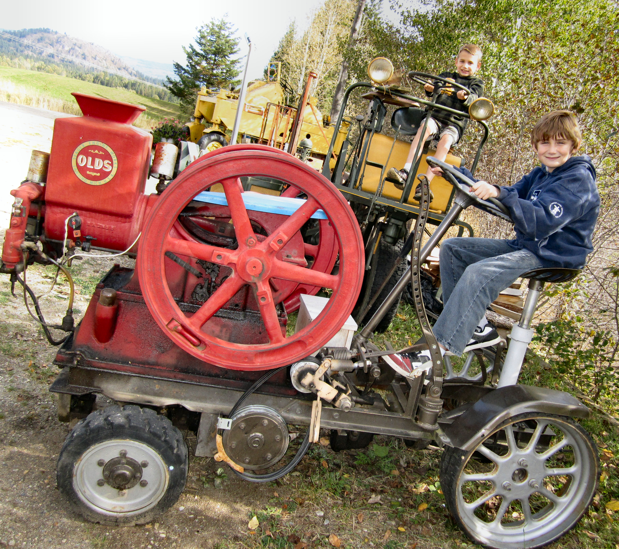

Kyle and Evan Flux ride some of the antique equipment on display at the Deep Creek Tool Museum.

Hang out with a historical handyman

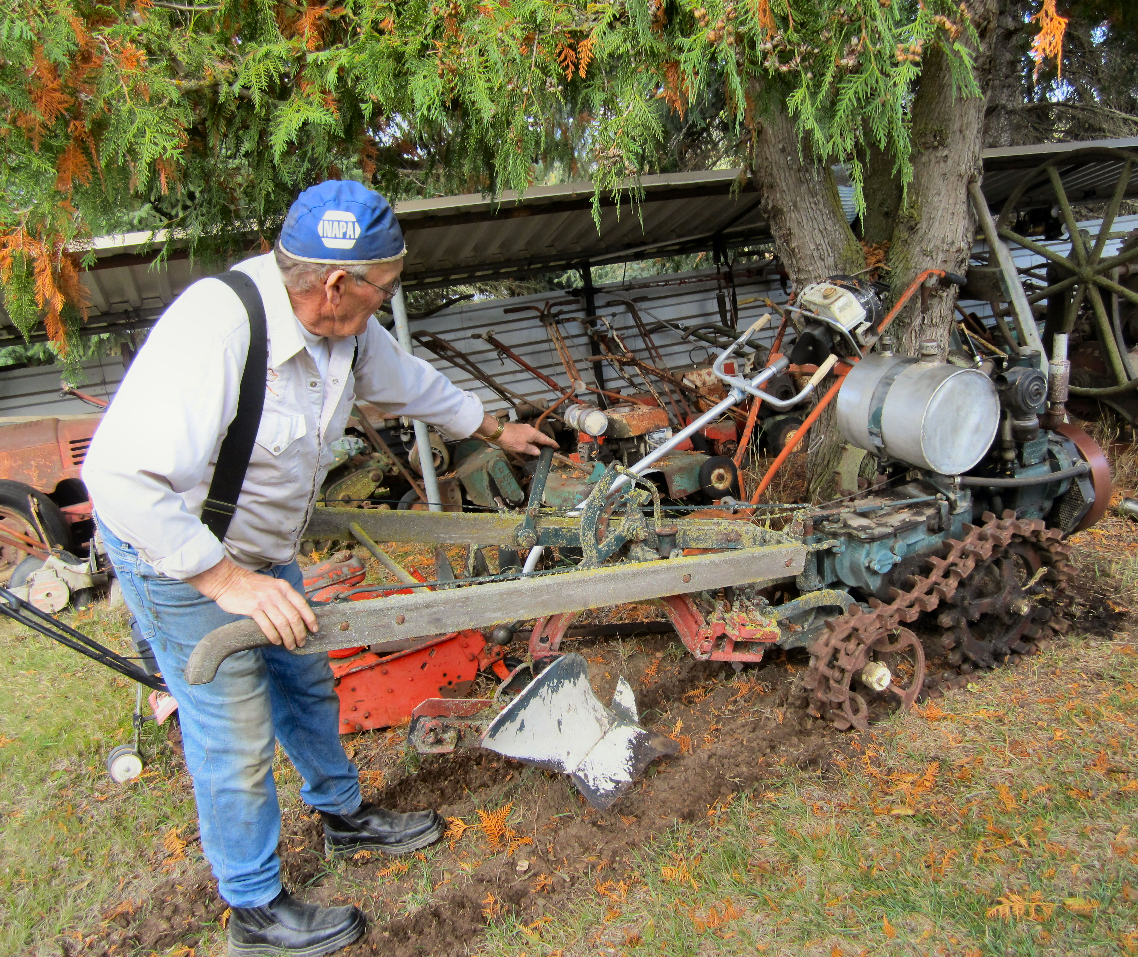
Driving down a country road in Tappen is the last place one would expect to encounter an enormous lawn mower. Anyone coming across it can’t help but to pull into the driveway and take a closer look check it out along with all of the antique equipment that decorate Herb front yard at the Deep Creek Tool Museum.
When Herb Higginbottom’s first wife got sick he needed to stay home and look after her. He had been collecting old tools for 50 years and was inspired to transform his house into a museum. His extensive collection of tools, engines, household items and equipment date back to the early 1900’s and he even has some of the original magazine ads to prove it.
The collection is spread out across his front yard, back yard and garage and his collection of household items fills two rooms in his house. But with very little money to advertise, Herb took the advice of his second wife who told him that if he wanted to draw a crowd, he needed to build something big…but what? And then it came to him, he would build the world’s largest manual lawnmower. It took Herb a year and a half to custom build the over 4000 pound work of art. He even had to build his own set of rollers to roll the steel. But that wasn’t the first time Herb customized his own equipment.
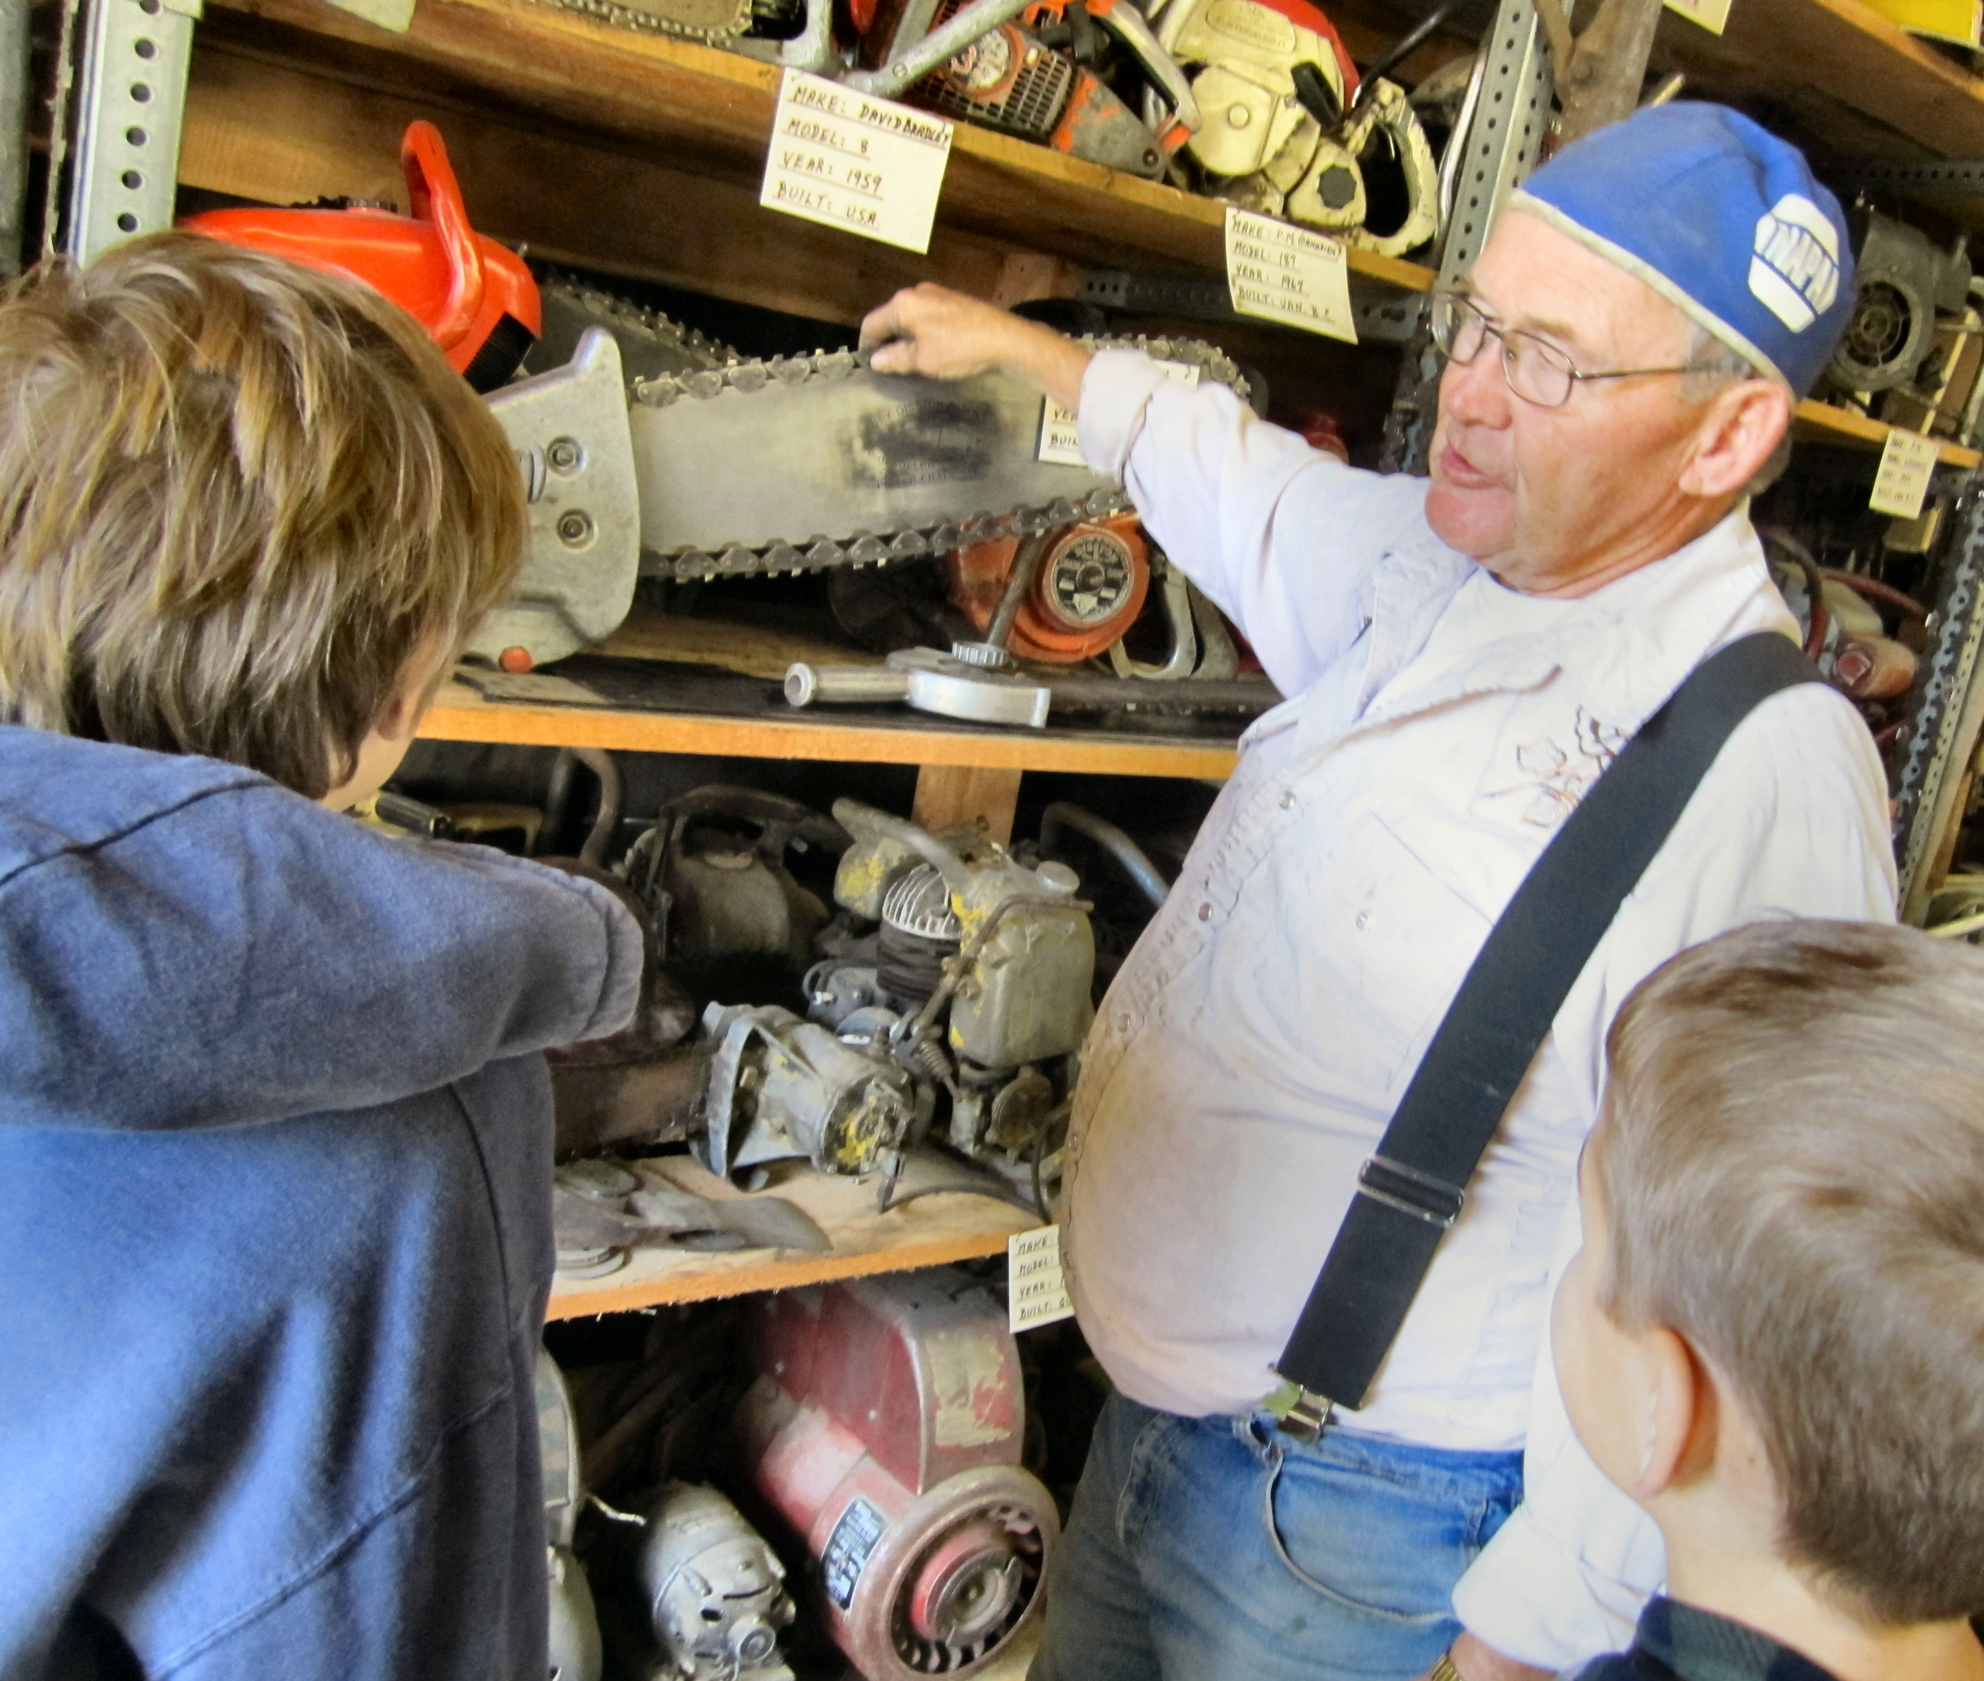
On the tour, be sure to ask Herb to show you his homemade woodcutting machine as well as his homemade bulldozer because what differentiates this museum from any other is Herb himself. His enthusiasm for antique tools and equipment is contagious.

HOW TO GET THERE – The museum is located at 91 Deep Creek Road in Enderby. Call 250-832-2506 for hours or more information. It is open year round offering tours, restorations, and sales.

Herb Higginbottom demonstrates how to use different old tools

