Have a drink
AT the Bullet hole Saloon

Ever since the Coquihalla Highway was constructed from Kamloops to Merritt the old Merritt Highway 5A has become a distant memory. It is definitely one of British Columbia’s hidden gems with its gorgeous lakes, historical buildings and breath-taking landscapes.
One of 5A’s highlights is most definitely the Bullet Hole Saloon at the Quilchena Hotel. Once a popular watering hole for cowboys it is now a popular tourist attraction where people come to have a drink and ponder how those three bullet holes really got there.
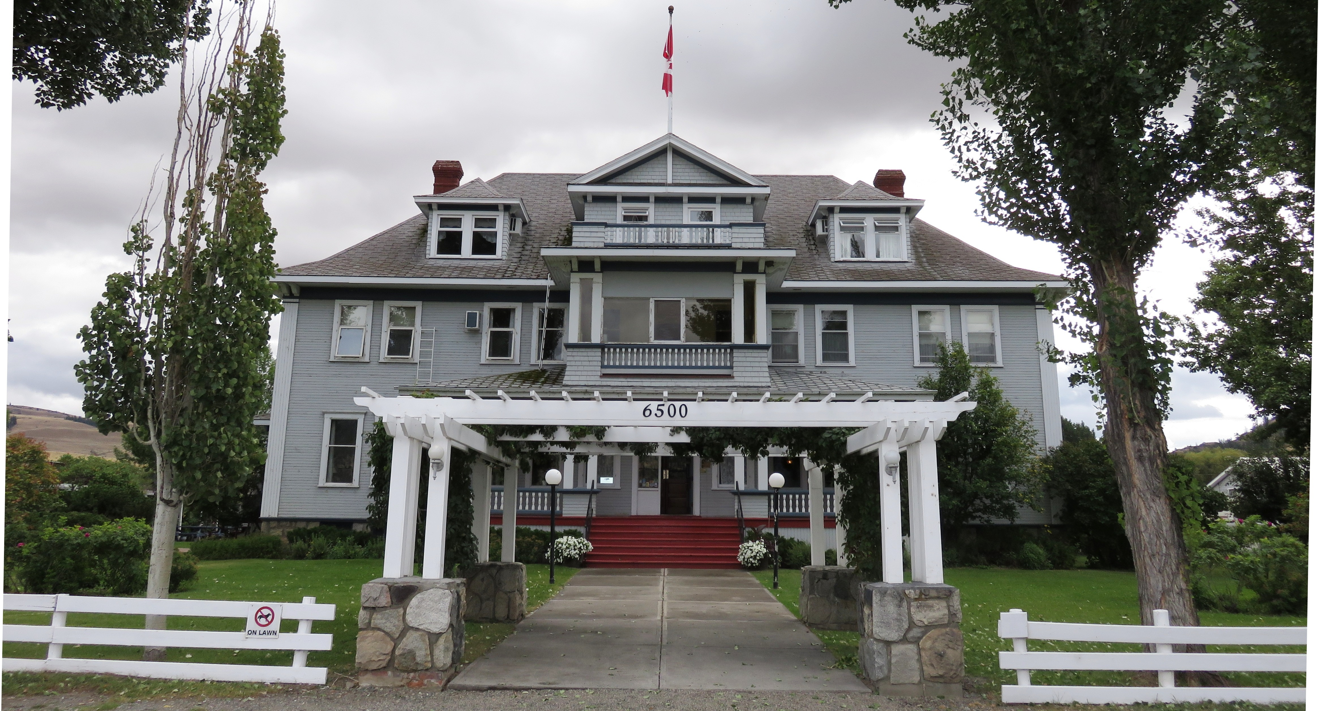

The Quilchena Hotel is located along the Old Merrit Highway and is owned by the Douglas Lake Cattle Company.

According to owner Guy Rose, a couple of drunken cowboys from the nearby Douglas Lake Ranch were cut off by the bartender. Angry, one of them drew his pistol and fired three shots at the bar, putting holes in a barrel of liquor. But is this the real story?
A sign on the bar admits that “Through the year bullet-holes-in-the-bar stories have taken some fantastic turns. We’ve told and invented many of them, but truth be told we don’t know the real story.” And I am sure after a few drinks; patrons love to invent their own stories.

The Quilchena Hotel officially opened on the evening of July 3, 1908. Unfortunately it closed in 1920 as a result of both the advent of the automobile which drastically cut travel times negating the need for overnight accommodations and prohibition which closed down it’s remaining income source the saloon.
During this time it was maintained by founder Joseph Guichon's descendents and remained closed until it was purchased by Guy Rose in 1957. The Roses reopened it as a hotel keeping much of the original furniture, monogrammed China and silver and keeping the rooms vintage 1908.
With a history this long this building no doubt has a few stories to tell. In fact, in 1906 when the previous 2-story hotel was still standing notorious Wild West train robber Bill Miner spent a night on the property, held at gunpoint in a shed until daylight. He and two of his bandit accomplices were caught by a posse after robbing a Vancouver-bound Canadian Pacific Railway train east of Kamloops and getting in a gunfight with mounted police.

The hotel has been visited by a number of famous and infamous people including actor Jack Nicholson who stayed in room #2 while filming The Pledge directed by Sean Penn.

According to former employee Adette Lacerte the hotel was also a popular “haunt” for a friendly ghost who liked to play tricks on the staff. It locked one employee in a storage room and loved to turn up the music in the kitchen when no one was there.

HOW TO GET THERE – The historic Quilchena Hotel is located on Highway 5A 20 kilometres northeast of Merritt.
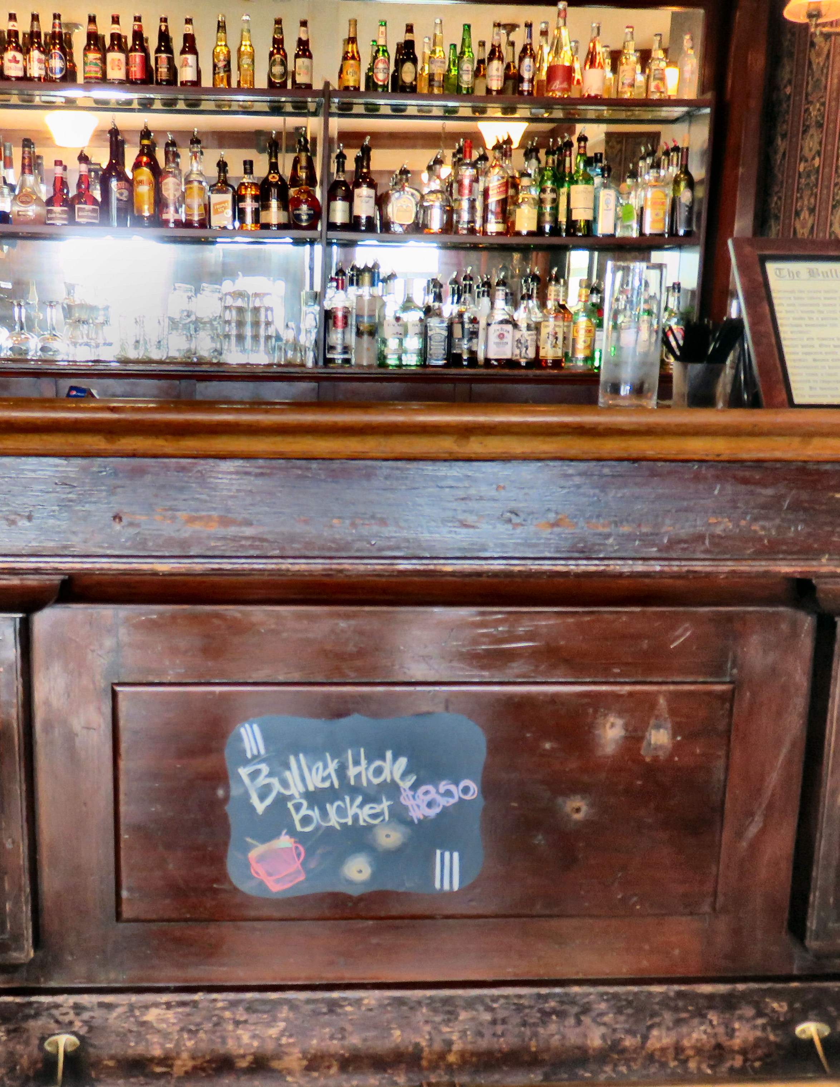

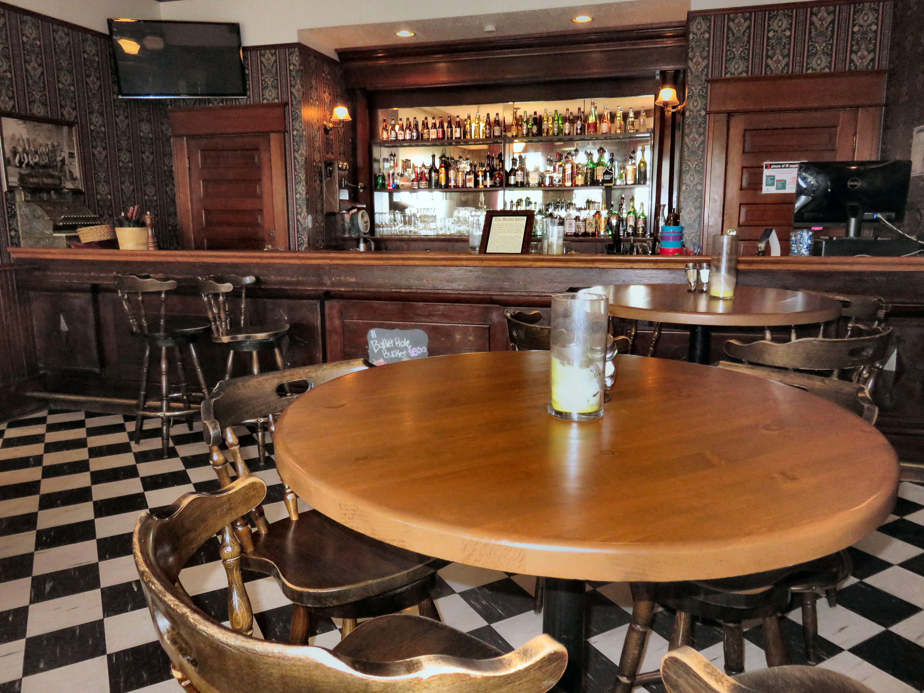

If you look at the wooden panel on the bar you can see 3 bullet holes.

