TAKE THE TIME TO TOUR TAKAkKAW FALLS

Takakkaw is a Cree word meaning magnificent and that is exactly what these falls are. Fed by the Daly Glacier (which is part of the Waputik Icefield), these falls drop 254 meters making them one of the highest in Canada.
To get to them you have to drive along a rather narrow and steep switchback but if numerous tour buses motor homes can do it so can you.
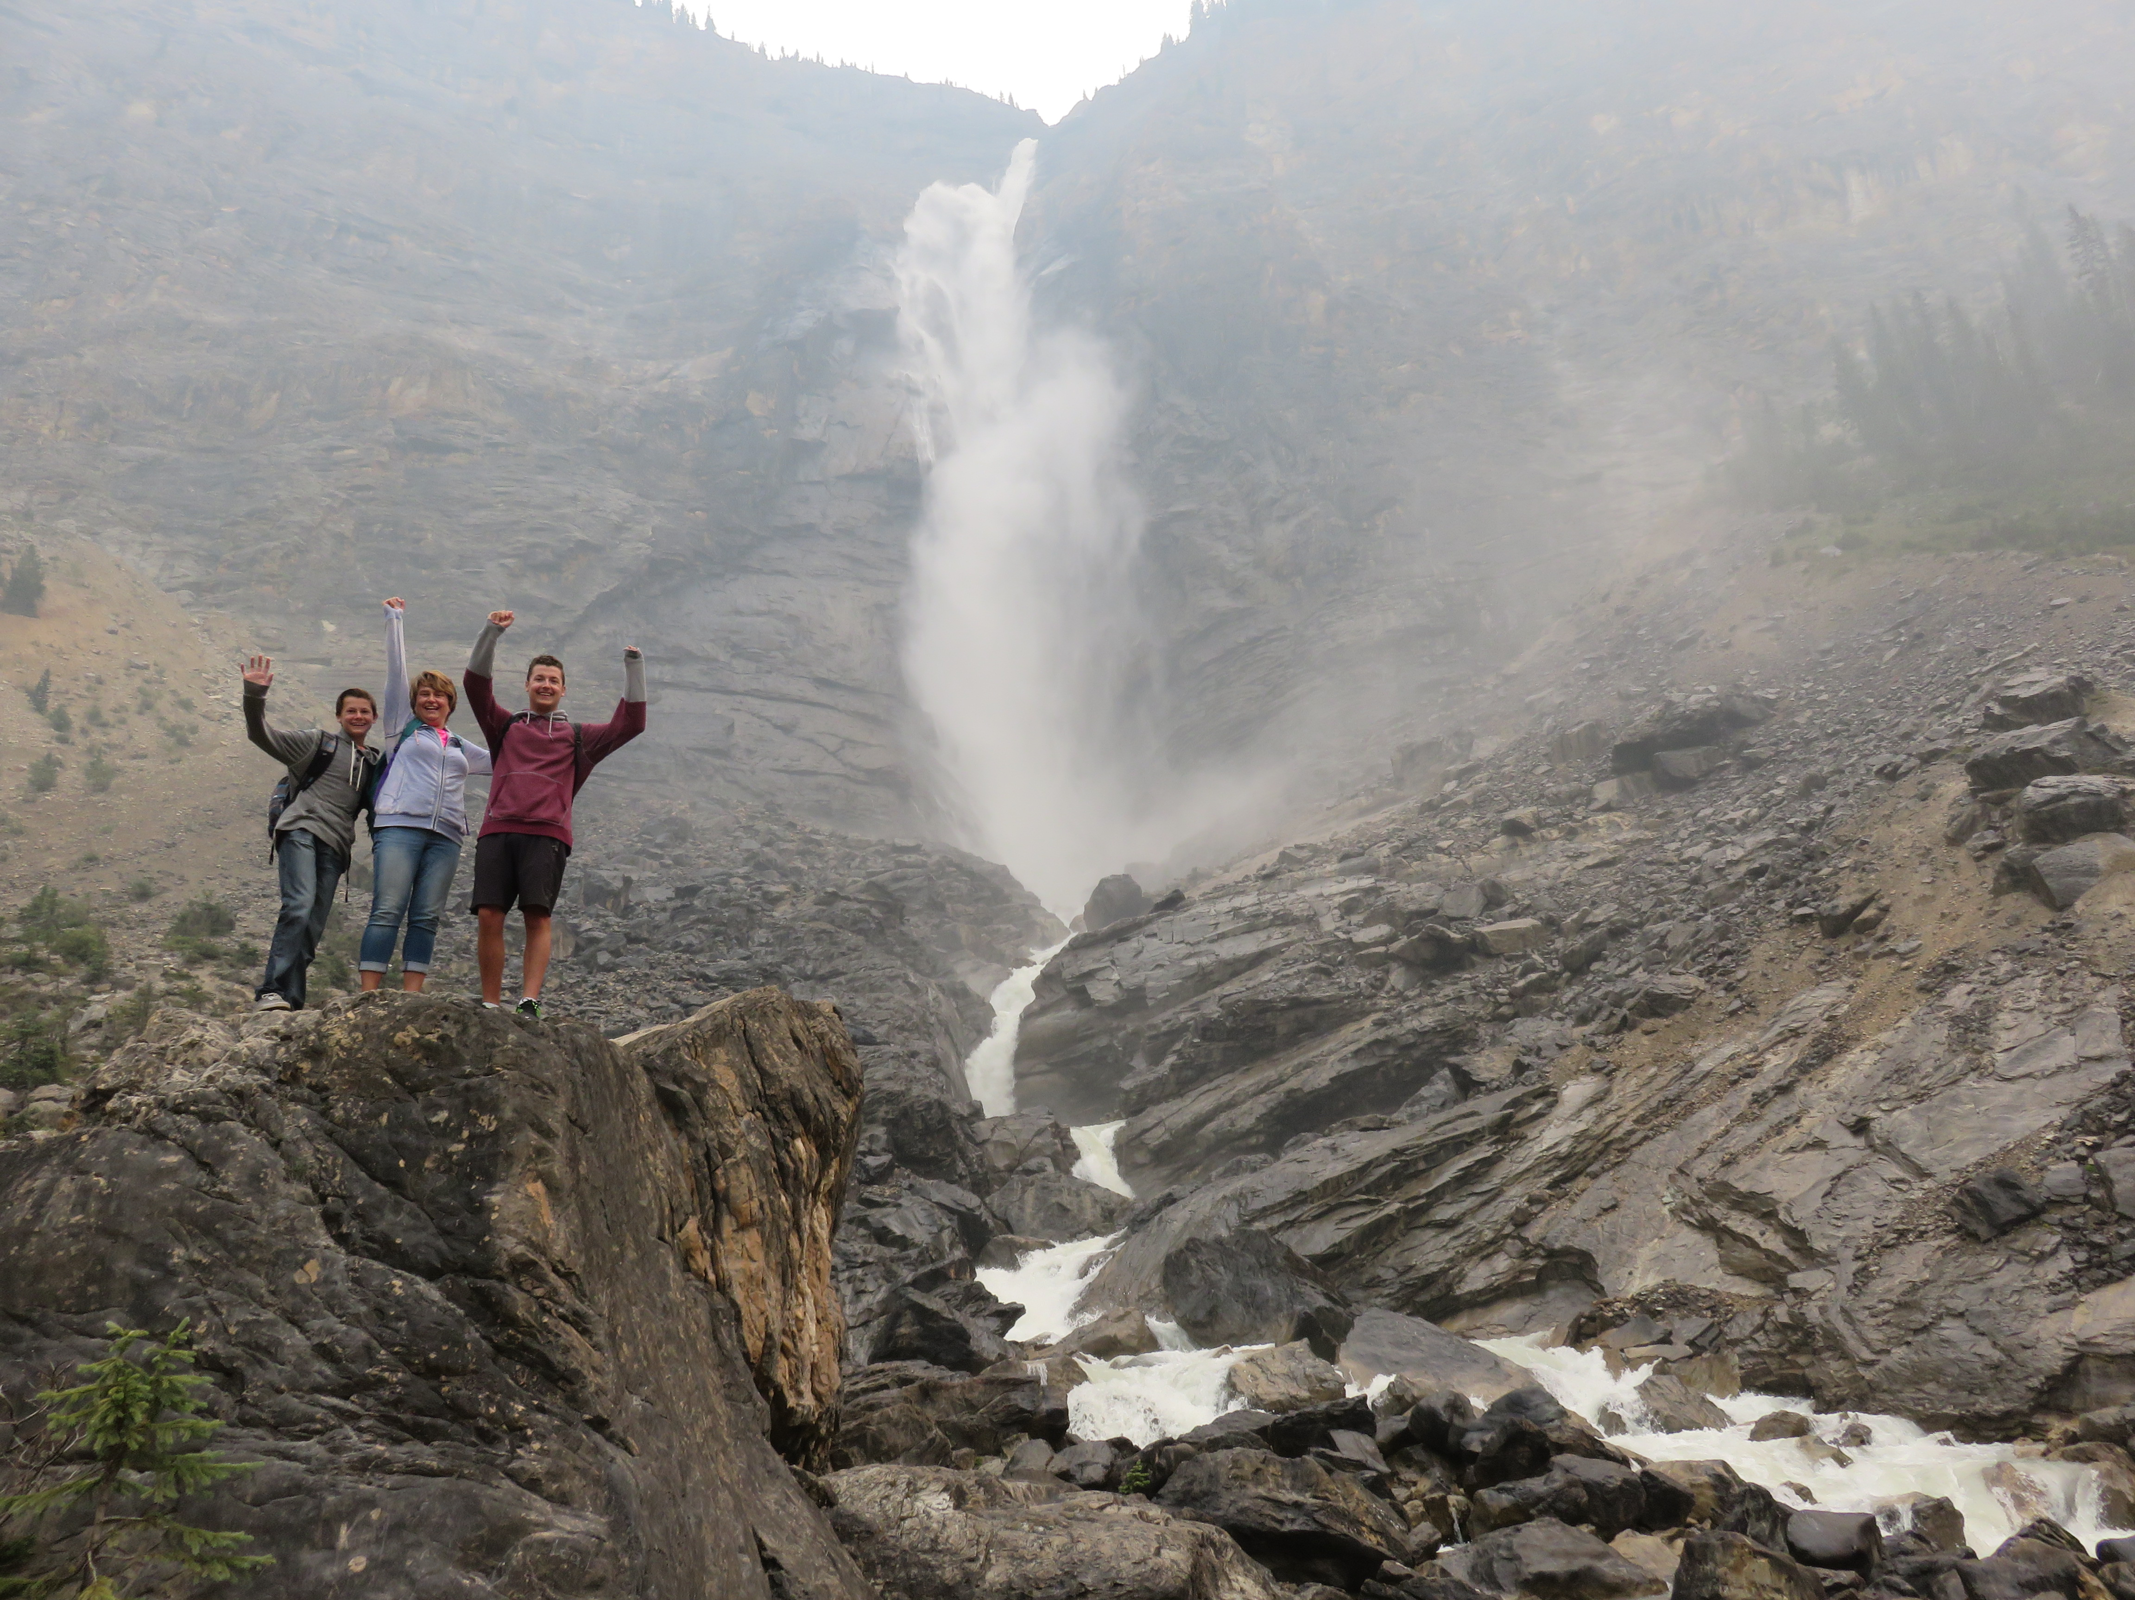

The Kardash family strike a victory pose in front of Takakkaw Falls in Yoho National Park.

The large day parking area is only a 10 minute walk from the base of the falls and is also the parking for a variety of different hiking trails.

HOW TO GET THERE – Takakkaw Falls is located between Field and Golden in Yoho National Park. Look for the turn-off signs along the Trans-Canada Highway.

