Sample Wine in one of Kelowna’s oldest homes

Quail’s Gate truly is a family winery. It is owned by the Stewarts who have been pioneering horticulturists in the area since the turn of the last century. Having come to the Okanagan in 1908, Richard Stewart Sr. settled in the Kelowna area and founded one of the valley’s most successful nursery businesses. Some 50 years later his son Dick Stewart carried on this tradition by moving into grape growing.
In 1989, Ben and Ruth Stewart founded Quails’ Gate Winery and began the family’s transition into the winery business. Over the next two decades the entire family joined together in the pursuit of making Quails’ Gate one of Canada’s foremost producers of premium VQA wines.
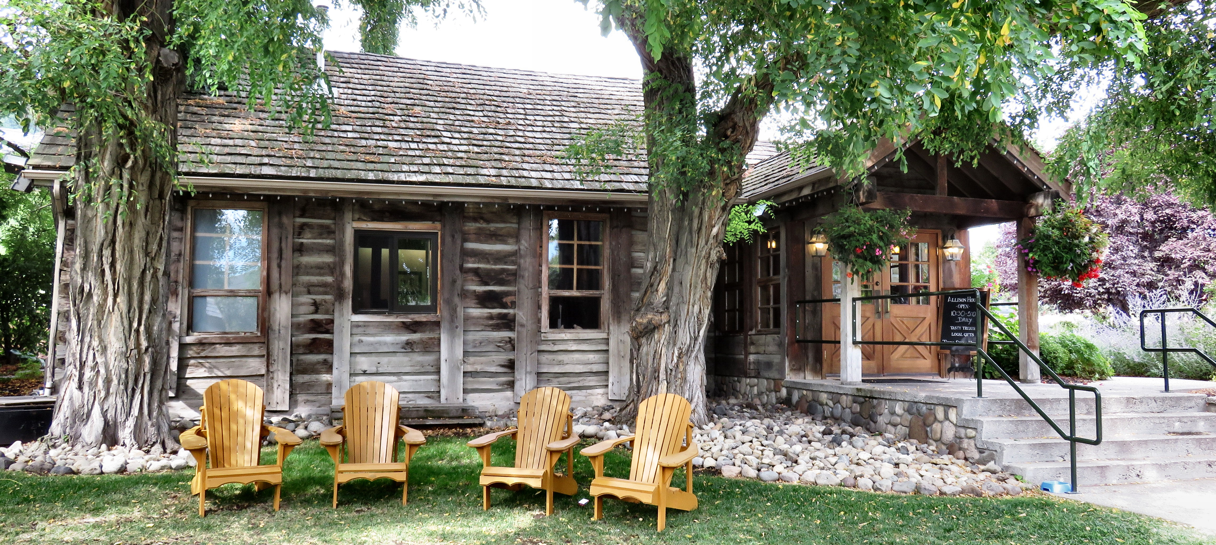

The Allison House, built in 1873 is the oldest home site in the West Kelowna area.

One of the things that truly make Quail’s Gate unique is Allison House once home to Susan and John Allison. Built in 1873, it is the oldest home site in the West Kelowna area providing an important link to our past and to early European settlement in the area.
Author and historian Susan Allison has been recognized as a Person of National Historical Significance by the Government of Canada having documented her early days in the interior of British Columbia and her time at the Allison House.
The house now serves as the meeting place for our summer season winery tours; as well, guests can tour the home and enjoy some wine while learning about the early pioneering days.

Did You Know?
- John Allison also had a First Nations wife. In fact their daughter worked for John and Susan (his British wife) helping them raise their fourteen children. It is not known how many children John had with his native wife.
- John Allison was the first white settler to take up land in the district of Princeton where he is buried in the family’s Castle Rock Cemetery.
- Susan Allison was the first white woman to travel the trail from Hope to Princeton. She started this adventure with her husband John two hours after they got married in Hope.

The restaurant and winery is open year-round. For more information visit their website at www.quailsgate.com or call toll free: 1-800-420-9463.

HOW TO GET THERE – From Kelowna (driving Hwy 97 South) Southbound from Kelowna, cross the W.R Bennett Bridge (Highway 97), turn left at Boucherie Road. Quail’s Gate is located at 3303 Boucherie Road.

Top: The notch style joint used back in the day. Middle: Entrance to Allison House. Bottom: John and Susan Allison.

