Discover the History behind Miner’s Bluff

Have you ever driven past the Monte Creek Junction on the East Trans Canada Highway, noticed the turnoff to Miner’s Bluff Road and wondered how it got its name? I did, so to satisfy my curiosity I did a little research and discovered that the road is named after the legendary Gentleman Bandit and reputed originator of the phrase “Hands Up” Billy Miner.
Born Ezra Allen Miner in 1847, Bill Miner was a notorious criminal from Bowling Green, Kentucky who served several prison terms for stagecoach robbery. After his third release from prison, Miner moved to British Columbia going by the name George Edwards. On September 10, 1904, it is believed that he staged BC’s first–ever train robbery just west of Mission.
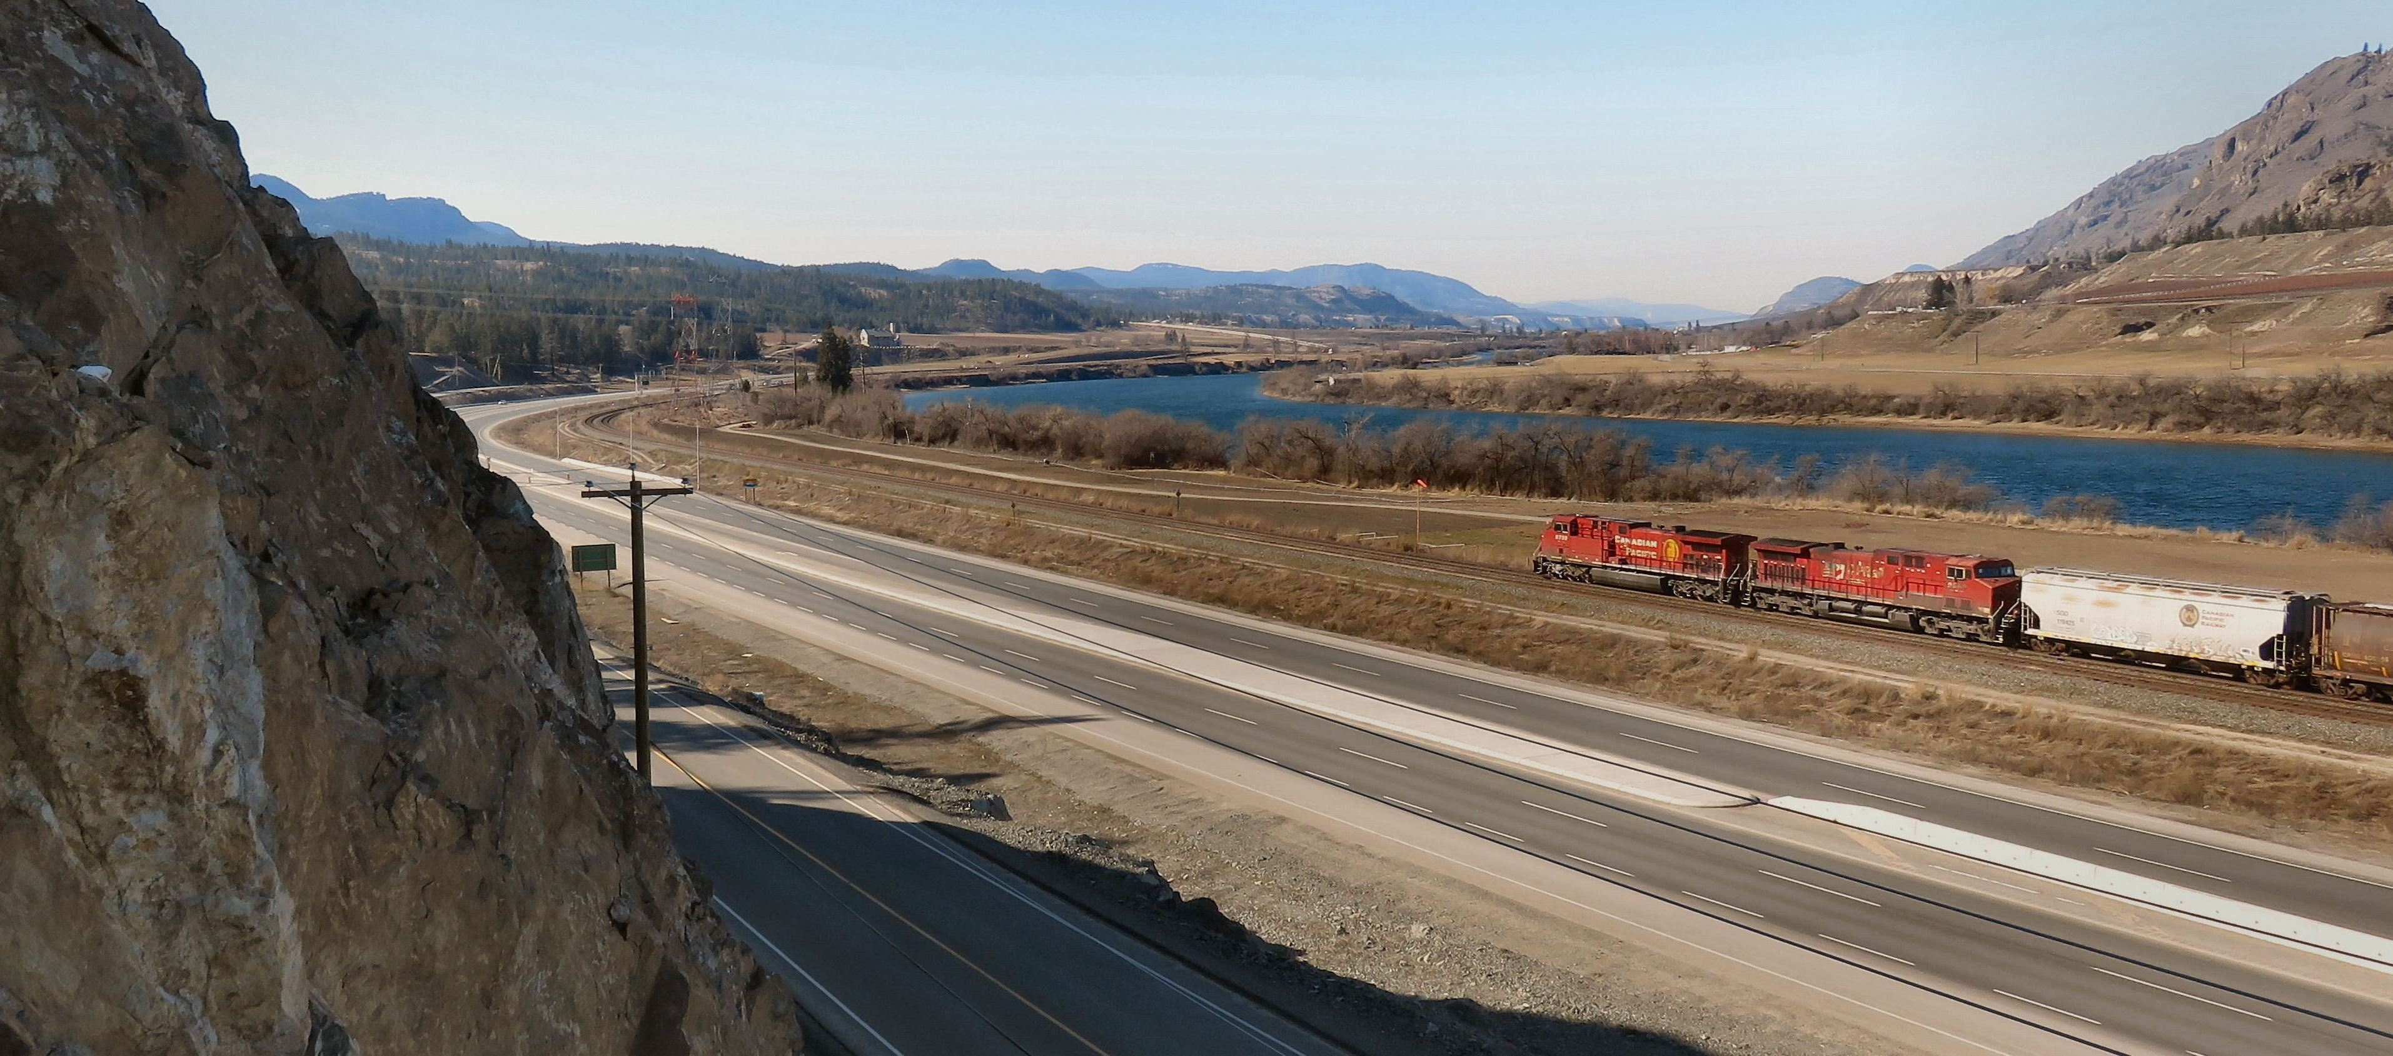

A train drives by the location where Billy Miner’s botched train robbery that led to his arrest took place.

On 8 May 1906, Miner struck the CPR again, near Kamloops at Monte Creek in an area now referred to as Miner’s Bluff, but bungled the robbery. Back in those days, gold was usually carried in the express car. When Miner and his accomplices boarded the train they forced the engineer to stop and release some of the cars then continue down the track while the robbers collected their booty. However, Miner attacked the baggage car instead of the express car, which was still connected to the train. He searched the baggage car but overlooked several packets of bank notes, getting away with a mere $15 in cash and a handful of liver pills. After the epic train robbery failure a manhunt ensued to catch Miner and his two accomplices Shorty Dunn and Louis Colquhoun.

The trio were found near Douglas Lake by the Royal North-West Mounted Police. They arrested, tried in a Kamlops Court and sentenced to 25 years in the New Westminster Penitentiary.
Miner’s reputation had gained celebrity status by this time and much to the surprise of local authorities, during his train ride to the penitentiary, the tracks were lined with supporters who were happy that someone had finally taken the unpopular CPR to task.
On 8 Aug 1907, Miner escaped the penitentary and fled back to the United States, where he continued to rob banks and trains. He eventually ended up in Georgia, where he robbed a train in February 1911. He was hunted down, arrested, tried and sentenced to 20 years. He escaped twice, in October 1911 and June 1912. He hid in a swamp and became ill from the dirty water. He never recuperated and died the following September in a Georgia prison. Miner was finally laid to rest in the Memory Hill Cemetery in Milledgeville, Georgia.

FAST FACTS
- It has been speculated that Miner left a hidden cache of loot in the forests south of Silverdale after the first robbery and local historians believe he used these monies to fund his escape, while others surmise that today there is still hidden loot to be found there
- Miner was the subject of the 1982 Canadian film The Grey Fox, in which he was played by Richard Farnsworth.
- Mount Miner near Princeton, (formerly Bald Mountain) was where Miner had lived at a ranch owned by Jack Budd while planning the train robbery near Kamloops.
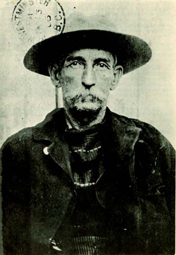

Bill Miner’s prison “mug” shot. Notice the prison stamp from Okalla Penitentiary, New Westminster, B.C., 1906.

HOW TO GET THERE – From Kamloops head east on the Trans Canada highway and just past Vernon turnoff will see the turnoff for Miner’s Bluff Road. Half the bluff has since been removed to make way for the Highway 1 Monte Creek to Pritchard Phase 2 Highway Improvement Project. Unfortunately there is nothing to mark this historic location but if you park near the bluff and climb it you may get a bird’s eye view of a passing train.

