GO OFF THE GRID TO RESCUE FARM ANIMALS

Many of the West Kelowna Wineries were once farms and orchards with a rich family history and Off the Grid is no exception. The land has been stewarded by the Paynter family for generations. In 1909, Margaret and Edwin Paynter immigrated to Canada from England purchasing a total of 80 acres of land.
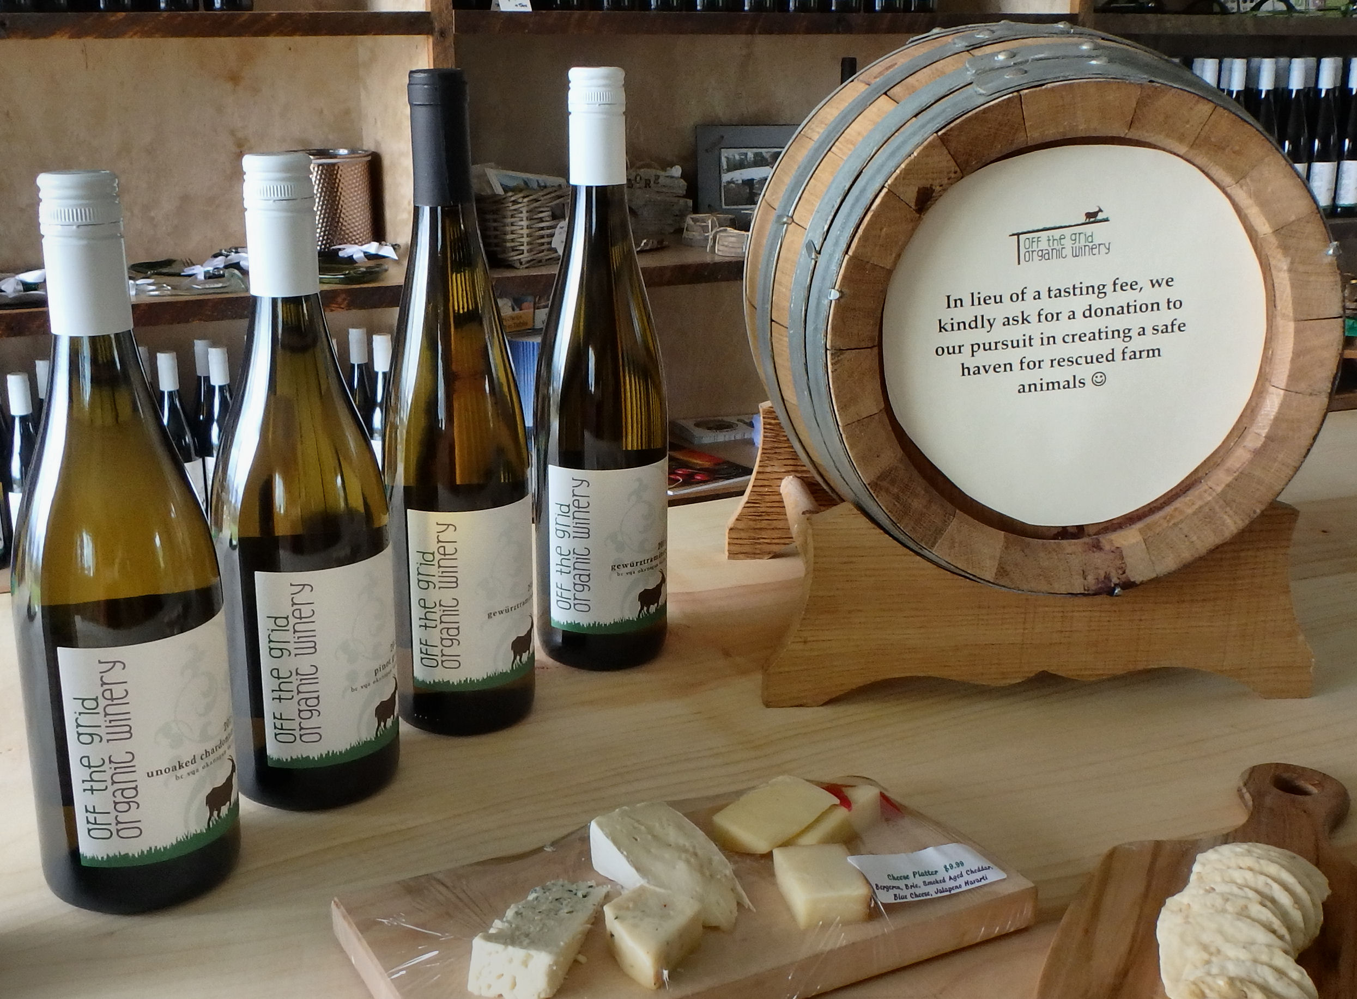

As the barrel states ‘In lieu of a tasting fee, we kindly ask for a donation to our pursuit in creating a safe haven for rescued farm animals.

Their plan to farm the land was briefly interrupted by the outbreak of World War I as they returned to England for the duration of the war. They returned in 1919 and started to farm the land, which upon their passing was divided amongst their descendents, some of whom diversified by bringing cattle onto the land.

Today, the portion of the land where the winery sits is now owned by Nigel and Travis Paynter and their wives Haley and Sheri. After years of selling their organic grapes including Gewurztraminer, Chardonnay, Pinot Gris, Zweigelt, Riesling, and Pinot Noir, to other wineries, they eventually decided to open their own.
Their belief in living green and protecting the land not only inspired them to maintain high standards of organic farming they are also extending this philosophy to the structures they build on the land. The wine tasting room has thick mud brick walls insulated with hay, plenty of natural light and a sod roof where their rescue goats can graze.
Yes, you read that right. The winery is also home to rescue farm animals. Wine-tasting is by donation with the proceeds helping to fund their efforts to provide both permanent and temporary homes to unwanted and neglected farm animals. Visitors to the winery can check out the penned area and visit the wineries pet turkey family along with a selection of rescue animals.
The spectacular view from the winery also makes it a popular venue for weddings, portrait photography and drop in yoga.
So be sure to make Off the Grid one of your stops on the Westside Wine Trail

HOW TO GET THERE – Off the Grid Winery is located at 3623 Glencoe Road in Westbank. From Kamloops drive towards Kelowna via Merritt and when you reach Westbank take the Glenrosa Road turn off and then turn right onto Glencoe Road.
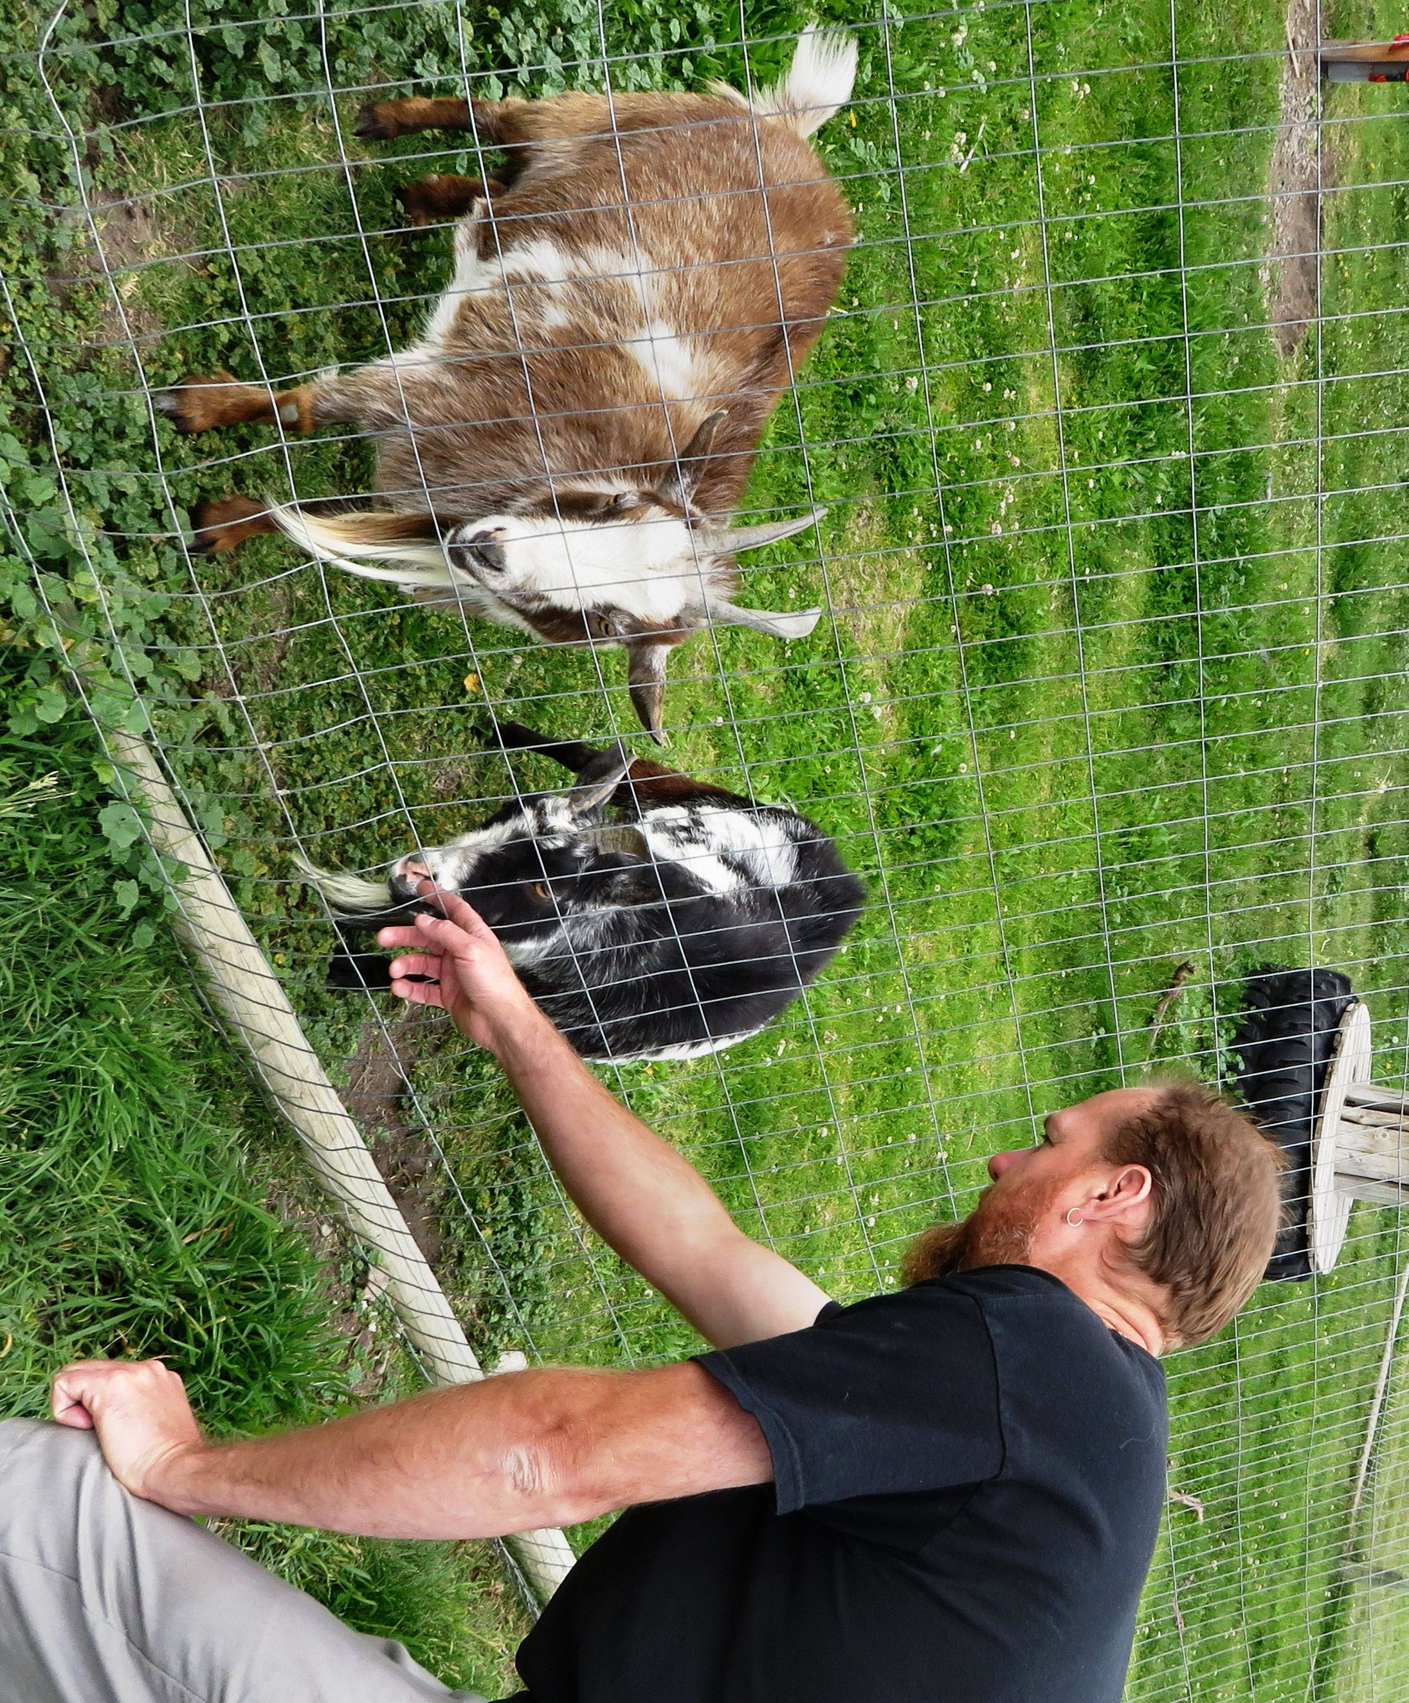

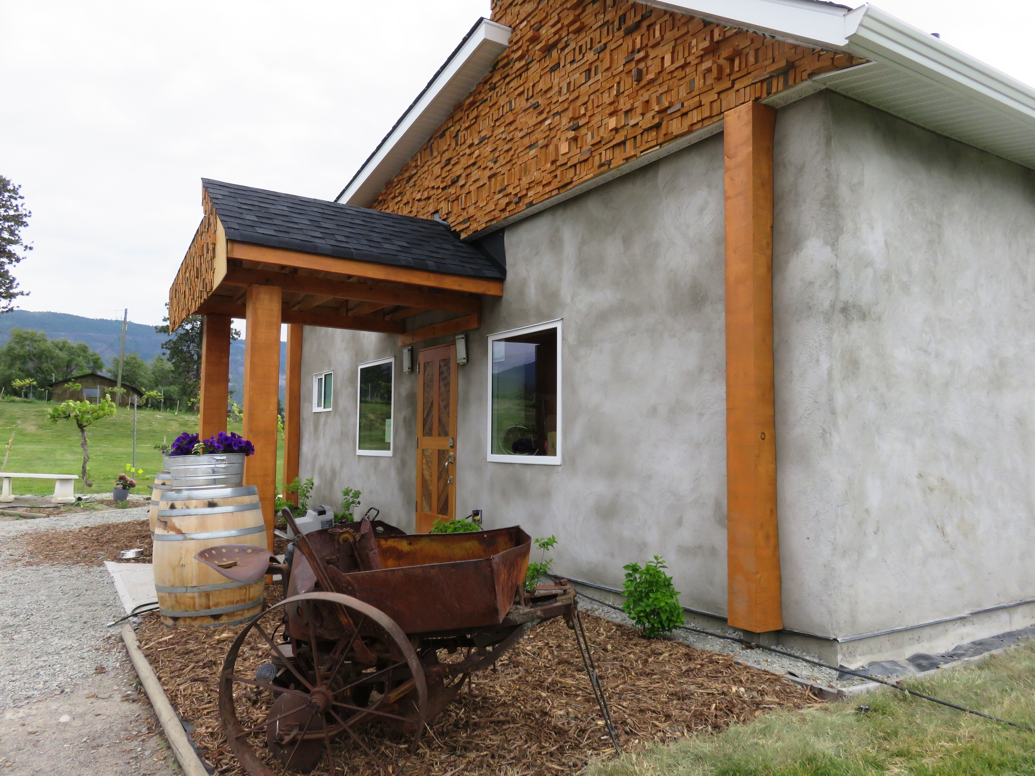

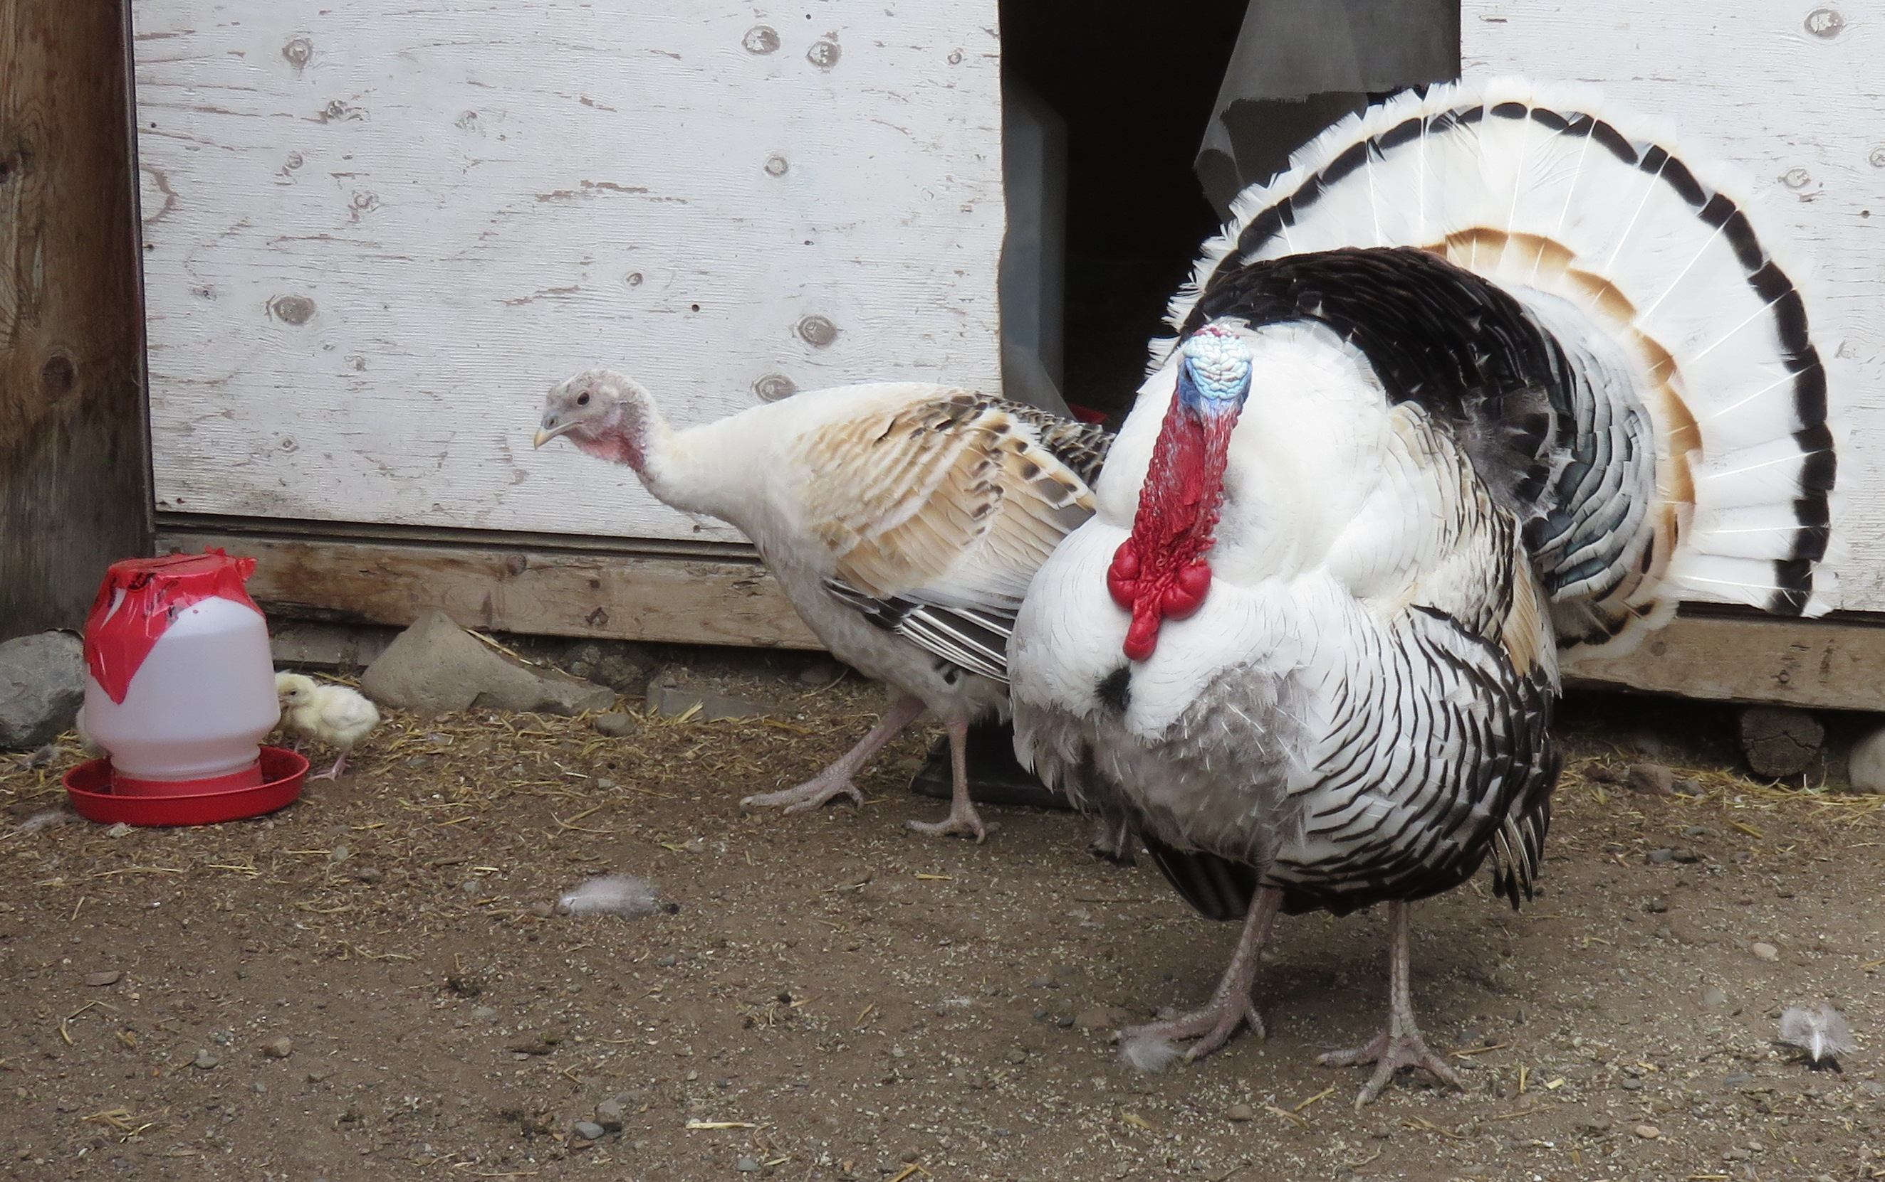

Top: Co-owner Travis Paynter visits two elderly goats in the rescue farm. Middle: The wine tasting room is insulated with straw bails. Bottom: A turkey family resides at the farm as pets.

