ADMIRE A LITTLE ART AT THE LITTLE STRAW VINEYARDS

In 1969, the Slamka family planted their first vineyard with the intention of selling grapes to large commercial wineries and by 1996 the three Slamka sons had successfully established their own winery. Today they are producing exceptional Sauvingnon Blancs and are well known for their Auxerrois Icewine.
After sampling wine in the spacious winery lounge, visitors can admire the paintings on display in the Mezzanine Gallery. They were created by local artist Anita McComas Specializing in nature inspired impressionistic abstractions; Anita uses acrylic on canvas with vibrant colours.
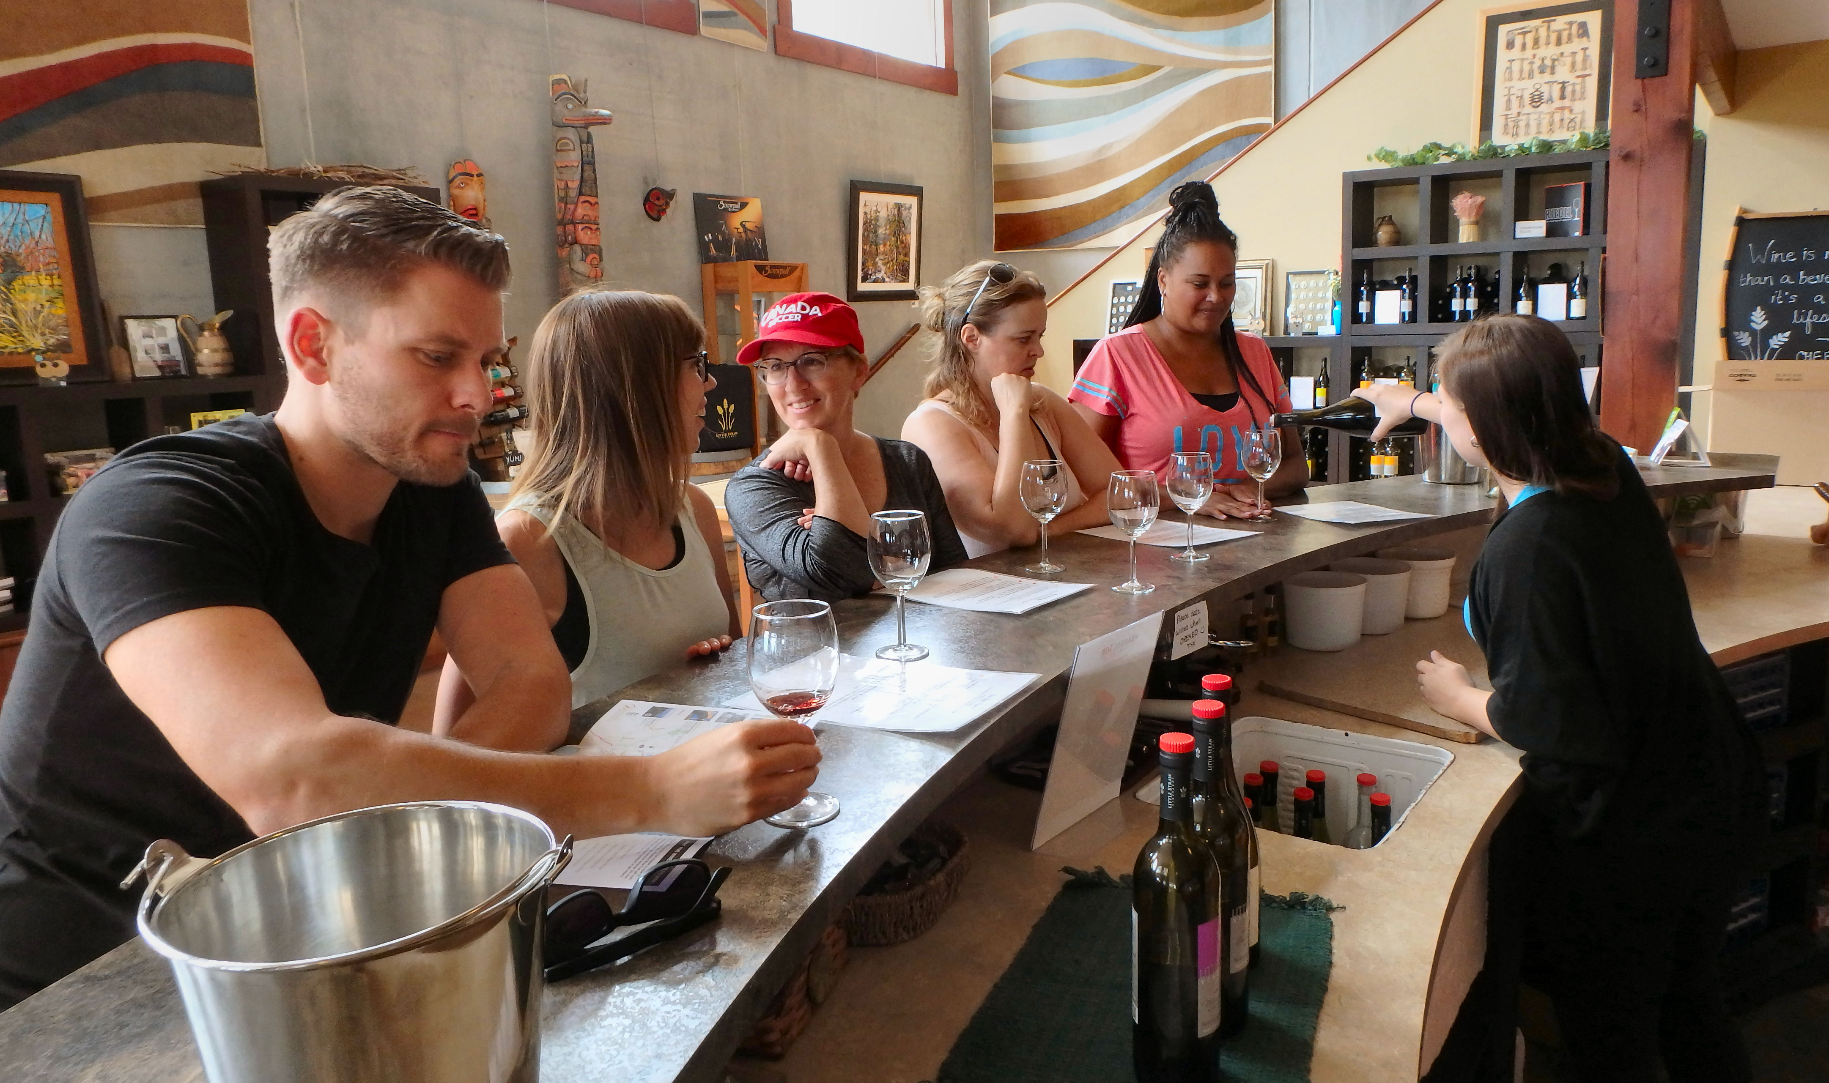

A group of thirsty tourists clamour around the counter for some wine-tasting at Little Straw.

Complete your visit with a glass of wine paired with some tapas at the Barrel Top Grill. Indoor and patio seating is available and gluten-free items are offered on the menu.
Little Straw is part of the Westside Wine Trail and is a stop on many of the wine tours.

HOW TO GET THERE – Little Straw Vineyards is located at 2815 Ourtoland Road in West Kelowna. From Kamloops, drive to Kelowna via Merritt and when you reach West Kelowna turn right onto Boucherie Road. Turn right on Ogden road then another right onto Ourtoland Road.

