Have Lunch at the Historic Hedley Hitching Post

Named after Robert R. Hedley, who at the time was the manager of the Hall Smelter in Nelson, Hedley is an unincorporated town in southern British Columbia located at the foot of Nickel Plate Mountain in the Similkameen. The town had a population of approximately 400 as of 2005 but in the early 1900s, during the gold rush, Hedley's population had peaked at over 1,000.
While the main attraction in this frontier town is no doubt the Mascot Mine Tour, there is quite a bit more to do and see in this small town. If you go past Hedley on Highway 3 towards Keremeos, you will come across St. Ann's, a quaint little white Roman Catholic Church built around 1910-11, on the Chuchuwayha Indian village.
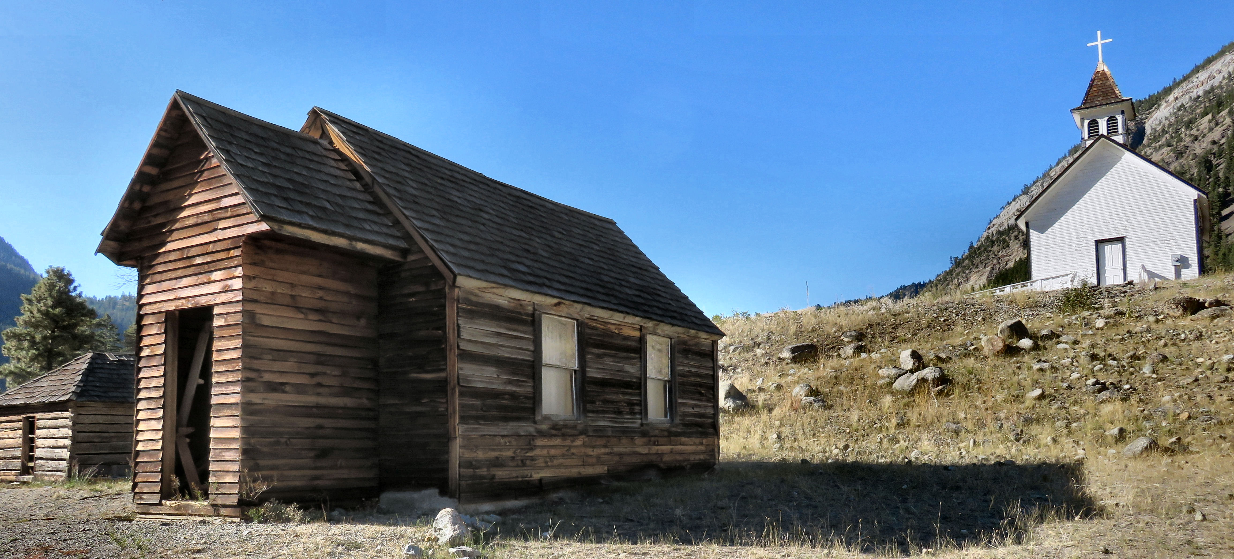

St. Ann’s Church built around 1910 sits above the original church built in the late 1800’s and the old jail.

Located just below the white church is the original church build in the late 1800’s and beside it is the old one room jail cell. Behind the churches is an old cemetery that is no longer in use.
When you head back into town, be sure to make a quick stop at the souvenir shop where you can find all sorts of treasures including historical books on the area. Be sure to say hi to the owner who is a wealth of information about what to see and do in the area. He will tell you how to get to the monks cave and some abandoned mine shafts.
From there walk over to the Hedley Heritage Museum and view their phenomenal collection of historic photographs. Many have been scanned so you can view them large scale,

When you get hungry, be sure to stop for lunch at the historic Hitching Post Restaurant. It is located in the oldest commercial building in Hedley. Built by L.W. Shatford, it opened in 1903 with a mining supply company store on the main floor and a Free Mason dancehall on the second floor which was infamous for staying open until 4am and knocking all the glassware off the store shelves.
In 1905, Shatford was quoted as saying that Hedley “will unquestionably become a large and important city”. His prediction came true in 1909 when the railroad came through running from Oroville, Washington to Princeton, BC putting the wealthy mining town on the map.
The Hedley Trading Co & Mining Supplies store later became Collen’s Department Store serving the Hedley area for many decades until the railroad was pulled up after the mines closed down in the 1950’s. The building was used as a railway warehouse through the 1950’s and 1960’s and was purchased in the 1970’s by Moses Brown.
He and his friends fixed up the badly dilapidated building transforming it into a popular restaurant called the Golden Nickel. It changed hands a number of times since then and is currently owned and operated by Wilson Wiley and Brenda Gould who provide quality homemade food and reasonable prices.
The story of the building can be found on the menu which points out some interesting features preserved from the past such as the original fir floor located in the private dining area, the wavy original windows in the front and a section of the original decorative tin ceiling.

HOW TO GET THERE – From Kamloops head towards Merritt on the Coquihalla and then take the Kelowna turnoff until you see the turnoff for Princeton, then follow take the Crowsnest Hwy/BC-3 E (signs for Keremeos/Osoyoos) until you reach Hedley. It is approximately 2.5 hours.

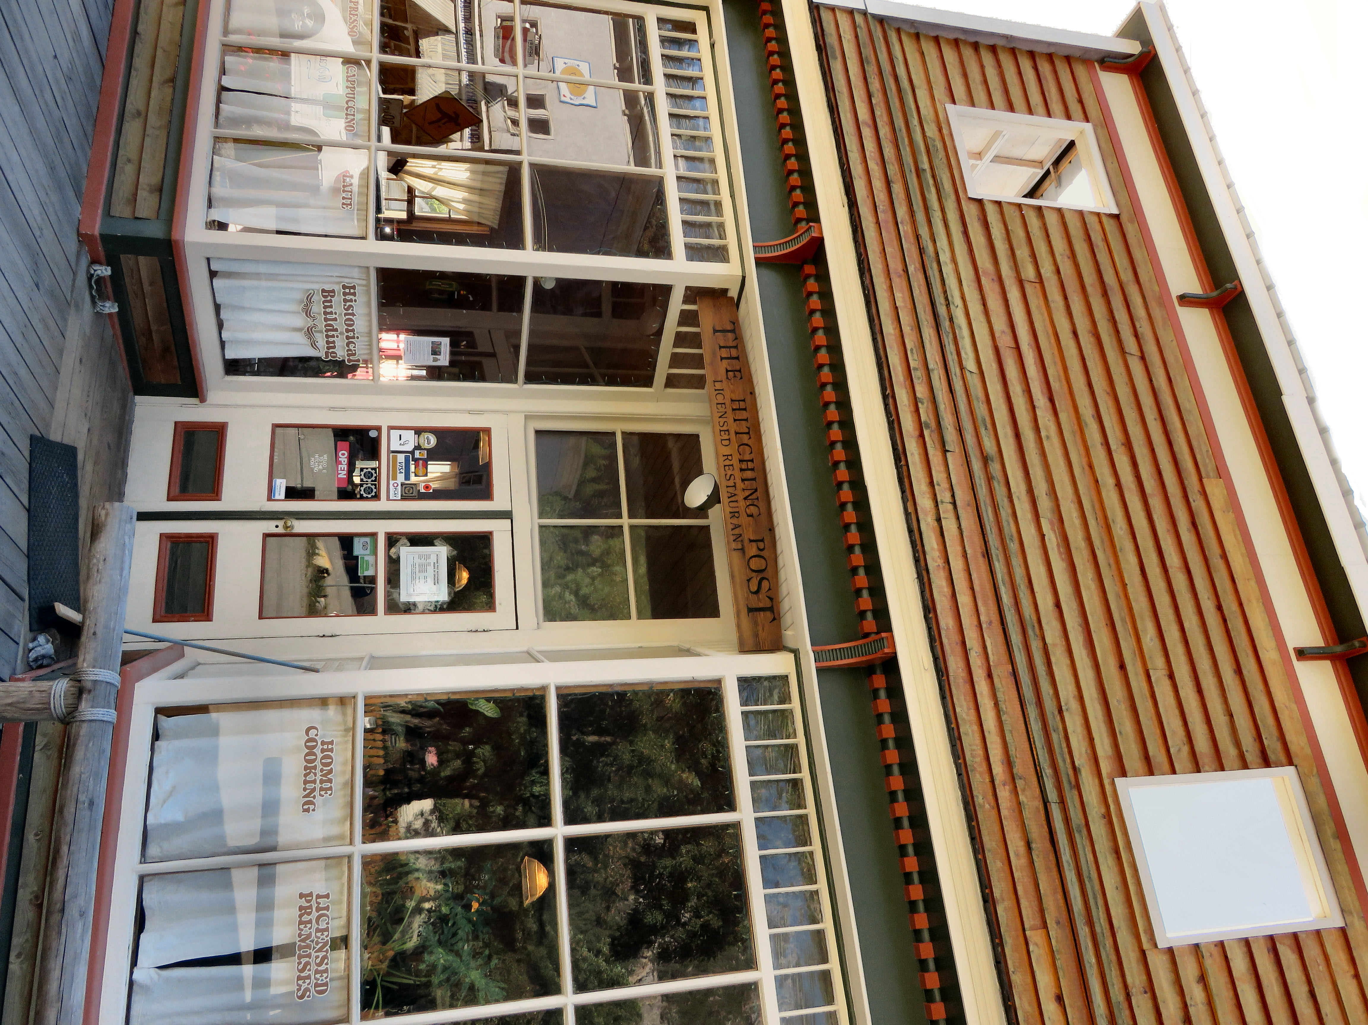

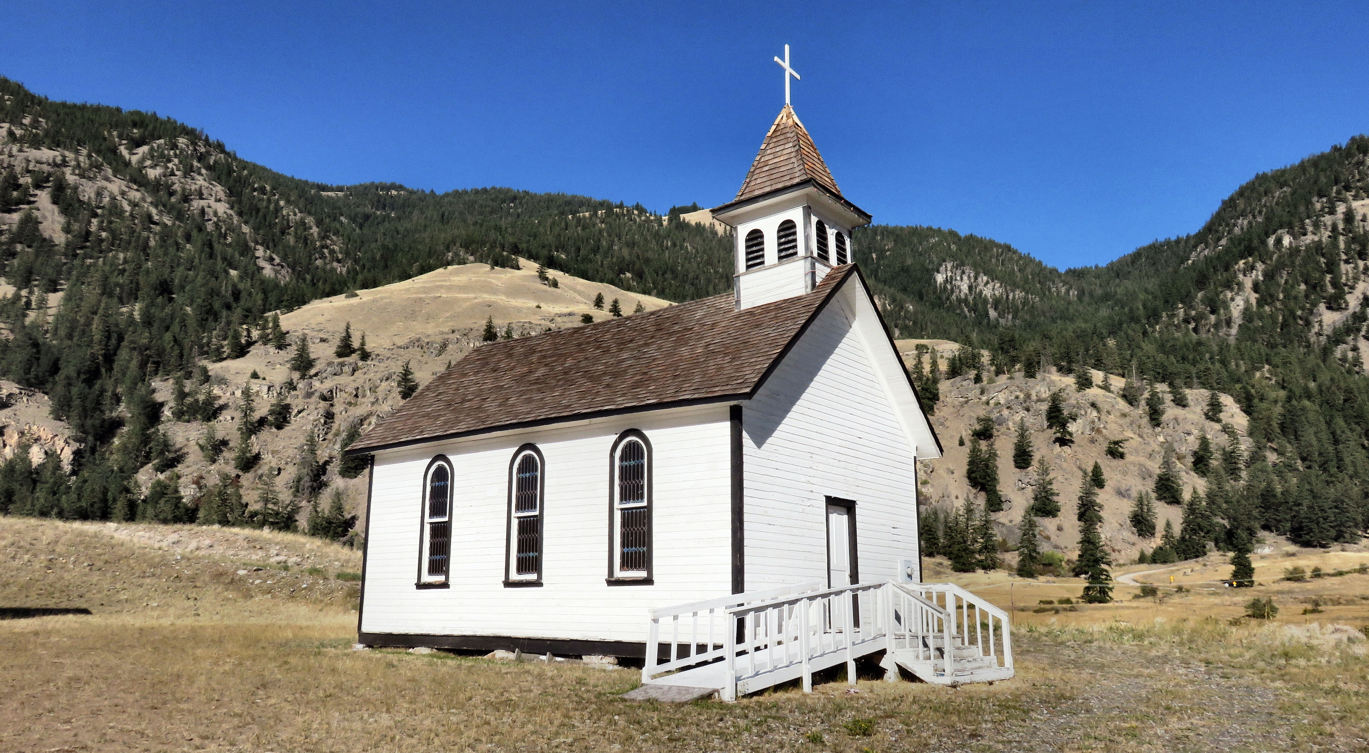

Top: The Hitching Post restaurant, the second floor has been removed and replace with a fake front. Bottom: St. Ann’s Church.

