DRINK WINE IN A JAPANESE LOG HOUSE TASTING ROOM

When I picture a log home it is usually set in the Canadian or American wilderness as a symbol of living on the frontier of the new world. It no doubt came as a surprise to me to learn that many Canadian built log homes are exported to Japan. Their appreciation for nature draws them to this style of house however their dwindling forests make it difficult to build them in Japan, so they buy them from Canada where logs are plentiful.
When a company based in the Shuswap area shipped a custom log home to Japan, the logs got water-logged and they were forced to build a new home for the client. This turned out to be a blessing in disguise for the owners of Recline Ridge.
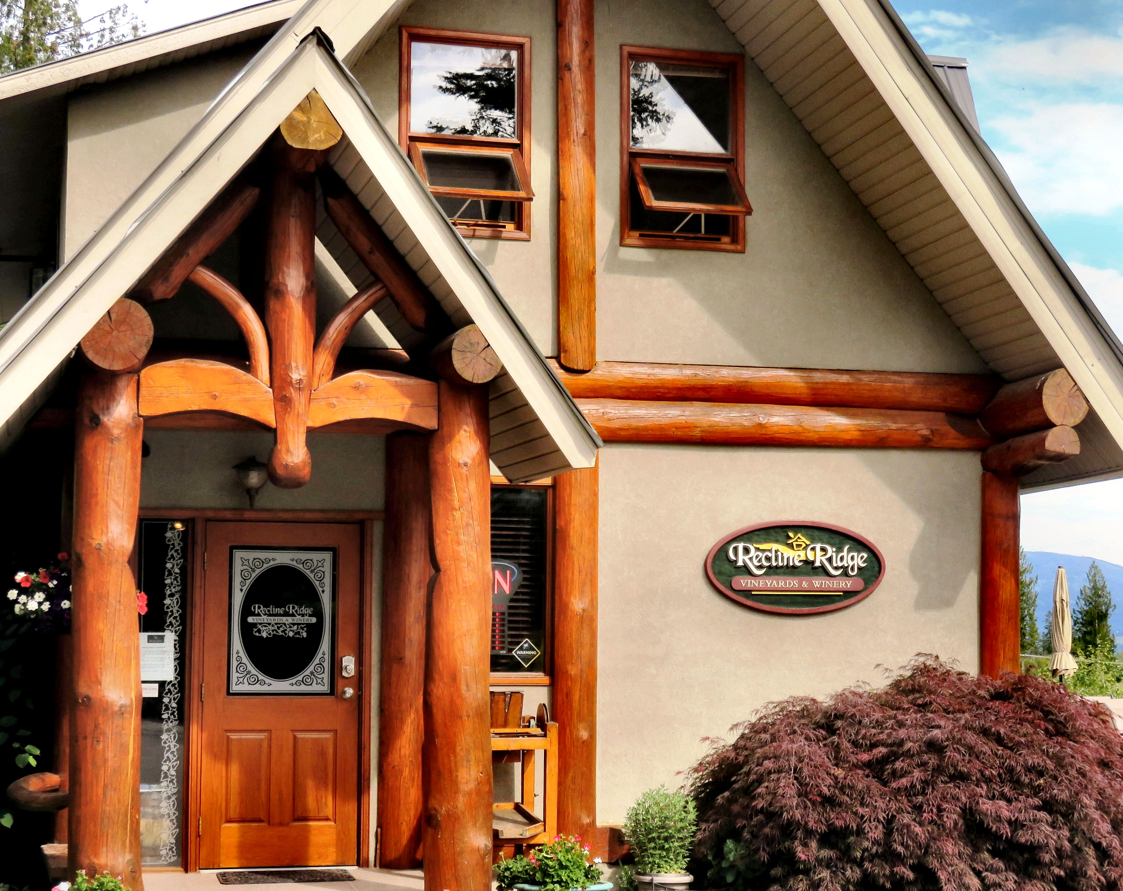

Left: The wine tasting room is a converted Japanese Log House. Right: Owner Graydon Ratzlaff tends to his grapes.

Graydon and Maureen Ratzlaff purchased the rejected log home from the builder and transformed it into their new wine tasting room. The ornate triangular Japanese style entry is a subtle hint as to the buildings original purpose.
So drop by to sample some delicious wine and be on the lookout for other clues to the wine tasting rooms Japanese heritage.

HOW TO GET THERE – Recline Ridge is located at 2640 Skimikin Road in Tappen. From Kamloops, drive East on the Trans Canada to Tappen, which is located between Sorrento and Salmon Arm. Turn right on Tappen Valley Road and follow the signs.

