Make a Royal Visit to Canada’s Camelot

In its heyday, from 1909 until 1914, Walhhachin was an affluent colony of English settlers and was often termed "Canada's Camelot". Established as a farming community for British settlers, thanks to the efforts of American entrepreneur Charles Barnes, the colony was marketed to people of affluence, education and refinement as a place where they could enjoy the good life.
Many of its residents had Chinese and Native domestic servants and indulged their taste for leisure by playing tennis, cricket, golf, polo and shooting and attending plenty of parties, fancy balls and amateur theatre.
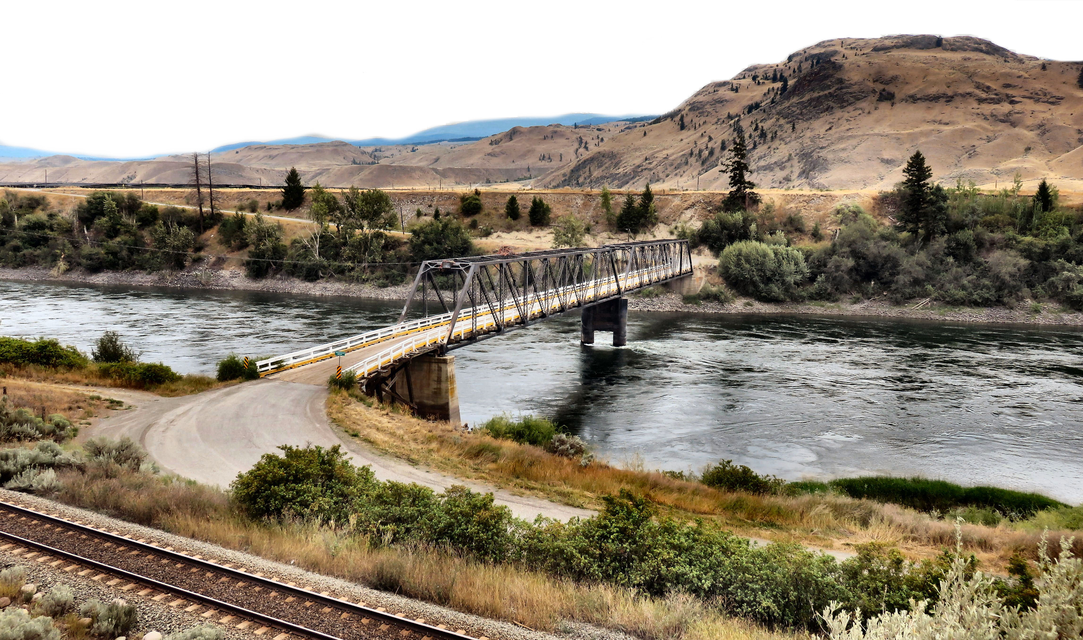

Walhachin is located on the river beside the train track making it easy to transport goods back in the day.

The houses were all ahead of their time with indoor plumbing, hot and cold water and carbide lighting. One estate even had a concrete in ground swimming pool when many a pool party was hosted – an unheard of luxury in this era of British Columbia’s history. The posh Walhachin Hotel was the hub of social activity in this community with its elegant dining room, three rotundas, steam heat and two saloons that allowed the casually dressed to be kept separate from the upper class. Since the community was nestled between mainlines of the two railways, CN and CP, supply of goods and transportation was never a problem.

To solve the problem of irrigation in this dry desert climate, a twenty-mile long wooden gravity flow flume was built to carry water down from the highlands to irrigate the field where onions, tomatoes, potatoes and other crops were planted.
The life of this small colony was short-lived mainly due to World War One. Many of the men were members of the Walhachin Company of the 31st British Columbia Horse, while others were affiliated with regiments in England.
Virtually all the men left to fight for King and Country leaving behind mostly women, children and the elderly to keep the orchards producing with the assistance of hired labourers.
In 1918 a flash flood severely damaged the flume causing another blow to the community leading to its final demise in 1922.
Today much of the original town structure including the hotel is gone and only the community hall and several houses including the first house built by Charles Barnes remains. It is home to around 100 residents. The hall has been transformed into a small museum that is open Monday to Friday 10am to 5pm during the summer months.
For more information or to tour the museum outside posted hours call Val at 250-457-6678 or Colleen at 250-457-6245.

Fun Fact – Walhachin has been used as a filming location for the popular television series, The X-Files.

HOW TO GET THERE - Walhachin is located between Savona and Cache Creek about 45 minutes from Kamloops. Look for the Walachin sign then turn left and cross the bridge into town.
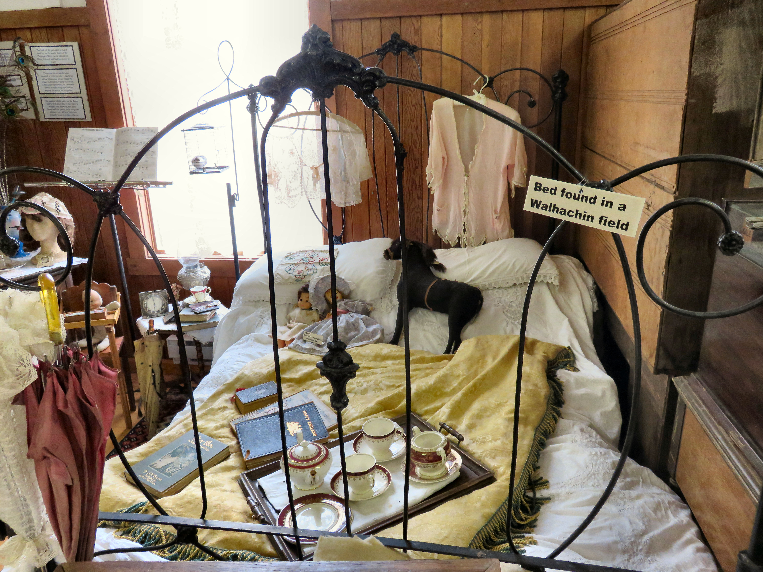

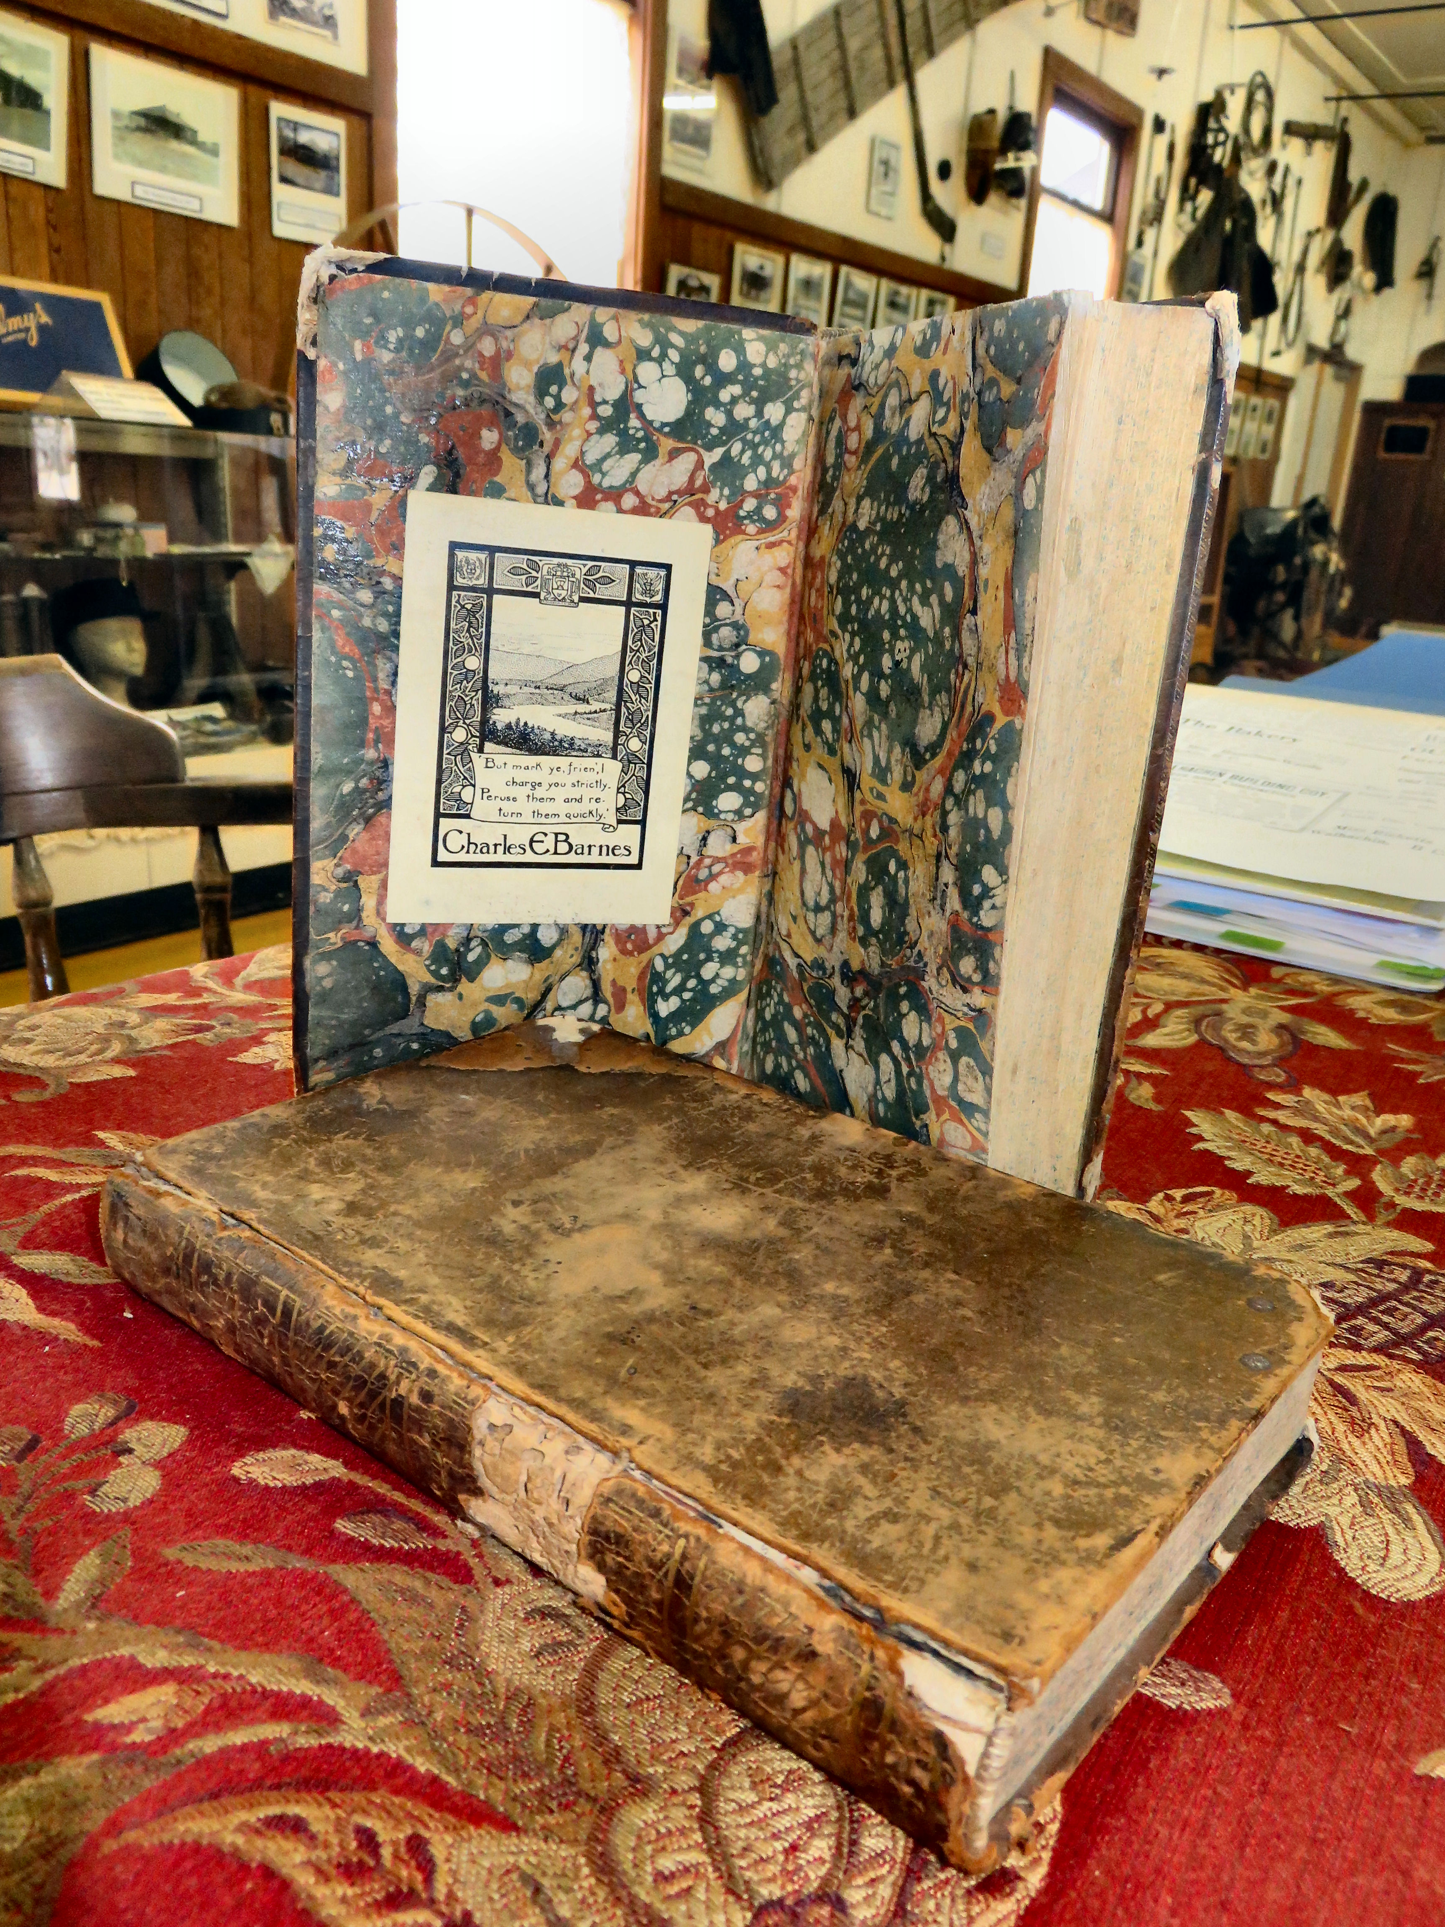

A bed found in a Walhachin field and books once owned by residents are some of the items on display at the Walhachin Museum.

