Take a historical walking tour of Clinton

A wonderful way to learn about British Columbia’s history is to take a historical walking tour of Clinton. Founded in the 1860s as a roadhouse on the Cariboo Trail, Clinton served those headed to the gold fields. After the discovery of gold in the Cariboo, Royal Engineers were commissioned to build a road through the Fraser Canyon to the Cariboo joining the already existing wagon road from Lillooet to Clinton. The junction was 47 miles from Lillooet and thus called 47 Mile until it was renamed Clinton, by Queen Victoria in honour of Lord Henry Pelham Clinton, the Colonial Secretary of the day.
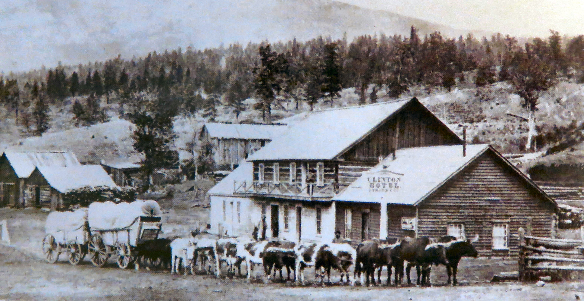

The Clinton Hotel was destroyed by fire in 1958 killing three guests.

This 20 stop tour starts at the Government Offices and Jail built in 1926 which now houses the Village of Clinton Municipal Offices. The guidebook which includes a map and some history on the various buildings can be obtained at the red-brick schoolhouse that houses the Clinton Museum and tourist office. T
he museum is stop #20 on the walk so just pop in to pick up a map and save the full museum tour for last.
Some of the stops along the way include the Old Cemetery, the Toll Office, China Town/Pioneer Cabins, Robertson Square and three churches.

Many of the original buildings have burned down including stop #8 - the former site of the Clinton Hotel (originally 47 Mile House). This 5-room 2-story hotel was built from hand-hewn and whip-saw logs using wooden pegs. Not a single nail was used in the construction of the hotel. It was at one time the oldest hotel west of the Rockies but was destroyed by fire on May 15th 1958 taking the lives of three guests.
Built in 1862, the Palace Hotel is one of Clinton’s oldest buildings and #13 on the walking tour. It was originally build as the LaForest residence and was later sold and became a hotel that catered to freight drivers who stabled their animals in the large barn next to the hotel.
The museum and final stop ties the tour together with it’s collection of machines, household items, photographs and other artifacts collected from the region. Some of the highlights include a 13-passenger sleigh that travelled from 20 mile house to Clinton in the late 1800’s, an 1861 freight wagon that ran freight from Yale to Barkerville, a buggy belonging to the first doctor in Clinton and an old wheelchair.

Fun Fact – The annual Clinton May Ball Rodeo and dance is one of British Columbia's oldest continual events having first been held in 1867. It was a highlight of the social calendar in the British Columbia Interior for many decades.

HOW TO GET THERE - Clinton is located on Cariboo Highway 97, 40 km (25 miles) north of Cache Creek, and 74 km (46 miles) south of 100 Mile House.

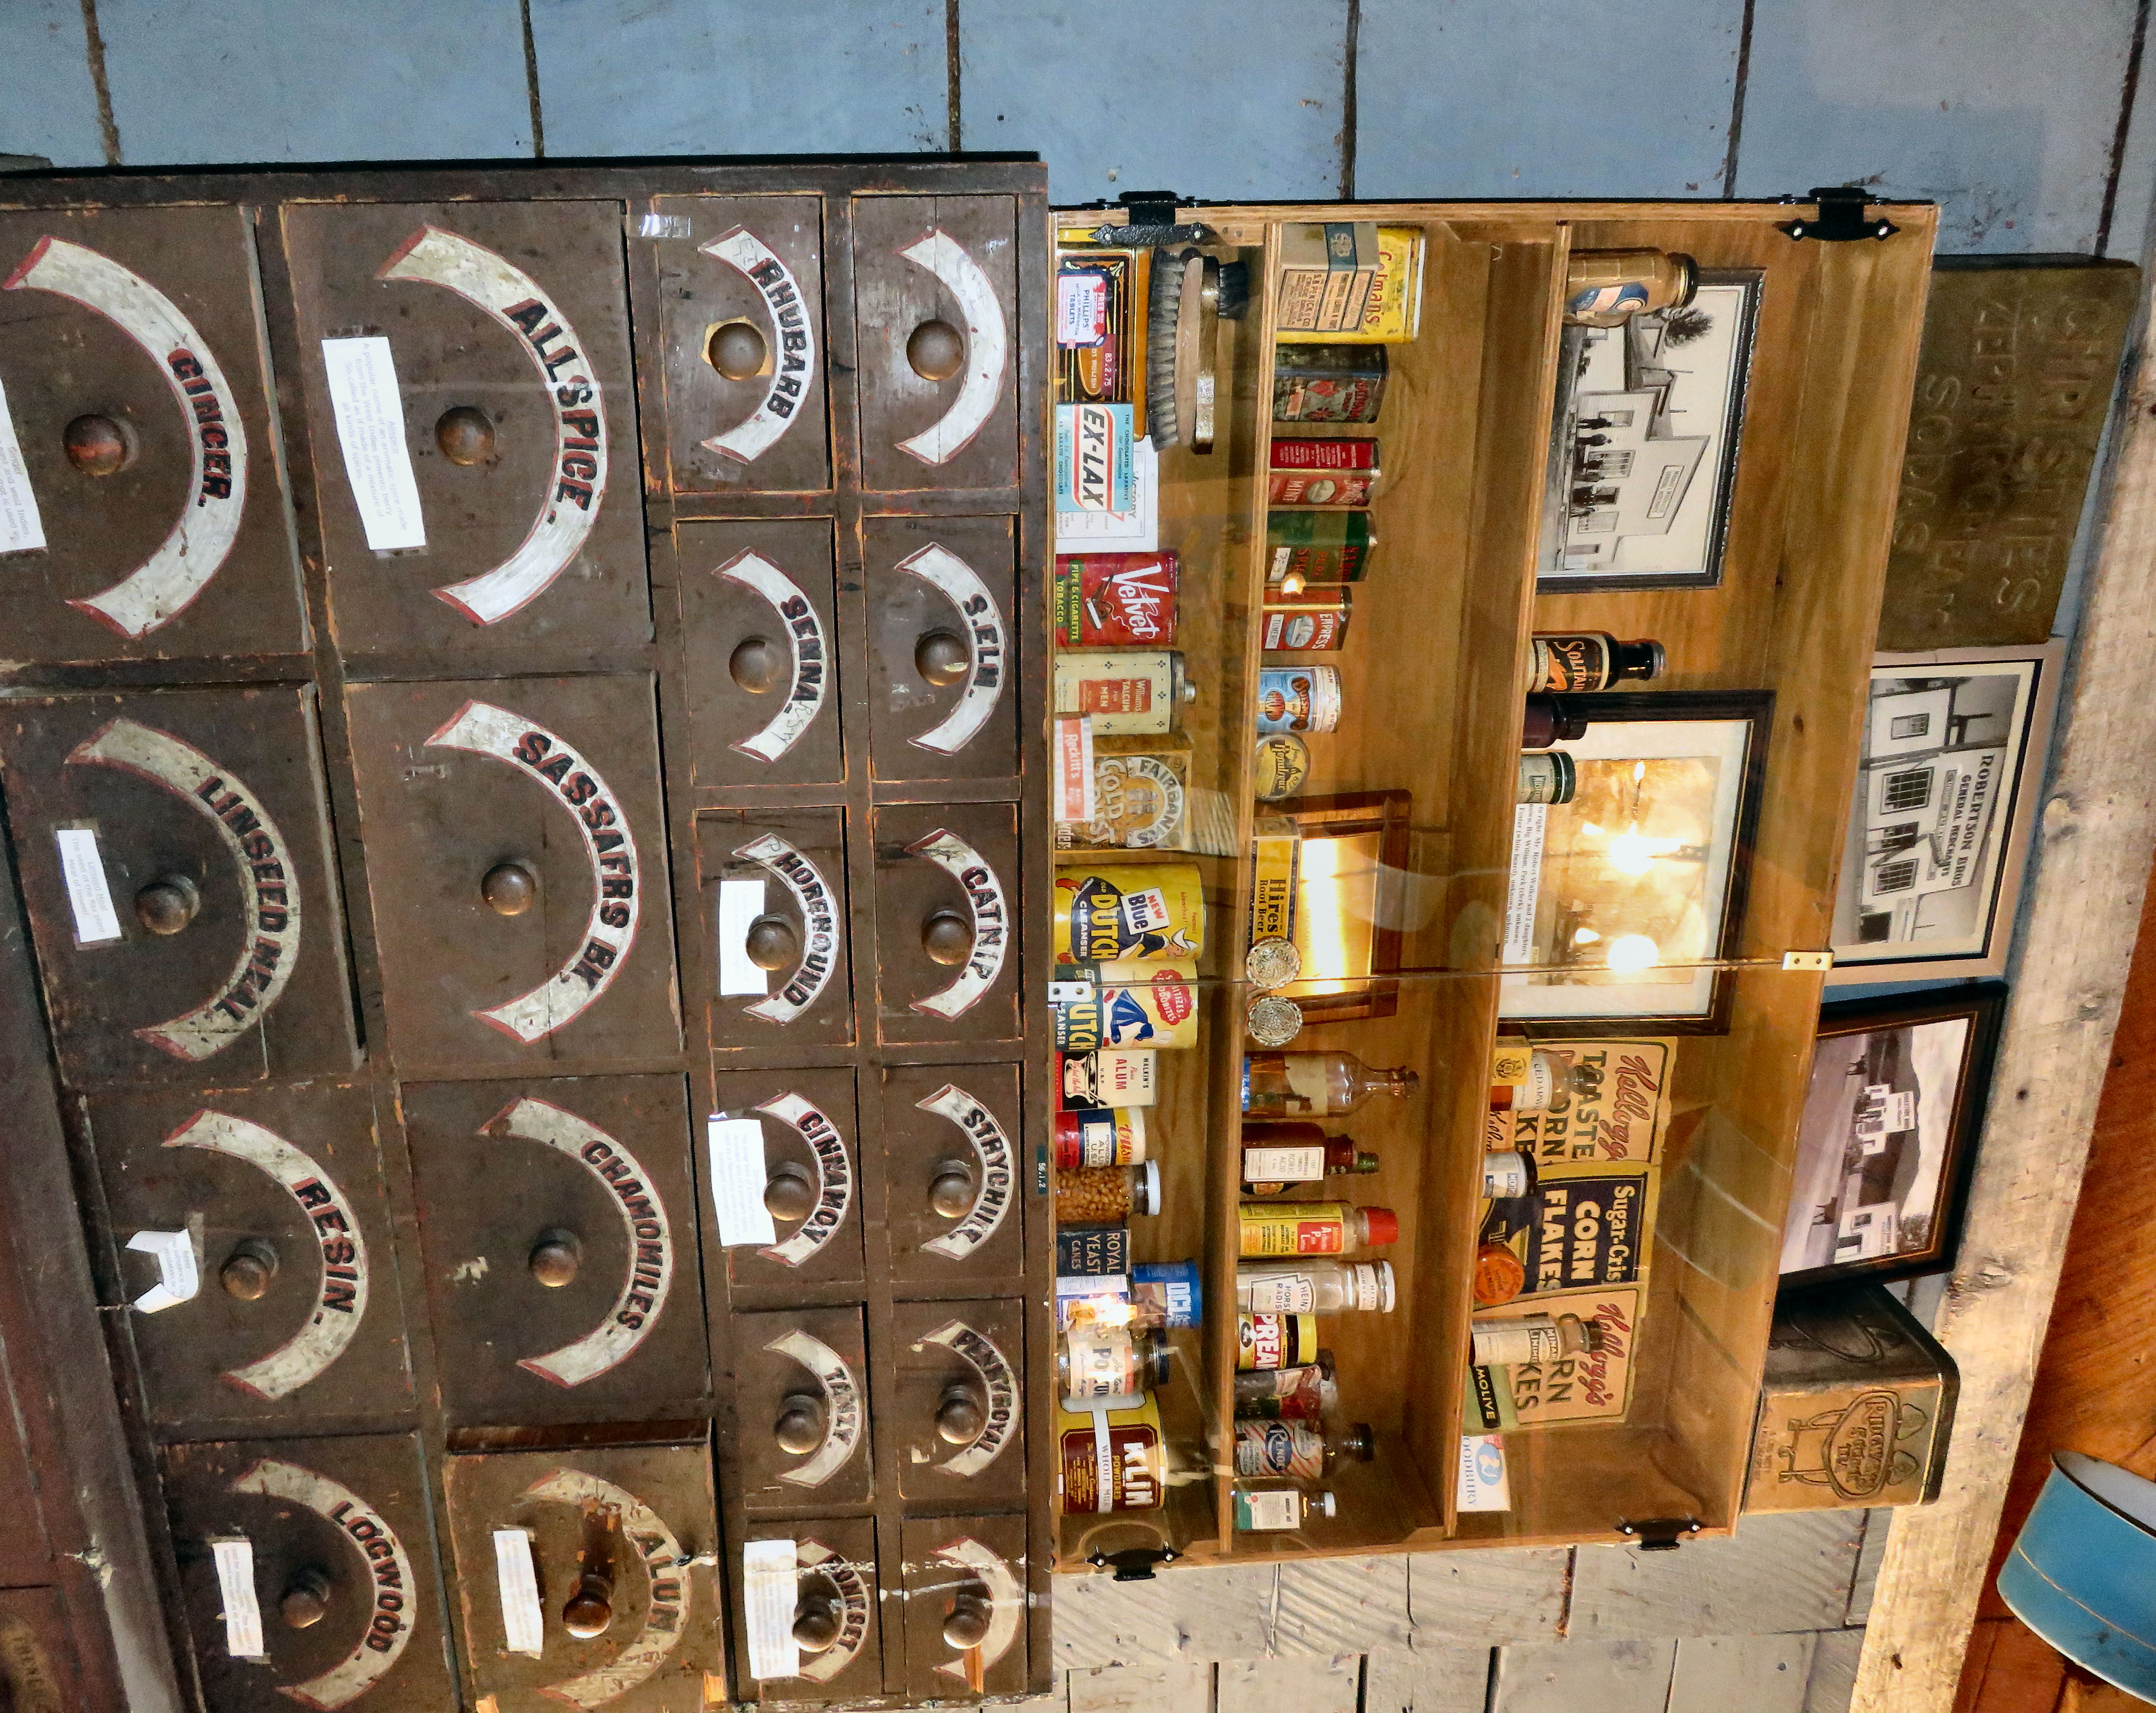

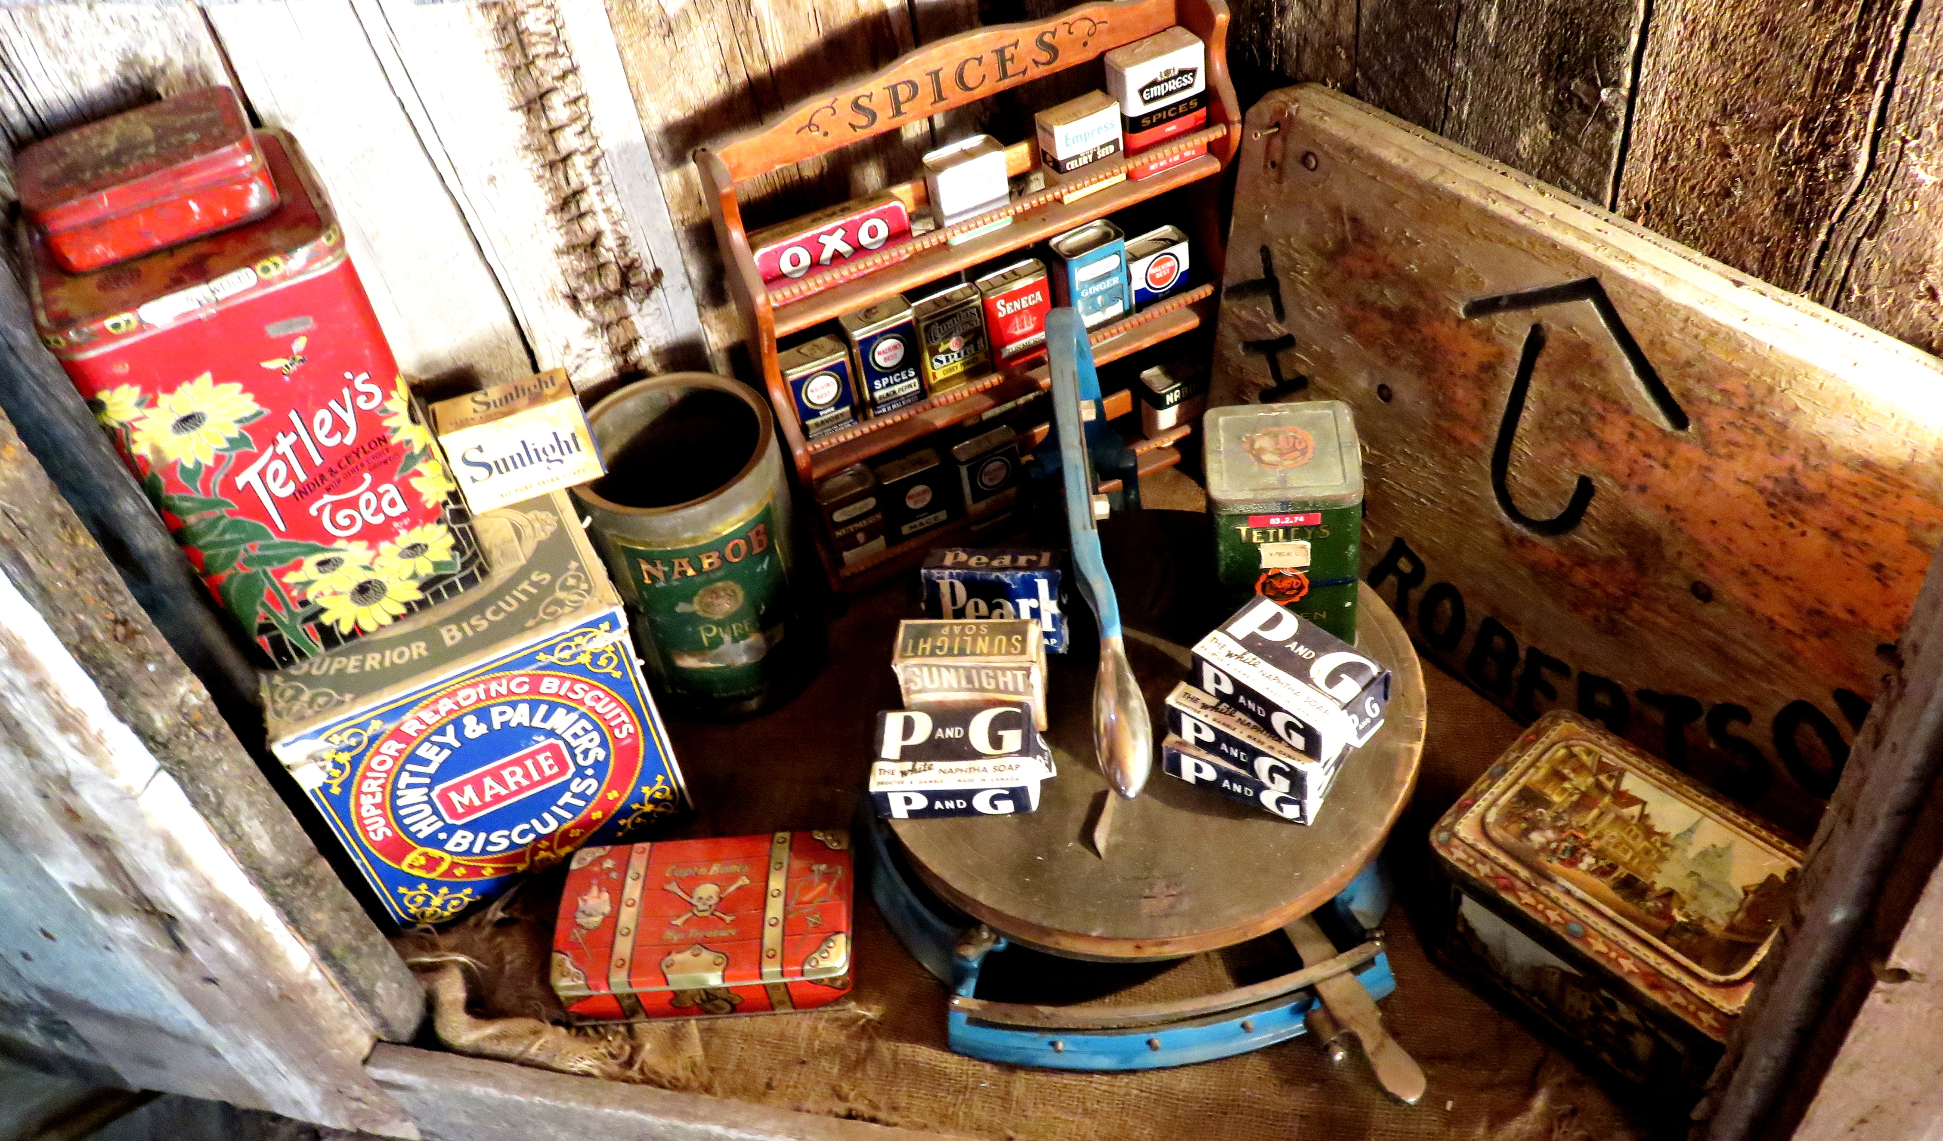

Some of the interesting daily household items from the old days are on display at the Clinton Museum.

