Trace Kamloops history along the River’s Trail

Situated at the meeting of the North Thompson and South Thompson Rivers is the City of Kamloops the anglicised version of the Shuswap word "Tk'əmlúps", meaning 'meeting of the waters'. In an effort to make the shorelines accessible to all, the city built over 40 kilometres of paved community path exploring the shores of both rivers winding through Pioneer Park, Riverside Park, Westsyde Centennial Park, MacArthur Island and all the way out to Kamloops Lake through the Lac du Bois Provincial Park.
My favourite stretch of the trail is from Pioneer Park to Schubert Drive as it is filled with landmarks, monuments and informational signs that trace the history of our beautiful city.
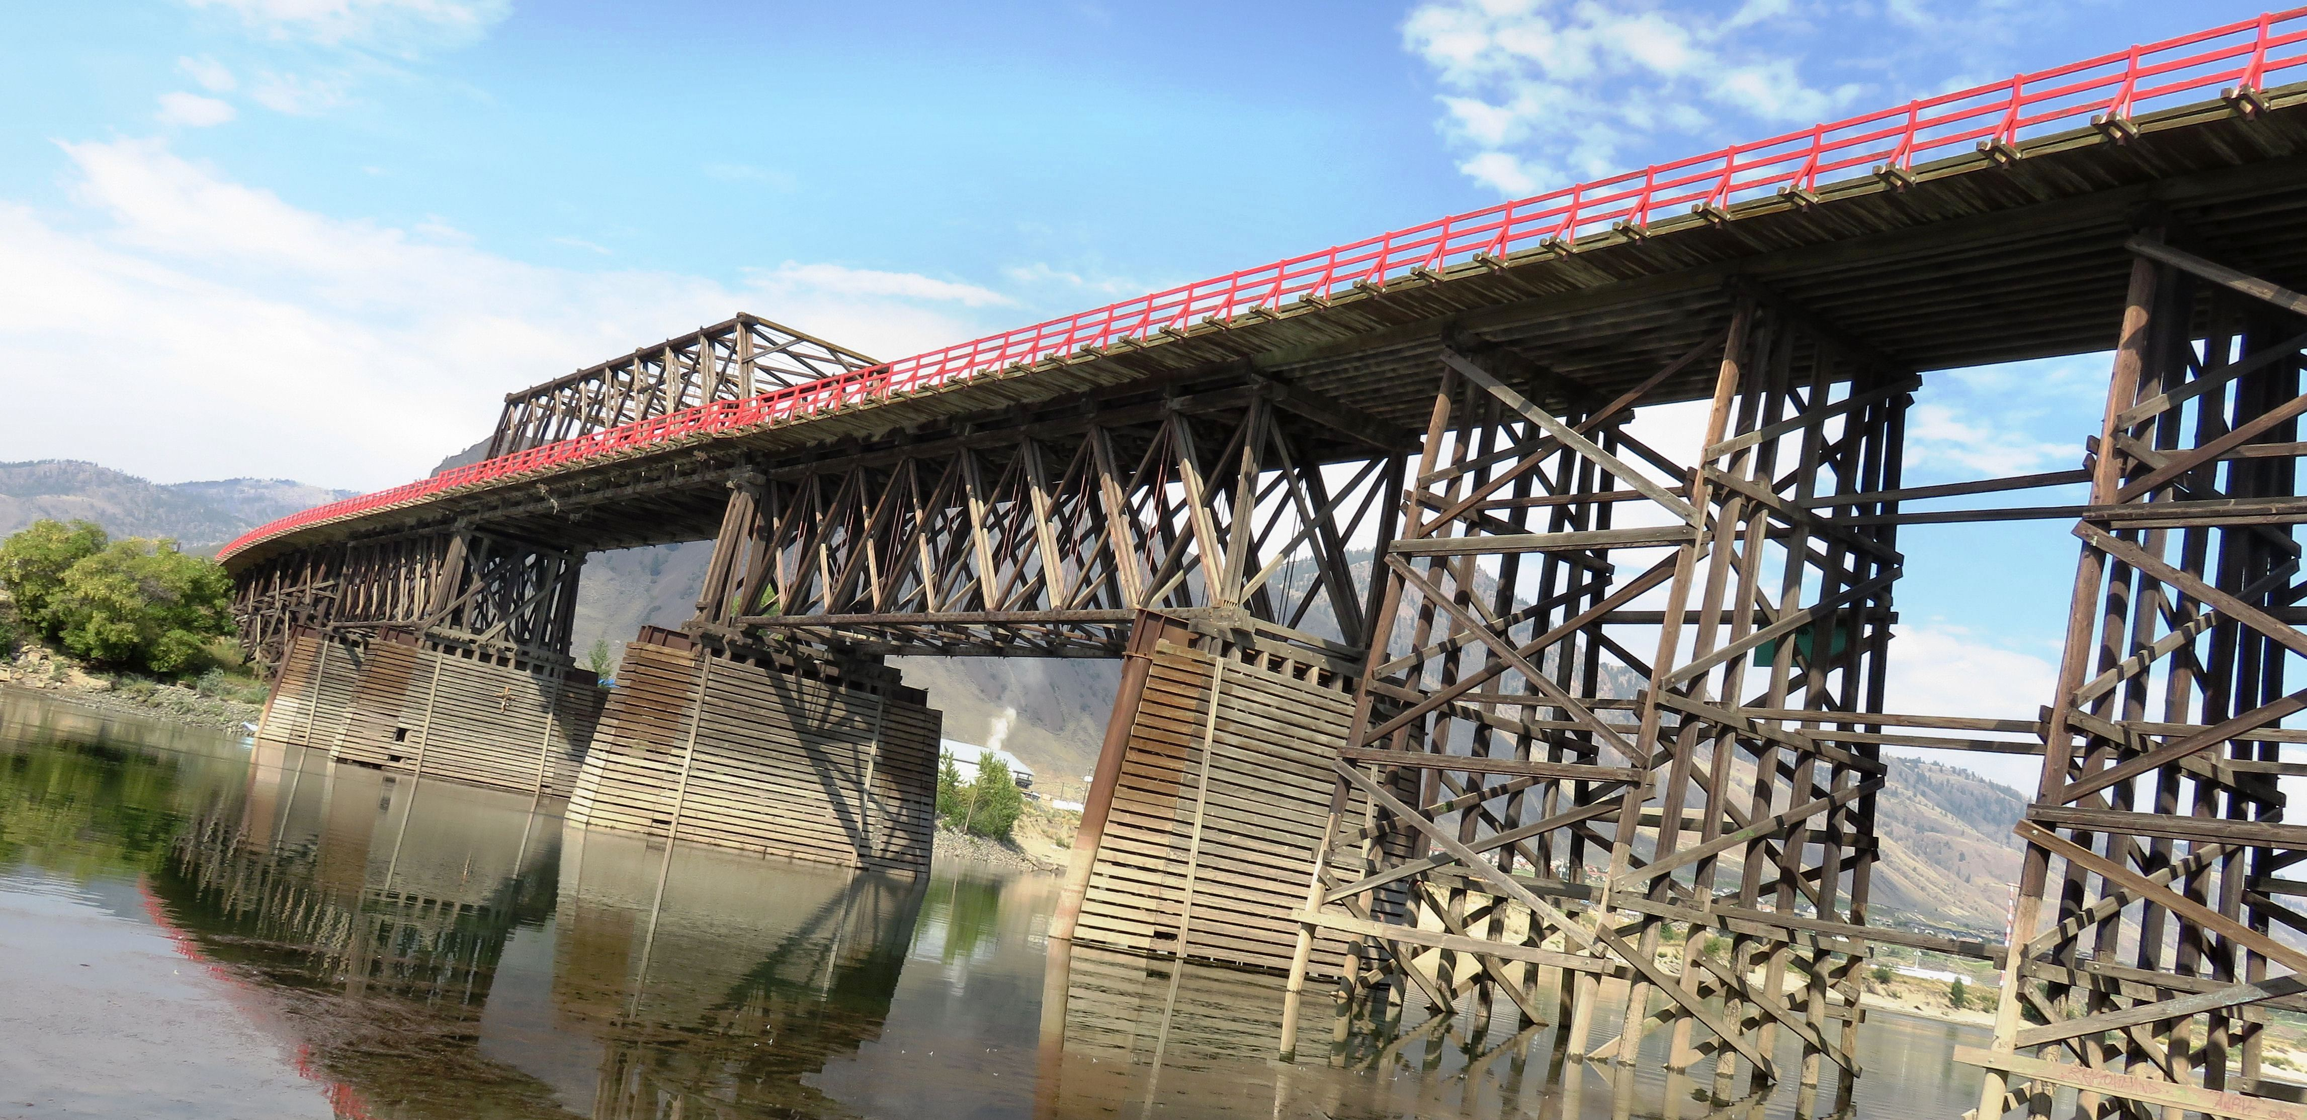

The Red Bridge is Kamloops’ most recognizable landmark.

The trail starts at the parking lot of Pioneer Park and goes under the Red Bridge – a well known Kamloops Landmark. The current bridge built in 1936 on the east side of the second bridge is actually the third of three bridges built to connect the white settlement of Tk’emlups to the Secwepemc Reserve on the other side. The first bridge was constructed in 1887 to replace the dangerous ferry that transported white settlers across the river to trade with the natives who through active trading with the other local bands controlled the fur trade in this region.

Fun Fact – The Red Bridge got its name from the red color of the Douglas fir beams used in its construction.

As you walk from Pioneer Park to Riverside Park you will come across the Labyrith – a brick circle with a path winding through it from the entrance to the middle. It is said that profound insights and understanding comes to those who walk along the path with patience and trust. This may or may not happen for you but it you stand in the center of the Labyrinth and clap your hands you will for sure be surprised by the fact that you won’t hear an echo. Weird or what?
Near the end of Riverside Park as you head towards the Overlander Bridge, you will come across the Japanese Garden – a monument to Kamloops’ sister city of Uji, Japan.

On July 1st 1990 a formal Sister City Agreement was made between the two cities and the agreement was reaffirmed on its tenth anniversary.

Go across the Overlander Bridge and make your way to Schubert drive where you will find a rest stop with a water fountain, three totem poles and a Rotary Shelter with a park bench. Here you can learn about the Schuberts who travelled over 2000 kilometres on foot and horseback in 1862 to get from the Red River Settlement in Manitoba to Fort Kamloops.
Continue along the path as it follows the river under the Halston Bridge to Westmount and enjoy the sandy beaches and stunning view of Mount Paul. This is not a loop so when you get to Westmount turn around and head back or keep going!

HOW TO GET THERE – Start your adventure at Pioneer Park located just off Lorne Street under the Red Bridge. Here you will see an informational sign about the River’s Trail.

A totem pole display and the Mayor’s History Monument are some of the cool things you will come upon as you venture down the River’s Trail.
