A WINERY YOU WILL LEAVE YOU FEELING INTRIGED

The Lake Country Wine Trail is a must for wine lovers and your first stop has a collection of wines that will no doubt Intrigue you.
Intrigue Winery has a picnic area open from May till October, from 10am-6pm everyday. If you are looking for something delicious to pair with the wine, check out their selection of tasty jams, jellies, antipastos and other preserves from Oyama Sunblush, as well as a variety of locally sourced and produced sausages and cheeses.
During your tasting be sure to sample a little Social.
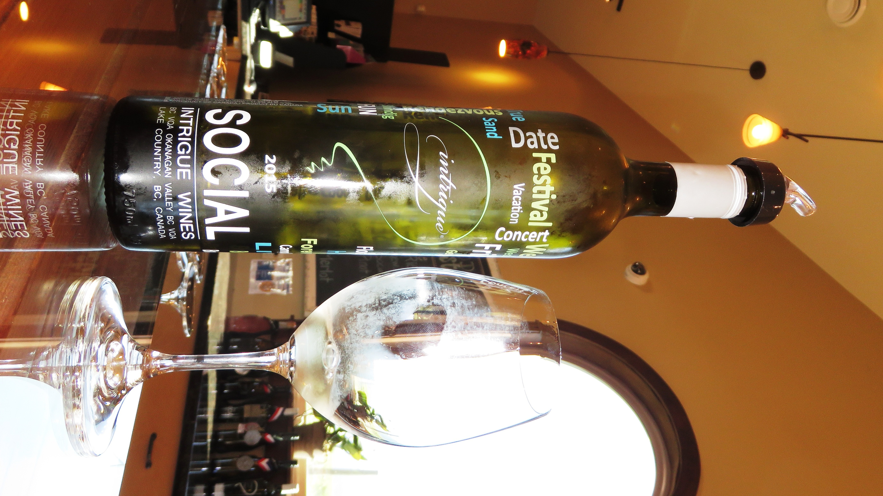
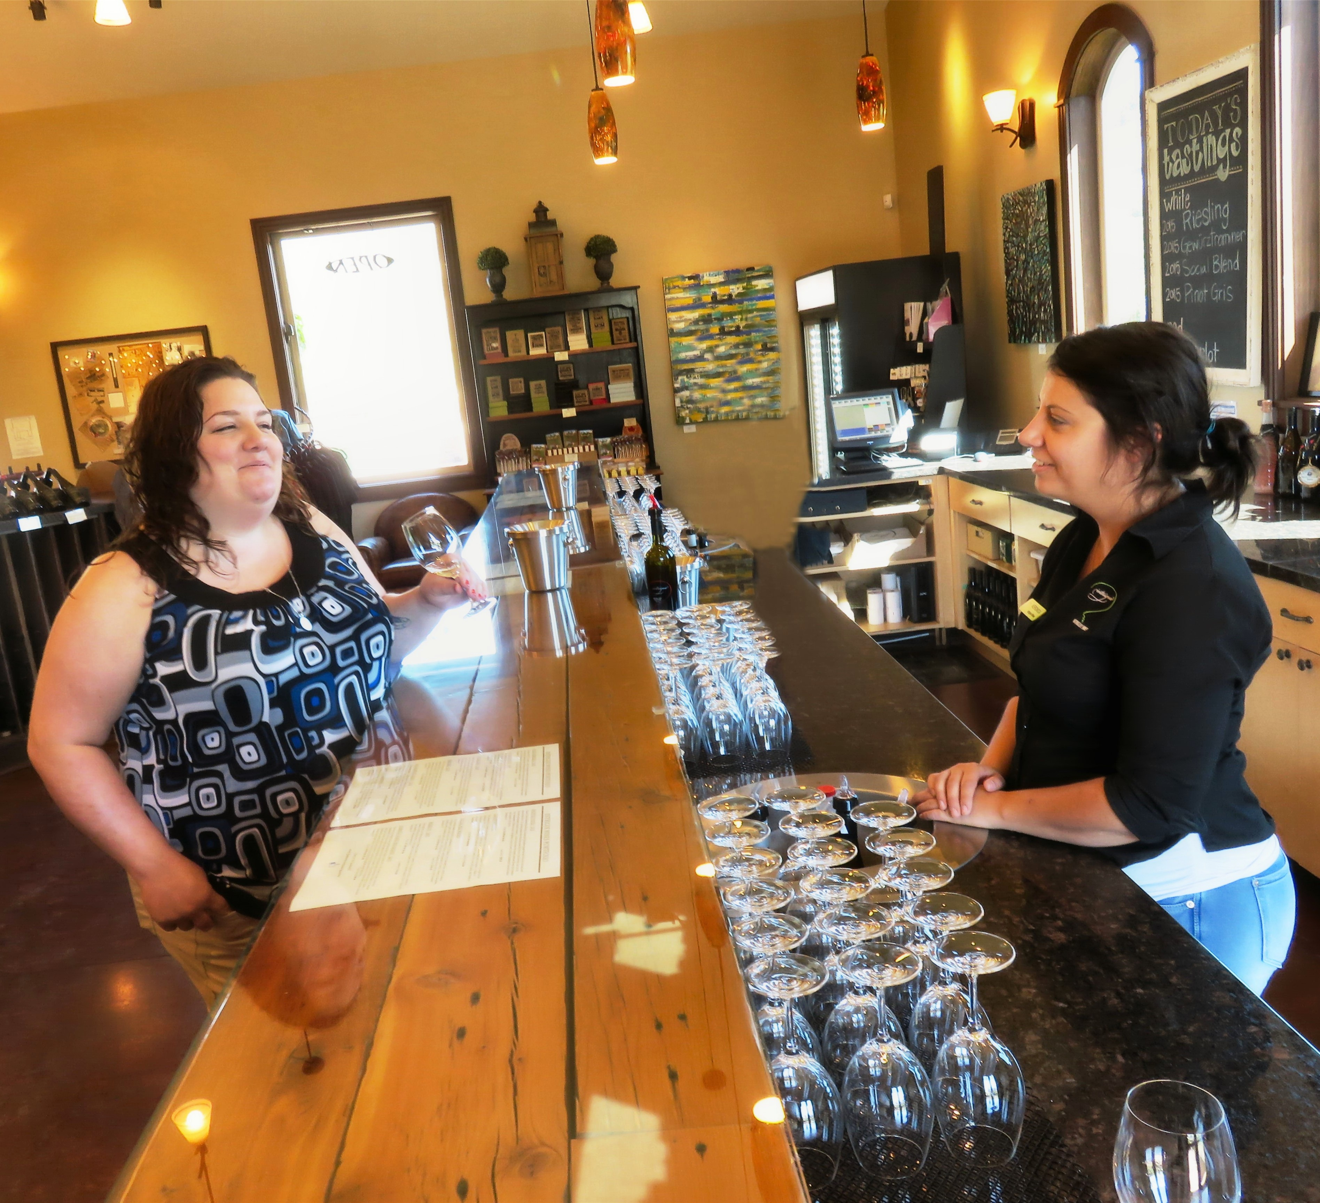

Kamloops teacher Jenifer Jones samples some Social at the Intrigue Winery.

Intrigue 2015 Social White Blend is their summer sipper. This is the perfect blend blend of 64% Riesling, 33% Gewurztraminer, and 3% Muscat Canelli; offering notes of lemon, apple, and pear on the palate.

HOW TO GET THERE – Intrigue is located at 2291 Goldie Rd, in Lake Country. From Kamloops drive through Vernon towards Kelowna on Highway 97 and then turn right onto Oceola Road which turns into Okanagan Center Road East. From there turn left onto Goldie Road.

