CHECK OUT THE ‘BLIND TIGER’ IN LAKE COUNTRY

During the Prohibition era in the United States (1920–1933), illicit establishments that sold alcoholic beverages sprung up across the nation. These establishments were known as Speakeasys, Blind Tigers and Blind Pigs. Patrons would buy tickets or tokens to see the "Blind Tiger" but really all they were doing was avoiding the cops and drinking illegally. That's why some were called "Blind Pigs" to taunt the law enforcement (pigs).
Cafe owner Vincent Chicco, ran a Blind Tiger in Charleston, South Carolina. He cleverly designed a coin that said "good for 5 cents in trade at Chicco's Cafe". The flip side revealed a picture of a blindfolded tiger. Blind tigers ran rampant throughout South Carolina, because they were so profitable. As soon as one was shut down another would emerge prohibition ended in 1933.
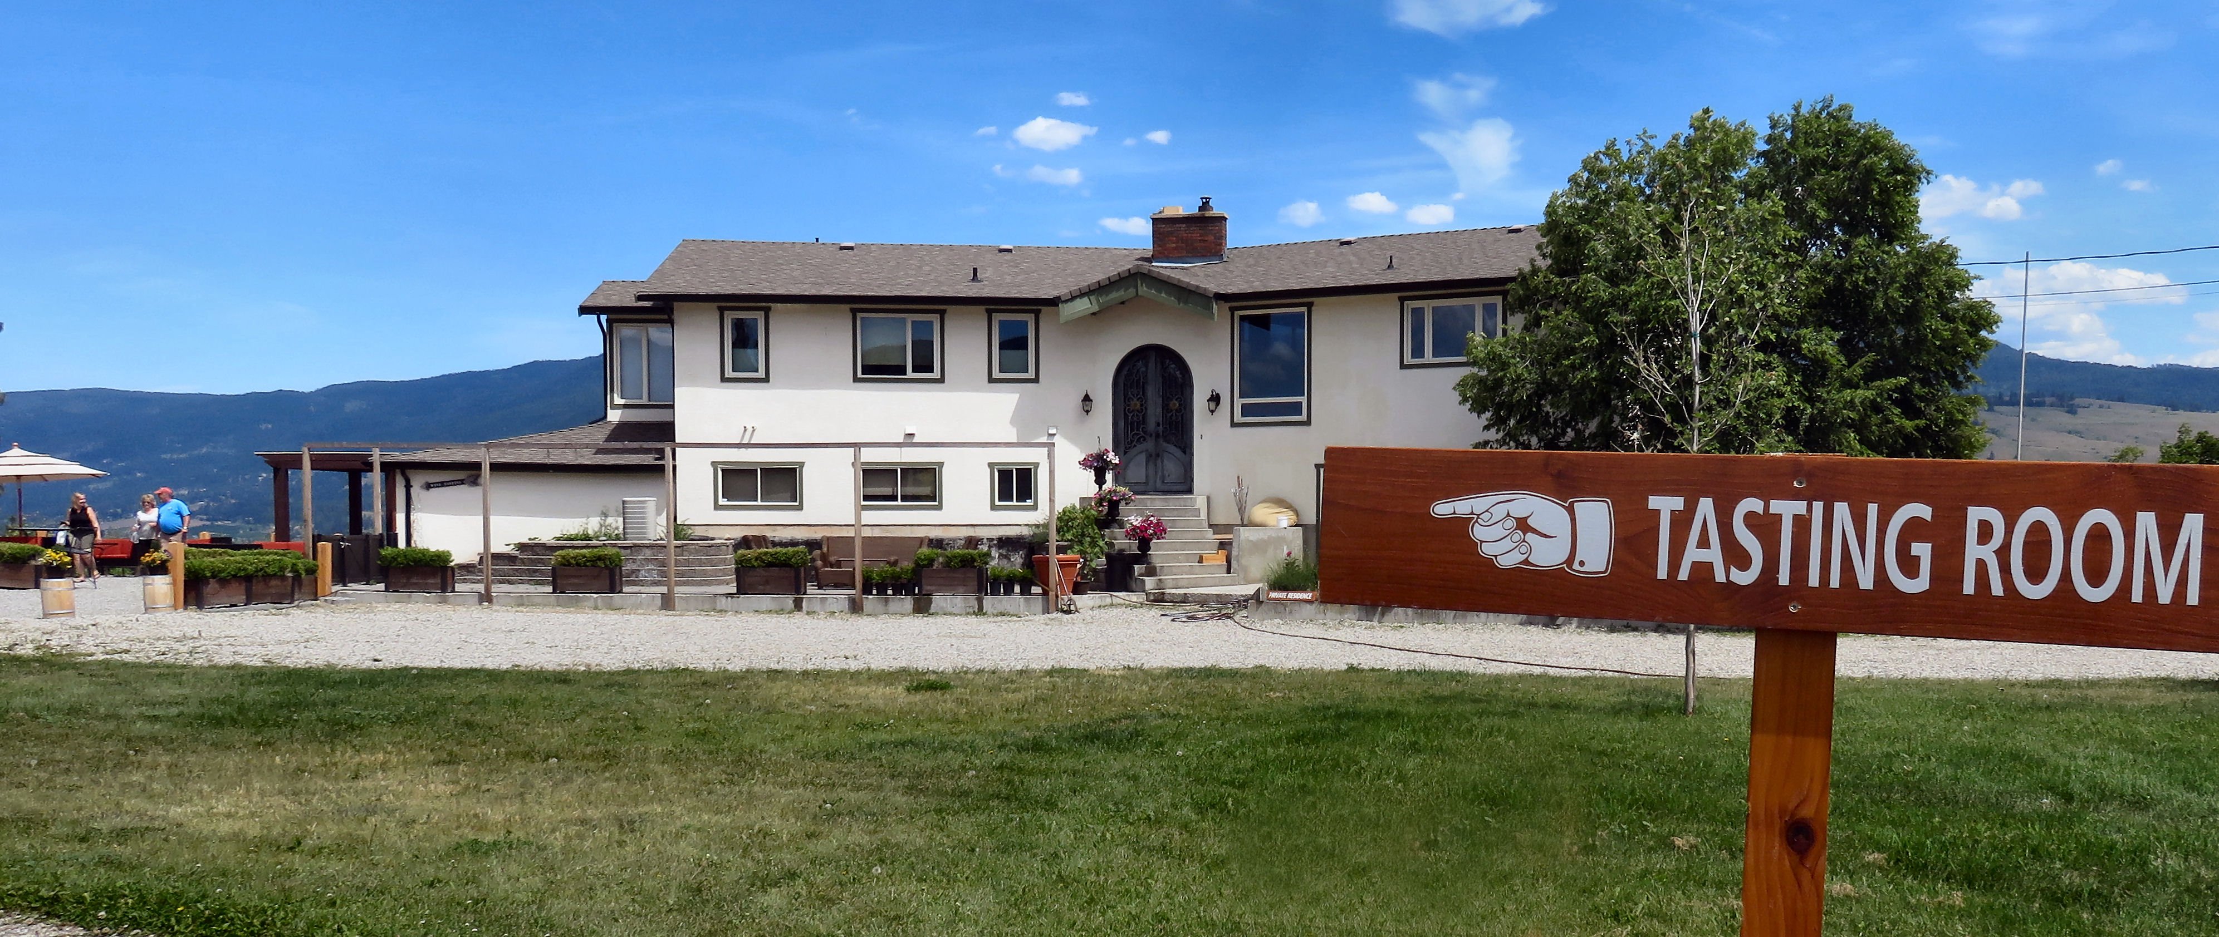

The Blind Tiger wine tasting room is off to the side of the family home.

The Blind Tiger Winery honours those who resisted prohibition to ensure people always had a place to unwind with friends over a glass of wine or cocktail. Owned and operated by Jerry and Charlene Wowchuk, the vineyard grows Pinot Noir, Chardonnay, Riesling and Gewürztraminer. They received their Organic Certification from the North Okanagan Organic Association and are committed to using as little chemical intervention as possible.

HOW TO GET THERE – The Blind Tiger Vineyards is located at 11014 Bond Road, Lake Country. From Kamloops drive past Vernon on the way to Kelowna on Highway 97 and in Lake Country turn right onto Oceola Road. Take a left onto Okanagan Center Road E and then a right onto Williams Road followed by a left onto Bond Road.

