Explore an abandoned mine on the side of a Mountain

When mining ended in 1949, the Mascot Mine buildings were stripped of all their equipment and abandoned. In the 1990’s for safety reasons, plans were being made to burn the buildings down. Fortunately Bill Barlee (who happened to be the BC Minister of Tourism at the time) convinced the province to buy the mine and transform it into a tourist attraction. The Upper Similkameen Indian Band has since taken over the mine site and is now working to restore it adding metal roofs and a new staircase. Visitors descend a total of 550 steps to get to the main Portal level below. This is where the miners entered the mountain and shoveled one ton of ore onto carts.
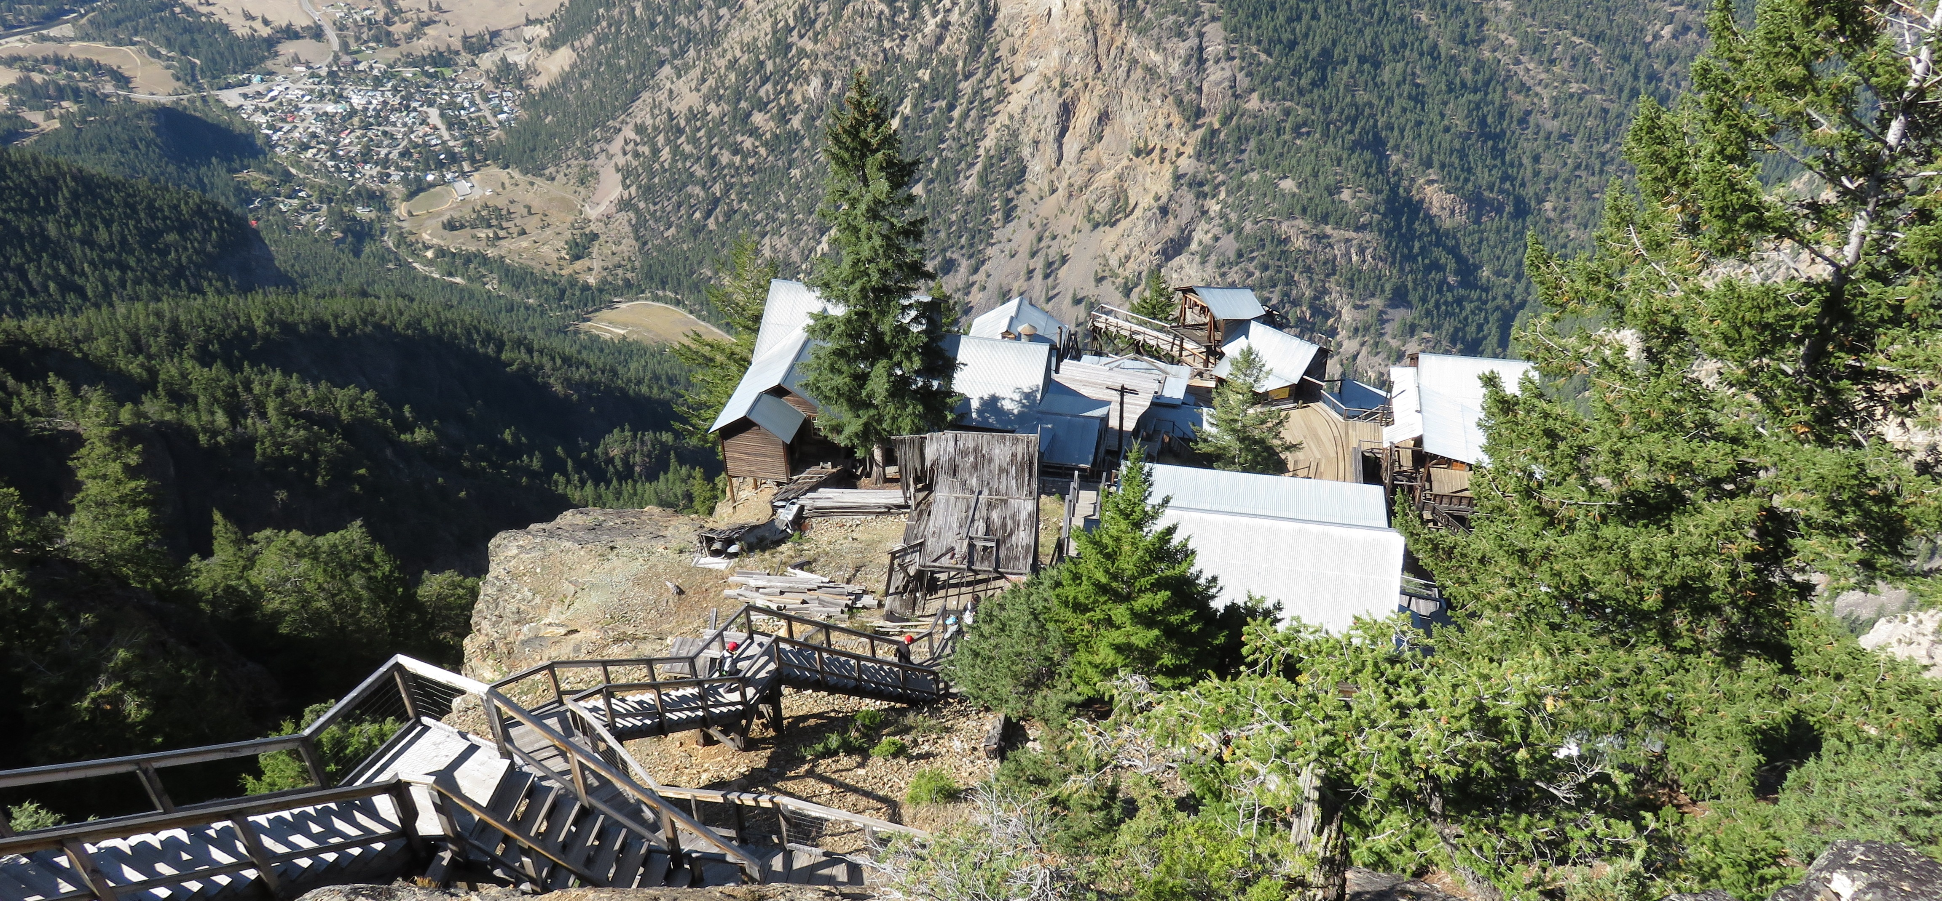

The abandoned Mascot Mine clings to the side of a mountain above Hedley

These carts, which were pulled by miniature locomotives called loci’s were then brought to the top of the bins where there contents were dumped into a skip. These three ton skips carried the ore on the aerial tram to the flotation mill below to be processed.
Visitors to the mine are given hard hats and brought into the Main Mine for a short sound and light show. This tunnel, which was the first tunnel blasted at the Mascot Mine and stretches into the mountain almost one-kilometre, was called Level 4800 because it was 4,800 feet above sea level. The mine had two other main levels one at 4,300 driven in 1938 and one at 3,700 driven in 1944, along with many sub-levels.

Fast Facts
- At the height of activity, about 130 men worked at the Mascot Gold Mine with some living in bunkhouses on site and others living in Hedley with their families and commuting daily to the site via the tram or the Nickel Plate Road.
- During its life, 682,000 tons of ore was extracted producing about 7 tons of gold which today would be worth $130 million Canadian.
- The mined ore went through a few different processes once it left the mine. First it was crushed and grinded into smaller pieces, then it was mixed with water and chemicals to form slurry and fed into flotation tanks and bubbles were added. Gold clung to the bubbles while the waste minerals or tailings sunk to the bottom. The liquid was then sucked out of the slurry by a vacuum leaving only gold mineral particles called concentrates. These concentrates were then shipped by train to the American Smelting and Refining Company in Tacoma, Washington where they were melted in a furnace and poured into moulds to make gold bars.
- Once a week the company would invite the wives up to the mine for a delicious dinner with their husbands. Otherwise it was very uncommon for women to visit the mine.

HOW TO GET THERE – From Kamloops head towards Merritt on the Coquihalla and then take the Kelowna turnoff until you see the turnoff for Princeton, then follow take the Crowsnest Hwy until you reach Hedley. It is approximately 2.5 hours. Park at the large red Snaza’ist Discovery Center which you will see just off the highway as you drive into Hedley

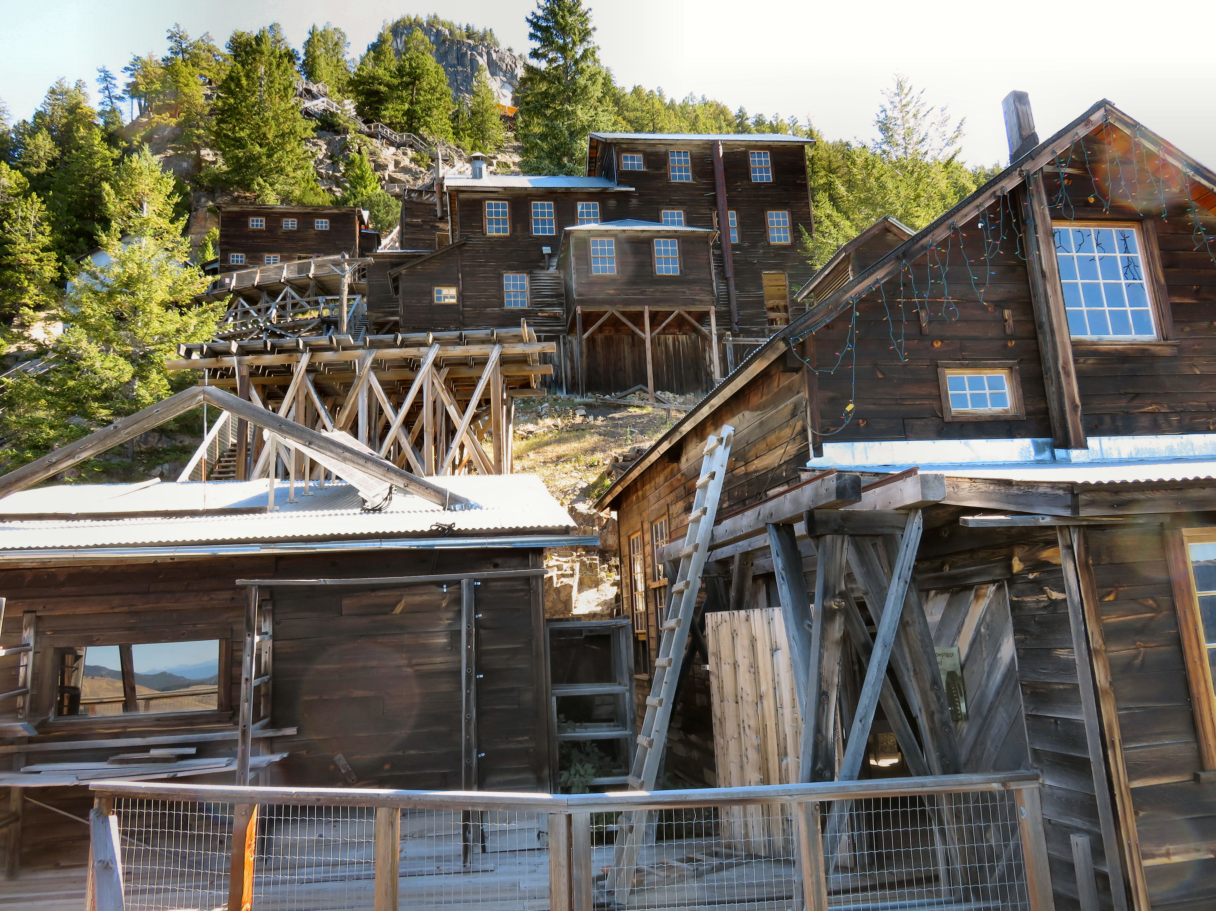

Top: Deanna McLeod goes inside the mine shaft. Bottom: Many of the buildings have been restored and turned into a tourist attraction.

