Explore the frozen beauty of Dew Drop Falls

One of my favourite hiking trails in Kamloops is the Dew Drop trail. Volcanic activity has created the most interesting landscape with plenty of tiny caves and rock sculptures to explore. At the far end of the range from the trailhead is a tiny waterfall in a canyon. It can be seen from the road but poses a challenge if you want to see it close up. There is no marked hiking trail; you must bushwhack to get close to it. In the summer months it is a barely visible trickle, in the spring it gets a larger volume of water and in the winter it freezes.
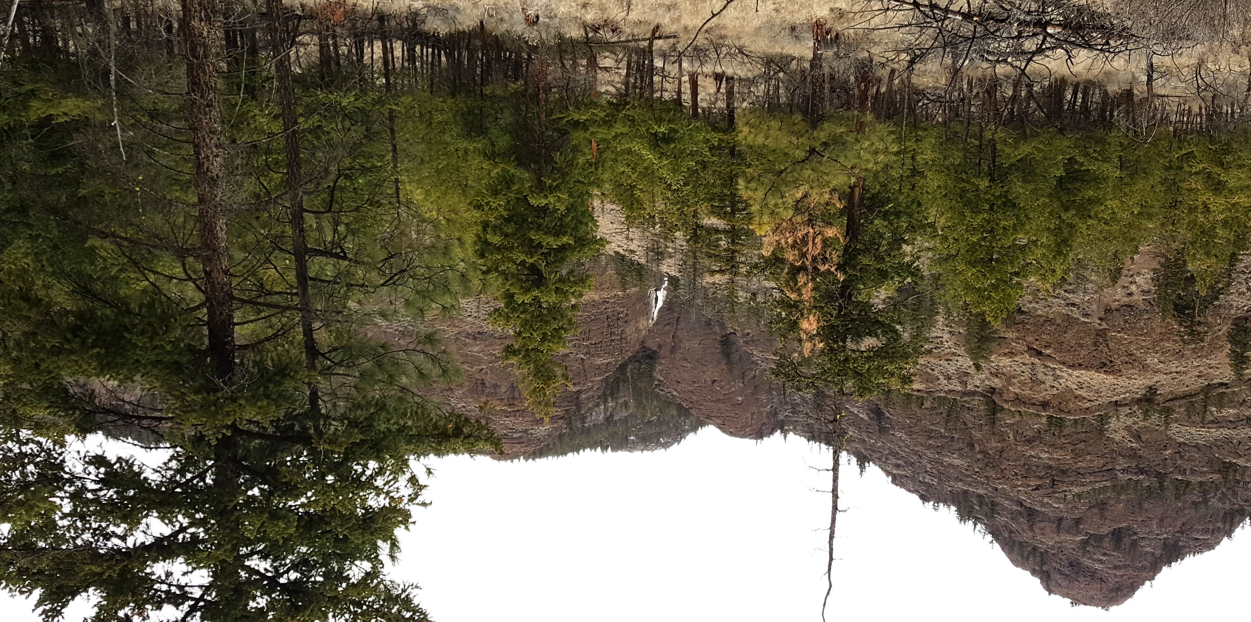

The falls at Dew Drop as seen from the road

HOW TO GET THERE – From Kamloops take Tranquille Road past the Kamloops airport and the golf course then take the right fork onto Criss Creek Road. From here go left on to Frederick Road a short distance down the road on your right you will see the parking area and the trailhead for Dew Drop. A few meters down the road to the left are the parking and trailhead for Battle Bluffs. Continue down the road and you will see another parking area to your right and if you look up the mountain you will see the falls.

