Pay Tribute to “The Great Moose” at Fulton Field

If you have ever visited the Kamloops Airport you have no doubt seen a large fighter plane decorated with a Canadian Flag perched on a pedestal beside the terminal. The last time I was there I ventured over to the memorial and discovered why the land on which the Kamloops Airport is located is called Fulton Field.
A graduate of Boeing School of Aeronautics in Oakland, California, Kamloops resident Wing Commander John "Moose" Fulton, a Royal Air Force pilot was the granddaddy of a hundred young RCAF fliers and one of the most beloved men to wear the King's uniform.
Serving with a bomber squadron in WWII Fulton flew in twenty major operations over three months. In 1940 he was awarded the Distinguished Flying Cross and received the Air Force Cross in 1942. That same year he was awarded the Distinguished Service Order for attacks on important enemy targets.
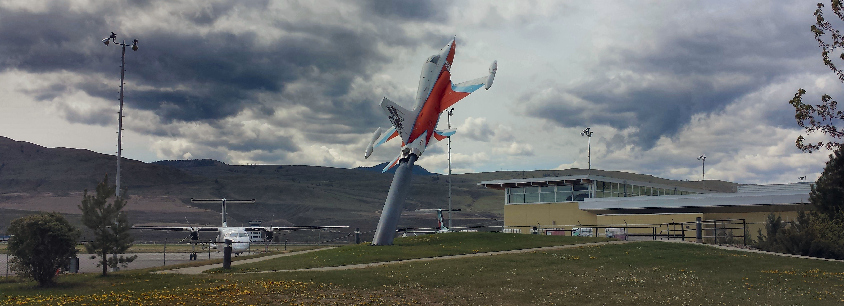

A CF-5 "Freedom Fighter" launches from its pedestal at the Kamloops Airport.

When the Royal Canadian Air Force decided to organize its own 419 Squadron, John Fulton was the first Commanding Officer. Popular amongst the officers and men of the squadron, they often referred to themselves as “Moosemen” after the John’s nickname.
Moose’s life ended tragically on the night of August 2, 1942, when his aircraft was set upon by enemy fighters on their way back from Hamburg. When it became known that he was down in the sea, the exhausted men of No. 419 requested permission to go right back out and commence a search but the job belonged to Air-Sea Rescue and the boys were ordered to bed. The high esteem in which the No.419 Squadron held their missing leader led to the adoption of Fulton’s nickname as their own.
The "Moose" Squadron is the only Canadian squadron to be named after a person immortalizing this great man for all time.

Today 419 Tactical Fighter (Training) Squadron conducts the NATO Flying Training Canada program for Canada, Denmark, Italy, Singapore and the Royal Air Force at 4 Wing in Cold Lake, Alberta. This program prepares future fighter pilots for training on CF-18 class aircraft. Members of the Squadron continue to refer to themselves as “Moosemen.”
On May 29, 1964, the Kamloops Airport was "Dedicated in Honour of Wing Commander John Fulton, D.S.O., D.F.C., A.F.C., and the men of the air service from Kamloops and District" by His Excellency Major General Earl of Athlone K.G. Governor General of Canada. The airport now bears the additional title “Fulton Field.”
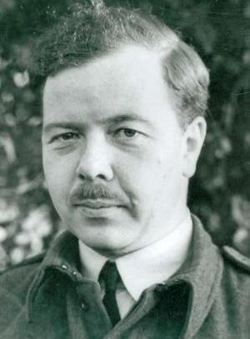

The airport Fulton Field is named in remembrance of Wing Commander John Fulton
Some Fulton Facts

- John Fulton is an alumnus of the Class of 1929 at Kamloops Secondary High School.
- He was deployed to Egypt for just over two years before the war.
- In most of his operations, he flew a Wellington, a twin-engined, stable aircraft that formed the backbone of Bomber Command's early efforts.
- On the night of 15th September an attack on the marshalling yards at Brussels was frustrated by the failure of the starboard engine and he turned for home. Later, however, the engine functioned normally and Squadron Leader Fulton decided to resume his mission. He made two successful attacks from 11,000 feet straddling the railway junction with both sticks of bombs. By his persistent determination, outstanding skill and devotion to duty in the face of heavy opposition and many set-backs, Squadron Leader Fulton was able to complete his task."
- D.S.O. was awarded on August 4th 1942 for his work in the raid on Kiel when Wellington X3488 he was flying was seriously damaged at an altitute of about fifteen hundred feet and then lost height. Fulton appeared to be very calm at the controls as he flew over a hundred miles just feet above the North Sea.
- In 1941 he flew as a test pilot, at the RAF Experimental station at Farnborough, testing the effectiveness of balloons and their cables as defenses against enemy bombers and was awarded the Air Force Cross (AFC) for his achievements.
- His brother was the Honourable Davie Fulton, Minister of Justice in the Diefenbaker government.
- John Fulton’s name is listed on the Kamloops War Memorial located at the N/E corner of Battle & 2nd.

