SATISFY YOUR SWEET TOOTH WITH A BLUEBERRY BLEND

Enderby is a popular place in the summer to float down the Shuswap River or slide down the natural waterfall slide. But did you know it also has a wine trail? Located on this trail is Waterside Winery. They make some delicious fruity dessert wines to make summer even more delicious.
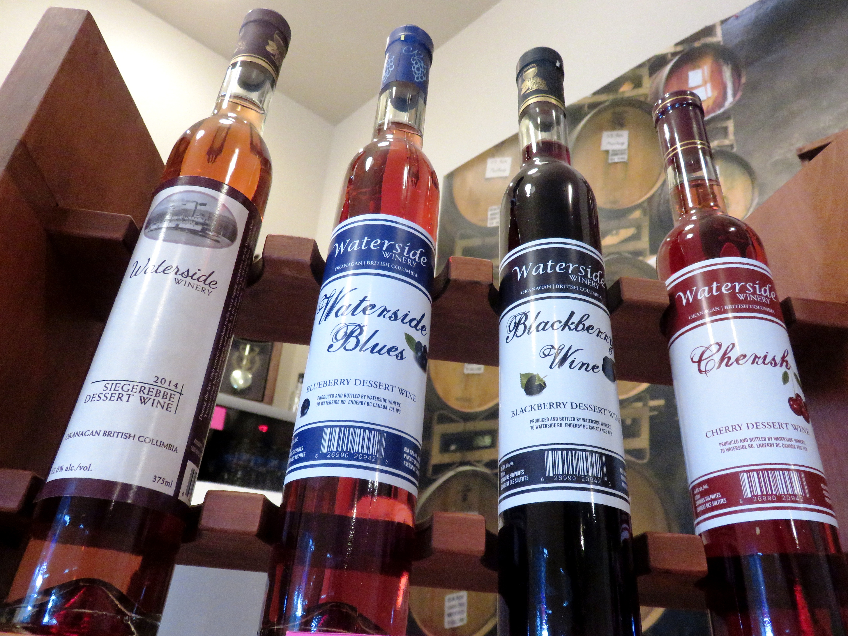

Waterside Vineyard and Winery offer 4 different and deliciously fruity dessert wines.

HOW TO GET THERE – Waterside Winery is located at 70 Waterside Road in Enderby . From Kamloops drive past Salmon Arm and then turn right onto the 97A towards Vernon. Watch for the wine signs and turn left onto Waterside Road and follow it the winery.

