Visit the historically Haunted Coalmont hotel

Opened on April 24, 1912 the Coalmont Hotel was built when horses were still the standard form of transportation. Today the town has been called a ghost town not only because of the coal mine closure in 1940, but Coalmont is known for paranormal events and sightings. This is not surprising when you consider the unusual lives of those who once thrived here.
The history of the three towns of Coalmont, Granite City and Blakeburn (of which only the town of Coalmont remains) are so intertwined that they are often considered one town.
The first influx of people to the area came to Granite Creek (which is within walking distance of Coalmont) during the gold rush of 1885.
Nevertheless, it was coal that offered the impetus for the building of this town as well as the Hotel, General Store, and Livery which still stand today.
Coal had been known in the area with serious explorations starting in 1901. Eventually, the Columbia Coal and Coke Co. Ltd. took control and the name Coalmont was given to the city and first mentioned in the Similkameen Star on February 15, 1911 with the announcement of their intention to develop the area. Everything came together at once with the Post Office being opened Aug 1, 1911, and the Vancouver, Victoria & Eastern Railway tracks reaching the town on Nov. 10 of the same year.
The start of WWI in 1914 put a damper on development but after the war ended in 1918 the coal company was reorganized and became known as Coalmont Colliers Ltd.
Despite Coalmont originally being touted by developers as The City of Destiny, the mining operation was now on the mountain nearby and the work camp there soon developed into another town named Blakeburn.

The famous 3 mile long aerial tramway used for transporting the coal down to the tipple in Coalmont was started in 1919 and completed in Nov 1920. The Blakeburn post office opened in 1920 and by 1923 the town had its own school and soon surpassed Coalmont in population.
On the 13th of August 1930, a terrible disaster befell the area leaving a dark shadow over the community. Forty six minors were working underground on the afternoon shift in number four mine when without any warning the mine suffered a double explosion, either from an excess of coal dust or more likely methane gas.
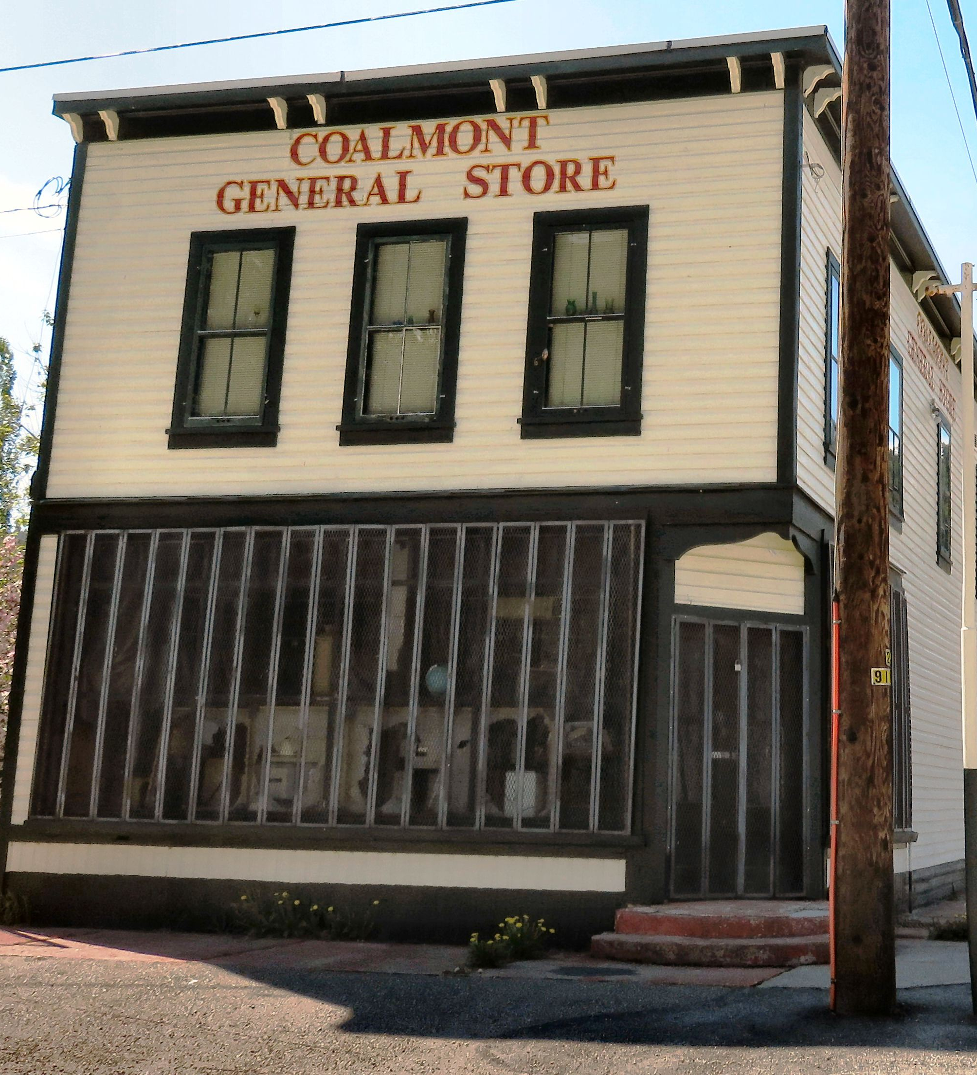

The Coalmont General Store was opened in January of 1912.
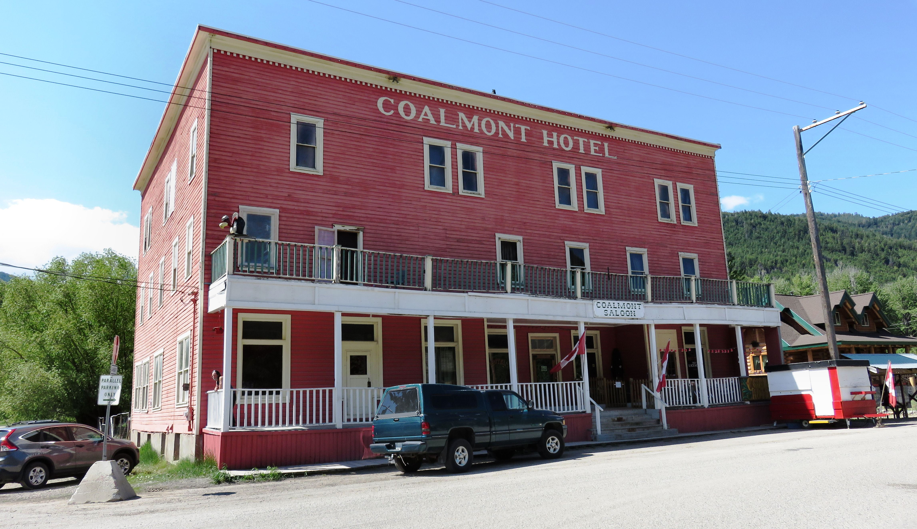

The Coalmont Hotel is amongst some of the locations in the town reported to be haunted. It is particularly well known for ghostly sounds and apparitional experiences. The third floor, which has been boarded up for years, is indeed spooky by anybody's standards

Despite the efforts of over 200 rescue workers, only one man survived with serious injuries. J. Porchella, happened to be near the entrance to the shaft when he heard the explosion. He dropped to the ground then started to crawl the wrong way but discovered his error and made his way out suffering a severe scalp wound.
Harry Vaton, who was on shift that fatal day, had a miraculous escape. His infant son was critically ill and he was called from the mine only an hour before the disaster.
The bodies of the others were recovered over next several weeks. Amongst the dead were three sets of brothers. A large amount of money was raised from people all over the province and beyond to help the families that had lost their breadwinner.

After that the coal business declined and Coalmont's population was already down to 100 when the mine closed in 1940. Most people abandoned their homes leaving a silence to descend upon the town but Coalmont continued to struggle long along after that while Blakeburn was abandoned and soon became a ghost town. Gone went the wooden boardwalks and most of the original buildings. One lone store remained for many years but closed on the last weekend of September, 1988. With it went the post office. On May 9, 1989 the last train ran.

HOW TO GET THERE – From Kamloops, drive to Merritt then take the Coquihalla connector towards Kelowna. Take the Princeton exit and from Princeton follow the signs to Coalmont.
The Ghost of Hattie McBride
Over the years, Coalmont has become a ghost town in more ways than one. Strange and seemingly unnatural occurrences are not unusual in this area. Amongst the former residents to haunt the town is the notorious Hattie McBride whose ghost is considered the most identifiable of the Coalmont ghosts.
Madam Hattie was the victim of Coalmont’s first murder which took place on the end of Main Street in November of 1920. A proud member of the world’s oldest profession, Haddie purchased a plot of land at the east end of Main Street in 1912, where she lived in a small cabin. She was a wealthy woman at the time of her death when she was found in the remains of her burned home. Despite the fact there was no question about foul play being involved; the police did not investigate her murder despite ample evidence and suspects simply because of her profession.
This incensed the residents of Coalmont who attended her funeral at the Granite Creek Cemetery in large numbers to pay their respects. As a result of her murder, terrified Coalmont residents demanded, and received, their first police officer.
Today while Haddie rests in one of the most prestigious graves in the cemetery, the remains of her house are buried under a pile of lumber on the north side of the east end of Main Street. Some residents and visitors report an eerie feeling when approaching the vicinity and claim they are sometimes able to catch a faint wisp of her perfume in the air and hear the clicking of her heels down the no longer existent moonlit boardwalks.

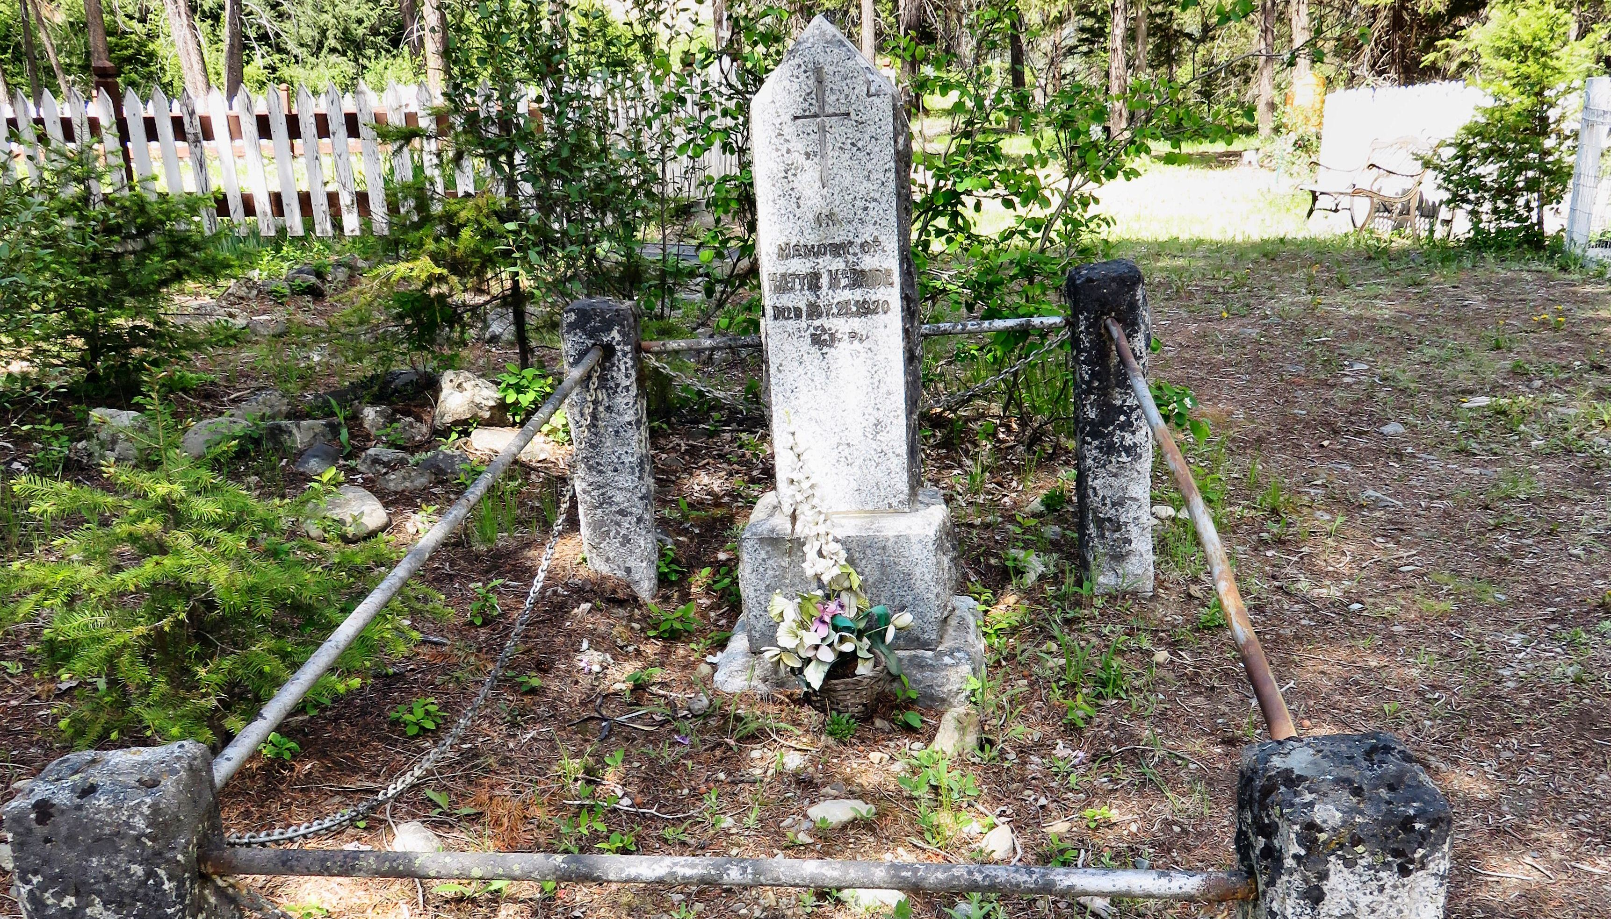

Hattie McBride was laid to rest in the Granite City Cemetery. Her grave has recently been restored by local Chris Goodfellow and is one of the most prestigious in the cemetery.

