Take a History Break at the Spiral Tunnels

When travelling on the Trans Canada Highway to Calgary, you have no doubt noticed the sign for the Spiral Tunnels but have you ever stopped to see what they are?
Opened on September 1, 1909 the Spiral Tunnels were the CPR’s solution to the problem of the Big Hill – an ascent of 1070 feet in the space of 10 miles that challenged the rail line. Before the tunnels, steam engines inched their way up the treacherously steep track then risked the nightmare of coming back down. Wrecks and runaway trains were common place in those days. In fact, the first train to attempt the hill in 1884 derailed, tragically killing three workers. In an effort to improve safety, 3 spur lines were created to divert runaway trains
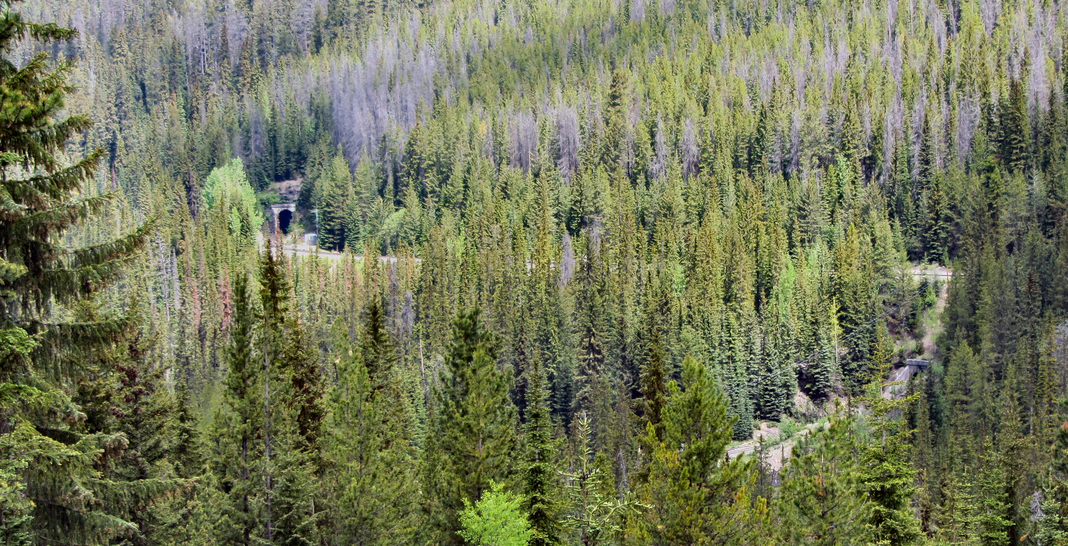

If you catch it at the right time you can actually see the train going through both tunnels at the same time.

Vancouver engineering firm McaDonnell, Gzowski and Company were tasked with designing the tunnels which were built at a cost of about 1.5 million dollars. Two tunnels were driven in three-quarter circles into the valley walls.
The upper one was about 1000 yards in length while the lower one was a few yards shorter. It took 20 months, 1000 men and 75 carloads of dynamite to complete. After 25 years of use the former track was abandoned and parts of it later became the Trans Canada Highway.

HOW TO GET THERE - From the viewpoint 7.4 km east of Field on the Trans-Canada Highway, you can see the Lower Spiral Tunnel in Mt. Ogden.

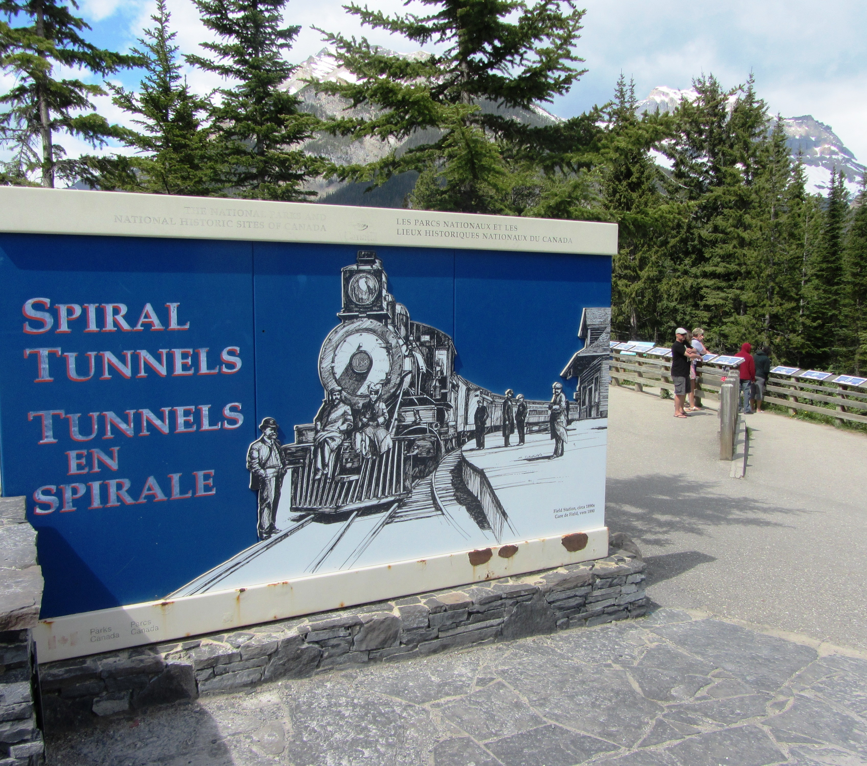

Some visitors stop at the Spiral Tunnels to read up on the history of the CPR and the creation of the tunnels.

