Follow the Caribou Gold Rush Trail to Barkerville

A stroll through the history of British Columbia would not be complete without a visit to our most famous ghost town. Preserved as a historic town Barkerville was the main town of the Cariboo Gold Rush in British Columbia, Canada. Once the largest city north of San Francisco and west of Chicago, Barkerville was named after Billy Barker from Cambridgeshire, England, who was one of the first gold at the location in 1861. His claim at 2,350 pound of gold was the richest and most famous.
The gold rush town went from consisting only of makeshift cabins and tents to having a population of approximately 5,000 by the mid 1860’s. It had several general stores and boarding houses, a drugstore, a barbershop, a Restaurant and Salon, and a theatre.
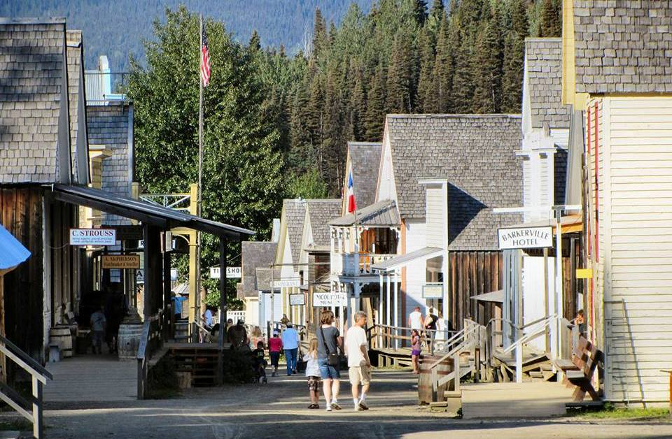

While strolling through Barkerville’s Main Street it is not uncommon to see actors dressed in period costumes.

The Chinese played an important role in Barkerville life for almost a hundred years establishing a number of businesses, including the Kwong Lee Company, a general store that sold groceries, clothing, hardware, and mining tools.
The Chinese community also built cabins for Chinese miners, who shared four or five to a cabin and a nursing home to take care of their elderly. Chinese benevolent associations provided social services to their community, and resolved disputes within the community without the use of the provincial court system.
Today, Barkerville’s Chinatown has the largest collection of pre-railway Chinese buildings in North America and one of the largest Chinese archival collections in Canada
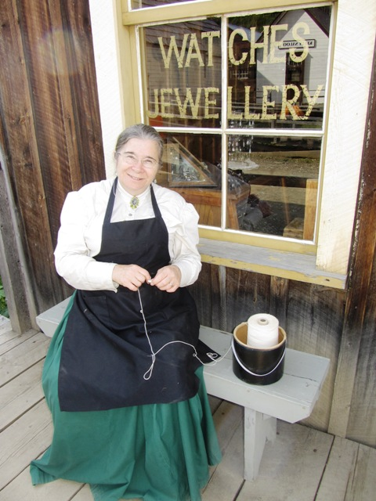

.

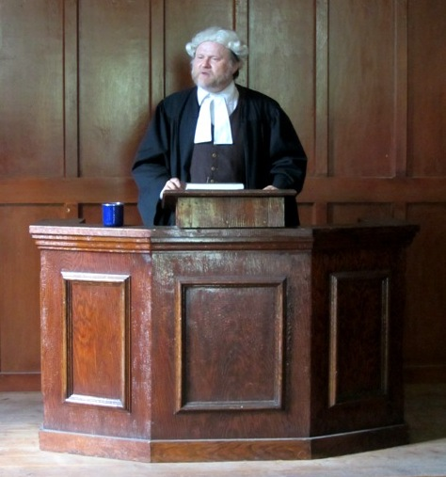

An actor portrays Judge Begbie in one of the regular court session held at the Methodist Church. Known as the “Hanging Judge” At age 39, Matthew Begbie who was originally from England was appointed as Judge of the new colony of British Columbia. The travelling judge was given his nickname only after his death in 1894. He was known as a stern yet fair judge who only ever gave the death sentence to two residents of Barkerville.

On September 16, 1868, a fire nearly destroyed the town of Barkerville. Amazingly, no one was killed despite the rapid pace at which the wooden buildings burned to the ground. Much like the great fire of London, the rebuilding process gave Barkerville the opportunity to reorganize and plan the town. Rebuilding began immediately and within six weeks, ninety buildings had been rebuilt. Barkerville’s main street was widened, buildings were arranged in a more organized manner, and a town-wide boardwalk was built to help residents get around during spring floods.
By the end of the century Barkerville's population was declining with the exception of a brief revival in the 1930’s during the Great Depression when the price of gold skyrocketed. The decline of mining activity reduced the town to a small village and by the 1950’s concerns about the future of Barkerville began to surface. In 1958 an organized campaign supported by the Wells Historical Society, concerned local residents, and local politicians resulted in Barkerville’s designation as a heritage site. This paved the road for modern day Barkerville which is run by the Barkerville Heritage Trust, with assistance by the Friends of Barkerville.
With over 100 heritage structures still standing in the spot on which they were built, Barkerville is a unique example of a gold rush town. In addition, there are two historic cemeteries and 187000 precious objects and photographs in the museum collection. Today visitors can stroll through the well preserved town and literally step back in time and experience life during the gold rush through interactive theatre and activities. Such regular shows and activities include:

- Court Sessions at the Methodist Church
- The Waterwheel Show
- Schoolhouse Lessons
- Historical Tour of Chinatown
- The McGinley Family Troupe Musical Revue
- Cemetery Tour
- Gold-Panning Lessons
- Stagecoach Rides
- Shows at the Theatre

HOW TO GET THERE – From Kamloops head to Cache Creek and take Highway #97 North. Follow #97 through Clinton, 100 Mile House, and Williams Lake to Quesnel. Turn right onto highway #26 and follow it to the end.

