An Abandoned Mine at the Center of the Universe

In 1980, a man dressed in white robes arrived at Vidette Lake in Deadman Valley claiming to have found the Center of the Universe. The apprentice monk from San Francisco had been sent there by his master teacher who had pointed to a location on a map claiming it to be the spot. The apprentice conducted a series of tests which produced positive results thus clearing the way for his Master Teacher’s visit. Along with his entourage of followers, the Master completed his tests proclaiming the top of a grassy knoll overlooking Vidette Lake to be the real deal. Monks believe that the Center of the Universe is an area where power lines intersect and one can find peace, or get centered.
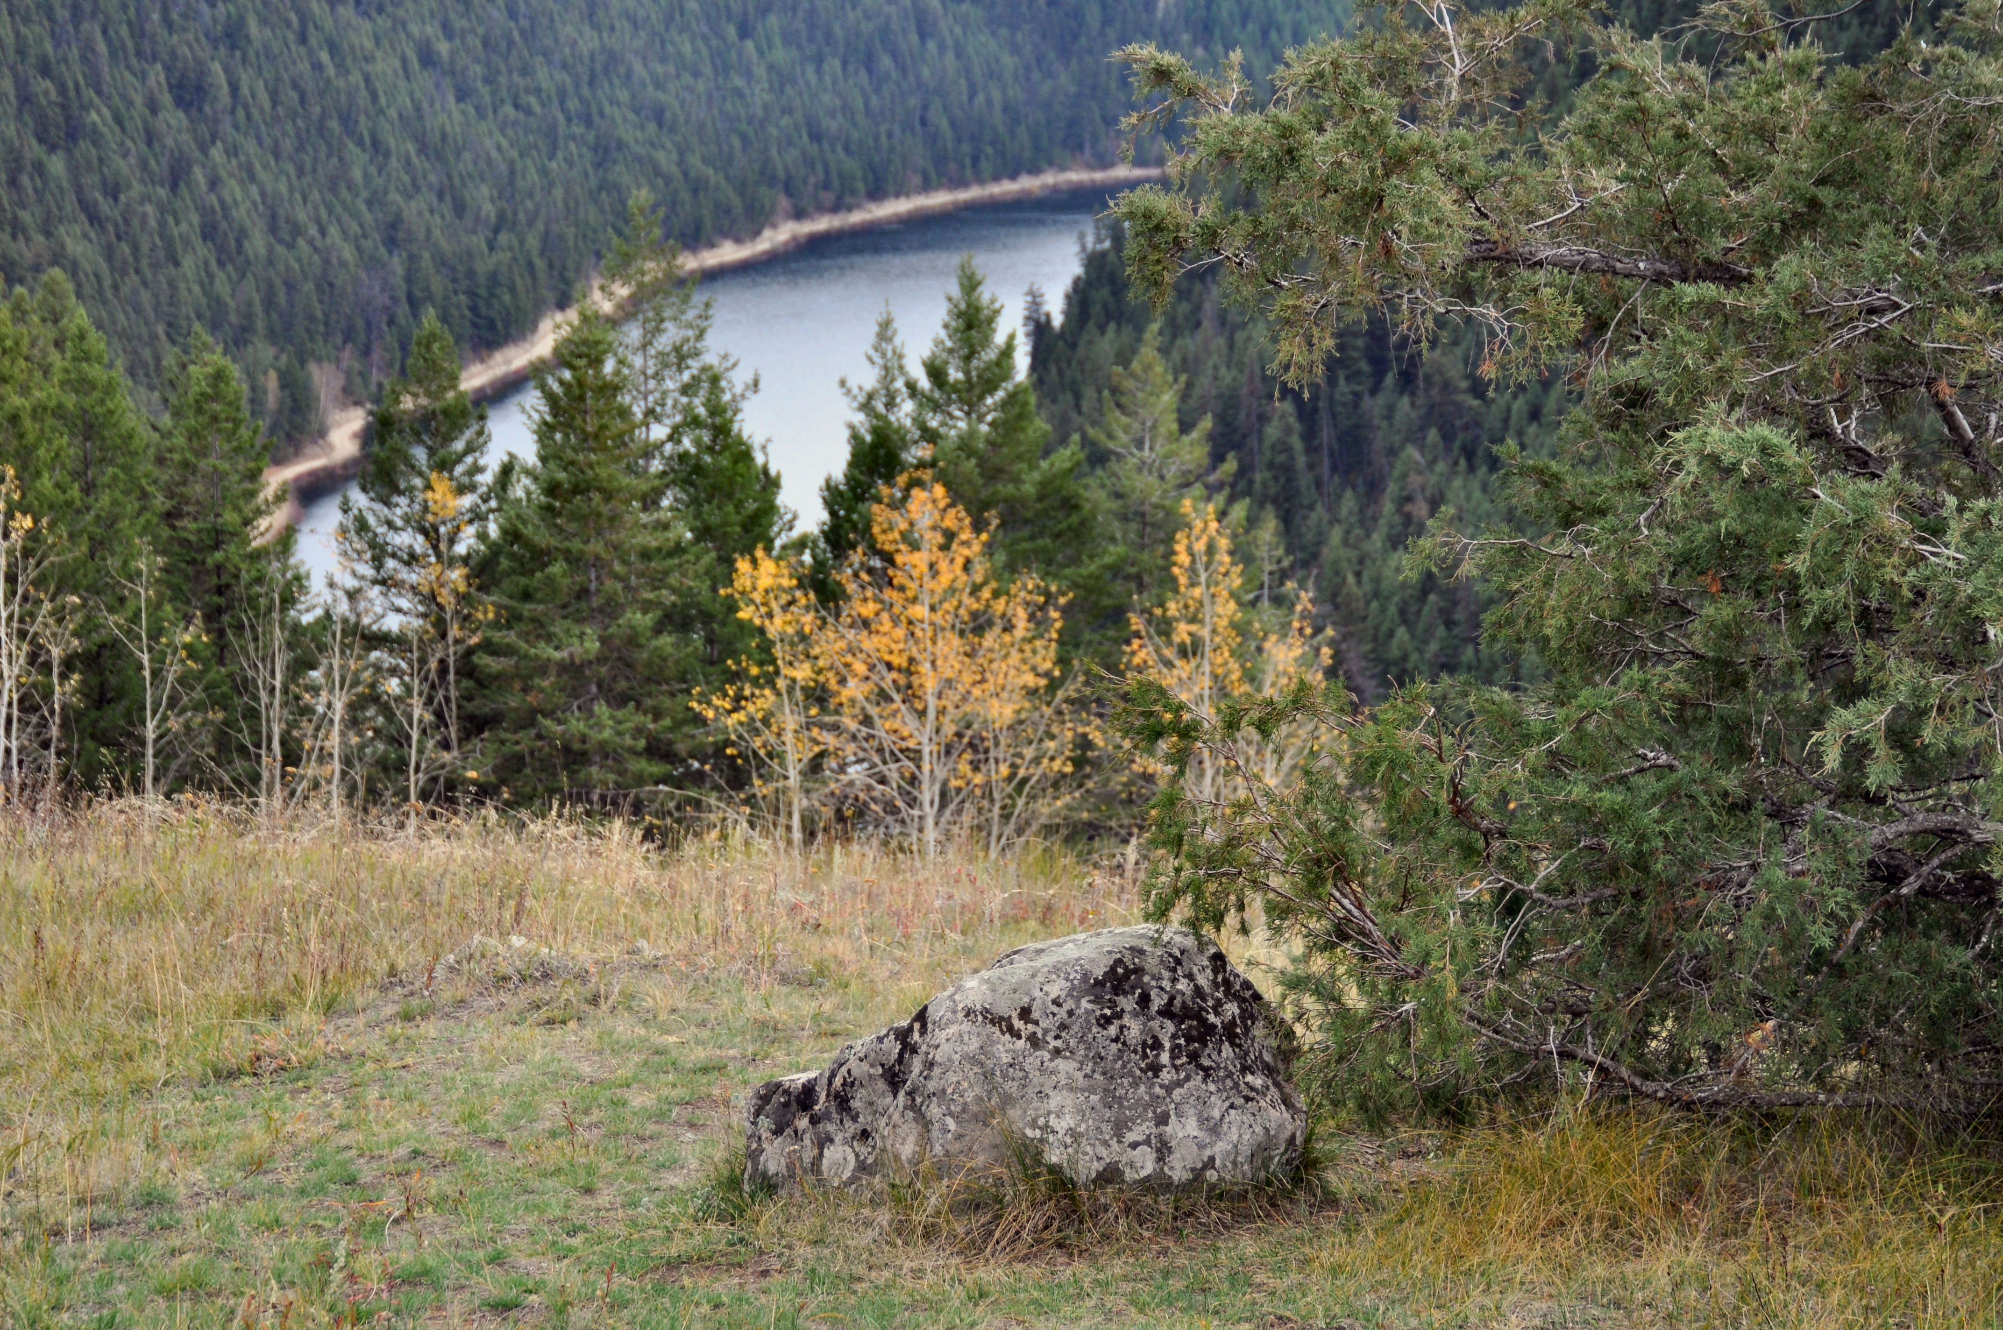

It is customary to circle the portal stone clockwise 5 times when entering the sacred site and 5 times counterclockwise when leaving the site.

The grassy knoll, which is part of the privately owned Vidette Lake Resort, is now a place of pilgrimage for Buddhists around the world. However, the Buddhists are not the first to recognize the healing powers of this location. This has been a sacred place for First Nations people in the area for hundreds of years.
According to caretaker Ray Stad, there is a significant amount of electromagnetic energy in the area which is most likely a result of the high mineral content. Following the gold rushes in the Fraser River and in the Cariboo, there was a flurry of exploration and gold panning throughout the area. Gold, silver and copper veins were known to prospectors as early as 1898.

However, it was not until the winter of 1931 when more extensive surveying was done by an American geologist who employed seven men at Vidette Lake and confirmed the presence of gold-bearing quartz veins. By 1932 equipment and supplies were shipped in and a portable sawmill was set up to provide lumber for above and below ground construction.
By 1934, a town site with log huts surrounded the mine site, which consisted of a two-storey bunkhouse with electric lights, flushing toilets and showers and a cookhouse.

Over 125 men were employed and with their families, the town site grew quickly to a village. It operated during the Great Depression making a significant economic impact on the region.

The payroll at the mine was about $75,000 a year, in 1934 dollars. At that time, workers were paid about $0.50 per hour working 8 hours a day, 6 days a week. Workers could stay and be fed at the company-owned bunkhouse for $1.25 per day. Medical plans and dentistry were also available. The village continued to develop over the 6 years that the mine ran in full operation. During those years the mine covered 5 miles of tunnels, including one under the lake. The company built 17 km of roads and about 28,000 ounces of gold was extracted and shipped. Mine operations reduced capacity in 1938 and with the onset of World War II in 1939 along with dwindling ores, the mine closed down and the surrounding village was eventually abandoned.

HOW TO GET THERE – From Kamloops travel west on Hwy 97 and after 50 km turn right on Deadman Creek Road. Follow this road for 50km and you are at Vidette Lake Gold Mine Resort. For more information visit www.videttelake.com or call 1-866-Vidette. Be sure to book your visit ahead of time to ensure the owners are there.
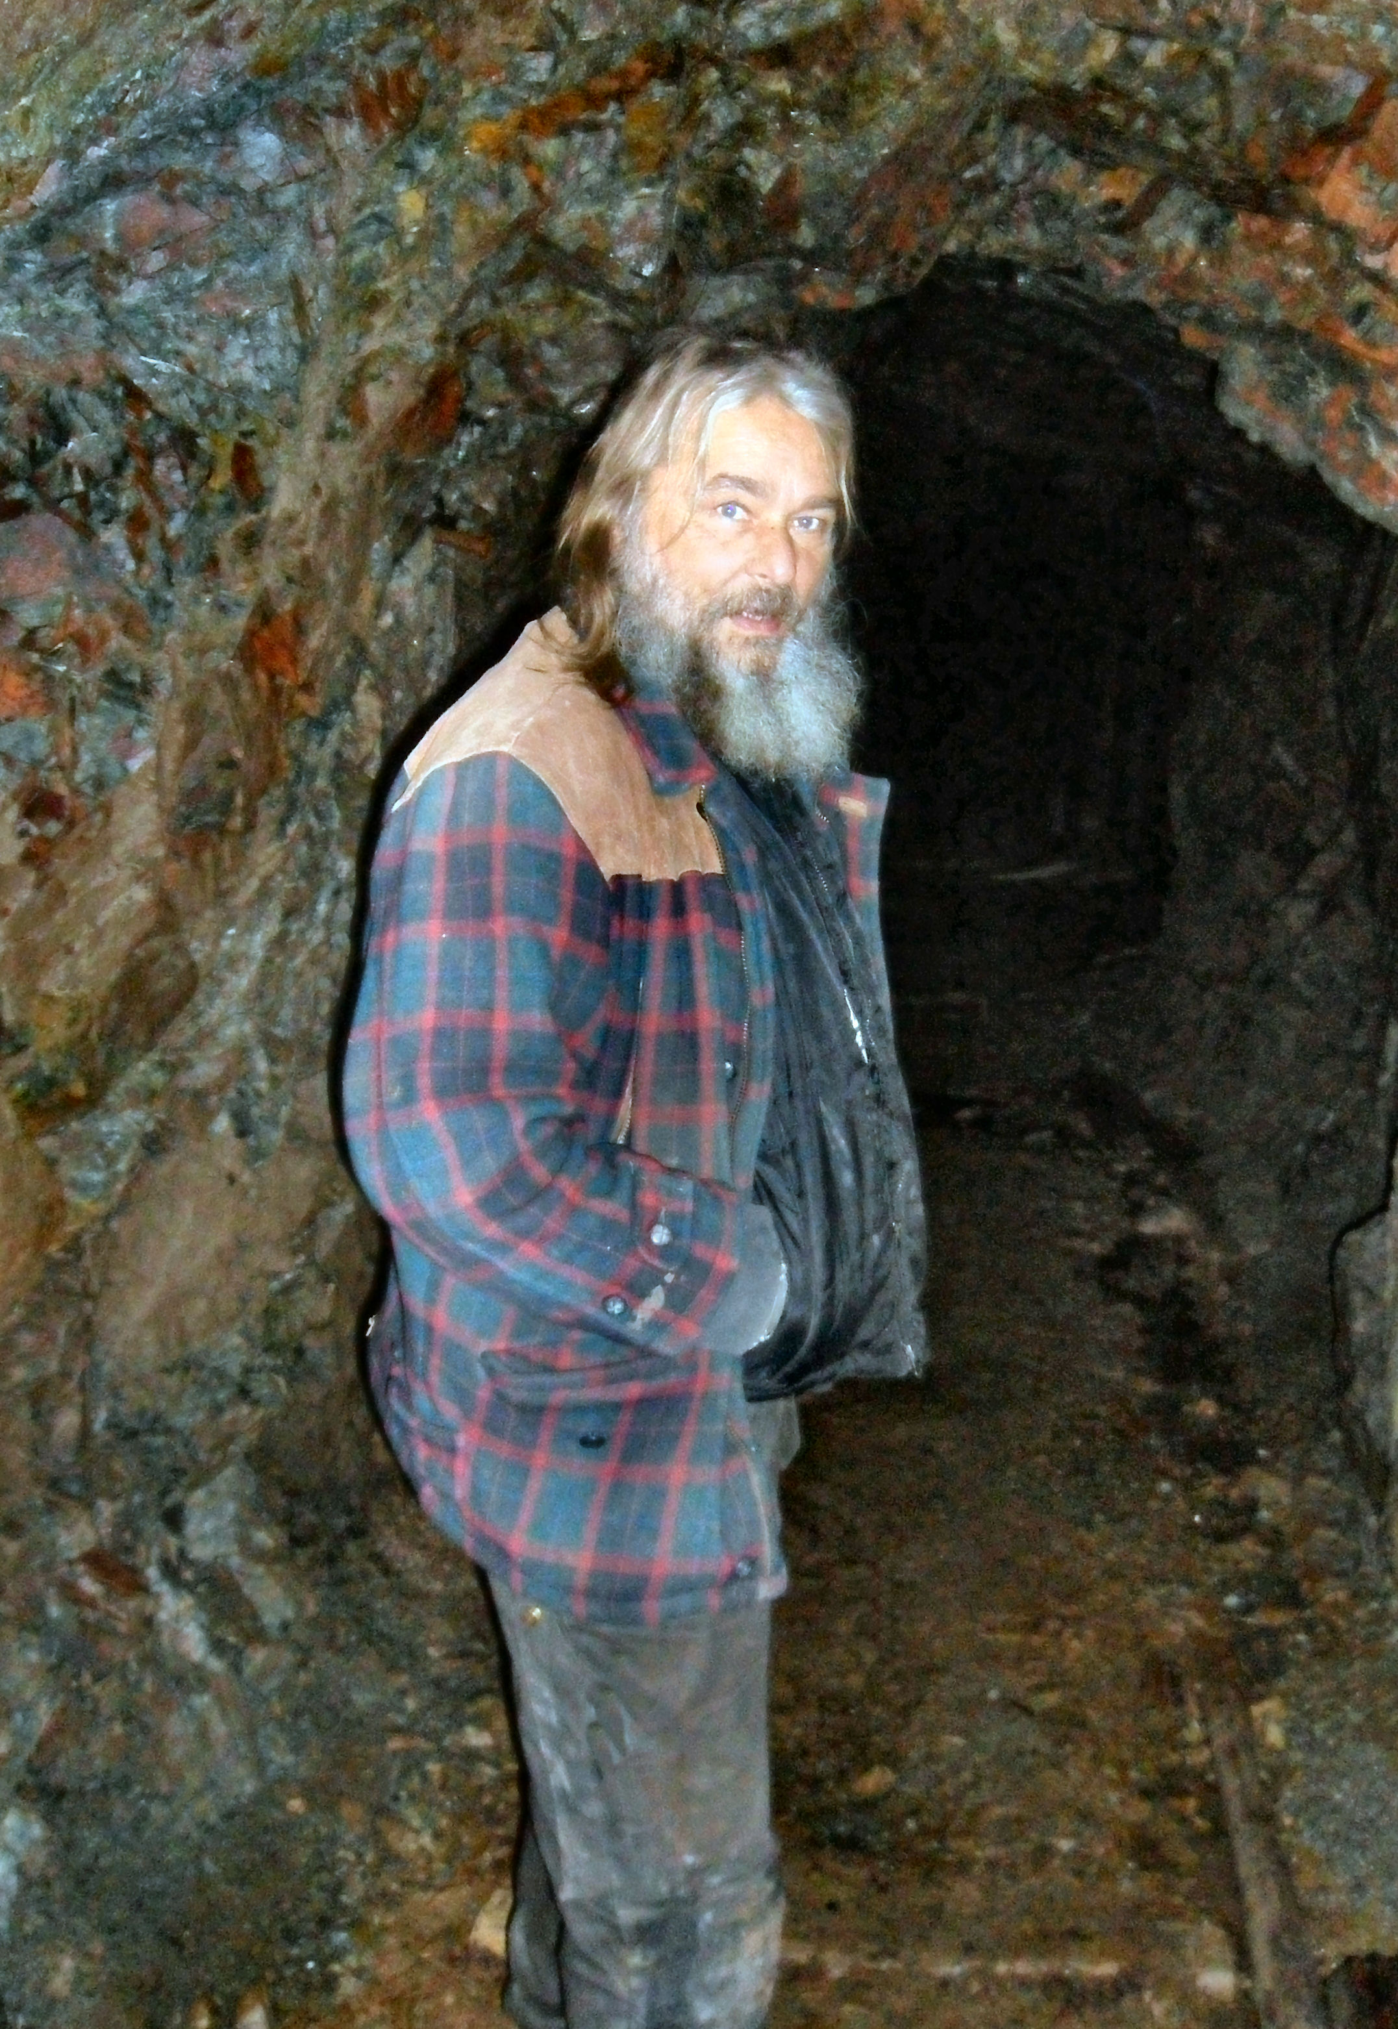

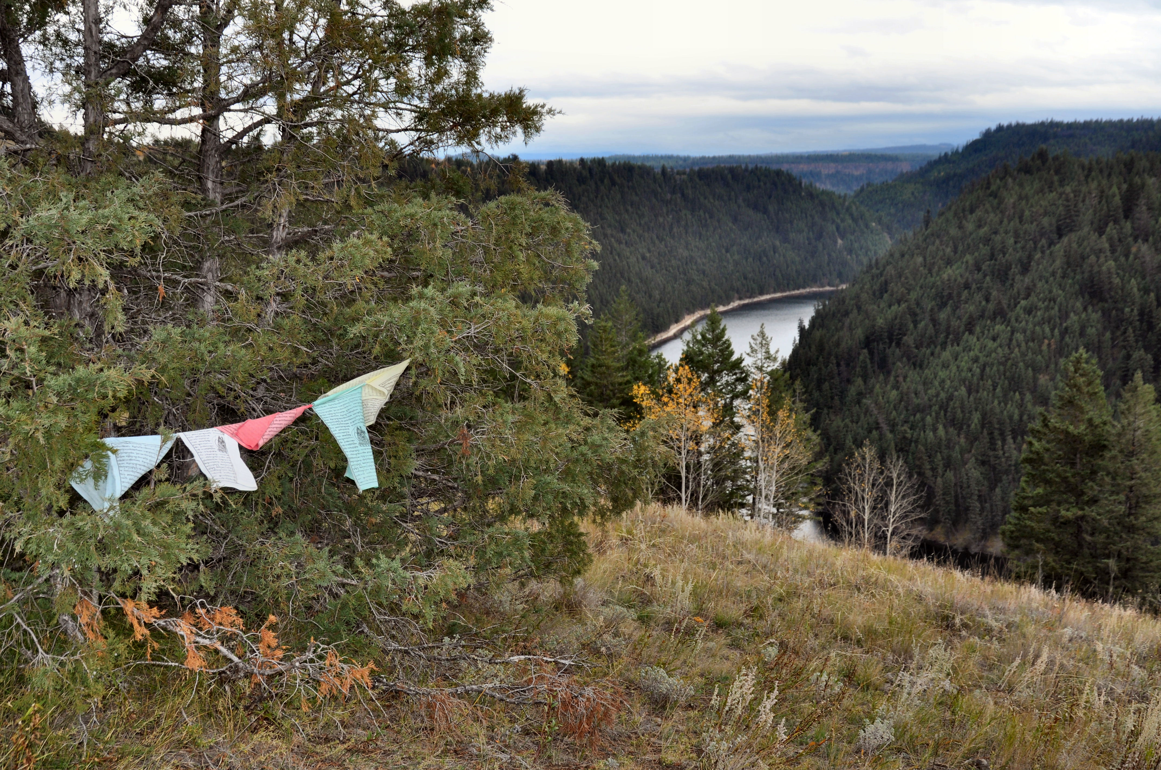

Top: Vidette Lake Resort caretaker Ray Stad explores one of the abandoned mine shafts. Bottom: A Tibetan prayer flag blows in the wind at the site.

