Be sure to make a Stop at the Langley Station

Built in 1915 on a site to the west of where it stands today, the Langley Station’s design was one of the Canadian Northern Railways "third class" plans used by the CN in Western Canada until 1924
In 1918 Canadian Northern became part of Canadian National, and the CN Station was enlarged to accommodate larger living quarters for the Station Agent. From 1918-1929 this agent was Mr. Richard Charles Simpson.
The Station was used full-time until 1972 when it was reduced to a flag stop. Passenger service was completely terminated in 1980 and stood empty for a time.
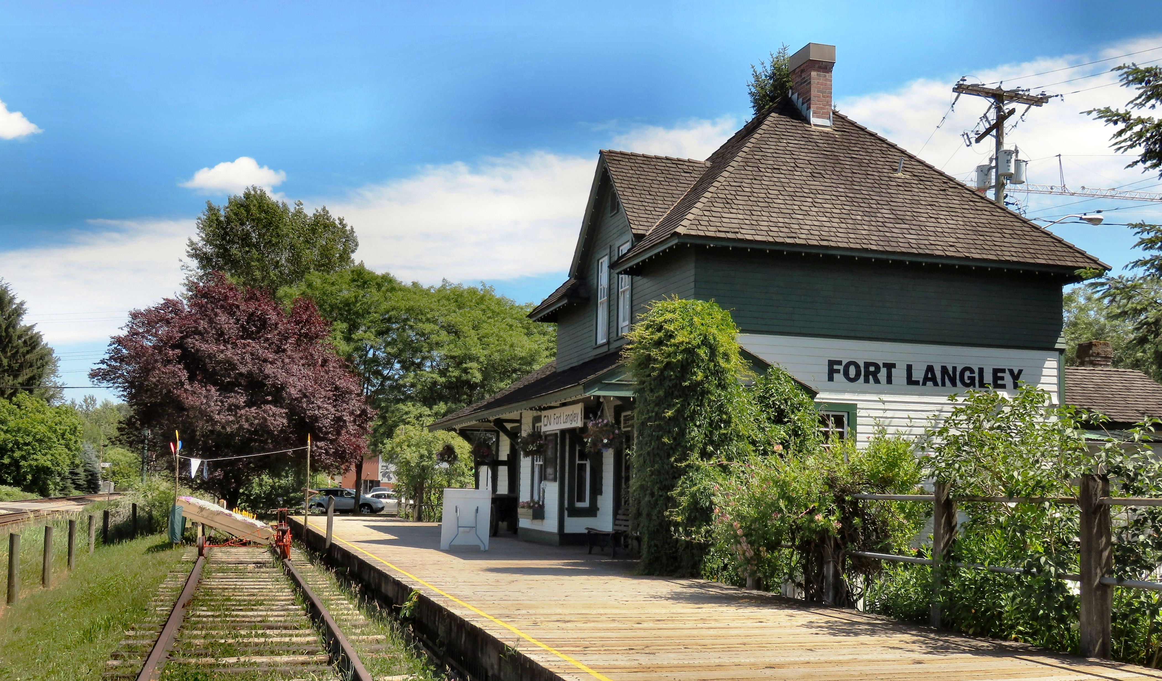

In 1980 passenger service was stopped and a year later the station was declared redundant.

Then in 1983 it was moved to its present location on the corner of Mavis Street and Glover Road in Fort Langley and restored by the Langley Heritage Society in cooperation with the Township of Langley. It was designated a Heritage Site on Feb. 27, 1984.

HOW TO GET THERE – From Hope, take the Trans Canada highway west for 105 km. Follow the 232nd Street exit north off Highway #1. Drive along 232nd Street until you reach the stop sign at Glover Road. Turn right, and continue into Fort Langley. You will see the station on the left on the corner of Mavis Street and Glover Road.

