Learn about generosity from the laird of fintry

Captain James Cameron Dun-Waters (1874-1939) bought a plot of land on Shorts’ Point on the Okanagan in 1908 and over the next 30 years, transformed it into a productive farm and impressive estate.
Named Fintry the small village in central Scotland where Dun-Waters grew up, Fintry Estate consisted of a large Manor House where he lived with his first wife Alice, an octagon-shaped barn where cows were milked, a large orchard, an innovative power generation system that harnessed the power of Shorts Creek and provided electricity to the estate, his own private telephone system and a packing house.
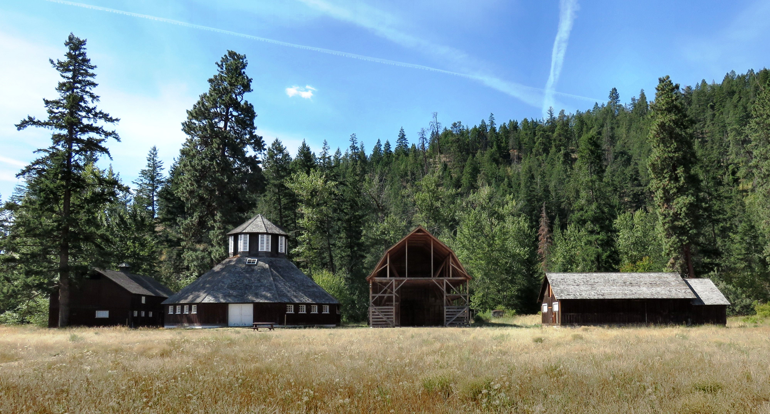

Much of the barn complex has been restored by The Friends of Fintry.

Having no heirs, Dun-Waters sold the estate for one dollar to Fairbridge Farm Schools Society, a philanthropic organization that brought English orphans to Canada and taught them how to farm.
Guided tours of the House and Octagonal barn are offered daily during the summer months. Visitors can discover what life was like for the British Landed gentry.

HOW TO GET THERE – Fintry Provincial Park is located approximately 34 kilometres north of Kelowna and 49 kilometres south of Vernon on the Westside Road along Okanagan Lake.

