a relaxing rest stop at bijoux falls

If you happen to be driving north of Prince George towards Chetwynd, you may want to make Bijoux Falls Provincial Park one of your rest stops. Facilities include picnic tables making it a great picnic lunch stop.
The falls are a series of four cascades with a combined height of 40 metres. They flow between a jagged chasm over horizontal shale. The highest of the falls measures 10 metres.
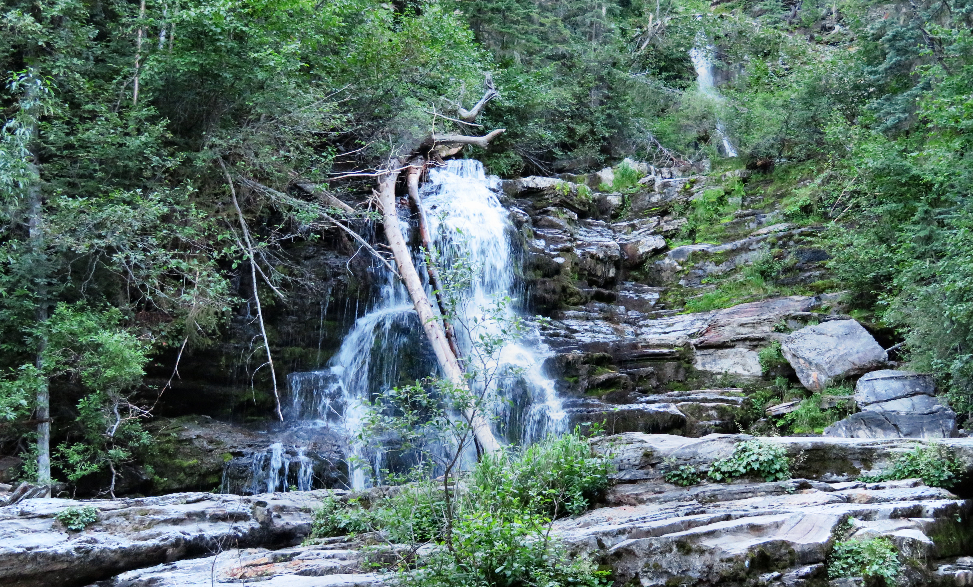

Bijoux Falls in the summer with just a trickle of water flowing over the rocks

If you want to get closer to that falls, there is a trail at the end of the fence where you can descend to the base. It is a bit steep and the rocks can be slippery so proceed with caution.

HOW TO GET THERE – From Prince George drive 188 km north on Highway 97over the Pine Pass and you will see the sign for the falls on the left hand side of the highway. The falls are right beside the parking area.

