Have a waterfall workout at Quality Creek falls

Quality Falls is one of Tumbler Ridge’s most popular waterfalls. A 2.5 km round-trip well groomed hiking trail takes you to a spectacular viewpoint complete with picnic sites. The falls drop 7 meters over a sandstone ledge before flowing through a perfect stone channel that almost looks man made. From the viewpoint continue down the trail and follow a series of switchbacks, walk over two plank bridges and descend down a staircase to get to the base of the falls.
Be sure to bring a swimsuit if you visit in the summer. You can wade through the cool water in the channel then climb up the ledges to enjoy the waterfall close up. I visited the falls with my friend Dariusz and he demonstrated how to do a waterfall workout on a hot day. The rocks can be slippery so use caution.

DID YOU KNOW? On September 23rd the Tumbler Ridge Geopark became a Global Geopark, supported by UNESCO. An application has been sent by the Tumbler Ridge Aspiring Geopark to the Global Geoparks Network to become a member of this network, and for the Tumbler Ridge area thus to become a Global Geopark. Currently there are close to 100 Global Geoparks, including one in North America (Stonehammer) and one in South America (in Brazil). The Global Geoparks Network (GGN) is a UNESCO assisted network established in 1998. Managed under the body’s Ecological and Earth Sciences Division, the GGN seeks the promotion and conservation of the planet’s geological heritage, as well as encourages the sustainable research and development by the concerned communities.

HOW TO GET THERE –To get to Quality Falls take Highway 52 from Tumbler Ridge Visitor Center towards Dawson Creek. Nine kilometres down the road you will see a sign on the highway pointing to a large parking lot. Park there and look for the trailhead sign.

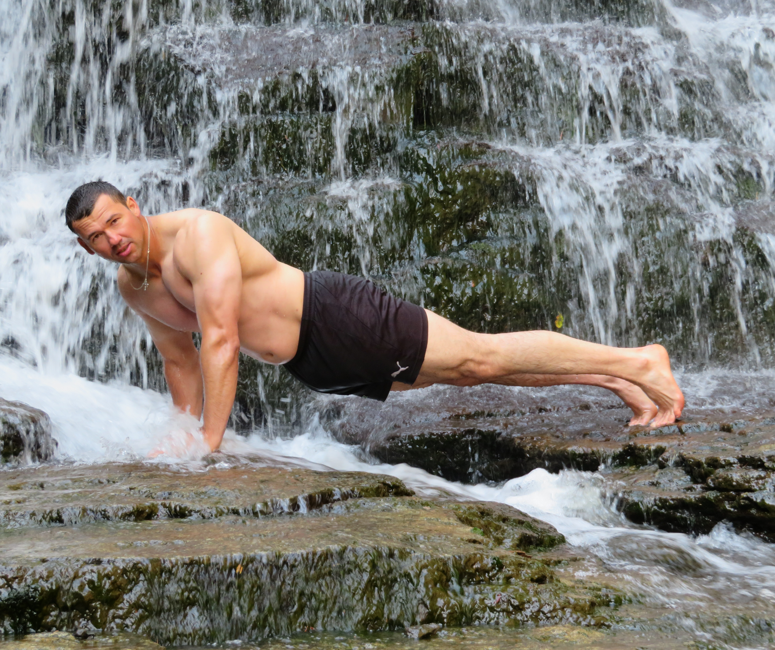

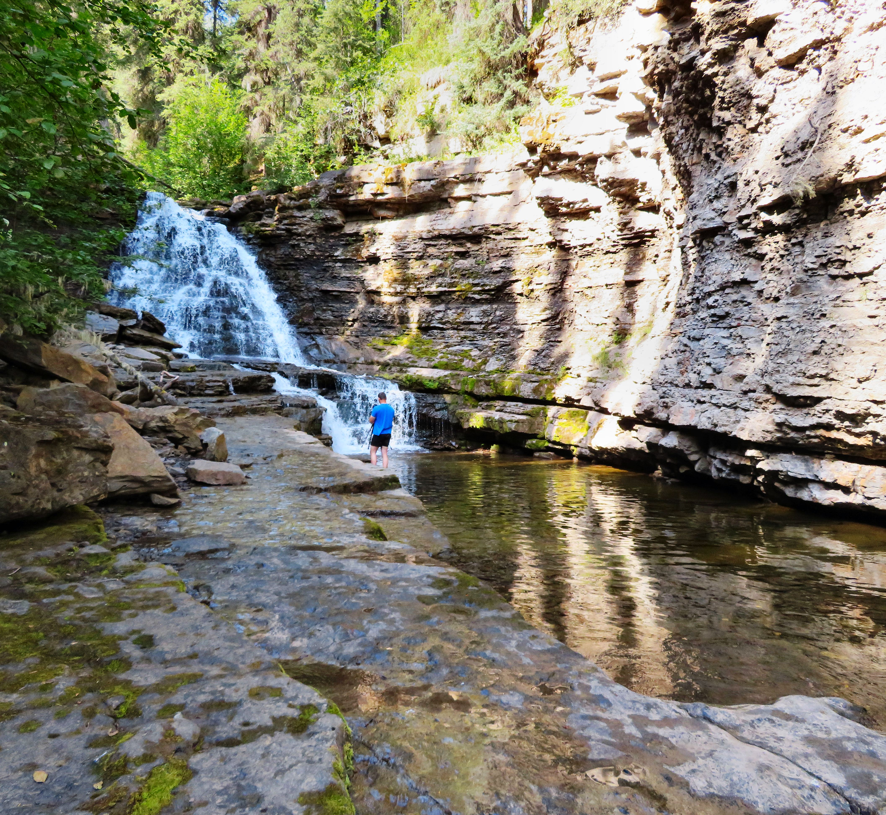

Top: Professional athlete and former Canadian Olympian Dariusz Slowik demonstrates how to workout in a waterfall at Quality Falls. Bottom: The rock carved channel in front of Quality Falls looks man made.

