A Magical Mountain Goat moment at sikanni chief

The dirt road had large potholes and ruts and required a level of skill to get my Toyota Rav 4 through safely. When we arrived at the viewpoint overlooking Sikanni Chief Falls, the frustration of getting there was quickly forgotten. A stony lookout at the edge of a steep cliff provides a stunning view of the falls.
As we admired the water rushing through the narrow channel and crashing into the canyon below, Dariusz noticed a mountain goat walking along the cliff side. Before long we saw two goats and within 30 minutes an entire herd made their way along the rocky cliffs. There were two babies and a few males who proceeded to spar with each other. As we watched the show, we kept saying, “wouldn’t that be awesome if they got close to the falls.”
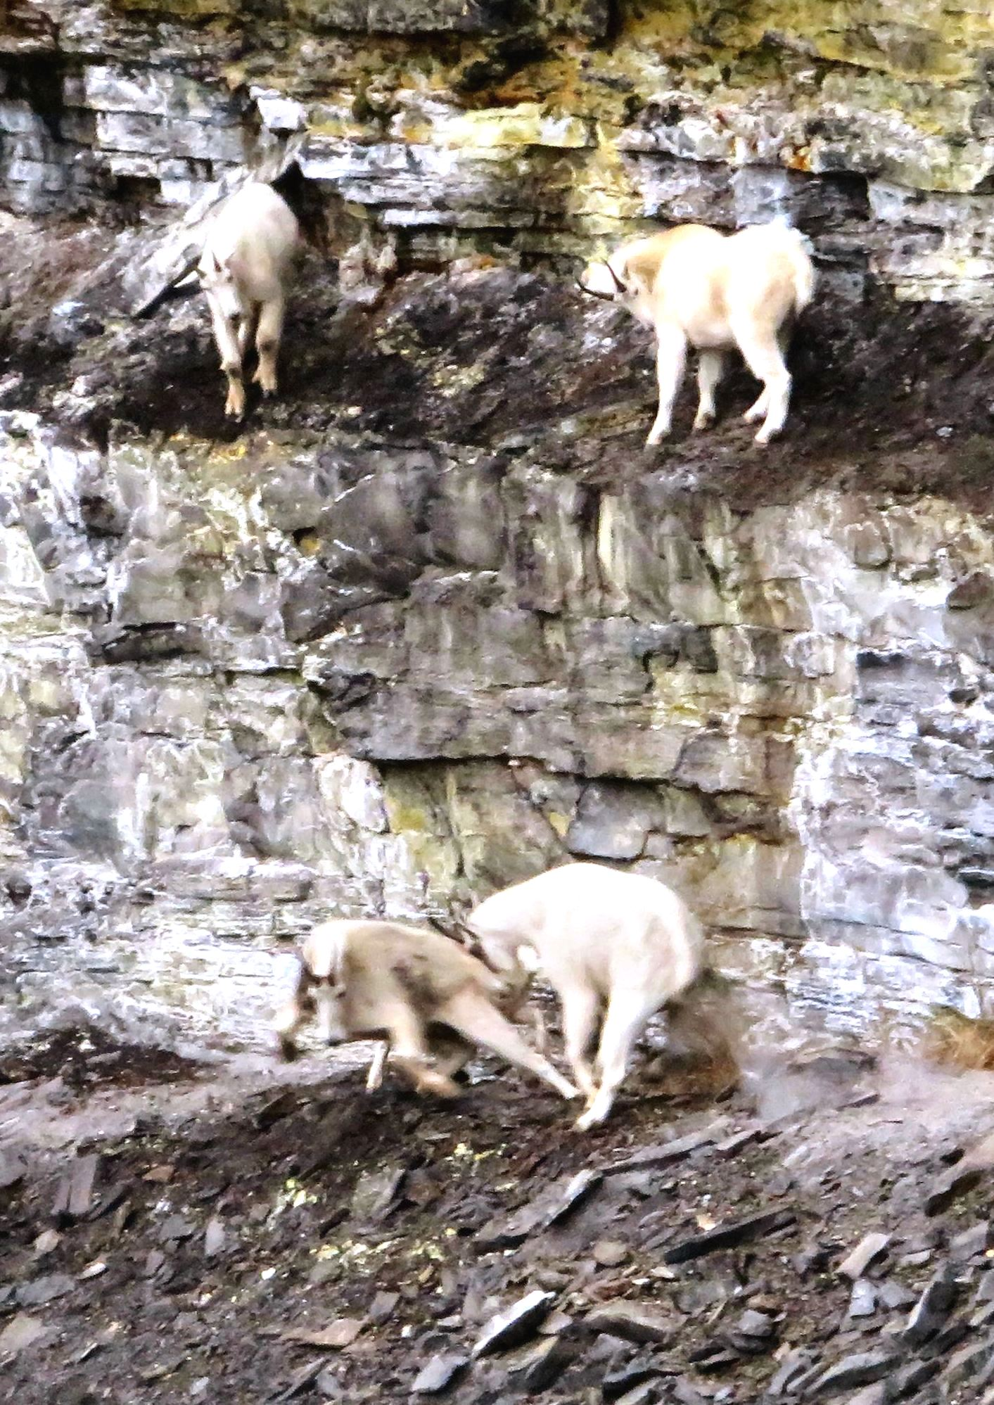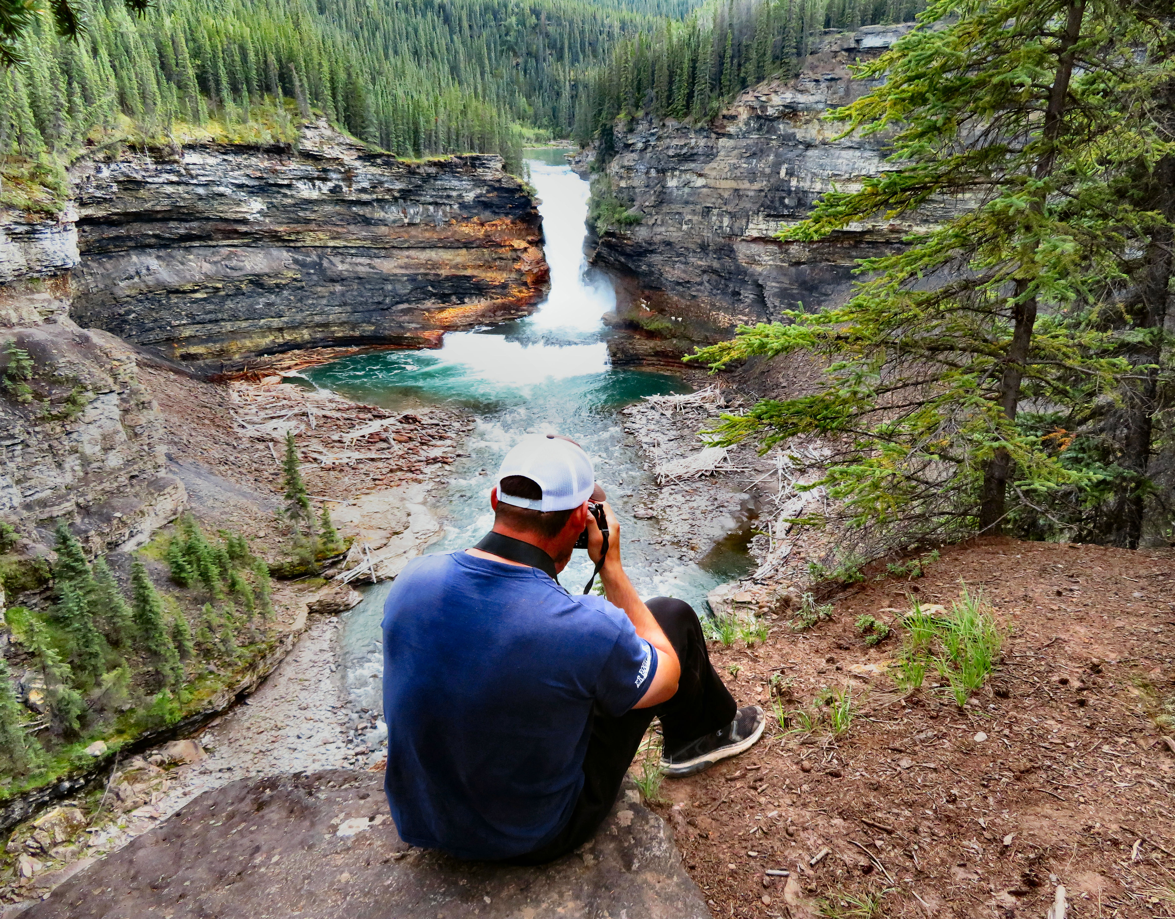

Left: The mountain goats are fighting on the cliff side Right: Dariusz Slowik takes pictures of the mountain goats beside the falls.

Then suddenly the entire herd started to make their way towards the falls. It was like Mother Nature responded to our request. We spent the next hour taking pictures worthy of National Geographic. I can’t promise the herd will be there when you visit, but if you come in the summer around 6pm, you just might see them.

HOW TO GET THERE – From Fort St. John take Highway 97 (the Alaska Highway). At historic mile 162 you will cross a bridge over the Sikanni Chief River. Fifteen kilometres north of the bridge (198km from Fort St. John) turn left onto the Sikanni River Ranch Road. Just beyond km 14 take the left road at the fork for 2.5 km until you see the parking lot. A sign marks the trailhead.

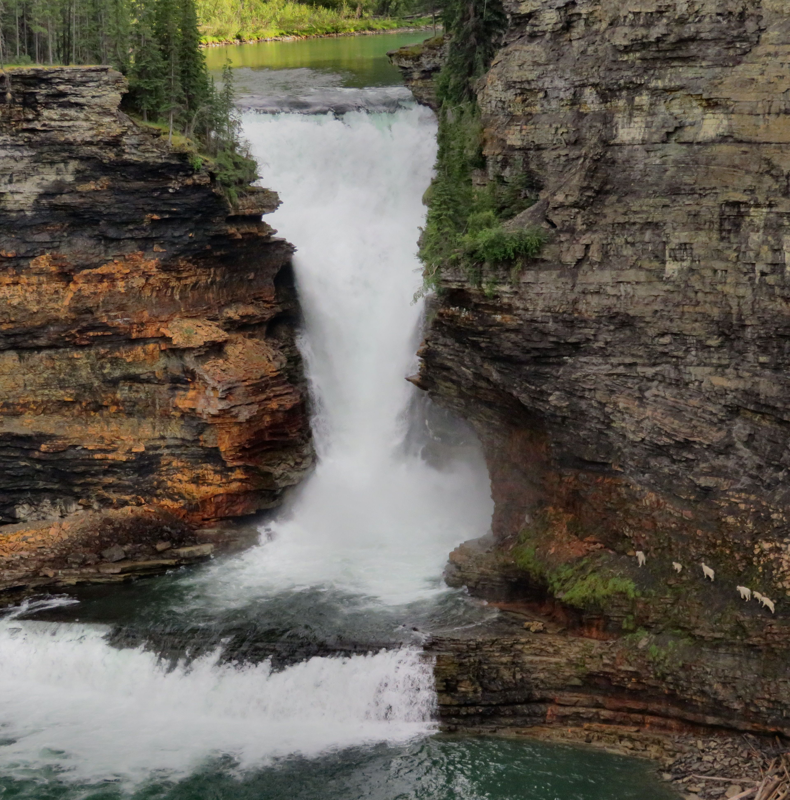

To the right of the falls you can see a herd of mountain goats.

