Paddle or float down the South Thompson river

Discover the best way to spend a hot Kamloops summer day by joining the hundreds of people who float the South Thompson River. To ensure an enjoyable experience you will need:

1. Floating device
2. Cargo Boat – a small plastic dingy
3. Food and Beverages
4. Electric air pump or great set of lungs
5. Rope/Waterproof Flashlight/Whistle
6. Lifejackets
7. Waterproof Camera
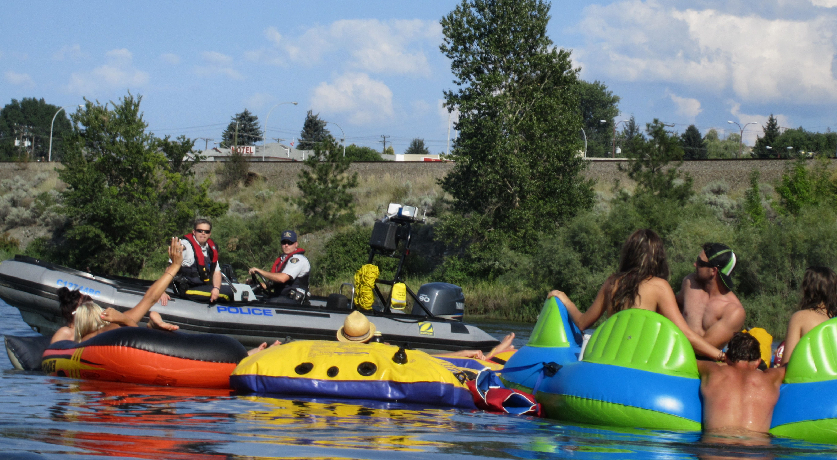

A police boat stops a group of floaters on the South Thompson River to ensure they are complying with the by-laws.

Most of these items can be purchased at Wal-Mart or Canadian Tire at a reasonable price. Be sure to keep food, cameras, etc in waterproof containers and be sure to tie those containers to the raft in case you accidentally flip over.
The Thompson River is the largest tributary of the Fraser River, flowing through the south-central portion of British Columbia, Canada. The Thompson River has two main branches called the South Thompson and the North Thompson. The river was named by explorer, Simon Fraser, in honour of his friend, Columbia Basin explorer David Thompson.

The South Thompson originates at the outlet of Little Shuswap Lake at the town of Chase and flows approximately 55 kilometres southwest through a wide valley to Kamloops where it joins the North Thompson.
While some kayakers will want to start in Chase and make a day of paddling back to Kamloops, most people on inflatable devices prefer a shorter route. The most popular one starts from the boat launch in Valleyview and takes about 4-5 hours to complete.
Start your adventure at Pioneer Park where you will leave one vehicle in the parking lot and load up another vehicle with your equipment and head to the Valleyview Boat Launch. Parking at the launch is reserved for people with boat trailers but you are free to park along Thompson Drive.
Pull out your floating devices and plug the electric pump into the lighter and start blowing up your rafts. Throw your supplies in the cargo boat and carry everything down to the river’s edge. It is here where you will need the rope to tie everything together. Paddle yourselves out into the middle of the river and spend the next four hours floating back to Pioneer Park.
There are a number of sandy beaches along the way if you want to stop for a picnic or go for a dip. And don’t worry, if the weather turns and things get a bit rough, there is no shortage of friendly boaters willing to help you out.
Be aware that there are laws in place that set rules for floating down the river. Alcohol is not allowed unless your craft has an onboard toilet. You are also required to have such safety equipment as rope, a waterproof flashlight, whistle and lifejackets onboard. This applies to inflatable watercrafts as well as boats.
Police boats regularly patrol this waterway to ensure people are complying with the law. So show up prepared, stay safe and have fun.

HOW TO GET THERE – From downtown, drive east along the Trans-Canada highway and turn right on River Road in Valleyview. Just across the railway tracks you will see the Valleyview boat launch.
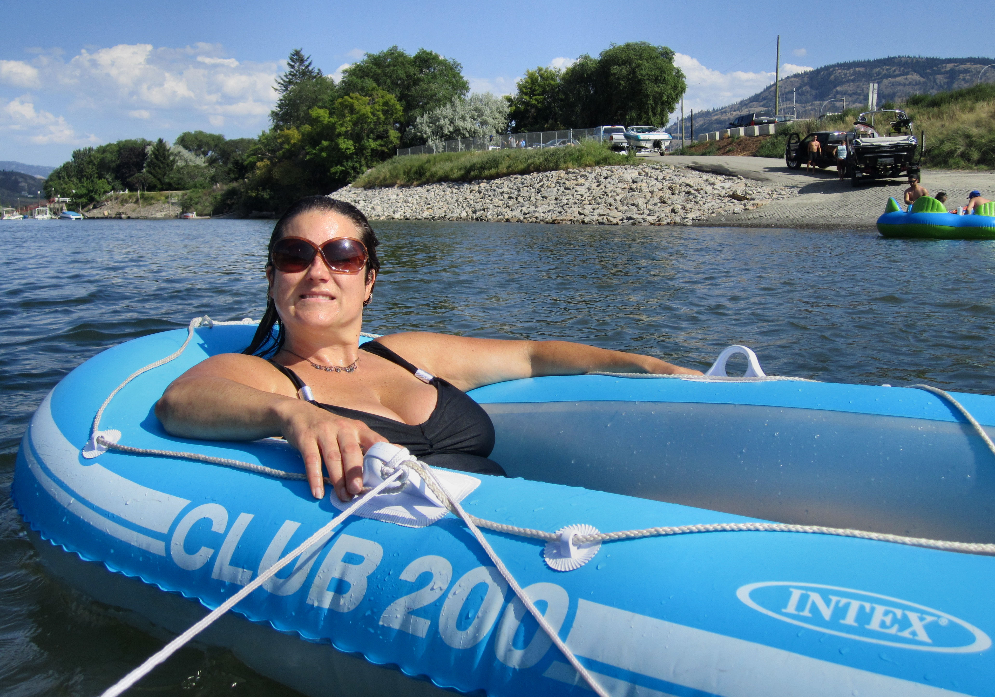

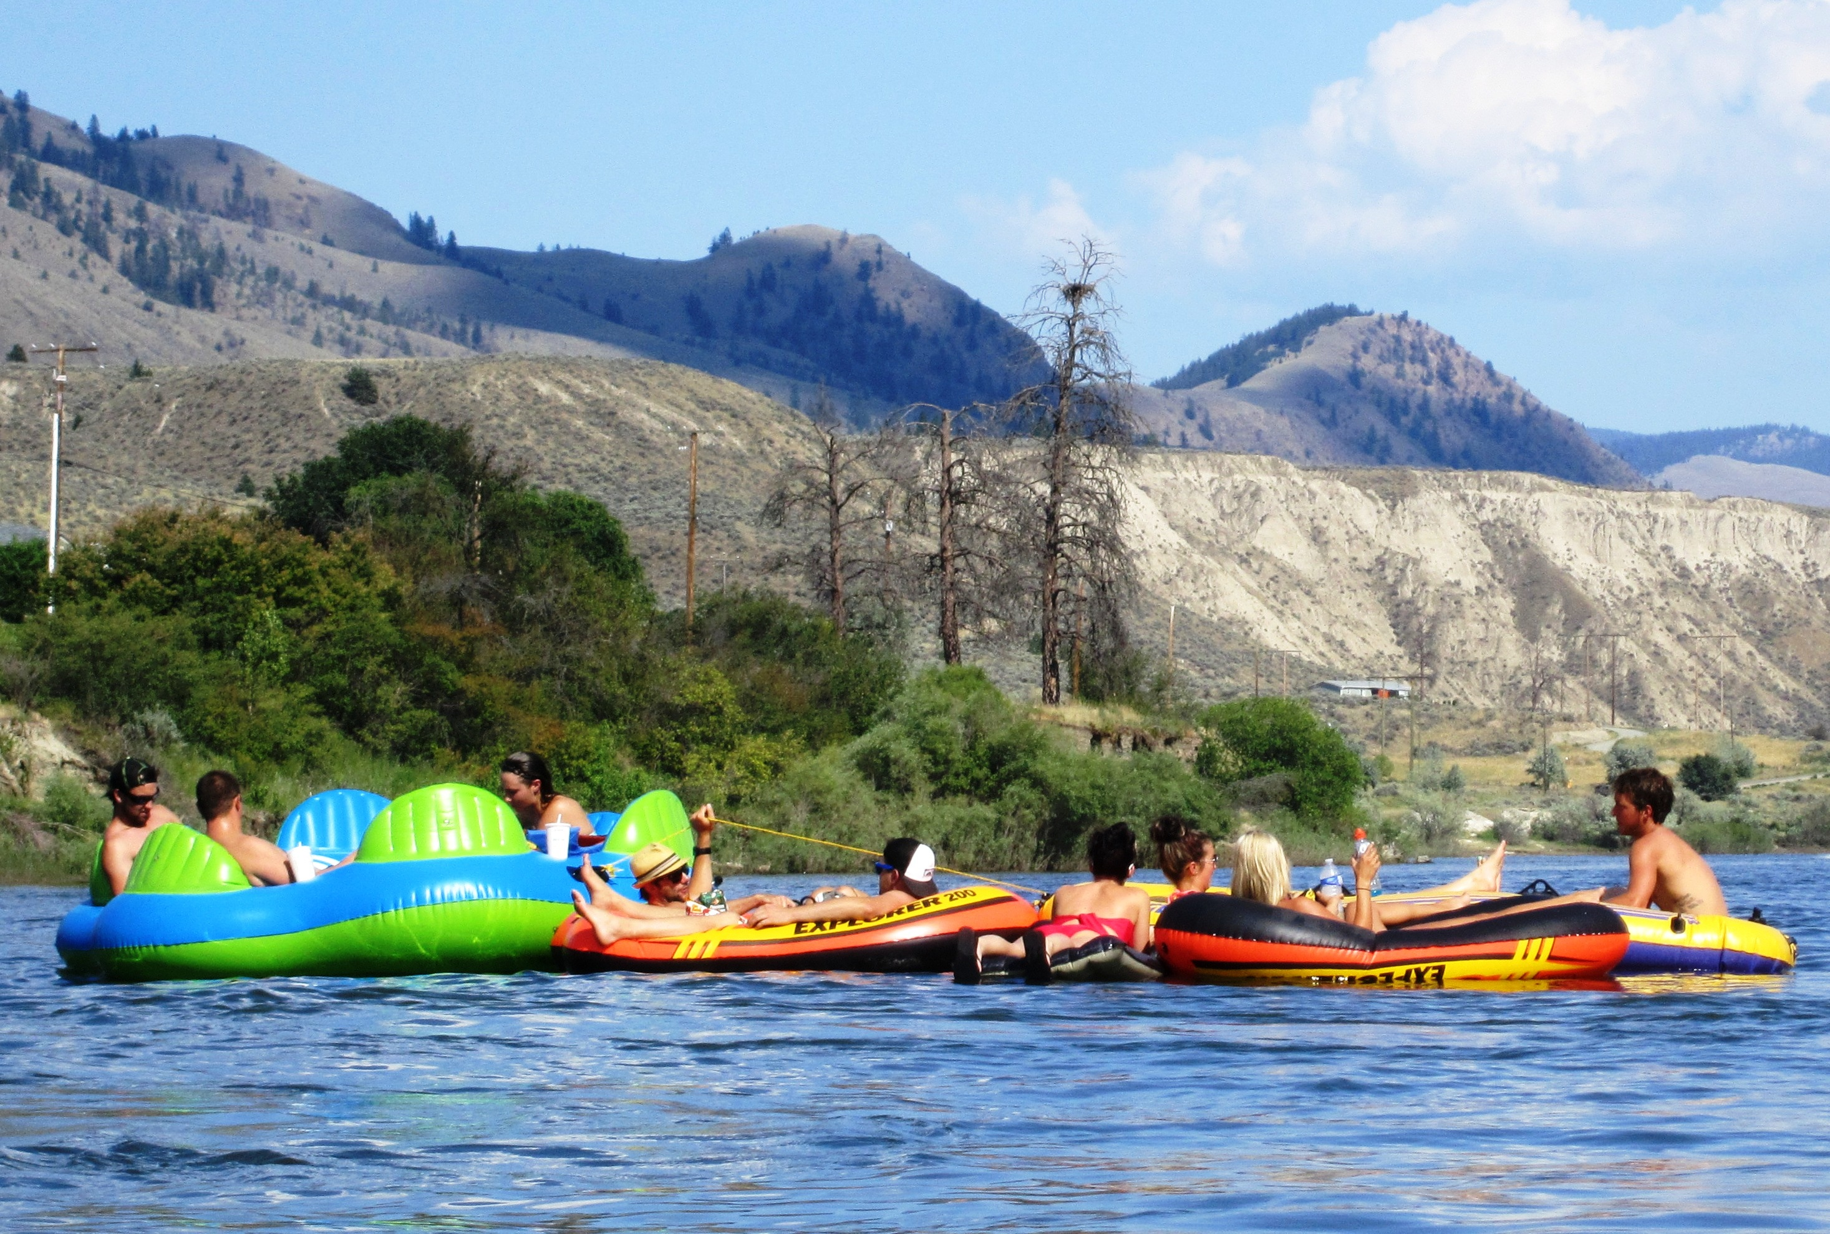

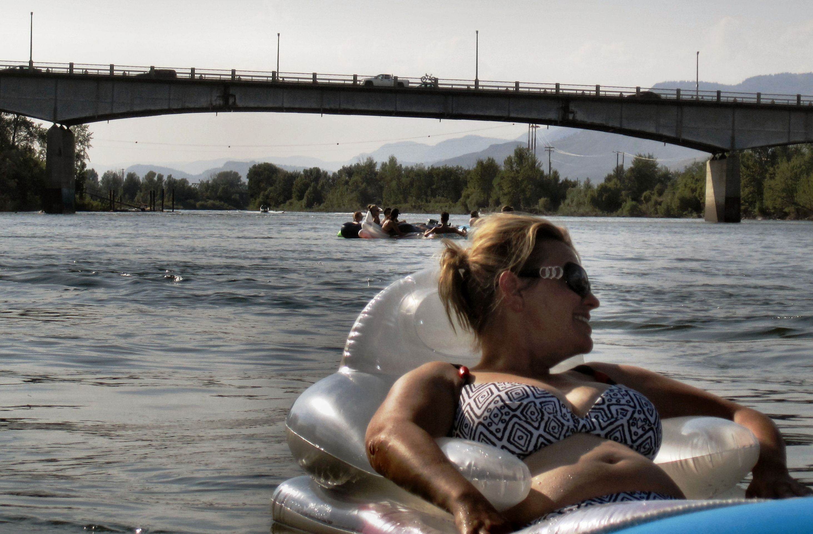

People float down the river in a variety of inflatable devices such as tubes, dinghy’s, mattresses and islands.

