TAKE A TOUR OF THE HILLSIDE WINERY IN NARAMATA

In 1989 Hillside Winery, Lang Vineyards and Wild Goose, lobbied the Provincial Government to pass the Farmgate Winery Policy. This policy allowed small vineyards of five acres or less to not only produce wine but also to sell it directly from their premises. This allowed the B.C. Wine Industry to grow and flourish and become the tourist attraction that it is today.
The industry in the Naramata area quickly turned from primarily orchards to primarily vineyards as a result. In fact, the Hillside vineyards were once an apricot orchard. The original farmhouse stood on what is now the tasting room. The last surviving apricot tree remains on the bank at the northeast side of the building
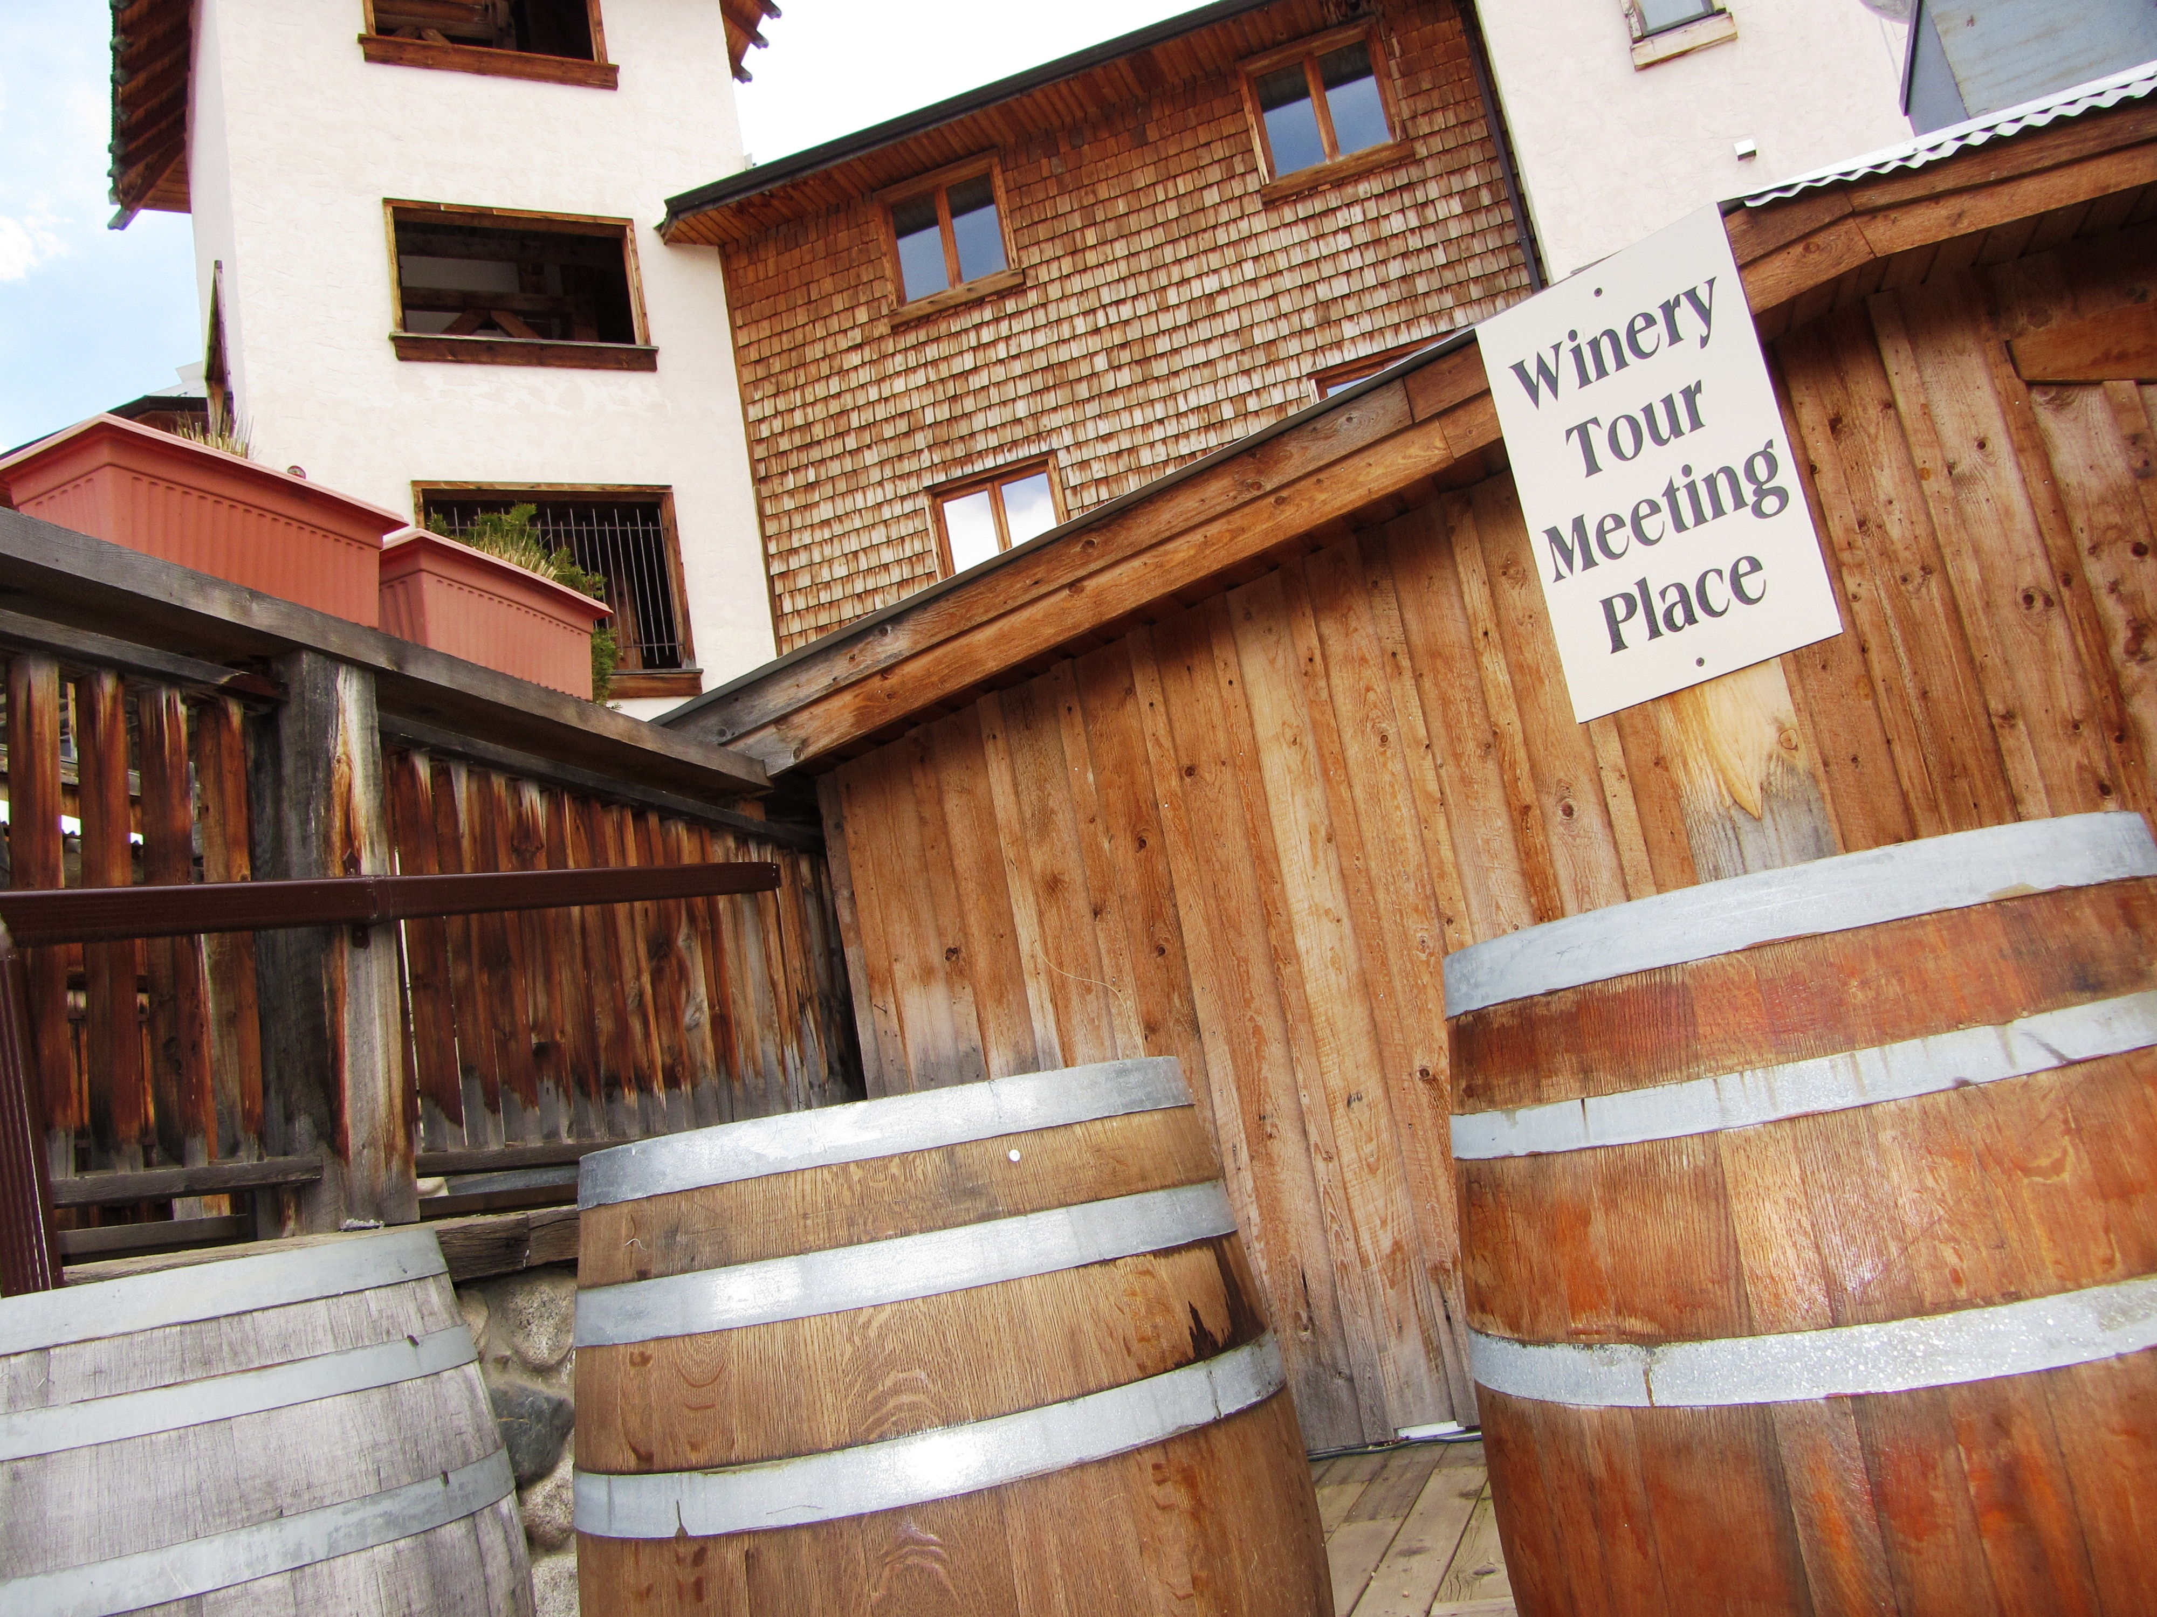

Hillside was the first winery designed by architect Robert MacKenzie back in 1997.

The unique winery building dominates the view on Naramata Road. Not only is the 72 foot tower architecturally stunning, it also acts as a ventilation shaft that helps to cool the winery cellar in the hot summer months. The four dark Douglas fir beams that hold up the roof of the Bistro were logged off Vancouver Island in the late 1800s and supported the roof of Acklands Hardware on Granville Island in Vancouver for almost 90 years.

HOW TO GET THERE – Hillside Winery is located at 1350 Naramata Road in Penticton. From Kamloops drive to Penticton on highway 97 and turn left onto Eckhardt Ave and follow the signs to Naramata Road.
