Stroll Across the
Historic Alexandra Bridge

Next time you drive across the Alexandra Bridge in the Fraser Canyon, stop at the Alexandra Bridge Provincial Park and learn about its predecessors.
The original Alexandra Bridge named after Princess Alexandra of Wales was constructed in 1861 by Joseph Trutch, the Commissioner of Public Works for the Colony of British Columbia as part of the development for the Cariboo Road. Built using native and Chinese labour, Trutch contracted the job privately and built a toll for remuneration.
Destroyed by Fraser Flood of 1894, the remains of the original bridge were dismantled in 1912 but the bridge was not rebuilt as the Cariboo Road had been abandoned as a result of the Canadian Pacific Railway opened in the 1880’s.
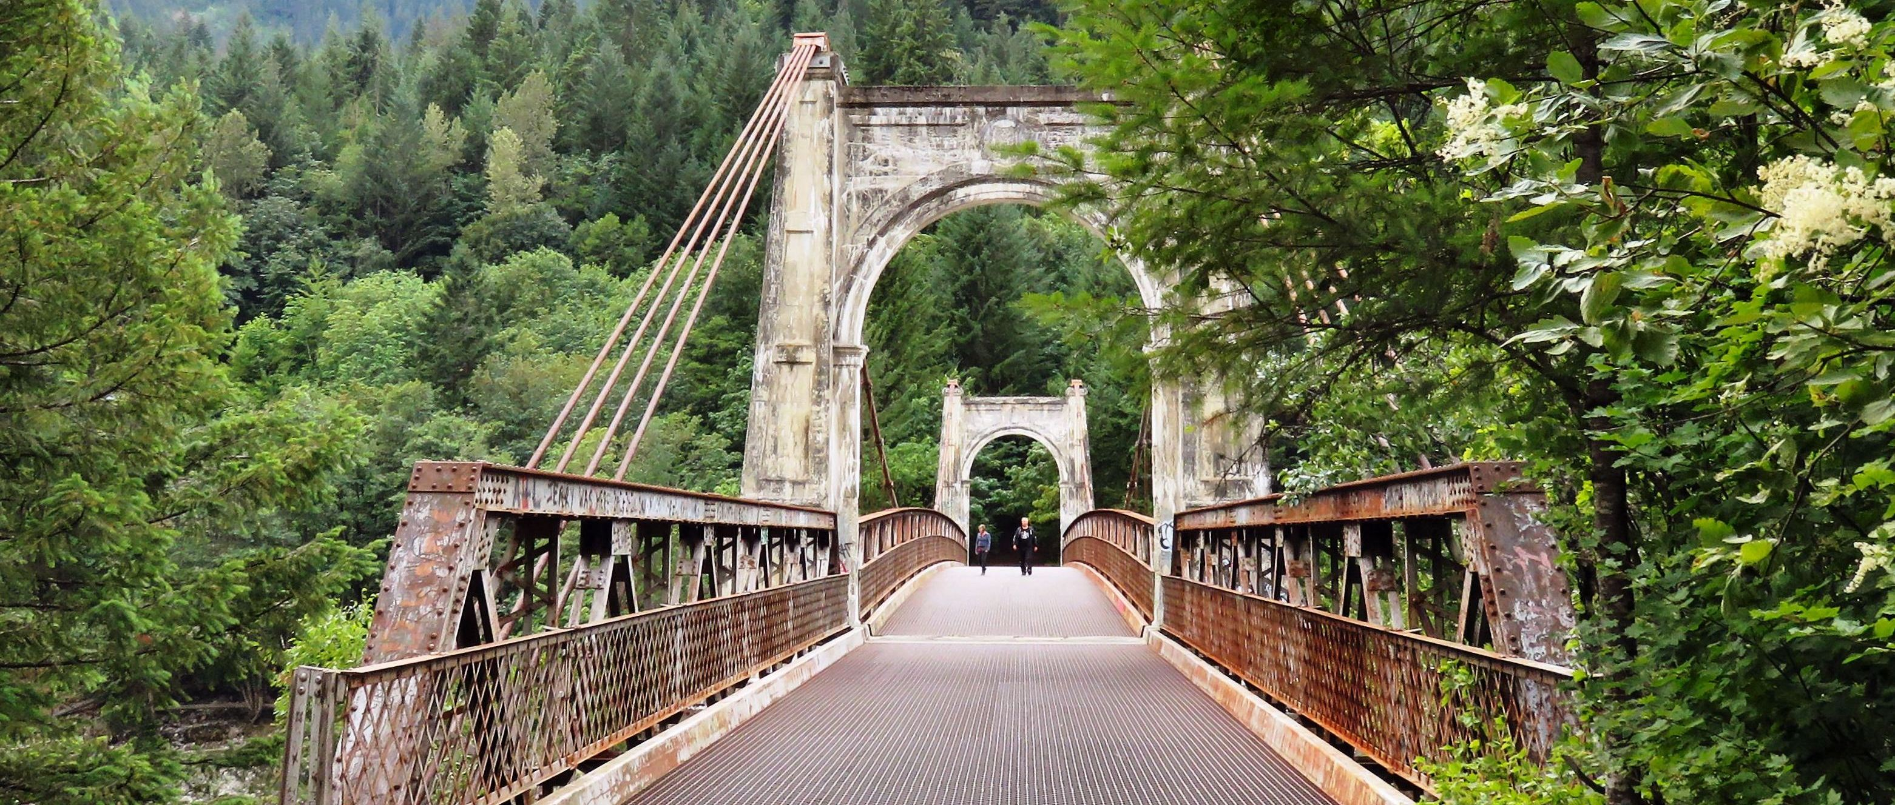

The current Alexandra Bridge was built in 1926 but ceased being used for automobile traffic in 1964.

With the dawn of the automotive area came a renewed interest in road construction and the Fraser Canyon’ re-opened to road traffic in the 1920’s with the new Cariboo Highway. In 1926, a new Alexandra suspension bridge was built on the original footings and still exists today although it was closed to automobile traffic in 1964. The new Alexandra Bridge was completed by the Ministry of Highways in 1964. Lovated two kilometers downstream of the original, it uses a high truss-arch span the cross the canyon.

HOW TO GET THERE – Alexandra Bridge Provincial Park is located in the Fraser Canyon approximately two kilometres north of Spuzzum and 40 kilometres north of Hope on the Trans Canada Highway.

