FOLLOW THE GIANT WINE BOTTLE TO POPLAR GROVE

Founded in 1993, Poplar Grove was one of the original five wineries on the Naramata Bench. It was purchased by Tony and Barbara Holler in 2007. Their sons, Matthew and Andrew, manage the 100 acres of vineyards that allow Poplar Grove wines to be made from 100 per cent estate grown grapes
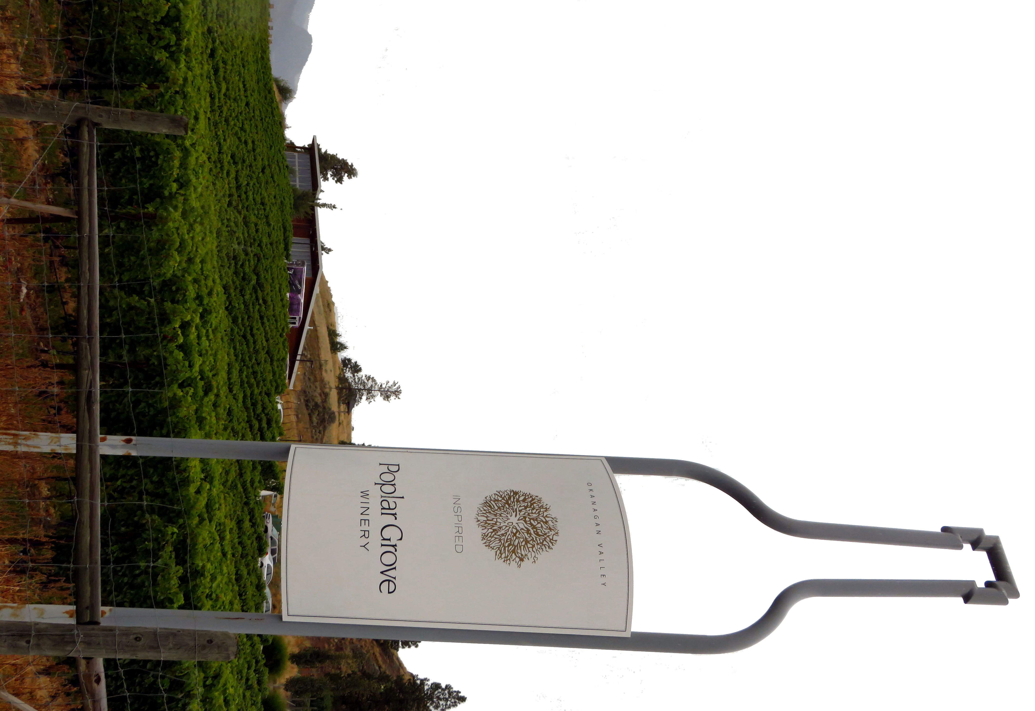
They focus on six core wines: Chardonnay, Pinot Gris, Merlot, Cabernet Franc, Syrah and a signature blend called The Legacy. Poplar Grove believes it takes patience to make truly great wines. This belief inspired their barrel aging and bottle cellaring program. The white wines are released the year following harvest to preserve the primary fruit flavours. The red wines spend a minimum of 18 months maturing in French Oak barrels and an additional 18 – 30 months developing in the bottle so that they are ready to be enjoyed upon release.
On July 1st, 2011, the doors to Poplar Grove’s brand new, 9500 square foot, state-of-the-art winery opened. The new building is home to a working winery, a showcase barrel hall, and an expansive tasting room.
While visiting, you may want to stop for lunch at The Vanilla Pod. The cuisine style is focused on local and seasonal ingredients including fresh herbs which in the summer months are picked from the herb garden next to the restaurant.

HOW TO GET THERE – Poplar Grove Winery is located at 425 Middle Bench Road North Penticton. From Kamloops drive to Penticton on highway 97 and turn left onto Eckhardt Ave and follow it as it turns into Upper Bench Road. Turn right on McMillan Ave and then left onto Naramata Road and follow the signs for Poplar Grove.

You can’t miss Poplar Groves big bottle sign.

