A CHRISTMAS TREE CUTTING WINE TASTING GOOD TIME

Is your family in need of a new Christmas tradition? Why not make cutting your own tree and sampling fine wines your new family ritual this holiday season?
Long-time Kamloops residents John and Debbie Woodward along with their three sons have transformed their Christmas tree farm into a “Private Heaven” by diversifying into a boutique winery and vineyard appropriately named Privato.
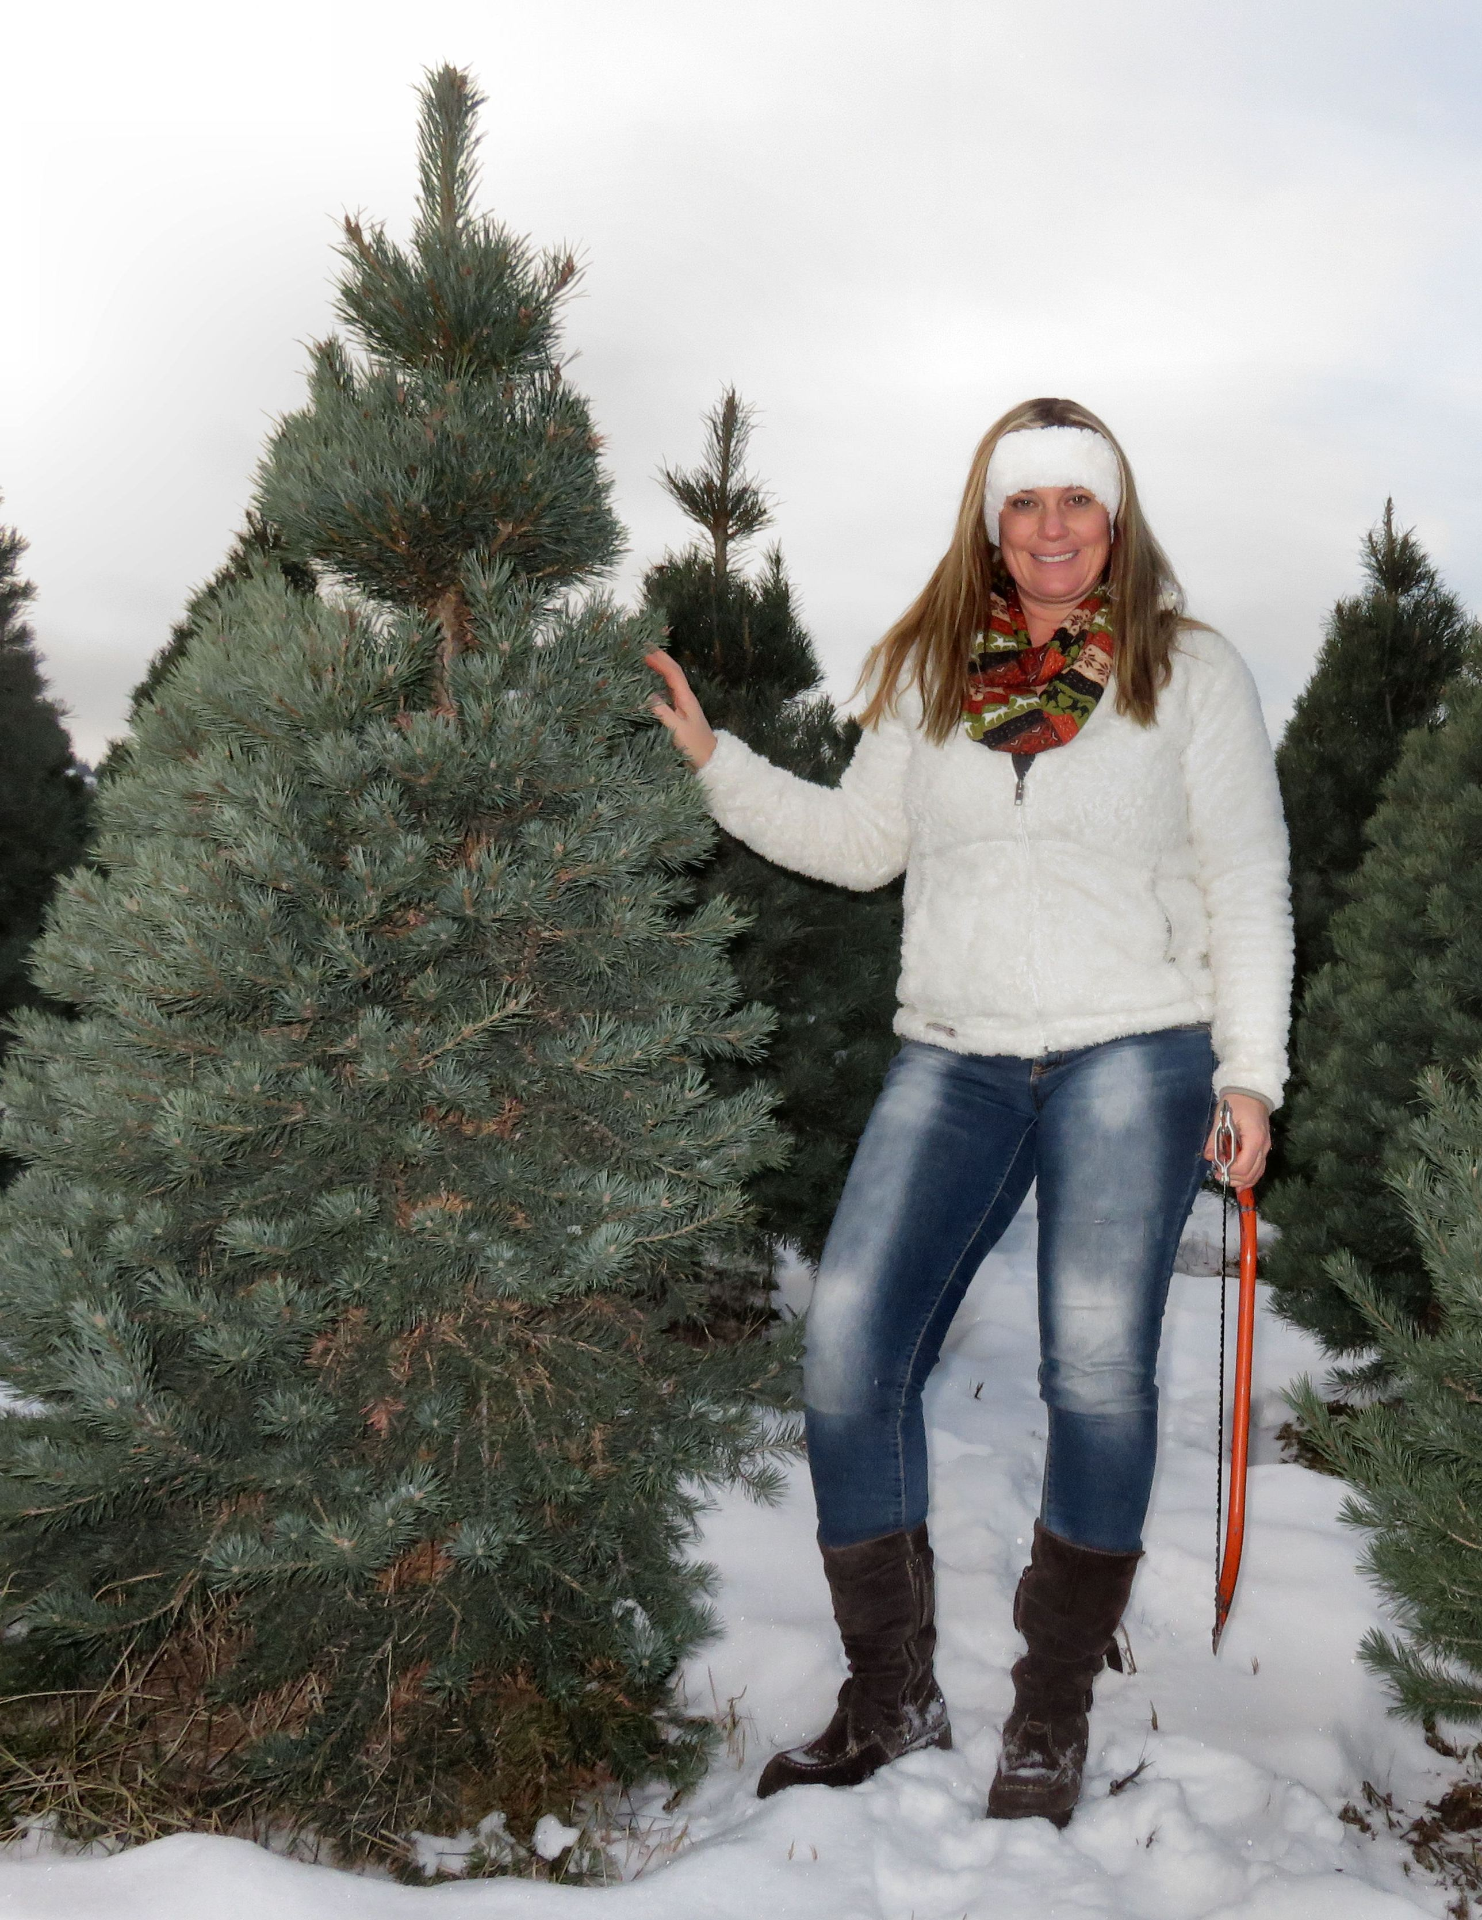

.

Teresa the Traveler hunts for the perfect Christmas tree.

From late November until Christmas, Privato opens up its wine tasting room and hosts weekend tree-cutting events at the farm. From 10 am until 4pm every Saturday and Sunday Privato Winery and Vineyard in association with Woodward Christmas Tree Farm offers activities that will make the entire family merry this holiday season.
Start your adventure on a hay ride into the tree farm where you can pick out and cut down your own Christmas tree. Afterwards you can warm up around the bonfire and enjoy a snack from the concession before heading into the wine tasting room and sample their exclusive selection of award winning Chardonnay’s and Pinot Noir’s.
What sets Privato apart from other wineries is their aging process. Their wine is aged in oak barrels, a practice only used by about 2% of the world’s wine market due to the length of time and hence expense of the process.
Aging in oak typically imparts desirable vanilla, butter and spice flavours to wine. The use of oak has been prevalent in winemaking for at least two millennia, first coming into widespread use during the time of the Roman Empire. Today many wineries use oak wood chips instead for aging wine more quickly while still adding the desired woody aromas and vanilla flavours.
Once aged in oak from 7-18 months depending on the type of wine, Privato wines are bottled and then aged for an additional year before being released to market.
While they are considered a small winery as far as their yearly output, their focus is on quality and not quantity. They have achieved that goal winning the Silver Medal in Wine Align's National Wine Awards of Canada 2013 for their 2011 Chardonnay and Bronze Pinot Noir at the 2014 All Canadian Wine Championship Awards.
With over 200 wineries participating and over 1300 entries, this was a much celebrated victory for their Pinot Noir.
So mark it on your calendar and this year have a holly jolly Christmas and do some merry making at Woodward Christmas Tree Farm and Privato Vineyard and Winery.

“Crafted only in small quantities, PRIVATO creates premium-quality, single-vineyard Burgundy wines. We distribute to a niche of fine restaurants and wine aficionados who love and appreciate the intricacies of a well-crafted wine. We hope that as you enjoy a glass of PRIVATO you will be reminded that you are experiencing your own private heaven."

HOW TO GET THERE – Head down Westsyde Road just past the Dunes Golf Course and you will see the signs for Privato on the right hand side at 5505 Westsyde Road. For more information call 250-319-0919 or find them online at private.ca. You can also follow Privato Vineyard and Winery and Woodward Christmas Trees on Facebook.

Top: The cellar where wine is aged in oak barrels. Middle: Debbie Woodward offers Teresa the Traveler a glass of their award-winning Chardonnay. Bottom: Their resident reindeer keeps the Christmas Trees fertilized and trimmed.

