sneak a quick peek at Canary Falls

Just before you reach Kinuseo Falls you will see a sign for the Lake Joan and Canary Falls Trail. This is a great pit stop on the way to the main attraction. You can do the entire 2 kilometre return loop to see the lake and the falls or you can just go ½ km to the falls.
In the 1930s, this lake was named Lake Joan by Ted Chambers, one of the Trailblazer Crew for the Monkman Pass Highway. He named it for his tiny infant daughter Joan, who at the time could fit neatly into a shoe-box. Photographs taken by Chambers in 1937 conclusively show that this lake is Lake Joan, and the falls on the creek that enters it are labelled Canary Falls. Over time the lake became known as Jade Lake, presumably a descriptive term for its colour, and this is how it is shown on topographical maps. It was officially renamed Lake Joan in 2008.
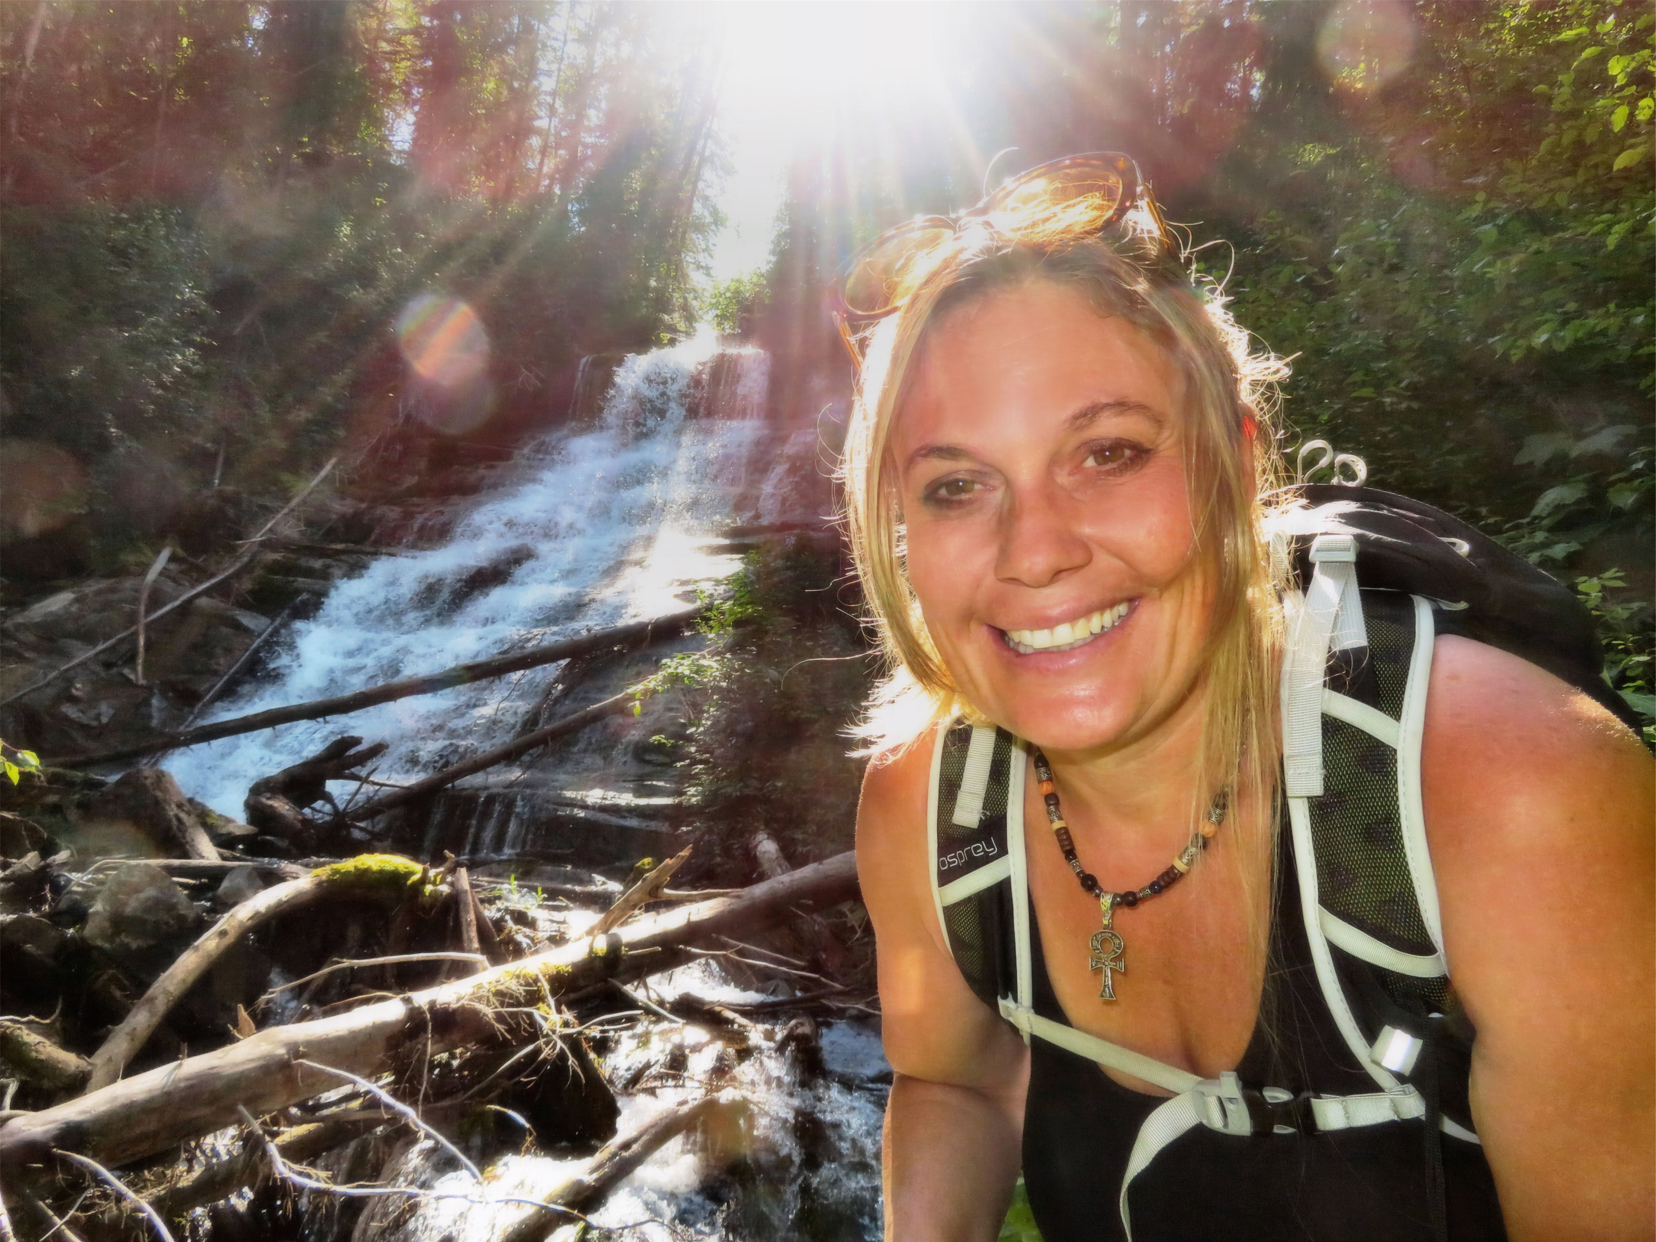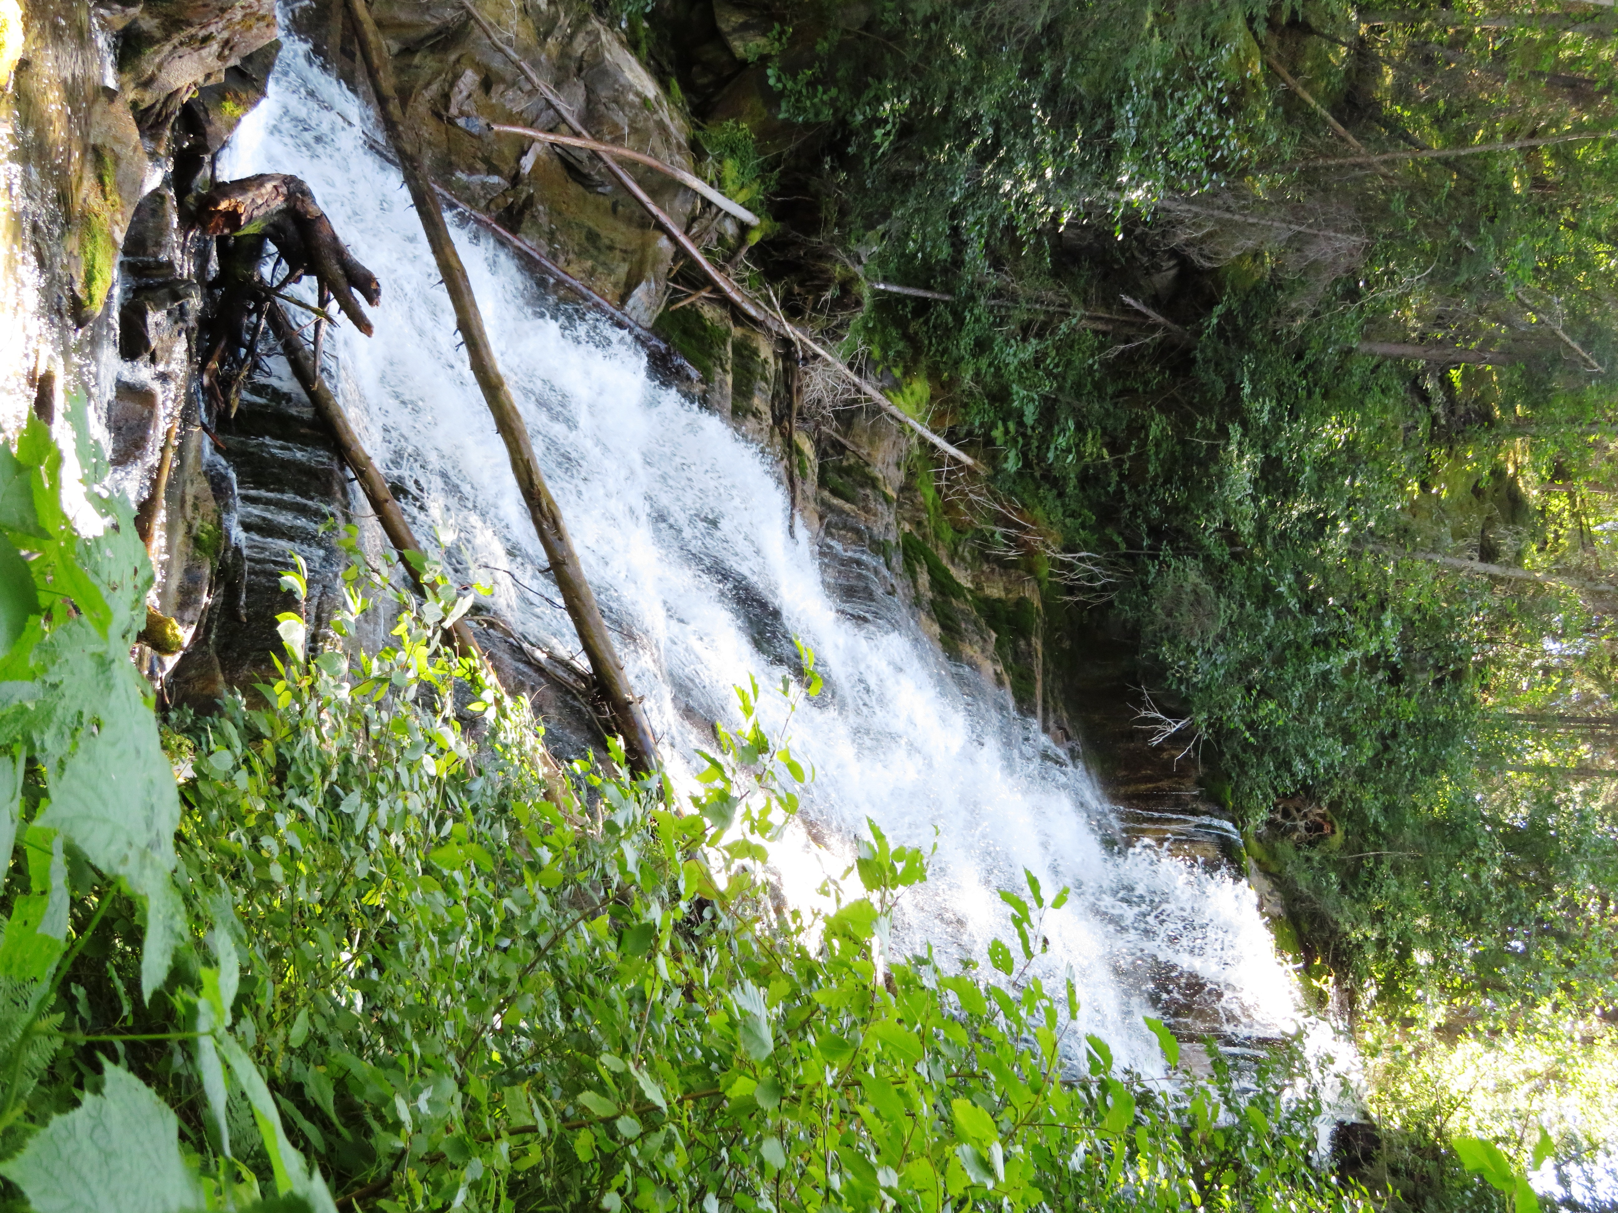

Me posing in front of Canary Falls on a sunny summer day

DID YOU KNOW? Alexander Monkman was hired by Bredin and Cornwall to become the trading post manager at the new Grande Prairie site. In 1922, while looking for tungsten in the Rocky Mountains, Monkman discovered a pass that would later be named in his honour. He died on September 26, 1941and his legacy now lives on in British Columbia's Monkman Provincial Park and Monkman Falls

HOW TO GET THERE – From Tumbler Ridge drive south on Highway 29 for 13.5 km and then turn right onto the Murray River Forest Service Road. Stay on the main road for 39 km and you will see the parking lot for the Stone Corral on your left. Park there and walk across the road to the Lake Joan and Canary Falls Trailhead.

