|  |  |  |  |
| --- | --- | --- | --- |
| **YOUR TOP WINE PICKS** | | | |
| **NAME OF WINE** | **WINERY** | **YEAR** | **COMMENTS** |
|  |  |  |  |
|  |  |  |  |
|  |  |  |  |
|  |  |  |  |
|  |  |  |  |
|  |  |  |  |
|  |  |  |  |
|  |  |  |  |
|  |  |  |  |
|  |  |  |  |
|  |  |  |  |
|  |  |  |  |
|  |  |  |  |
|  |  |  |  |
|  |  |  |  |

# VOLCANIC HILLS

2015 Pinot Noir Ice Wine  
13.2% alcohol  
100% estate grown, it is bursting with aromas and flavours of strawberries, honey, tangerine, lemon, and spices.

# SUMMERHILL PYRAMID WINERY

2015 Organic Riesling   
11.2% alcohol  
Notes of orange blossom, white peach, and ripe citrus fruits

OUTSHINERY-ElephantIsland-Apricot-max.jpg

# LUNESSENCE

2014 Pinot Blanc Late Harvest  
9% alcohol  
Fresh citrus bouquet with s hint of apples and peaches.

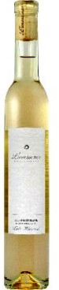

Previous to writing this book I was not much of a wine drinker. I would buy the occasional bottle of Chardonnay or Pinot Gris and could not understand the whole wine culture. After spending a summer sampling BC’s best wines, I am now a wine enthusiast. Sweet white wines mainly Riesling, late harvests and ice wines are my passion. Here are some of my top picks.

# FORT BERNES

2014 Late Harvest Riesling   
8% alcohol  
Aromas of peach, dried apricot and papaya.

# ELEPHANT ISLAND

2015 Apricot Dessert Wine   
9% alcohol  
The sweet taste of apricots melt in your mouth with this decadent delight.

**TERESA’S TOP SIX PICKS**

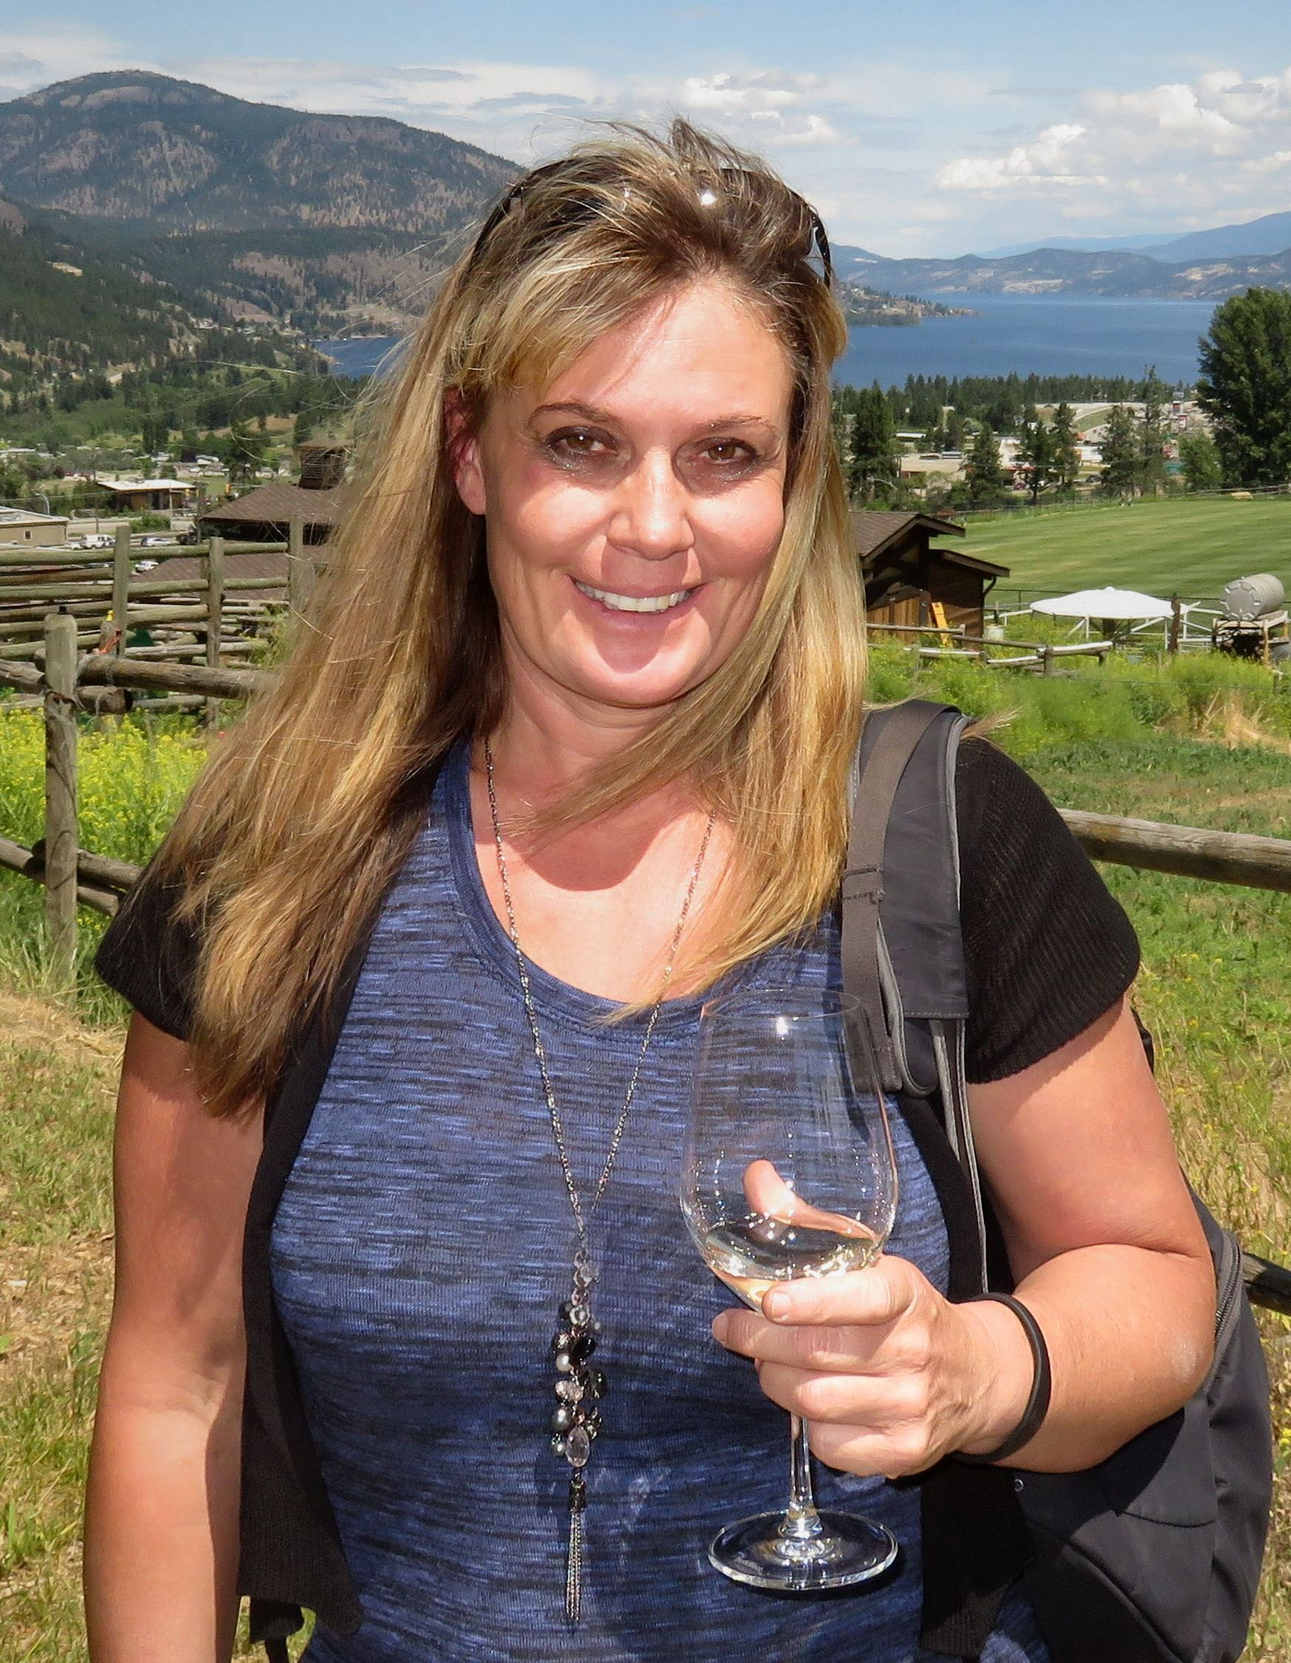

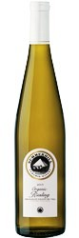

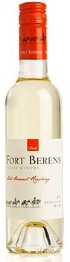

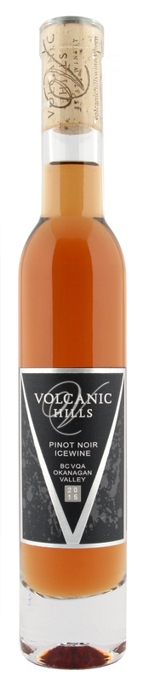

# HARPER’S TRAIL

2014 Silver Mane Block Riesling   
11.6% alcohol  
Flavours of ripe apple, Bartlett pear and honeydew melon, this wine is slightly off-dry and absolutely balanced.

2013_SilverManeBlock_Riesling_thum.jpg