All aboard the HISTORIC
S.S. Sicamous

The SS Sicamous is a large five decked sternwheeler that was built by the Canadian Pacific Railway (CPR) for Okanagan Lake service between the fruit communities of Penticton, Kelowna and Vernon. Launched in 1914, the Sicamous served the area until her retirment in 1937.
Passengers boarded the ship on the cargo deck before heading up one of the two exterior staircases leading to the saloon deck which housed an exquisite dining hall featuring an impressive mezzanine balcony and clerestory windows. Located at the bow was the Gentlemen’s Saloon with bar, while the stern housed the Ladies Saloon complete with a beautiful bridal suite.
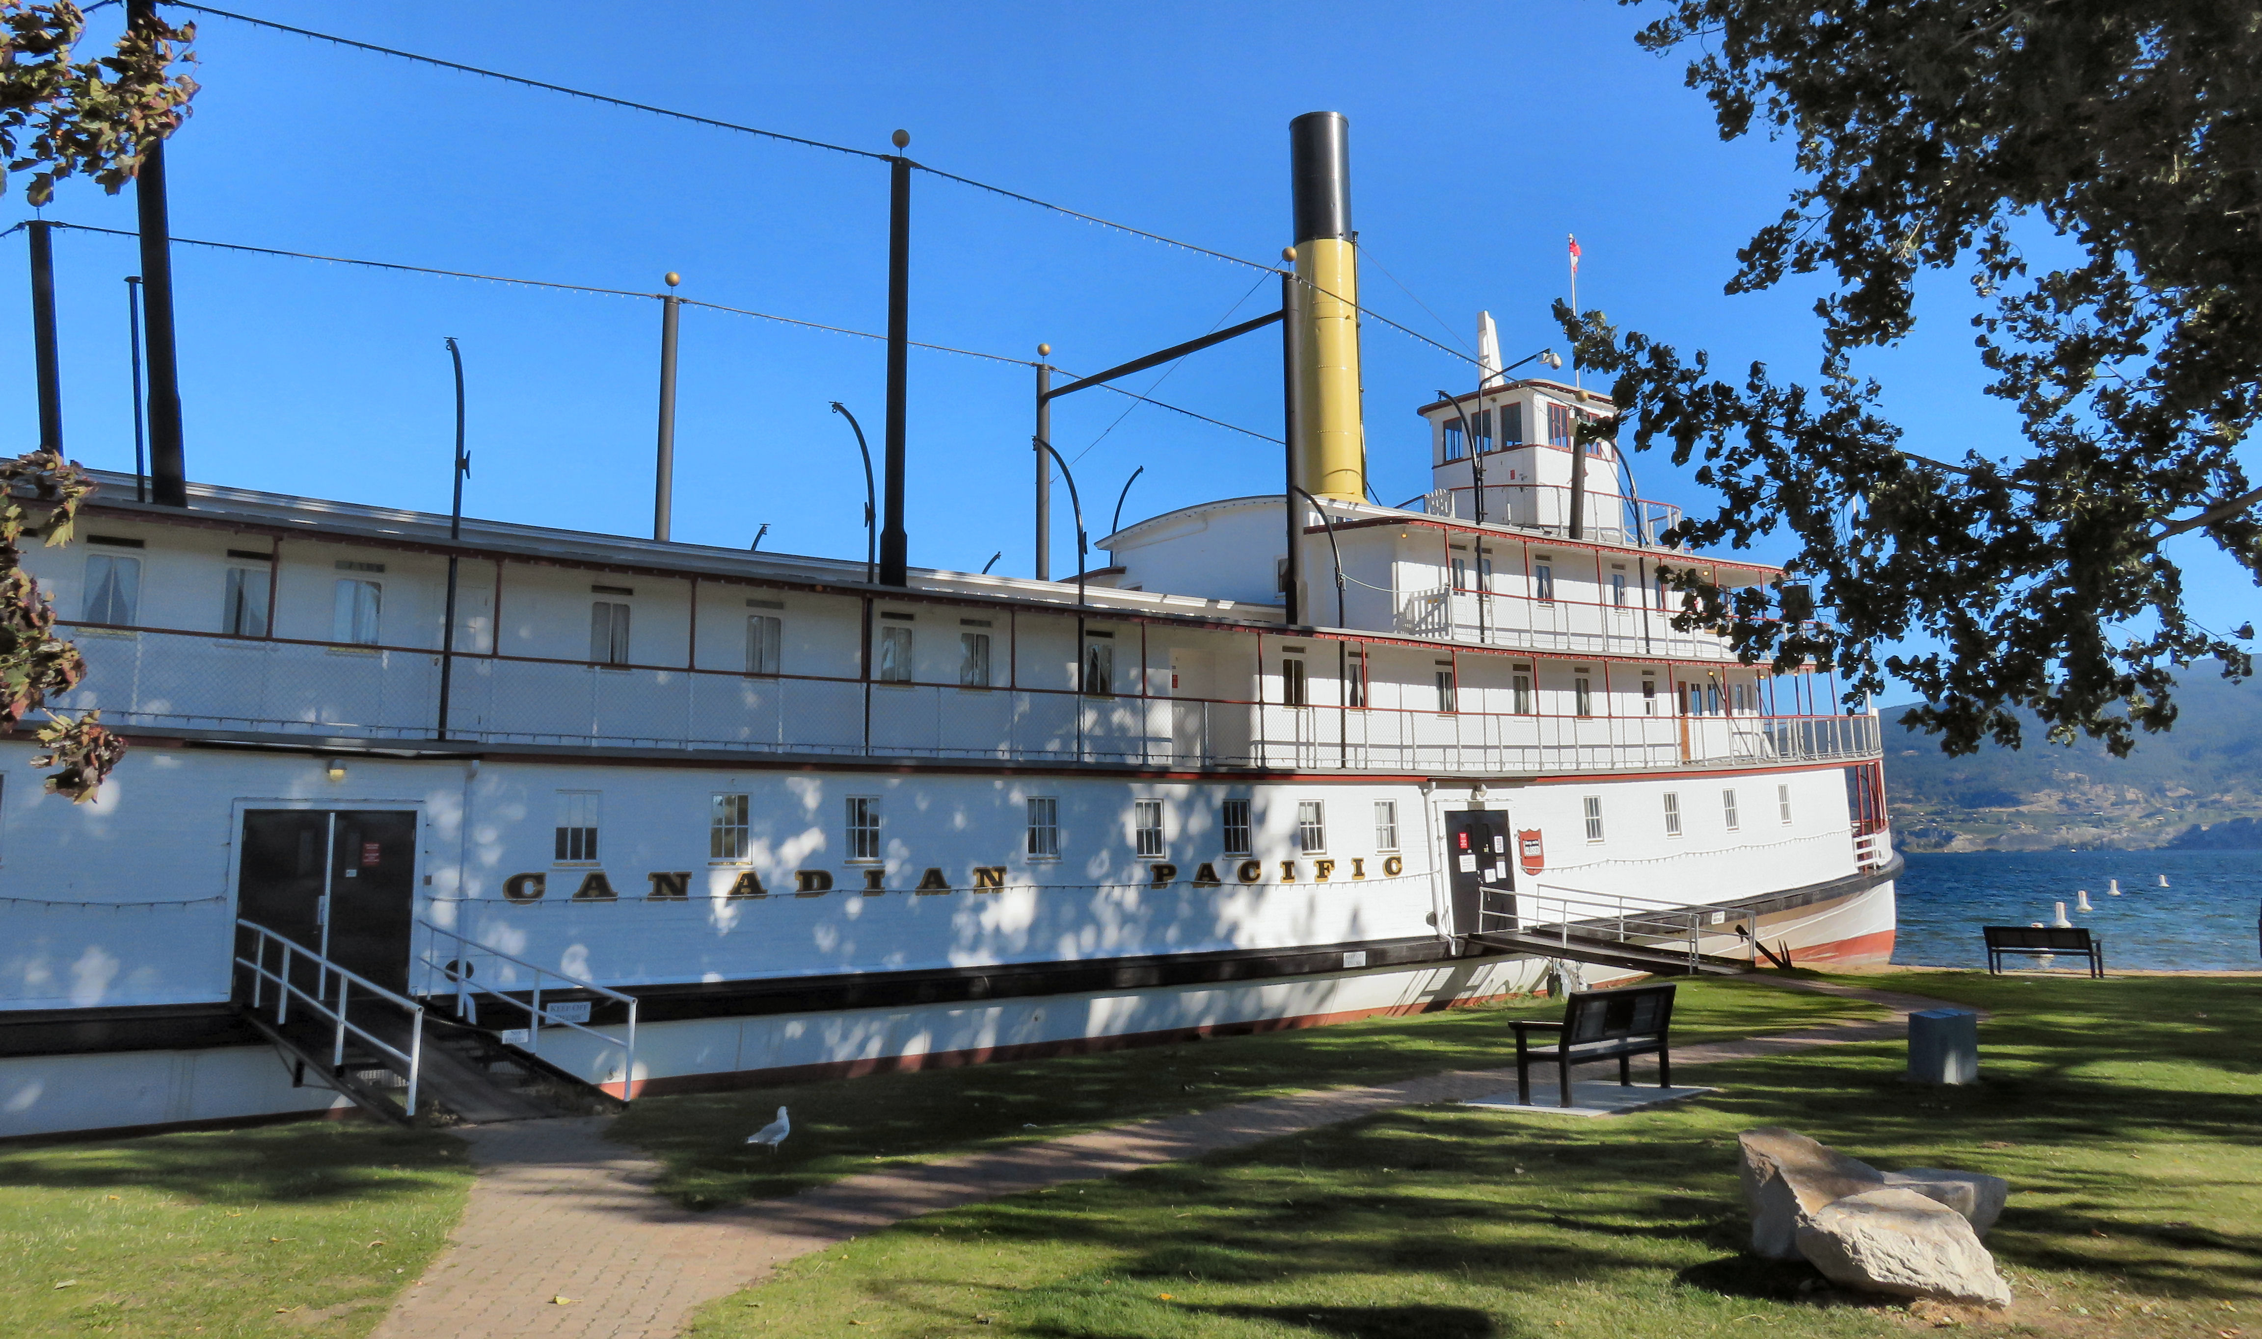

Launched in 1914 and retired in 1937, the S.S. Sicamous is not w museum and special events venue

Above the saloon deck was the observation deck or gallery deck where passengers could admire the beautiful view of Okanagan Lake. As was proper during this time period, the men and women also had their own separate observation areas with women at the bow, and men at the stern.
For over a decade after its last run, the SS Sicamous floated quietly at Okanagan Landing until it became clear that the CPR would never run the ship again. In 1947 a few buyers showed interest in the vessel but the CPR wanted the Sicamous to be preserved as a historical vessel and refused to sell her. That is until the Penticton Gyro Club decided to take it on.

On August 27th 1951, the City of Penticton agreed to purchase the Sicamous for $1.00 and, the steamer was towed back to her new home in Penticton. Hundreds of people turned up to witness the Sicamous as she was eased into a trench, and back filled with sand to keep the vessel in place.
Restoration of the vessel proved challenging. Pipes needed to be replaced and a new staircase fitted. Simply providing light, running water and basic amenities cost a staggering $18,000 in 1952 alone. Opening day was May 24th 1952, with a celebratory party the night before. In the years following the Sicamous hosted many meetings, gatherings and special events, but caring for the ship proved a bigger job than anyone had anticipated.
For a first few years the ship was home to the Penticton Museum, until a new museum building was completed in 1965. The ship was then used by a host of other businesses, including several restaurants, and even a wax work museum.
By the 1980’s the vessel began to fall into a state of disrepair and it was clear that something needed to be done. Years of scarce and haphazard repairs were showing their effect, and major structural work was needed if the Sicamous was going to survive.
In May 1988 the S.S. Sicamous Marine Heritage Society was founded to begin restoring the SS Sicamous to its former glory. Layers of paint, rust and neglect were scraped away, rotten wood replaced and the ship’s wheel re-hung. With its beauty restored, the vessel is now a museum and a popular venue for weddings and special events.
Since its formation, the society which is operated by volunteers and funded by charitable donations, have taken several other heritage lake vessels into their care such as the S.S. Okanagan and the S.S. Naramata which are now parked beside the S.S.Sicamous.

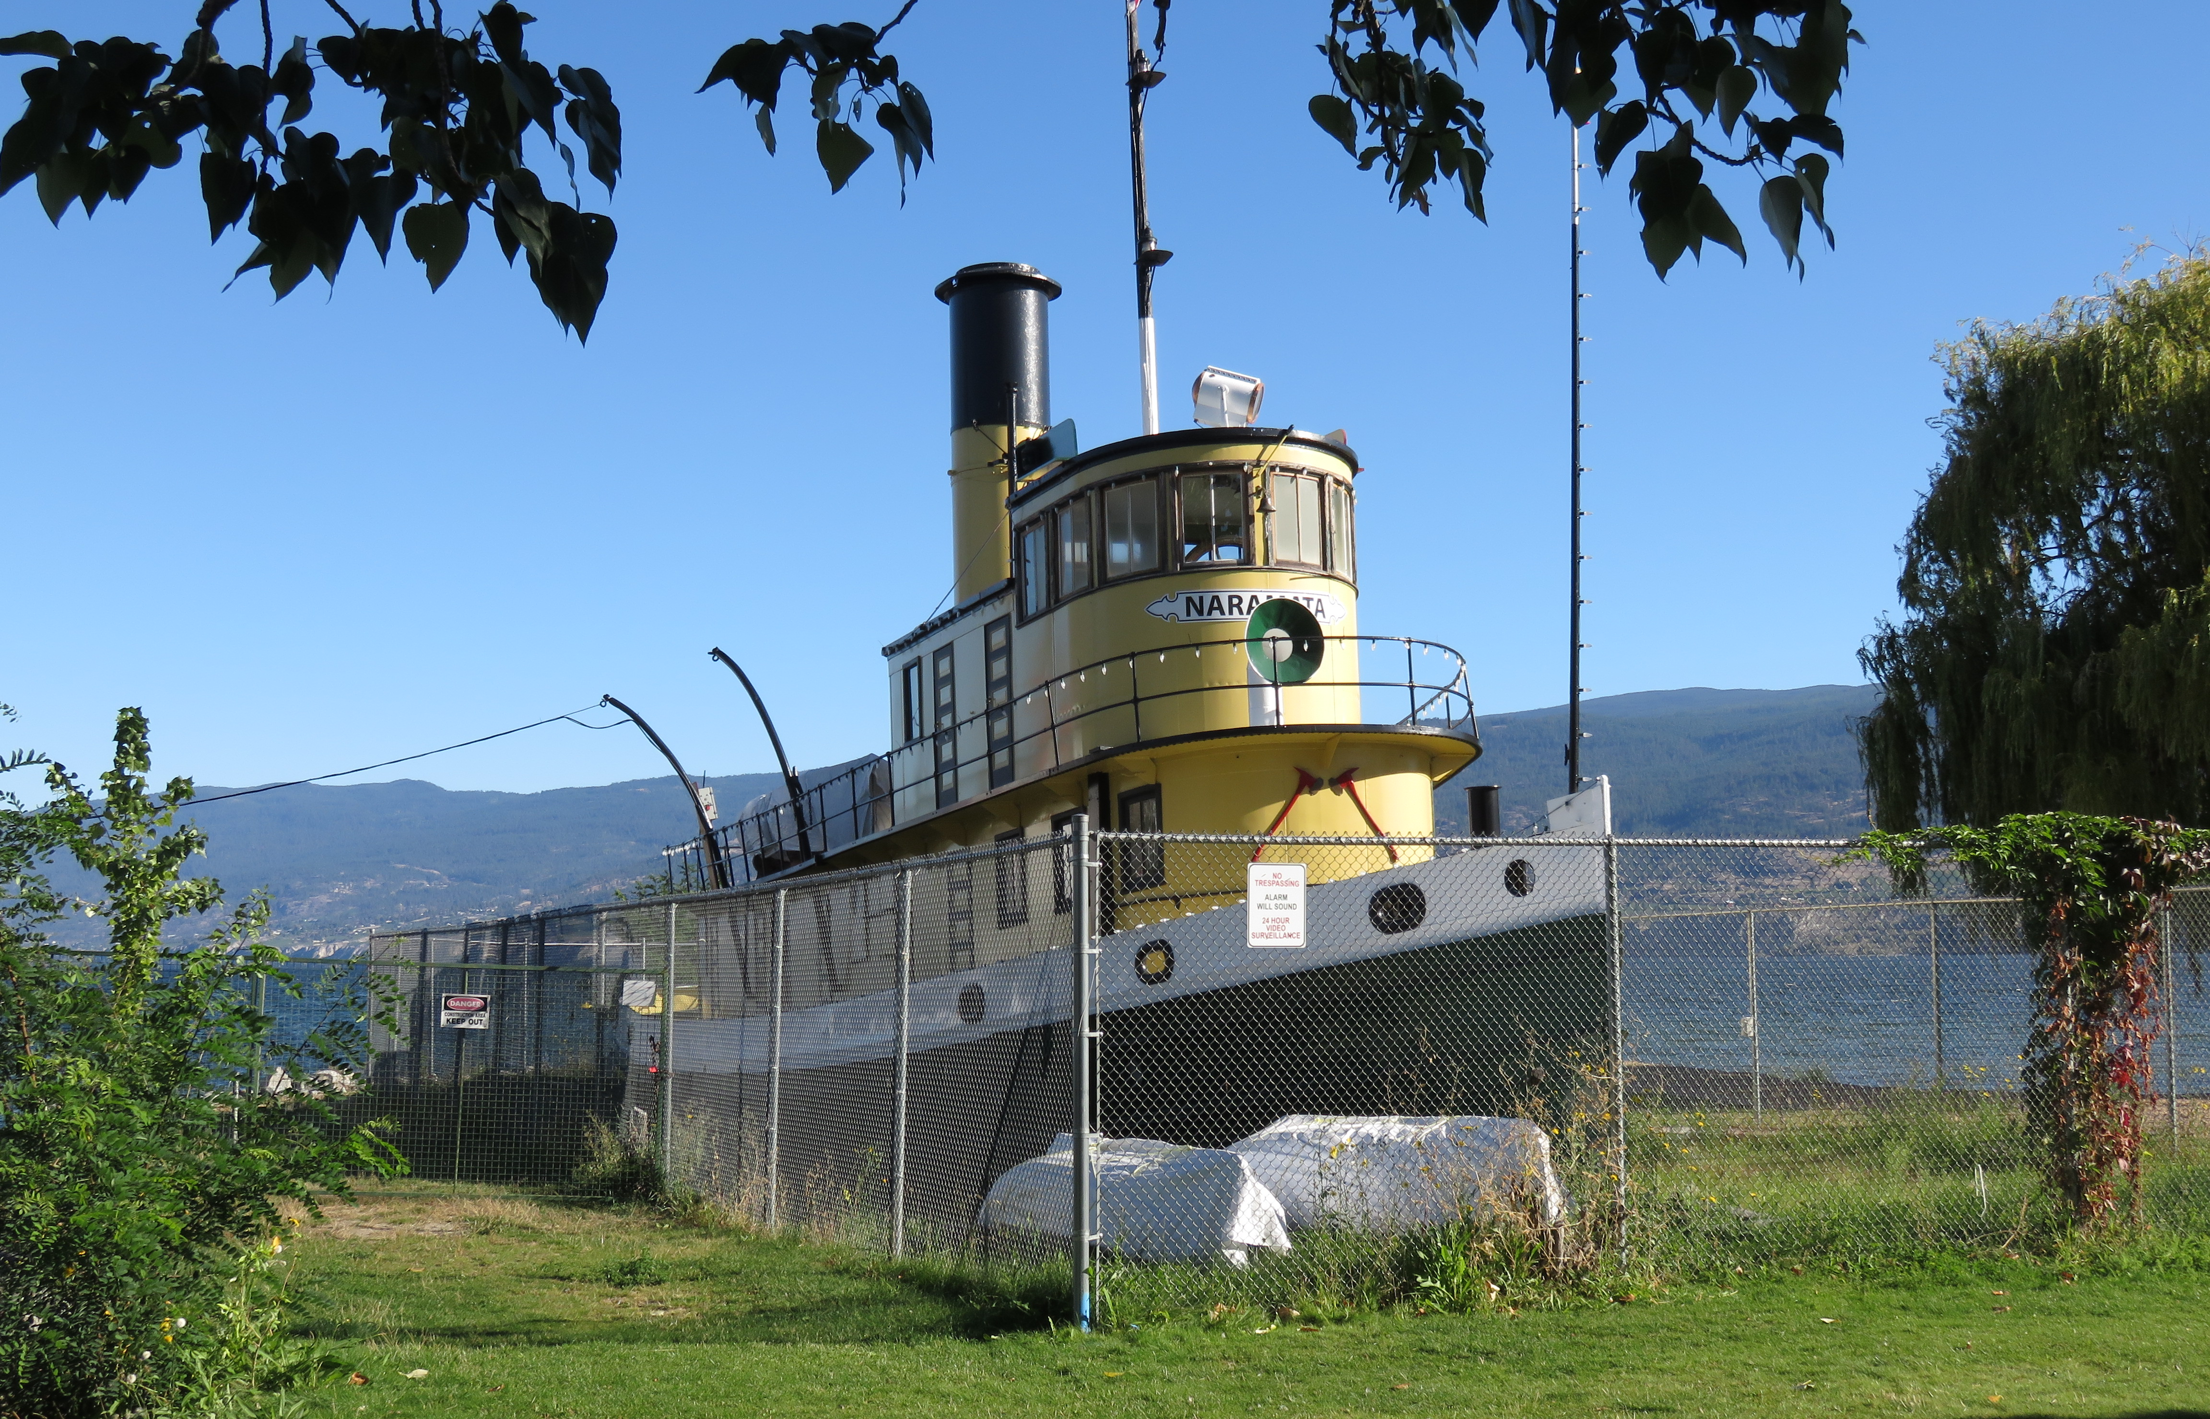

The S.S. Naramada is the only remaining tugboat in the Interior of British Columbia.

The SS Sicamous Marine Heritage Society is operated by volunteers, and relies upon the support of the City of Penticton and numerous charitable foundations. Members have worked tirelessly since that first day in 1988, to restore the SS Sicamous and make the ship enjoyable and informative for all who visit. Over the years the scope of the society has increased, but their aim remains the same.

Fun Facts:
- S.S. Sicamous was a steam-driven sternwheeler, consuming an average of fifteen to seventeen tons of coal each day
- S.S. Sicamous remains the largest and only remaining steam-powered, steel-hulled sternwheeler in Canada.
- The first captain to pilot the ship was Captain George Estabrooks

HOW TO GET THERE – The S.S. Sicamous is located at 1099 Lakeshore Drive, Penticton. For more information call 250-492-0403or visit their website at sssicamous.ca

