Experience The Art of wine tasting at Mission Hill

The Southern Interior of British Columbia produces some of the best wines in the world and wine tasting has become a big industry in this region. The competition is fierce and wineries have really stepped up to the plate to make wine tasting an unforgettable experience.
Mission Hills Family Estate does not just produce award-winning wines; it also offers unforgettable social experiences. Whether you have a romantic dinner in their outdoor Terrace Restaurant overlooking Okanagan Lake, go on one of their signature wine tours or take in one of their summer concerts in their spectacular 1200 seat Greek style outdoor amphitheatre you will no doubt create unforgettable memories.
Mission Hill offers four signature wine tours: Heritage, Discovery, Legacy and Vineyard Luncheon all lasting from 1-2 hours and ending with a wine-tasting.
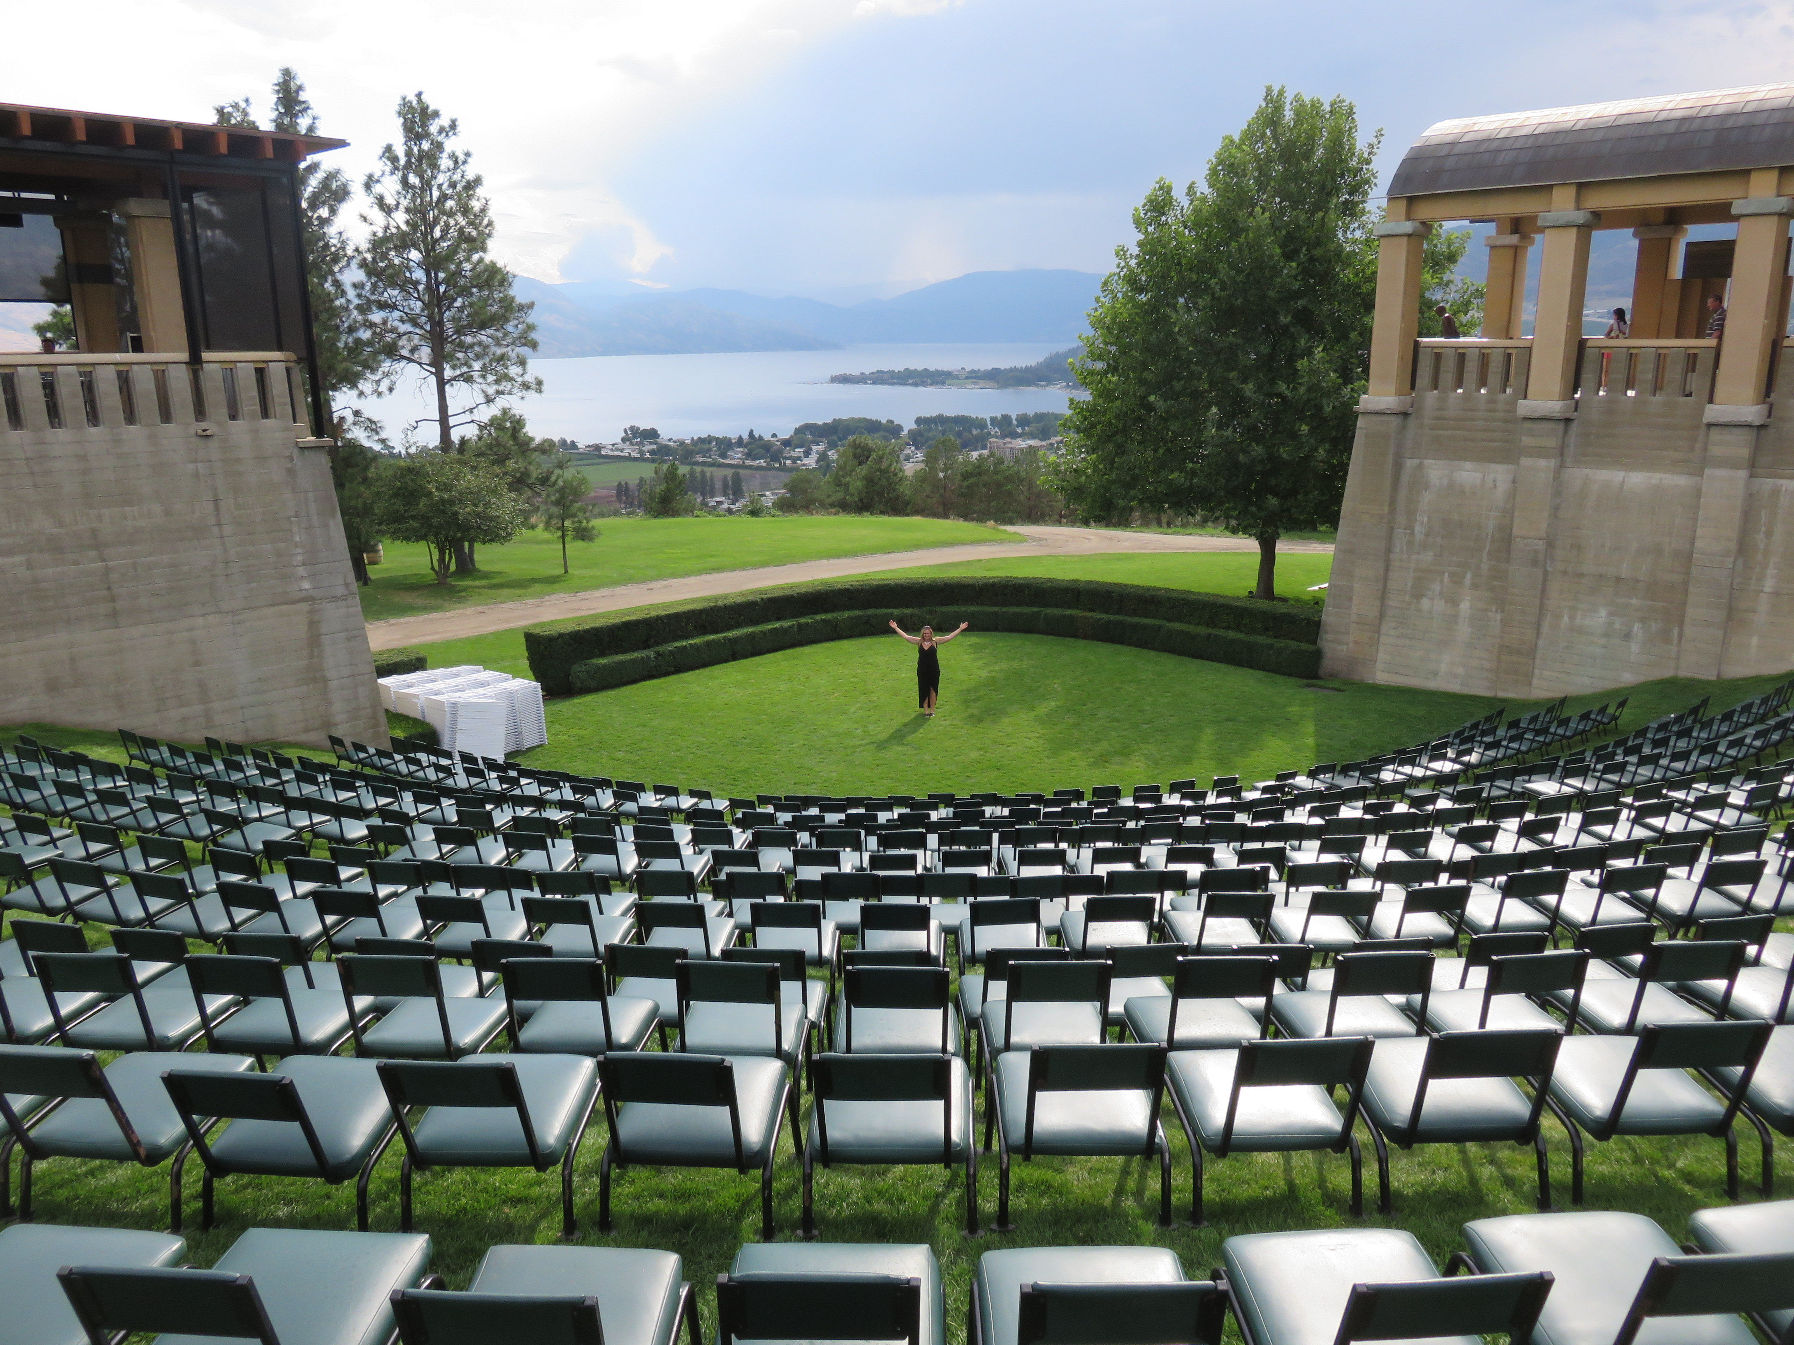
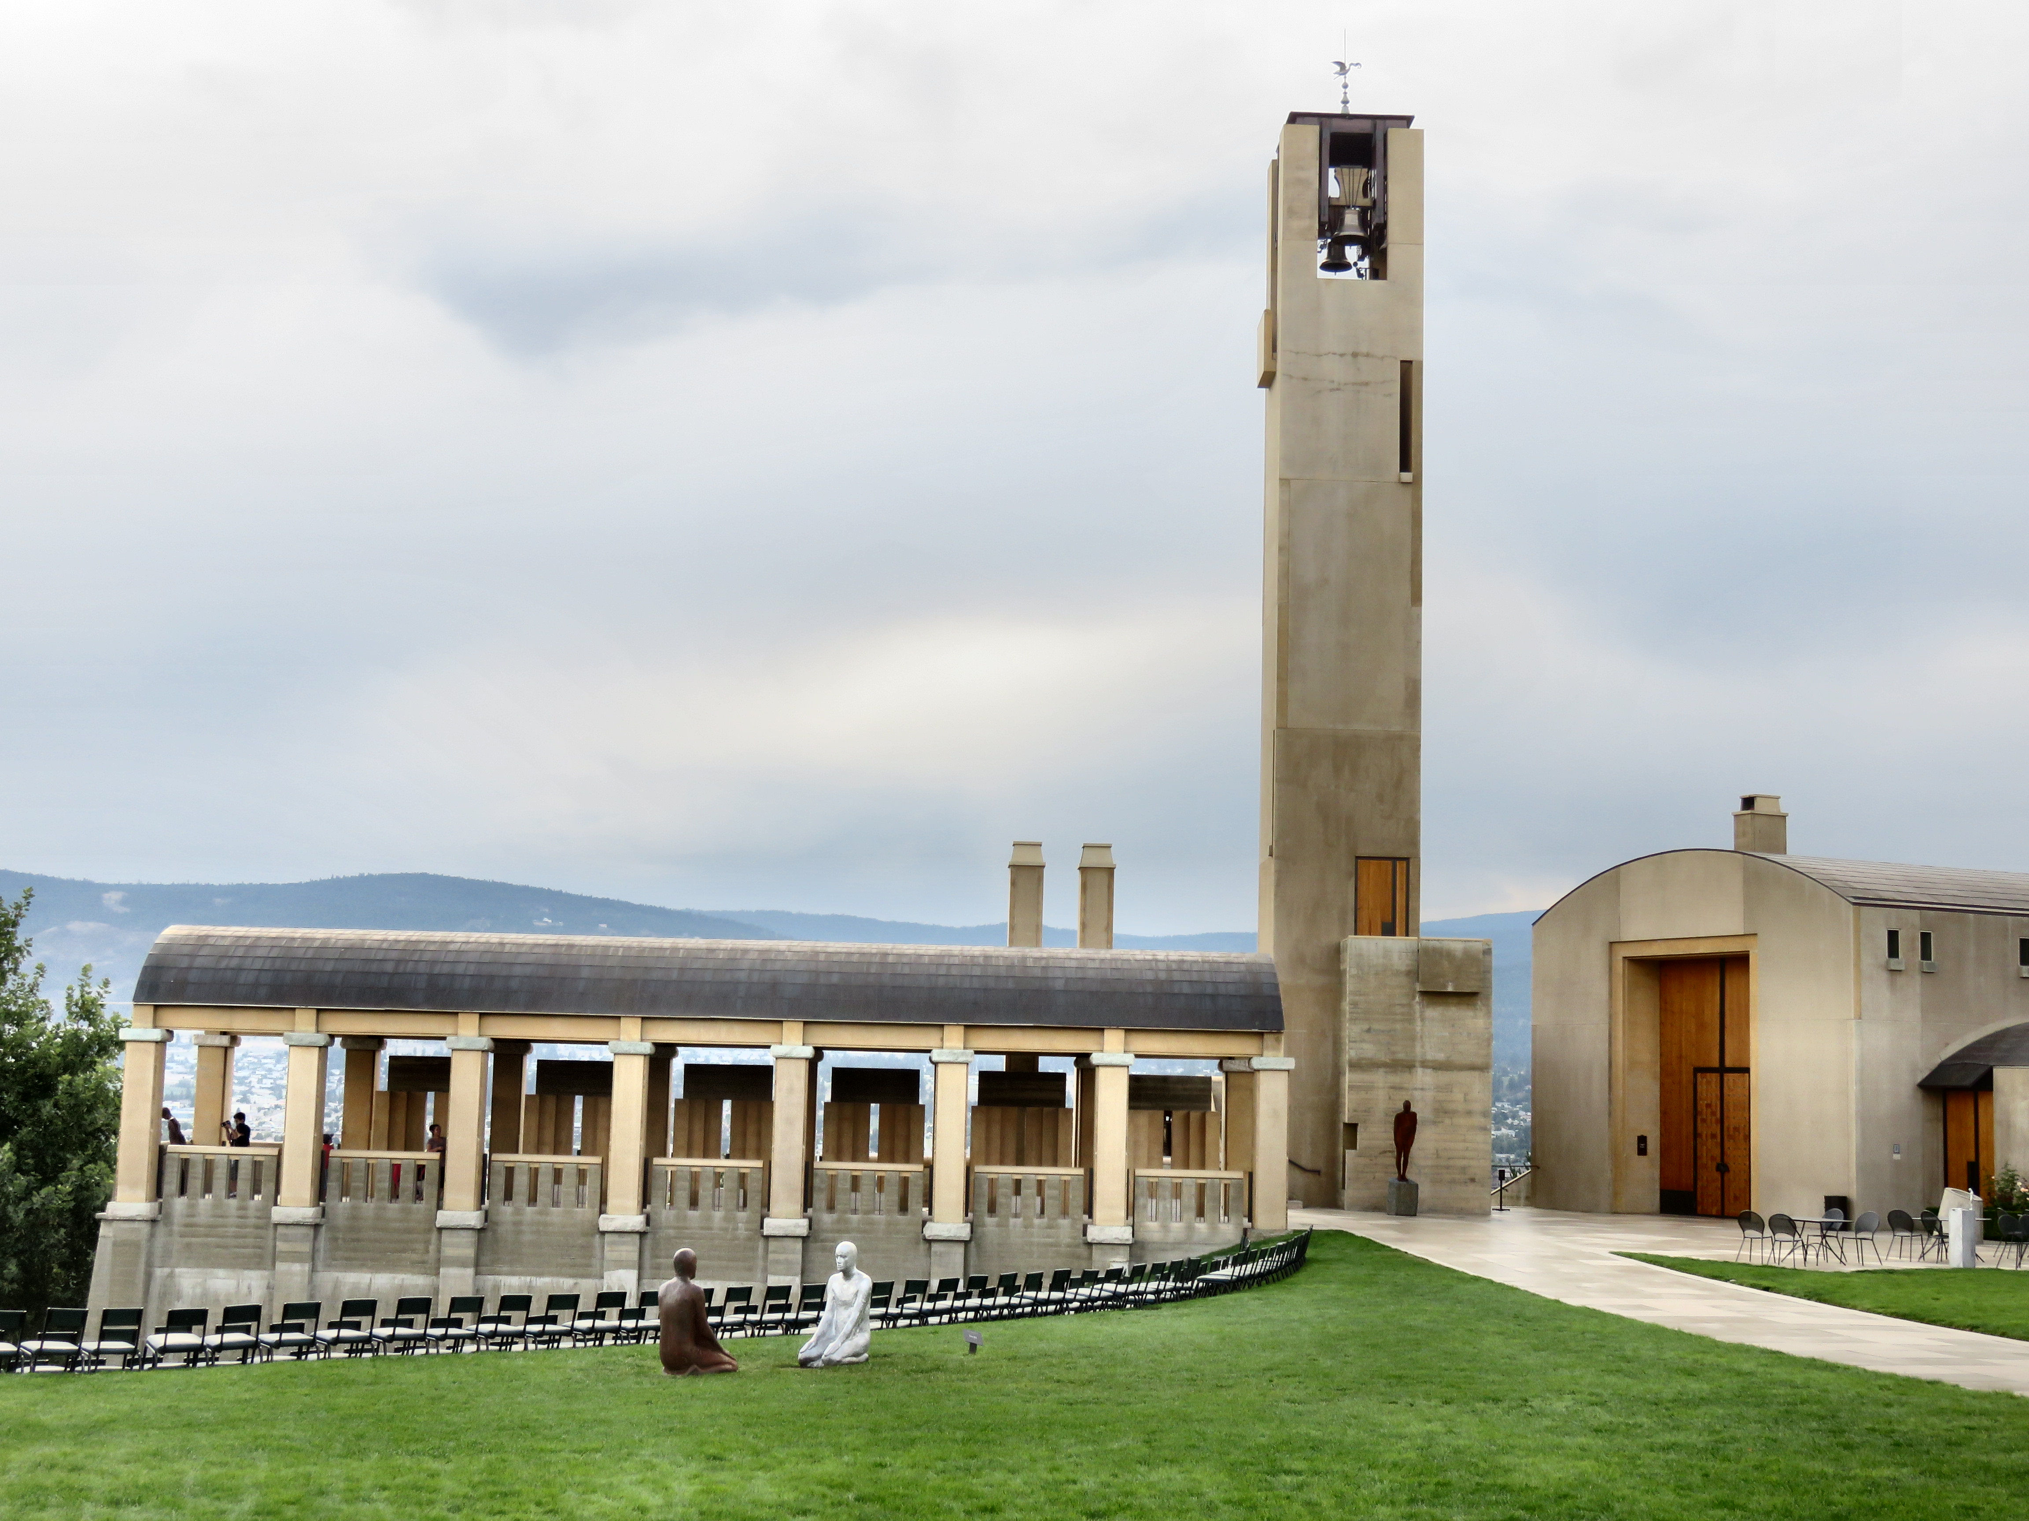

Right: Inside the 12-story bell tower has four hang four brass bells. Right: The 1200 seat Greek Outdoor Amphitheatre.

What sets Mission Hills apart from other wineries is its beautiful setting. Everything about it from the well dressed staff to the well manicured landscape and majestic architecture just oozes class.
The winery recently underwent a six-year transformation completed under the watchful eye of a dedicated team of international architects, designers and craftsmen who created a landmark that will stand the test of time and delight visitors from around the world.
The crowning glory is no doubt the 12-storeys tall Bell Tower, with its lightning rod and pelican-inspired weathervane, taken from the von Mandl family crest. Inside the tower, are four bronze bells, handcrafted in Annecy, France by the Paccard Bell Foundry. Each is dedicated to a member of Anthony's immediate family, his late father Martin, his mother Bedriska, his sister Patricia and himself.

For a truly unique experience book your tickets for the Mission Hill Summer Concert Series. This venue attracts celebrated artists from around the world searching to engage with their fans on a more intimate level. Some of the artists that have graced the stage include: The Canadian Tenors, the Gypsy Kings, Chris Botti, Chris Issak and Lyle Lovett.
The winery is open year round. For more information about hours of operation and upcoming events, visit their website at www.missionhillwinery.com or call 250-768-6448.

Fun Fact - In 2008 Mission Hill Winery’s Terrace Restaurants was named by Travel + Leisure magazine as one of the five best winery restaurants in the world.

HOW TO GET THERE – From Kelowna (driving Hwy 97 South) Southbound from Kelowna, cross the W.R Bennett Bridge (Highway 97), turn left at Boucherie Road. Follow Boucherie Road for 5 kms and turn right onto Mission Hill Road. Follow Mission Hill Road to the very top of the hill.

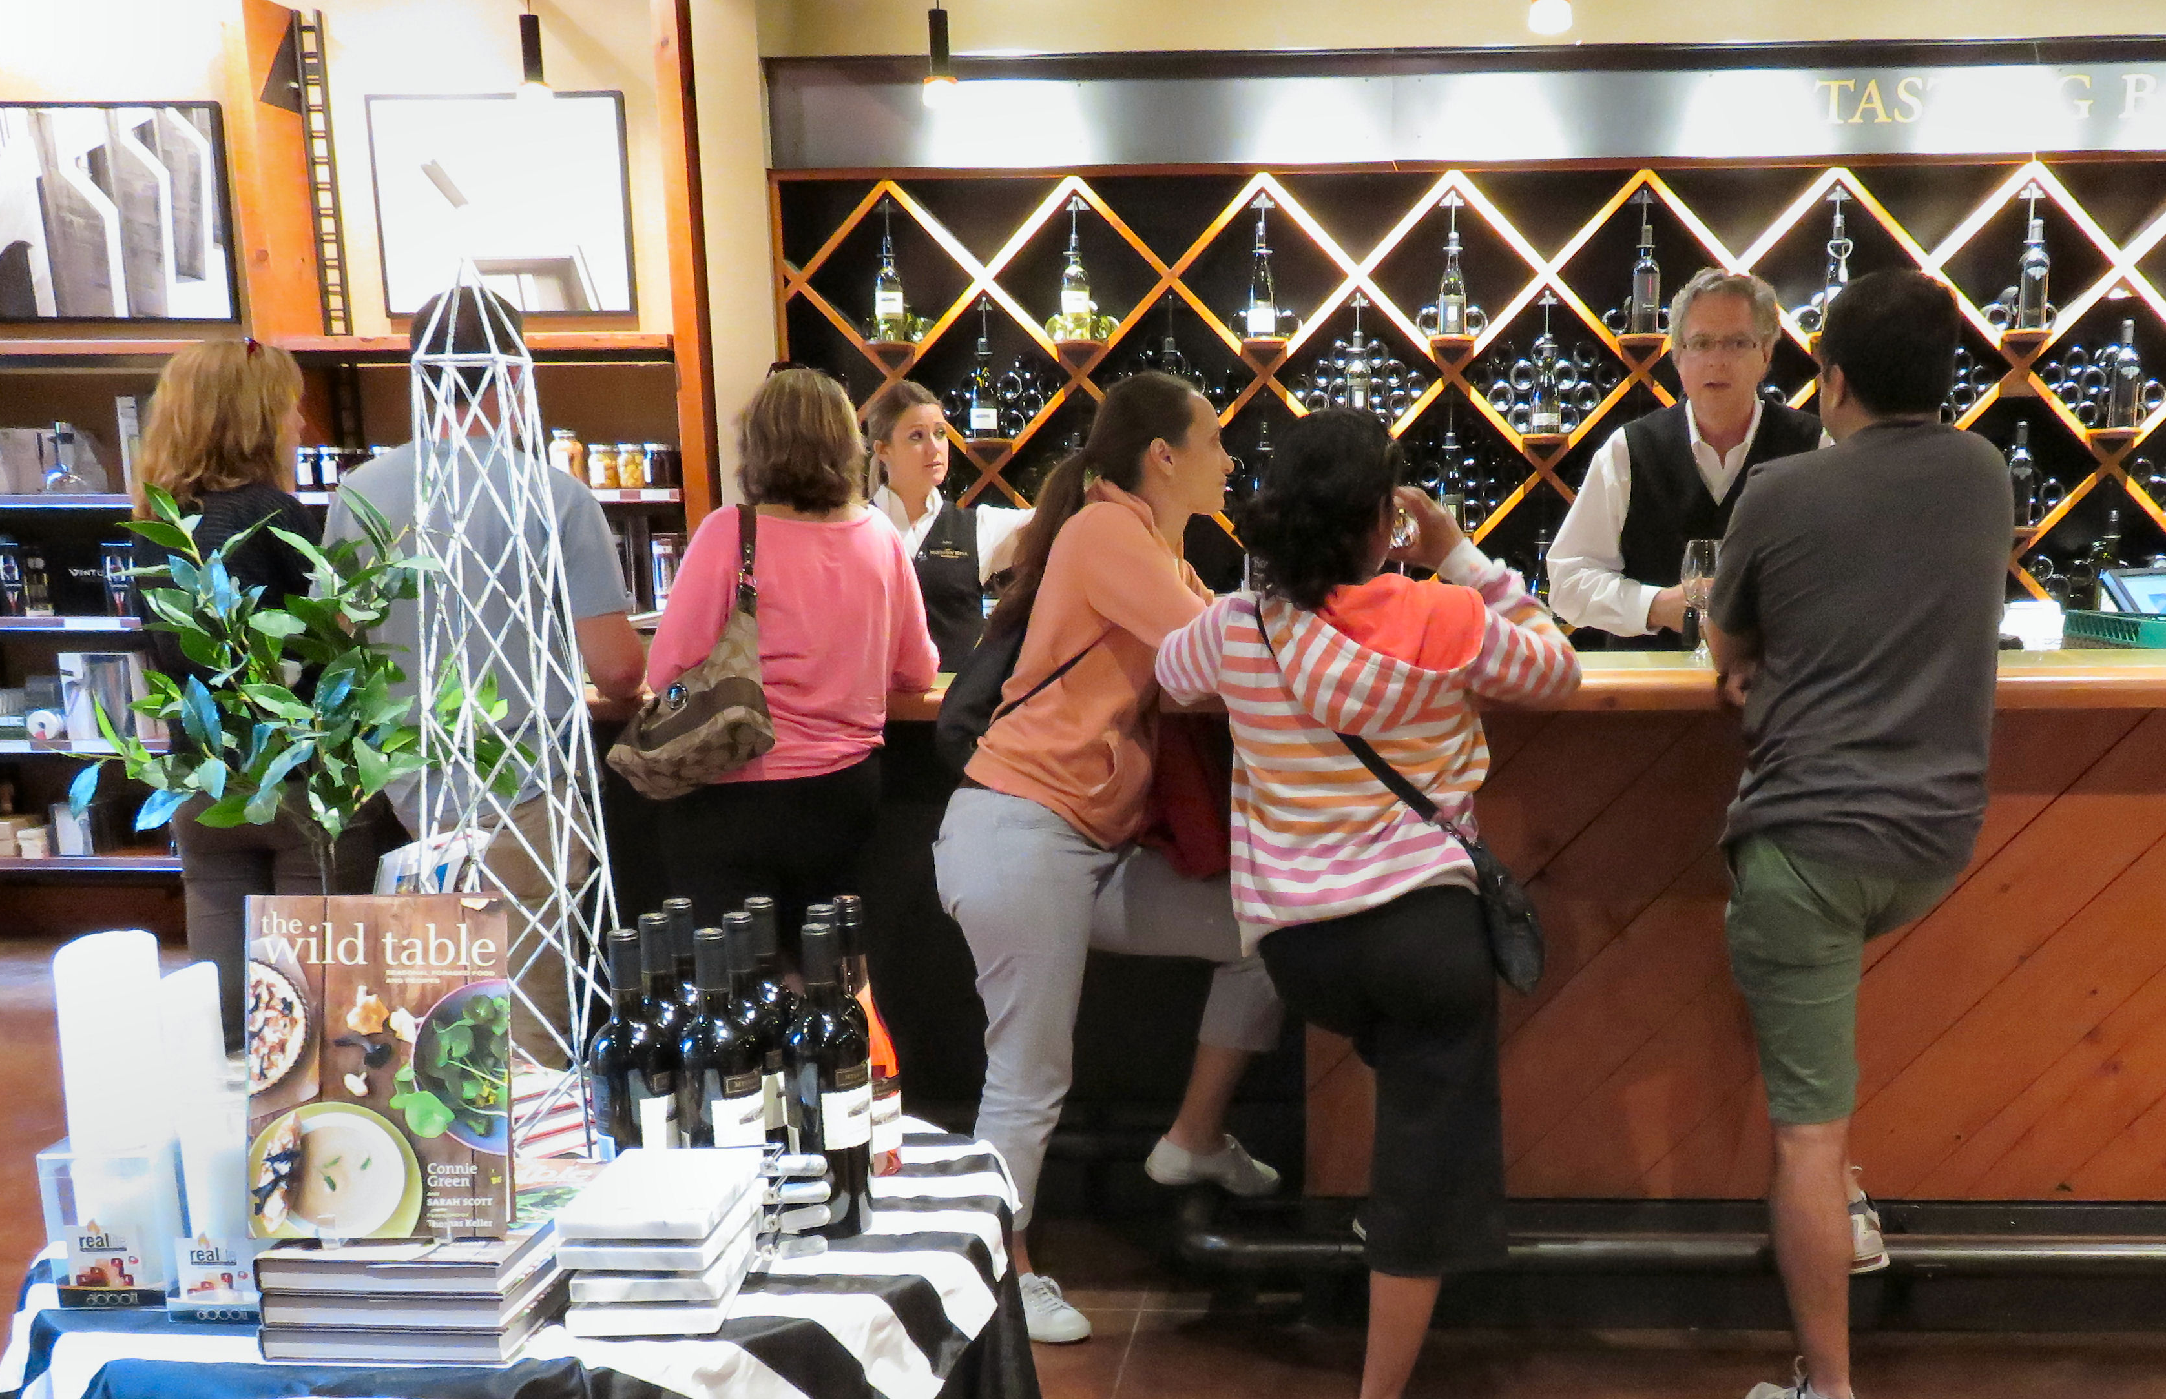

Top: Host Michael holds a bottle of their signature wine. Bottom: Teresa the Traveler and her friend Kathi Meyn pose in front of the fountain. Left: Visitors sample wines in the Wine Boutique.
