Discover where Okanagan’s First apple was planted

If you want to trace the footsteps of the first white settlers in our area, you need to start your journey at Father Pandosy’s Mission in Kelowna. It was here that Father Pandosy, an Oblate priest, established the first permanent European non-native settlement in the interior of the Crown Colony of British Columbia now known as British Columbia. Born in 1824 near Marseilles France, Father Pandosy, along with other missionaries, sailed from France arriving in Washington territory in 1847. Ordained as a Catholic priest in 1848, Pandosy administered the needs of the Catholic congregation throughout the Province of British Columbia for 32 years until he passed away on February 6th 1891 in Penticton in the arms of First Nation Chief Francois.
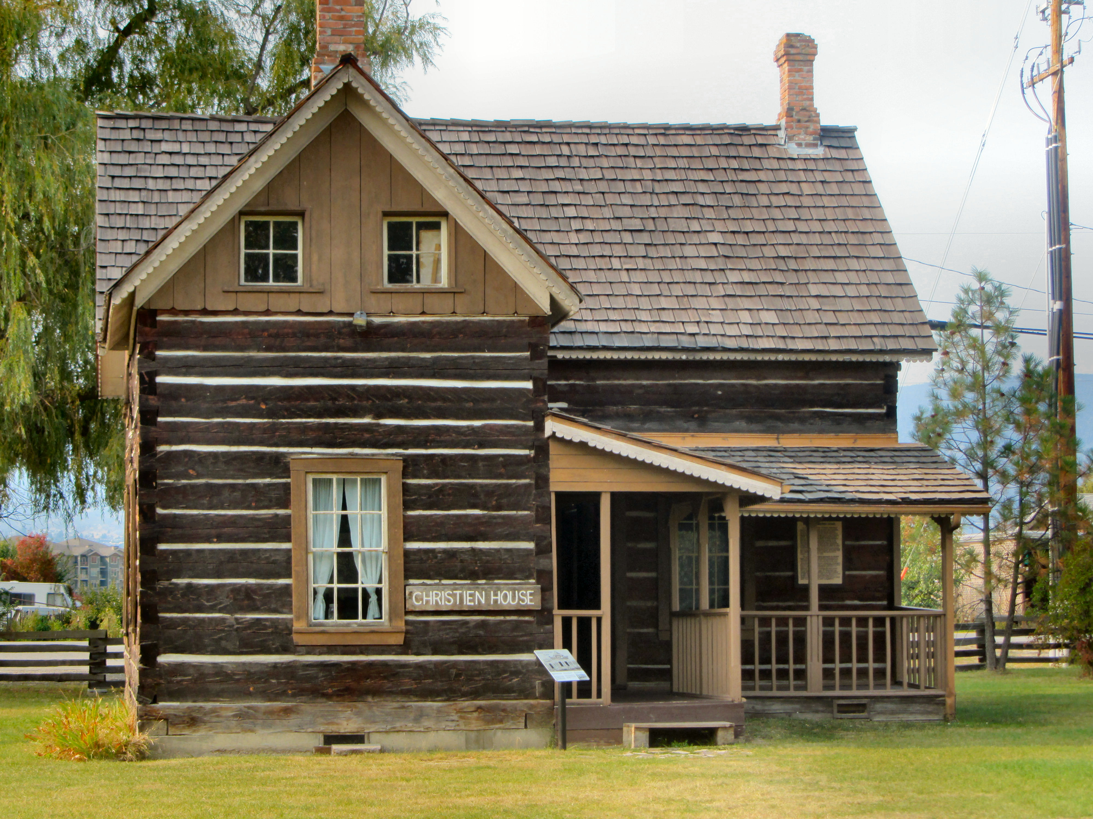

The rooms in the houses are decorated in period antique furniture and artifacts.

In the autumn of 1859, Father Charles Pandosy and Father Pierre Richard were sent to open a Mission in the Okanagan Valley. The two chose this site and over the next 30 years turned the Mission into an important religious, social and cultural center.
The two Fathers, along with Brother Surel began an ambitious agricultural enterprise that at its peak covered 2,000 acres of land where they raised 500 head of cattle, 35 horses, and planted numerous fruit and vegetable gardens.
In fact, it was here that the Okanagan’s first apple orchard was planted using a seedling from St. Mary’s Mission in Mission, BC.
The Mission was decommissioned in 1896 and the land was subdivided into smaller farm lots.
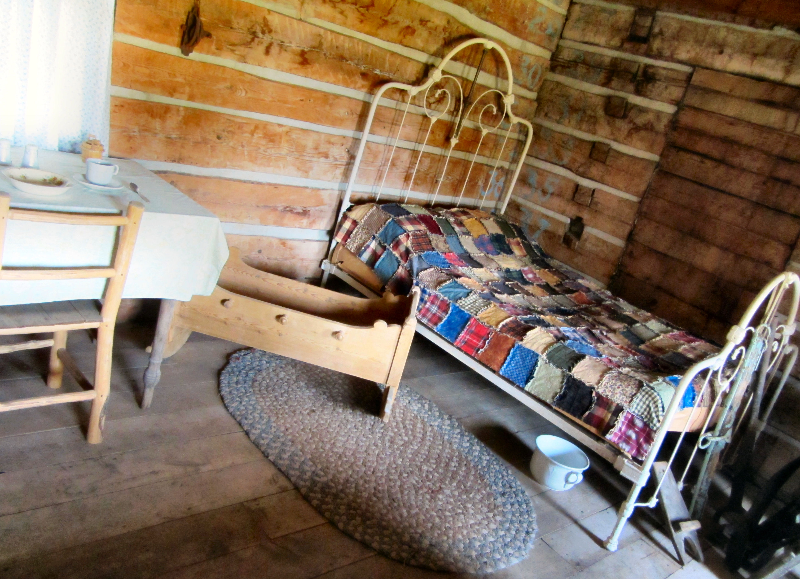

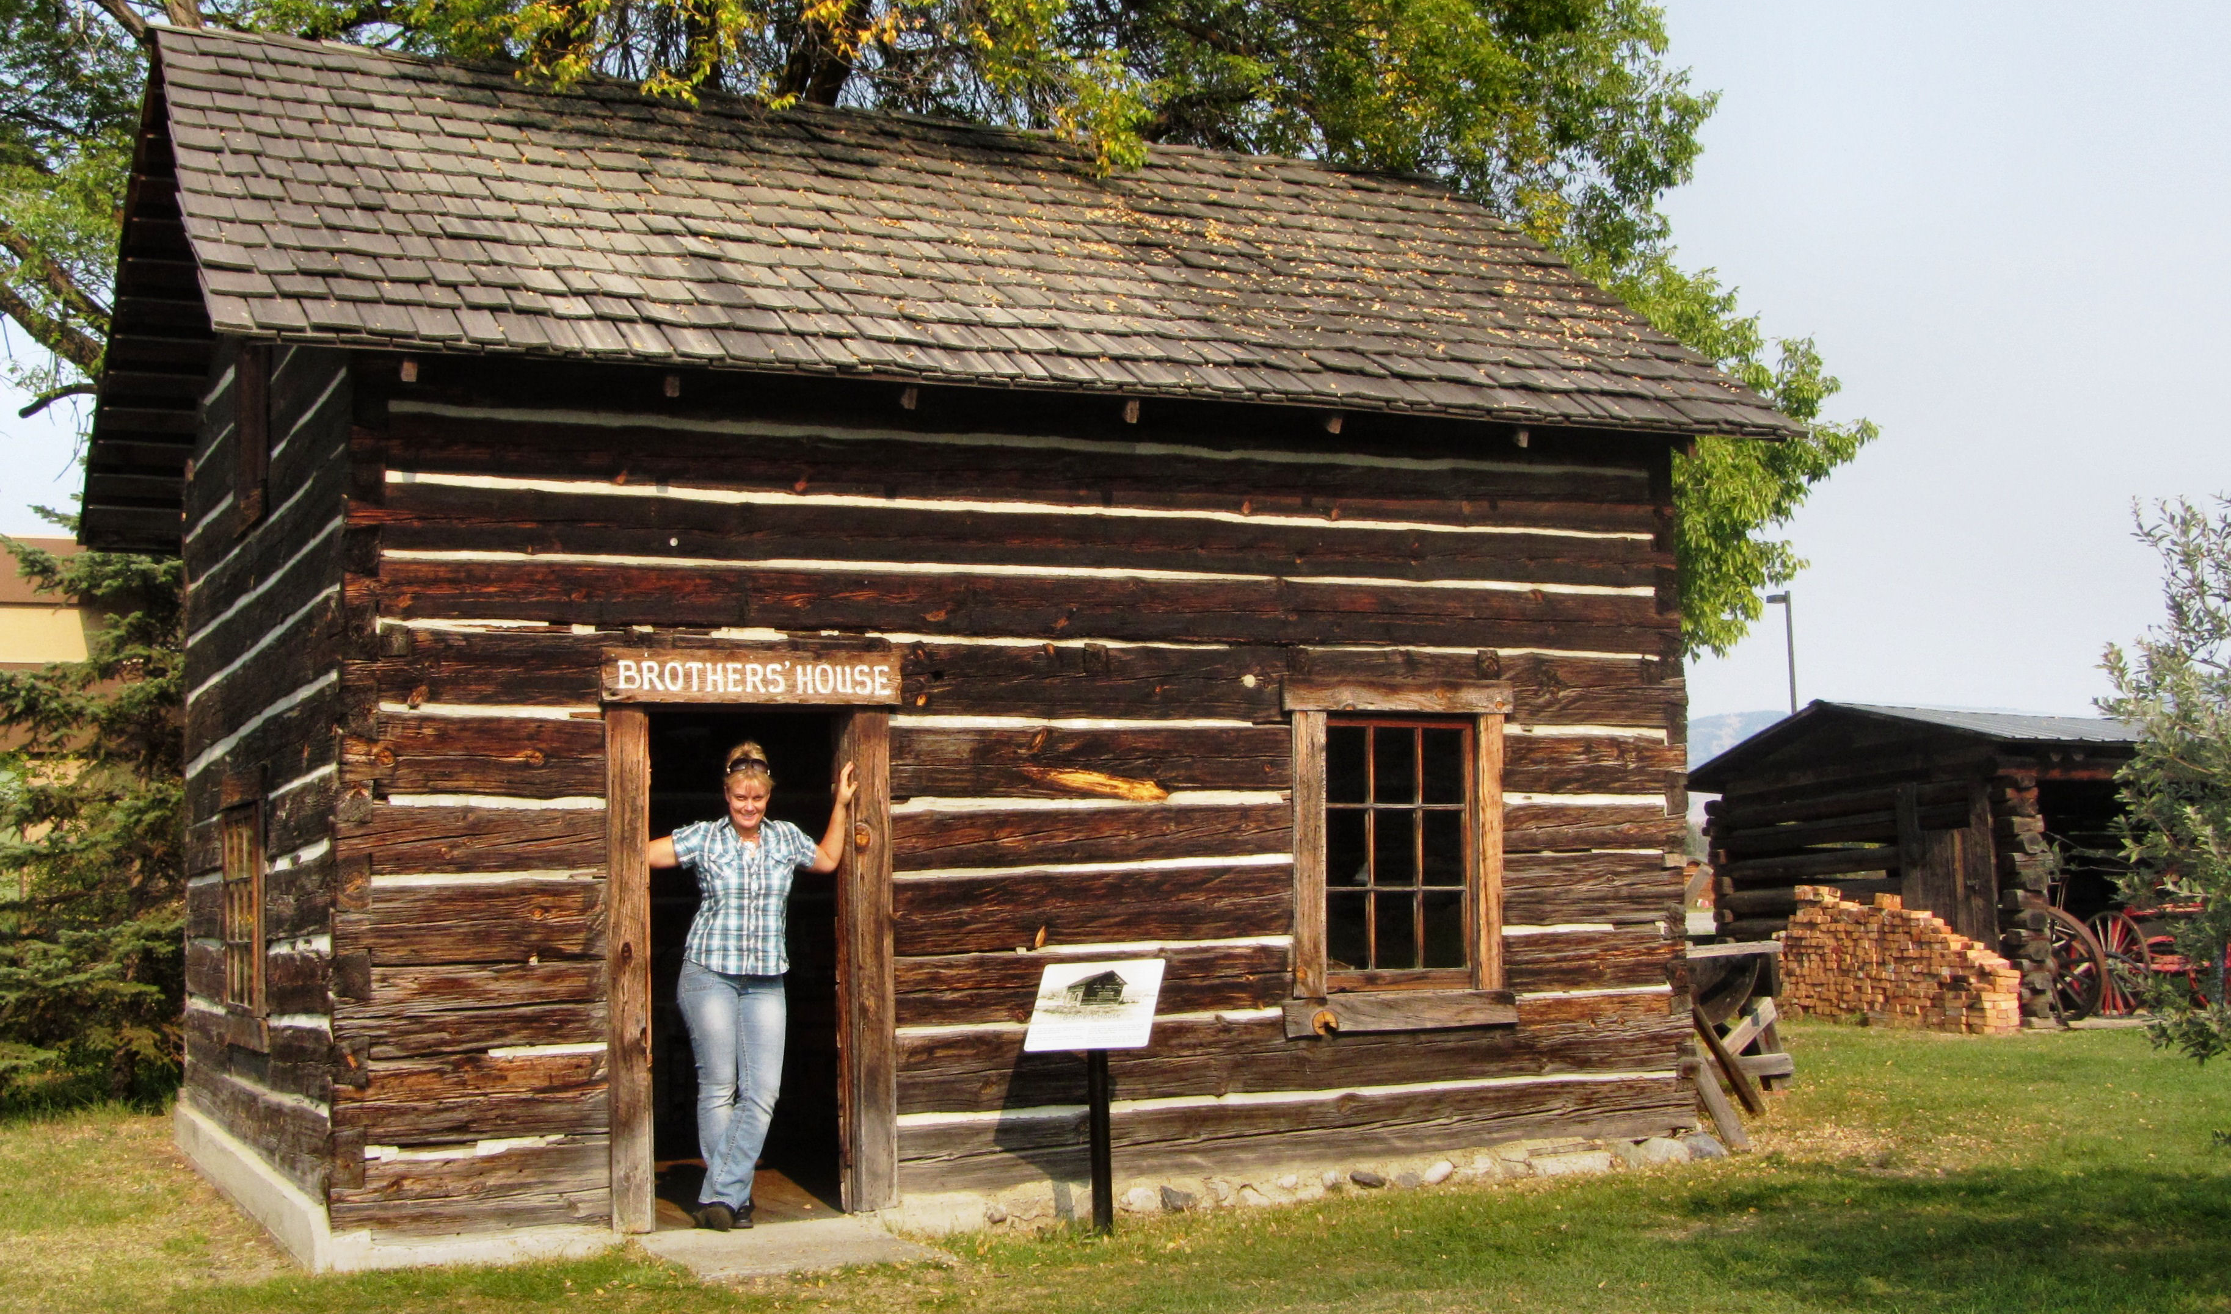

Teresa the Traveler visits the Father Pandosy Mission.

Four original buildings remained and thanks to the help of the Okanagan Historical Society and the Knights of Columbus, the site was turned into a museum and a number of other significant heritage buildings have been moved to the site.
Visitors to the heritage site can get a glimpse into the life of our early settlers. The buildings and rooms have all been restored and furnished with items of that time period including bedrooms, a classroom, a blacksmith shop, a living room and a chapel. The site also has a collection of early farm machinery, household equipment such as old washing machines, as well as a collection of horse drawn conveyances.

FAST FACT- in 1983 two Simon Fraser University students discovered Father Pandosy's grave in a vegetable patch off Gordon Drive with his robes and wooden cross still intact inside the coffin.

HOW TO GET THERE – As you enter Kelowna from Vernon on Harvey Street (Highway 97), turn right on Dillworth, left on Benvoulin Road and you will find the Mission at 3685 Benvoulin Rd. For more information, visit their website at www.okanaganhistoricalsociety.org/pandosy_mission or call (250) 860-8369. Admission is by donation and the site is open from March 1st to October 31st.

