Relax at the best rest stop on the way to Calgary

My favourite stretch of highway is the Trans Canada from Kamloops to Calgary. The abundance of wildlife, the glacier covered mountains and the countless waterfalls ensure a lively trip every time. I like to turn the 6 hour drive into an all day event by stopping at various points of interest and rest stops. Being a fan of waterfalls, I love stopping at the one in Glacier National Park 30 minutes from Revelstoke. I can have lunch on a picnic table while enjoying the view of a waterfall emptying into a river.
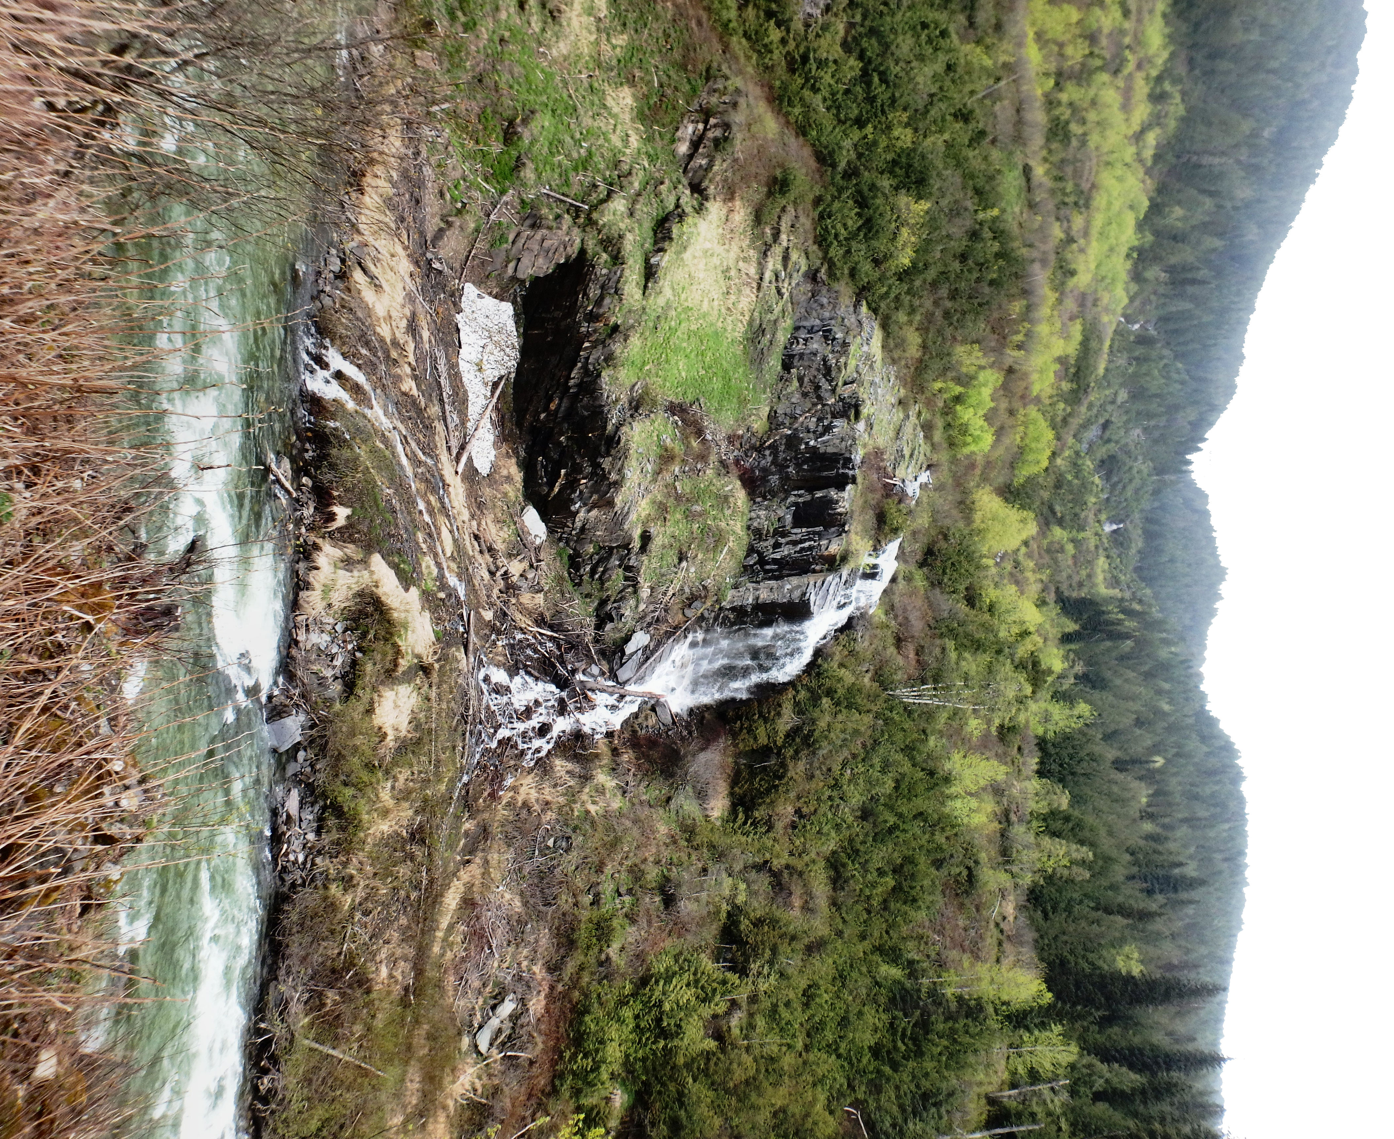

A Prairie Dog takes a relaxing break at the rest stop.

From the rest stop you can see the side of the mountain where an avalanche cut through the forest. While avalanches cause destruction, they also create open slopes favoured by many plants and animals. That’s why the park has an abundance of berries and bears, flowers and marmots, grasses and mice.

HOW TO GET THERE – Drive 50 kilometres past Revelstoke on the East Trans Canada Highway towards Calgary. You will see the rest stop on the left.
