HANDS UP, KAMLOOPS’ MOST NOTORIOUS WINERY

On 8 May 1906, Miner struck the CPR again, near Kamloops at Monte Creek in an area now referred to as Miner’s Bluff, but bungled the robbery. At that time gold was usually carried in the express car. Miner and his accomplices forced the engineer to stop and release some of the cars then continued down the track while the robbers collected their booty.
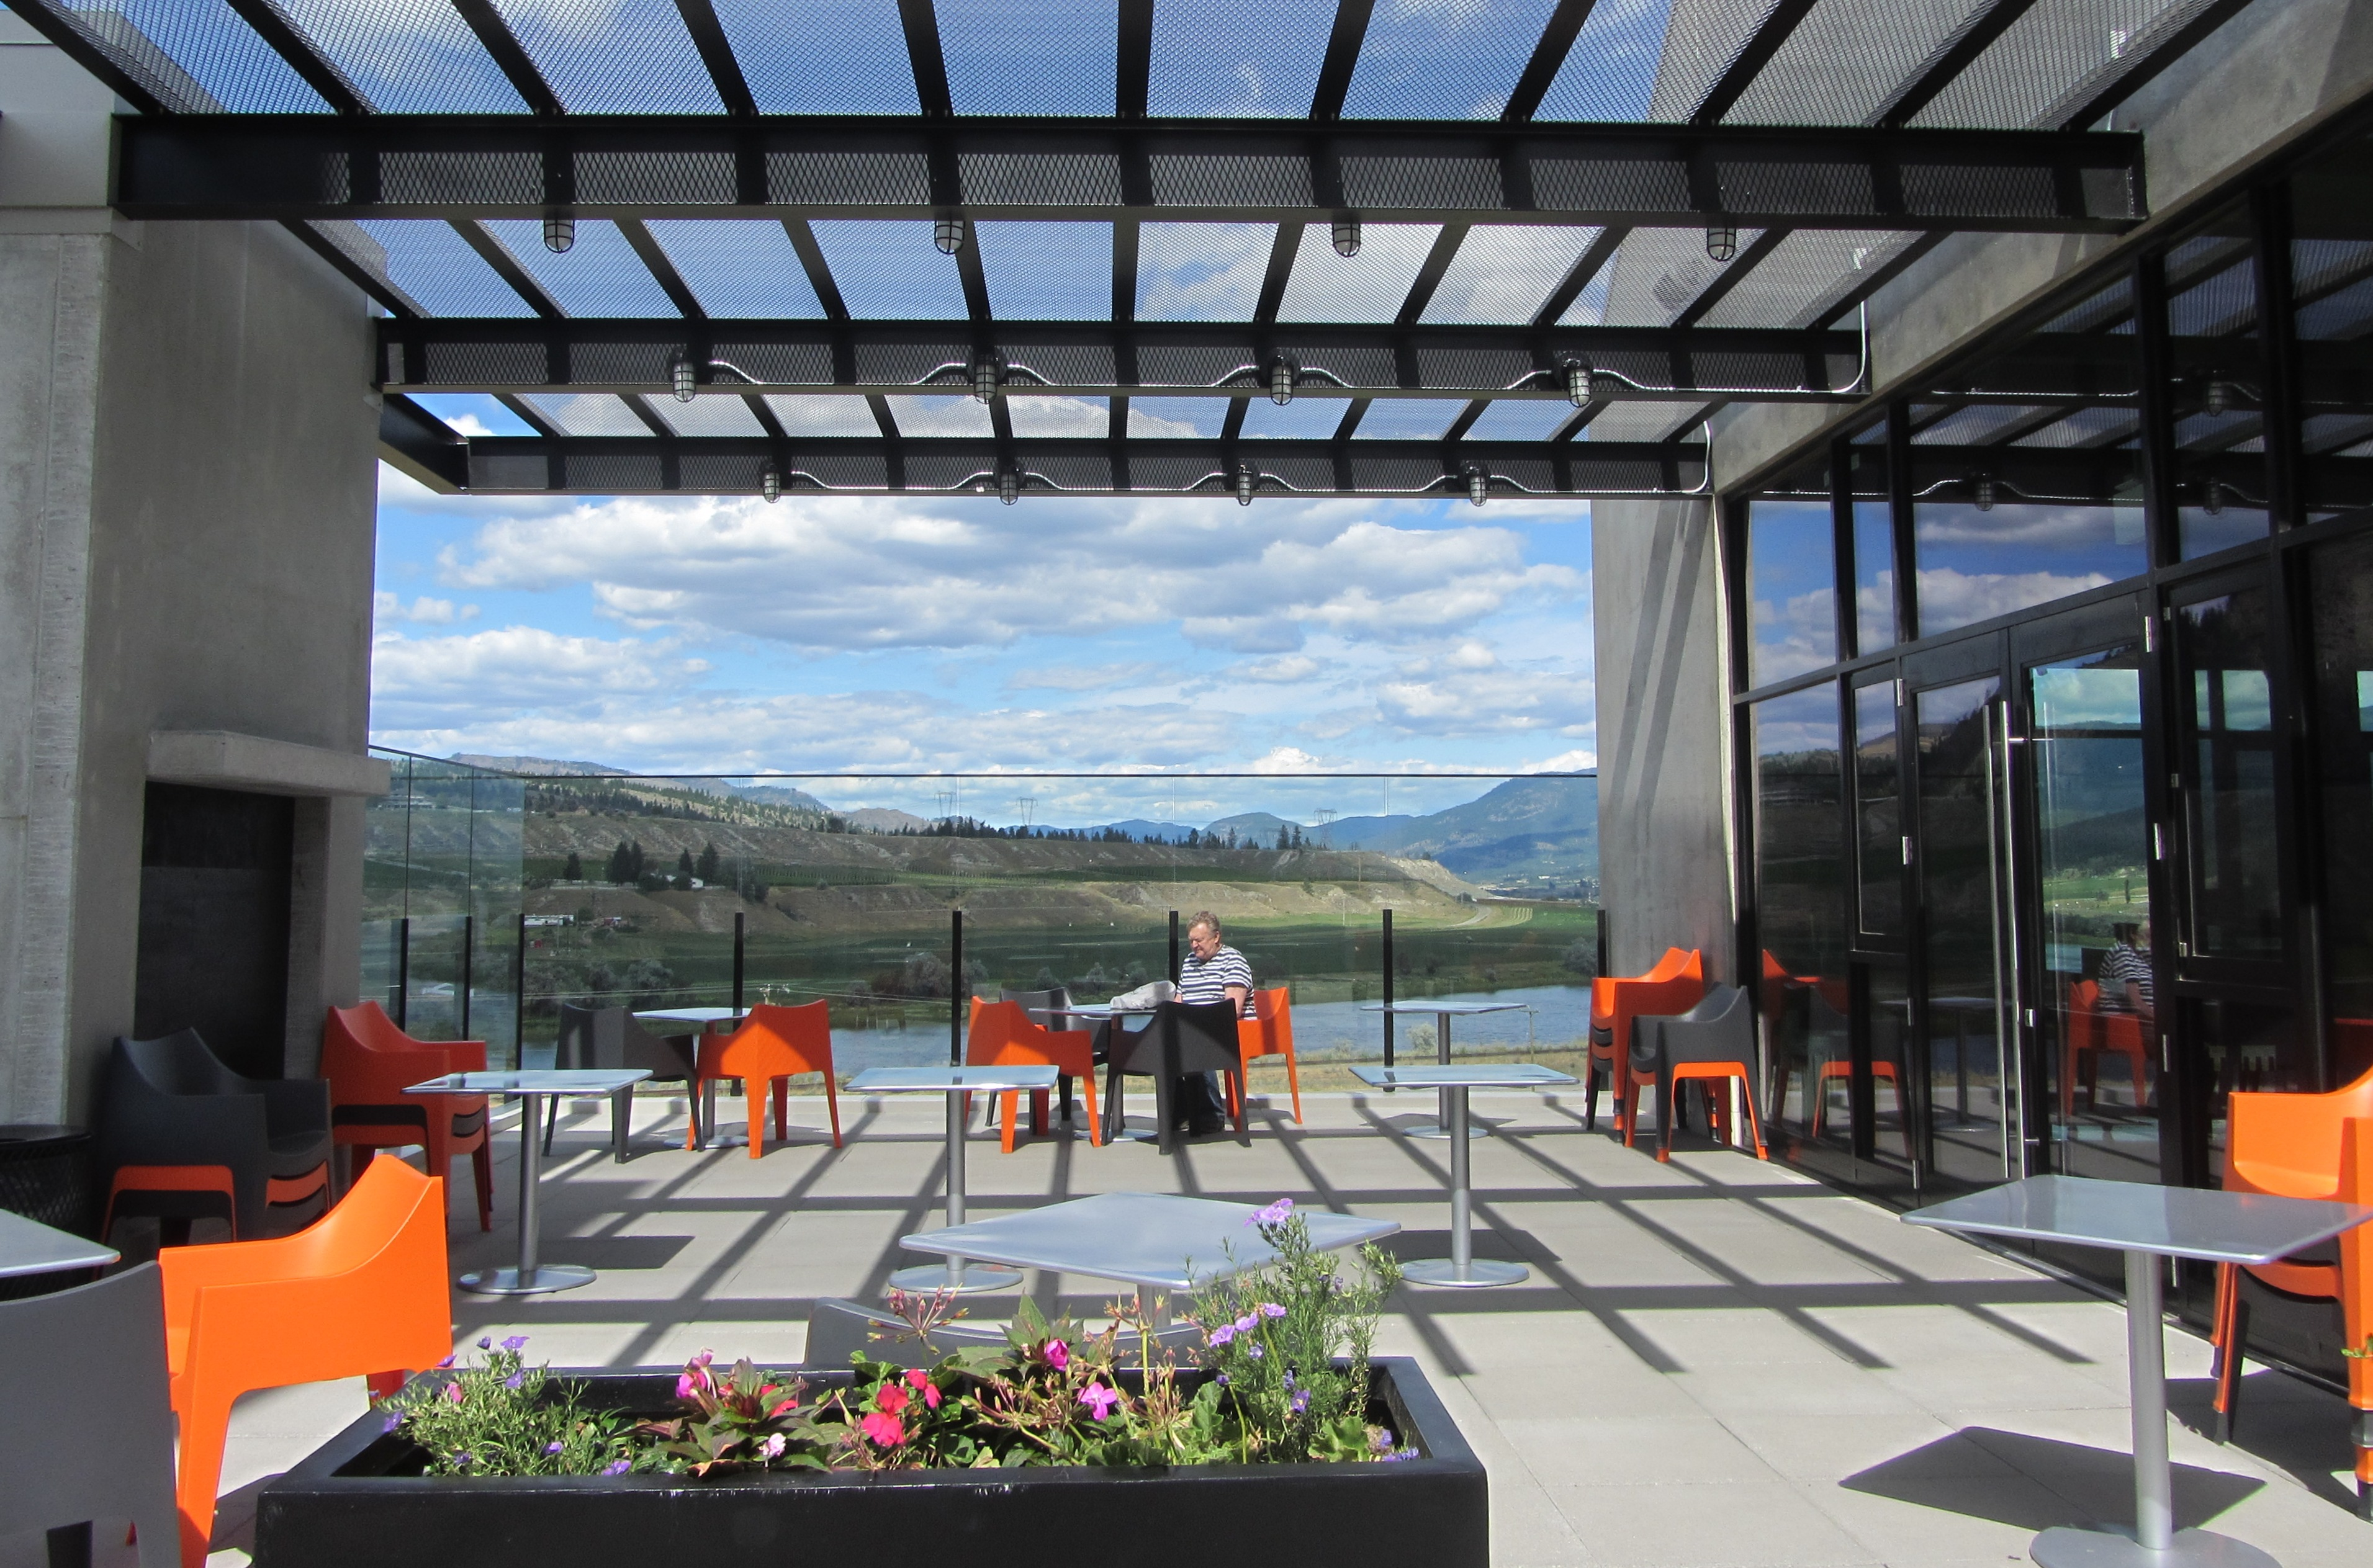

The patio at the Monty Creek Ranch Winery offers a breath taking view of the South Thompson River.

However, Miner attacked the baggage car instead of the express car, which was still connected to the train. He searched the baggage car but overlooked several packets of bank notes, getting away with a mere $15 in cash and a handful of liver pills. After the epic train robbery failure a manhunt ensued to catch Miner and his two accomplices Shorty Dunn and Louis Colquhoun.

While Monty Creek was not so lucky for the notorious Bill Miner it has been all good for the Monty Creek Ranch Winery. The winery commemorates the areas outlaw past with their Hands Up Red and Hands Up White wines.
As its name implies, this is also a working cattle ranch. Their cattle graze on native grasses and hay grown organically on the property. Grass fed beef contains less fat, fewer calories and more fatty acids compared to cows fed grain. They produce a rare breed of Black Angus fed a steady diet of grass and not grain because cattle were born to eat grass not grain.
They also grow Haskap berries which are part of the Blue Honeysuckle family. These delicious berries are very high in antioxidants and help prevent cancer, diabetes and cardiovascular diseases. These berries are eaten fresh and also used to make pie, jam, ice cream, yogurt and wine.
The berries are also popular with the farms honey bee population that feed on the nectar to produce 400 litres of honey each year. Their all natural, un-pasteurized honey is available in the wine tasting room.
The ranch has 44 acres of vineyards. The Monte Creek Vineyard is located by the wine tasting room and the Lions Head vineyard is located on the other side of the river under a cliff that resembles a lion’s head.
Opened in 2015, their wine tasting room also boasts an incredible terrace. Enjoy a bottle of wine while sitting by the outdoor fireplace and overlooking the magnificent Thompson River. Gourmet menu items are available for purchase to compliment your favourite wine.

HOW TO GET THERE – Monty Creek Ranch Winery is located at 2420 Miner’s Bluff Road just 10 minutes from Kamloops off the East Trans Canada Highway.

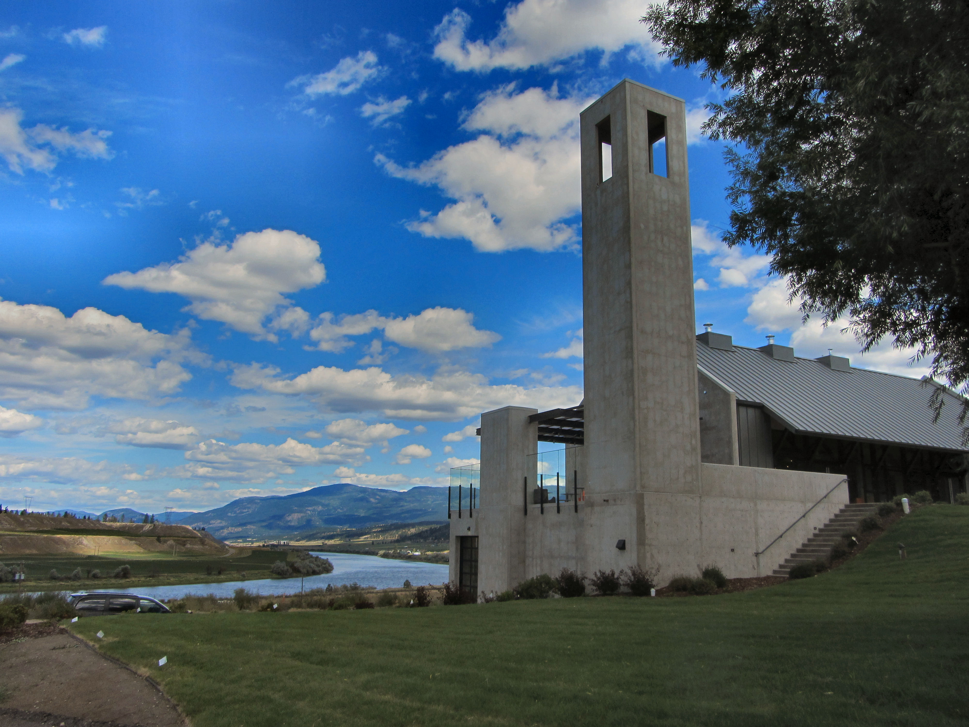

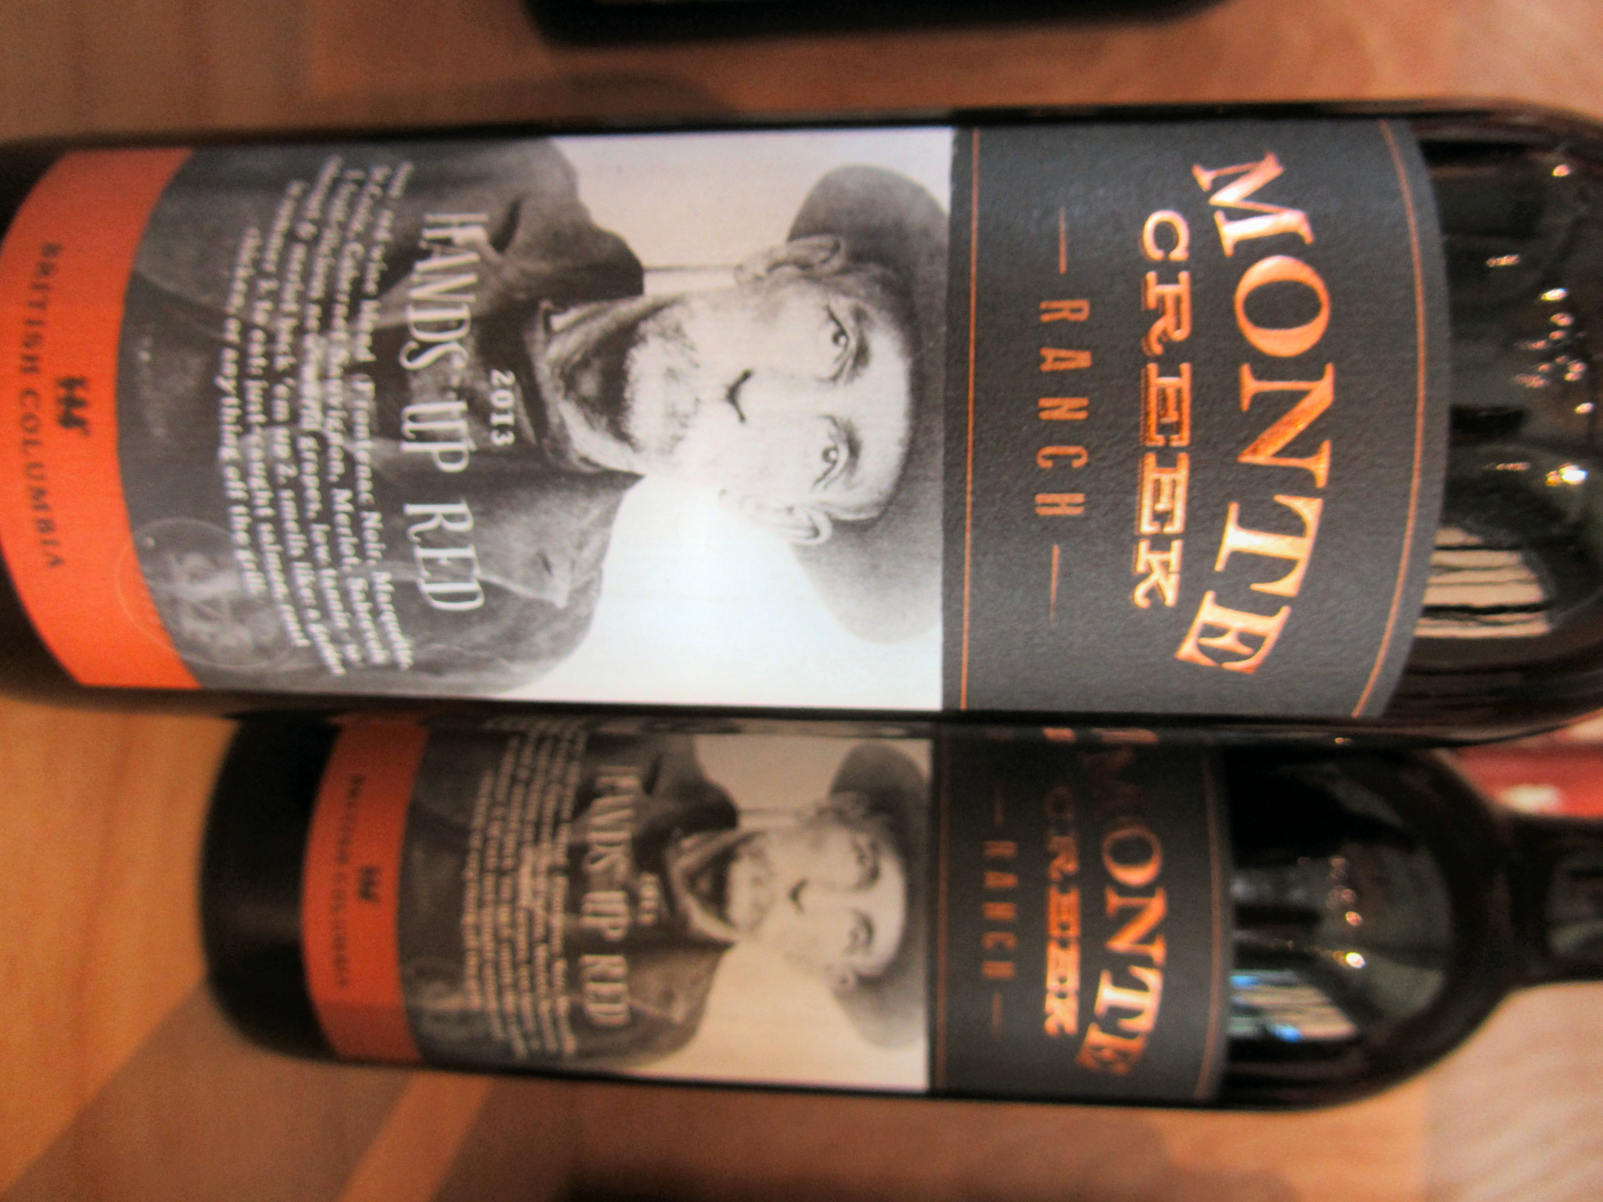

Top: The wine tasting room overlooks the Thompson River. Bottom: Hands Up Red celebrates outlaw Bill Miner.

