Hop Aboard the Kettle Valley Steam Railway

Every kid and kid at heart loves to ride a train but not everyone gets to ride an authentic steam powered train along the only preserved section of the historic Kettle Valley Railway. If you want to give your kids a summer to remember, take them out to Summerland for a ride into Okanagan’s rich history.
Hop aboard a restored 1912 Steam Locomotive the “3716” and take a 90 minute round-trip journey in a vintage passenger coach or open air car through lush vinyards and over the Trout Creek Bridge.
In the 1890’s the CPR had extended their lines to the South Okanagan from Sicamous through to Okanagan Lake. From that point CPR sternwheeler ships traveled south to Penticton carrying people and freight making frequent stops along the way.
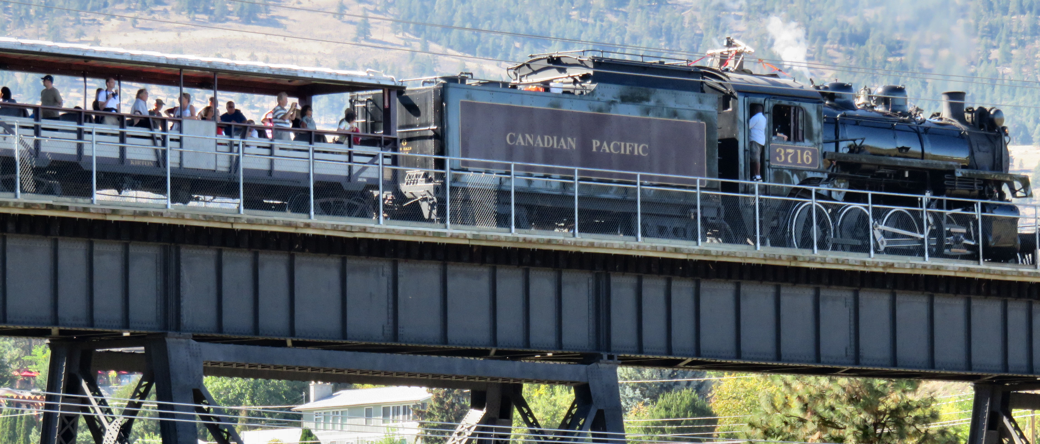

The Kettle Valley Railway train crosses the Trout Creek Bridge.

It was a long trip to the coast or points east for people living in the South Okanagan creating a demand for a “Coast-to-Kootenay” connection.
Built during 1910-1915, the KVR “Kootenay to Coast Connection” - the Canadian Pacific Railway’s new line in the southern interior of British Columbia, powered the Okanagan’s pioneer fruit industry into world markets, transported families on vacations, and created employment. The railway, which was built to prevent our American neighbours from exploiting our provinces mineral wealth, closed its passenger line in 1964 as highways as airlines took over. The challenges of Mother Nature such as major snow in the Coquihalla also took their toll and in 1989, the last freight train rode the rails.

DID YOU KNOW? One of the many KVR engineering achievements designed by Andrew McCulloch was the Trout Creek Trestle Bridge in Summerland, which stretched 619 feet across and 238 feet above the Canyon floor. It was and is known as the “infinitesimal” bridge – “incalculable, inestimable, great and fathomless”. It was the highest structure of its kind on the KVR and the third largest of its kind in North America at the time it was built. The Trout Creek Bridge was upgraded in 1927 & 1928 by filling in the Trestle approaches and replacing trestle work with steel girders.

For a really unique experience book yourself onto the Great Train Robbery Ride and Barbeque. Experience the “Old West” with the notorious Garnett Valley Gang as they rob passengers for local charities. This event sells out fast so be sure to check their website for dates and times and book your tickets early.

HOW TO GET THERE – KVR is located 6 km from the Hwy. 97 exits (approximately a 10 minute drive at 18404 Bathville Road, Summerland. For more information visit their website at www.kettlevalleyrail.org . Make your reservation by calling toll free 1-877-494-8424

Top: The train steams through a road crossing. Bottom: Entertainment is included at the bridge stop.

