Visit a popular winery in a historic Location

Did you know that some of the best wines in the world are grown right here in British Columbia? I had no idea until my friend Pam brought me for a wine tasting at the Summerhill Pyramid Winery – the most visited winery in British Columbia and the first winery to be certified an Organic Winery by the Pacific Agricultural Certification Society of Vernon. Why do they call it Pyramid Winery? Because they age the wines in a four story replica of the Great Pyramid built with marble imported from Egypt. In fact, its alignment and precision is second only to the Great Pyramid which was built to absolute sacred geometry with both pi and phi aligned to absolute True North and contains no ferrous metals that would have it re-orient to magnetic north.
The story of Summerhill began in 1986 when New York developer Stephen Cipes first visited the Okanagan and found the perfect conditions to produce the intensely flavored small grapes needed to make the best sparkling wines.
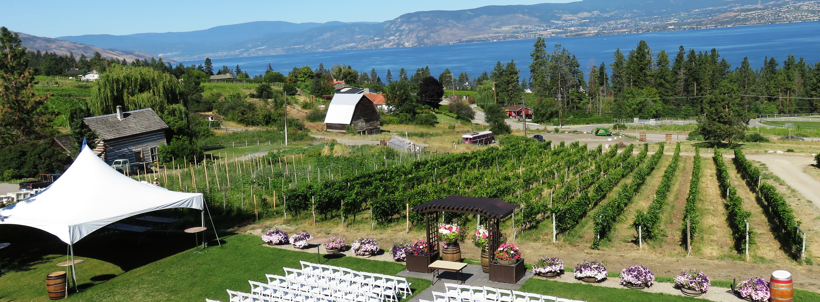

Summerhill is a popular venue for weddings with its fantastic view of Okanagan Lake

So does pyramid power really work? Amazingly enough yes it does. The winery had been conducting blind taste tests with their visitor having them compare wine aged in a traditional cellar versus the same type of wine aged in the pyramid. An astounding 90% of people preferred the pyramid aged wine. Further proof that sacred geometry combined with organically grown grapes produces the world’s best wines is the number of international gold medals won by the winery; not only were they named the best winery in Canada; they even won the gold medal in Champagne France against French Champagne. Today all of the wines produced at the winery are aged for at least 30 days in the pyramid allowing the sacred geometry to enhance and clarify them.
Summerhill is the largest organic winery in North America with over 80 acres or vineyards. They use no chemical pesticides or fertilizers and their spiritual beliefs and interest in preserving the Earth extend far beyond their wines.

They have partnered up with renowned Canadian wildlife painter Robert Bateman to market and promote a series of organic wines called the “Get to Know” series with profits going to Bateman`s non-profit society `Get to Know Your Wild Neighbours` which takes youths away from their computer and TV screens and into nature.
After our tour of the pyramid, Pam and I were treated to a special private tour of the vineyard and much to my surprise we were brought to a sacred native earth house and an early European birthing house. How appropriate that a winery that values spirituality, healing and healthy living be located on the same property.
It is a little known fact that the vineyard is also home to Canada's only Exhibit of First Contact between the Original Peoples and First European Settlers. The exhibit, which came with the property, consists of a heritage house owned by early settler Henry Cecil Mallam who in 1904 bought the property complete with the two story hand hewn log house built in 1897.
With a scarcity of doctors in the area, the Mallam women all acted as midwives bringing many babies into the world in the log home.
In the gully next to the Mallam house is the Makwala Kekuli - a replica of the sacred earth house used by the indigenous peoples for centuries as their winter home. The fire in the centre kept the earth covered dome warm and is believed to be the passageway to ancestors on the other side. Spiritual ceremonies are still held in the Kekuli.

HOW TO GET THERE – Cross the bridge over Okanagan Lake entering Kelowna, take a Right at the second set of traffic lights on Pandosy Street which becomes Lakeshore Road which becomes Chute Lake Road. Summerhill Pyramid Winery is located on 4870 Chute Lake Road. For more information visit www.summerhill.bc.ca or call toll free: 1-800-667-3538
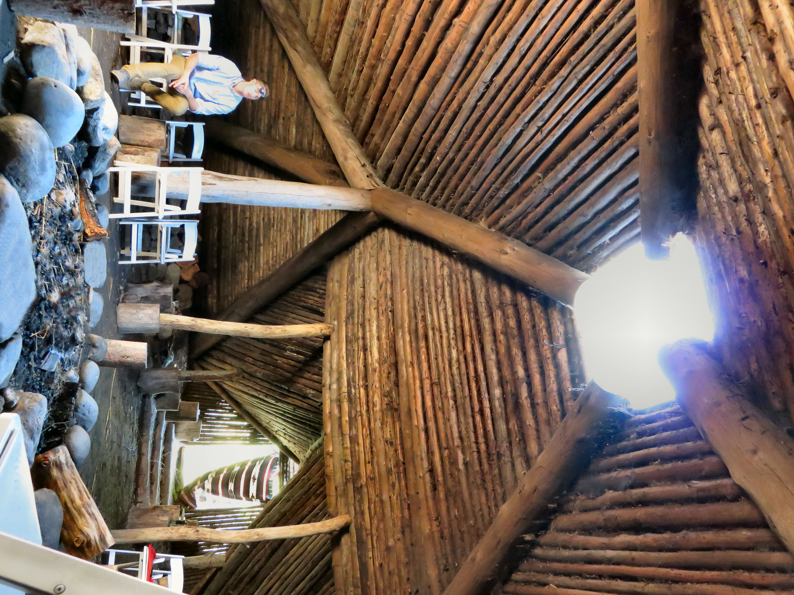

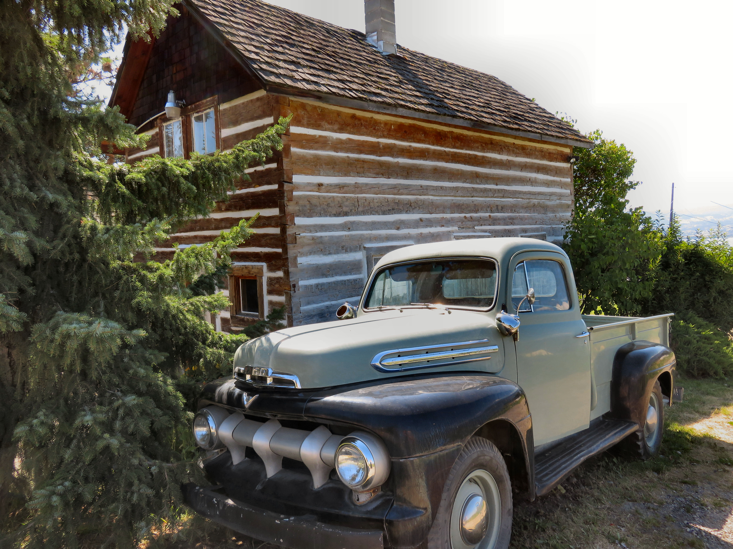

Top: A replica of an authentic Makwala Kekuli located at Summerhill.. Bottom: An old truck is parked in front of the Mallam House.

