Teresathetraveler logo B&W.tif

**Copyright 2017**

All photographs taken by Teresa Cline unless otherwise specified

Published by

Teresa the Traveler Multimedia

Kamloops, BC, Canada

[*www.teresathetraveler.com*](http://www.teresathetraveler.com)

[*teresathetraveler@hotmail.com*](mailto:teresathetraveler@hotmail.com)

*Follow Teresa the Traveler on…*





All rights reserved. This book or any part thereof may not

Be reproduced without written permission from the publisher.

Visit our website at [TeresaTheTraveler.ca](http://www.TeresaTheTraveler.ca)

**Printed at lulu.com**



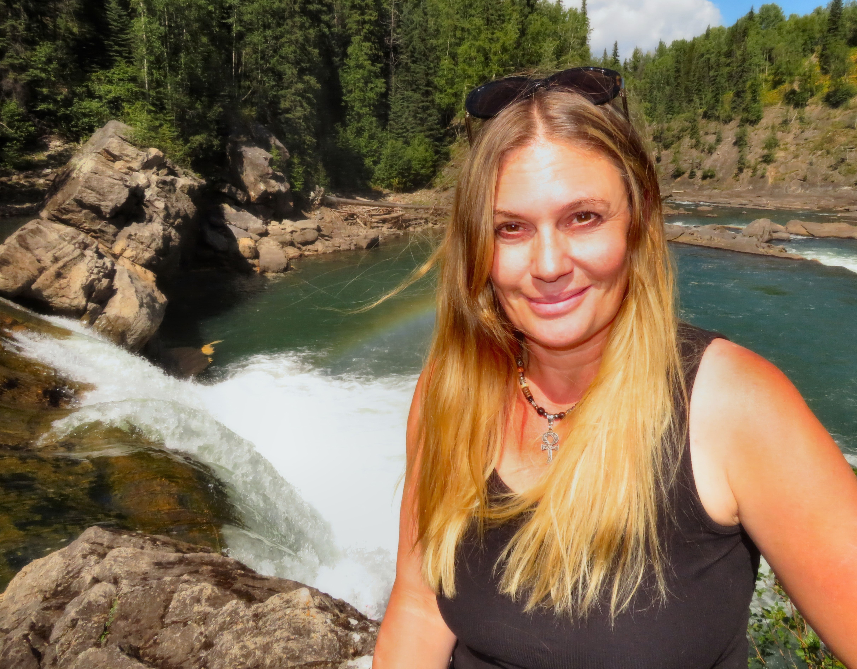

**DO YOU LOVE WATERFALLS, HOTSPRINGS AND SWIMMING HOLES?**

Did you know that standing near a waterfall can improve your mood, reduce stress and improve our health? It’s because waterfalls are probably the greatest producers of negative ions, thanks to the violence with which falling water breaks apart on both hard and aqueous surfaces.Negative ions are odourless, tasteless, and invisible molecules that we inhale in abundance in certain environments. Think mountains, waterfalls, and beaches. Once they reach our bloodstream, negative ions are believed to produce biochemical reactions that increase levels of the mood chemical serotonin, helping to alleviate depression, relieve stress, and boost our daytime energy. So next time you are feeling down, go chase waterfalls! Photo taken at Shannon Falls near Squamish

▲ Teresa the Traveler poses in front of Sukunaka Falls

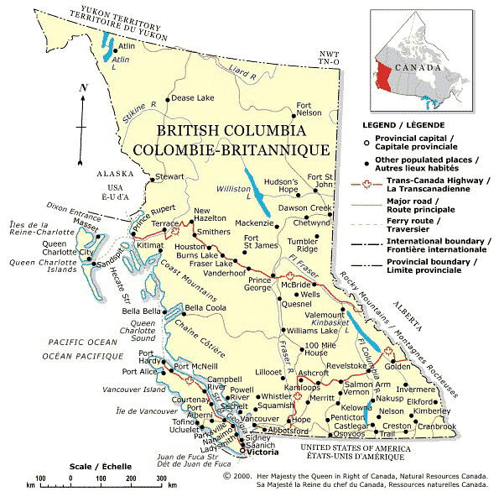

Explore Beautiful British Columbia

If you want to discover the secret waterfalls, hot springs and swimming holes hidden in this magnificent province of Canada keep reading. But please **keep these amazing places secret** so they don’t get overcrowded and destroyed. Don’t post the directions online. If your friends want to know where they are tell them to buy the book or invite them along with you for an awesome adventure!

MCj03354820000[1]

*A special thanks to all the people who shared their favourite waterfalls, hot springs and swimming holes with me so I could compile this book!*

Please note: Some of the trails in this book may have closed since I have visited them. It is a good idea to call or do some online research before visiting to make sure they are still open.

If you choose to visit without checking up and discover they are closed, be happy that you got yourself off the couch and go find other cool things to explore in that area and if you find something cool that isn’t in this book let me know.

**Table of Contents**

1. Watch Water Disappear into Syphon Falls 1
2. Slip Sliding Away at Ashton Creek Falls 2
3. Explore the Frozen Beauty of Dew Drop Falls 4
4. Hike Way up the Mountain to Weyman Falls 5
5. Take a Thrilling Jump off Bromely Rock 6
6. After You Visit Kay Falls, Check Out Kay-2 Falls 7
7. Relax at the Best Rest Stop on the Way to Calgary 8
8. Become Bear Aware at Bear Creek Falls 9
9. Experience the Wonder of Wapta Falls 10
10. Cross Over a Waterfall Turned Natural Bridge 11
11. Rugged Rock Formations at Hamilton Falls 12
12. Take the Time to Tour Takakkaw Falls 13
13. Don’t Be Fooled by the Other Harrison Hot Springs 14
14. Beat the Heat at Bear Creek Falls 16
15. Discover How Nairm Falls Came to Be 17
16. Awestruck at Alexander Falls 18
17. Breathtakingly Beautiful Brandywine Falls 19
18. A Secret Waterfall in an Abandoned Mine 20
19. A Symphony of Water at Shannon Falls 22
20. A Deadly Swimming Hole in Lynn Valley 23
21. Camp at Blanket Creek Near Sutherland Falls 24
22. Take a Sexy Selfie at Ione Falls 25
23. Swimsuits are Optional at Halfway Hot Springs 26
24. Try Cold Water Therapy in Gardner Creek Falls 27
25. A Covered Bridge and Hot Spring at Kushanax Falls 28
26. Wilson Creek Falls at the End of the Rainbow 29
27. Play Fetch With Fido at Fletcher Falls 30
28. Watch the Salmon Spawn then Hike to Canyon Falls 31
29. Jump off a Cliff into the Silver Spring 32
30. Marvel at the Marvellous Marysville Falls 34
31. Take a Soak in the Lussier River Hot Springs 36
32. Make a Relaxing Pit Stop at Rearguard Falls 37
33. Set You Aperture on the Amazing Athebasca Falls 38
34. Climb to the Top of Tangle Falls 39
35. Soak in the Serenity of Sunwapta Falls 40
36. Feel the Rush of Water in Maligne Canyon 41
37. Watch the Weeping Wall of Waterfalls 42
38. Explore the Cascading Pools of Sukunka Falls 43
39. Discover Two of the Four Falls on Martin Creek 44
40. Step Back in Time at Fossil Falls 45
41. A Relaxing Rest Stop at Bijoux Falls 46
42. Have a Waterfall Workout at Quality Creek Falls 47
43. A Magical Mountain Goat Moment at Sikanni Chief 48
44. A Magical Creek Flowing out of a Rock Face 50
45. Jump off the Rocks into Flatbed Falls 51
46. Go For a Dip Near Some Dinosaur Tracks 52
47. Dinosaur Print on the Trail to Nesbitt’s Knee Falls? 54
48. Swim in the Upper and Admire the Lower Barbour Falls 55
49. Visit Every Lookout for the Best Views of Kinuseo Falls 56
50. Sneak a Peek at Canary Falls 58
51. Tips for Reducing Your Environmental Footprint and Staying Safe 59