Watch water disappear into syphon falls

I asked my friend Michelle Holmes if she knew of any great waterfalls in her hometown of Salmon Arm. She replied “yes, Syphon Falls”. It was a sunny fall day so I asked her to show me the falls.
The falls are part of a trail called the Gayle Creek Loops. A 20 minute walk takes you to the falls. The complete loop takes 40 minutes.
When I saw the falls I suddenly realized how it got its unusual name.
As defined in Wikipedia, the word siphon \sy-fun\ is used to refer to a wide variety of devices that involve the flow of liquids through tubes. In a narrower sense, the word refers particularly to a tube in an inverted 'U' shape, which causes a liquid to flow upward, above the surface of a reservoir, with no pump, but powered by the fall of the liquid as it flows down the tube under the pull of gravity, then discharging at a level lower than the surface of the reservoir from which it came.
The water seems to drain into a siphon and disappear then reappear on the other end. It’s quite a remarkable site.
There is a rope located along the side of the falls for those wanting to climb up and see the falls from the top. The trail is rugged so wear good hiking boots and bring some poles.
There is also an area for rock climbing. The crag is about a 15-20 minutes hike up stream. The Shuswap Rock Guidebook gives detailed instructions.

HOW TO GET THERE – Traveling west of Salmon Arm on Hwy 1, turn left/west just past the Welcome Sign onto 1st Ave. SW. Wind up the hill where the road becomes 50th St. NW and continue north to 40th Ave NW, where you turn left/west and drive past the Glen Eden Firehall (on your right). Drive up the hill around the bend, and turn left on 60th St. NW. The trailhead parking area is the second entrance on the right.

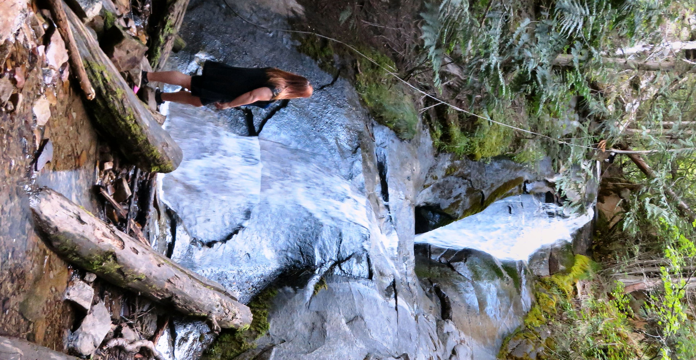

Michelle Holmes admiring Syphon Falls

