CROSS OVER A WATERFALL TURNED NATURAL BRIDGE

The natural bridge in Yoho National Park is located in a spot where the Kicking Horse River carved a canyon into the bedrock. It’s hard to believe that the natural bridge was once a waterfall and it serves as a testament to the influence rushing water has in the shaping of landscapes. The soft rock located under the hard limestone band was eroded away over time until the flow of water diverted underneath forming a rock bridge. Overtime the gorge is expected to deepen and eventually the bridge will collapse creating a gorge.
Visitors are warned not to cross the bridge but that doesn’t seem to stop eager tourists from capturing the perfect natural bridge picture. A lookout and bridge are provided so people can view the bridge from a safe location.
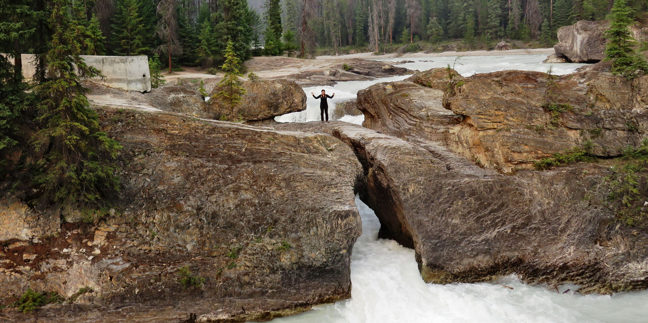

Teresa the Traveler crosses the Natural Bridge over the Kicking Horse River.

The parking lot for the natural bridge is also the parking area for a trailhead that leads to the following five trails: Kicking Horse Trail 2.5 km, Junction – Emerald River Trail 2.3 km, Amiskwi Pass 26.7 km, Junction Otterhead Trail 6.6 km and Tocher Fire Lookout 16 km.
The Kicking Horse trailhead leads to the Meeting of the Waters where the Amiskwi River and Emerald River merge with the Kicking Horse River.

HOW TO GET THERE - The natural bridge can easily be reached by car just 3km (1.9 miles) from Field on Emerald Lake Road. It is part of Yoho National Park so be sure to purchase a park pass in Field before entering.

