RUGGED ROCK FORMATIONS AT HAMILTON FALLS

Hamilton Falls may not be the most spectacular falls in Yoho National Park, but it is well worth the short hike to admire the surrounding rock formations. The water is crystal clear and there are a few pools where you can dip your feet in.
It is located near Emerald Lake, one of the most popular tourist stops in Yoho National Park. The emerald green water with the bridge leading to the Emerald Lake Lodge set against the surrounding mountains makes a picture postcard vista. In the high season there are crowds of people and the parking lot is full. However, you can escape the crowds by renting a canoe and paddling around the lake, or taking the 10.9 km trail that circles the lake.
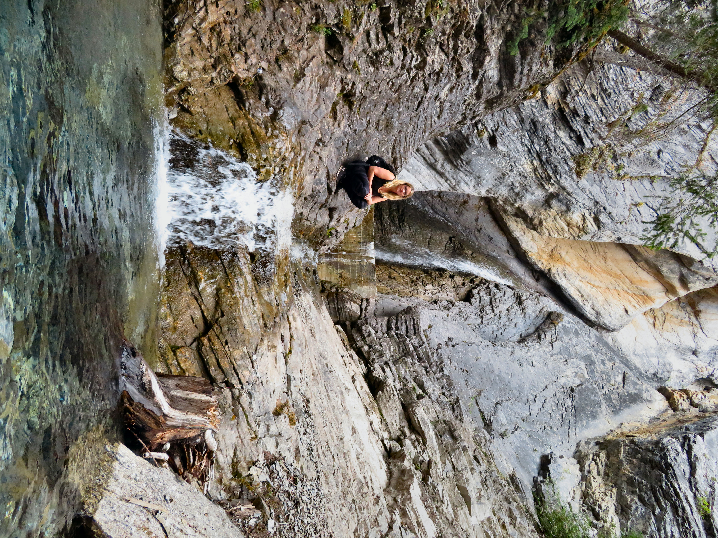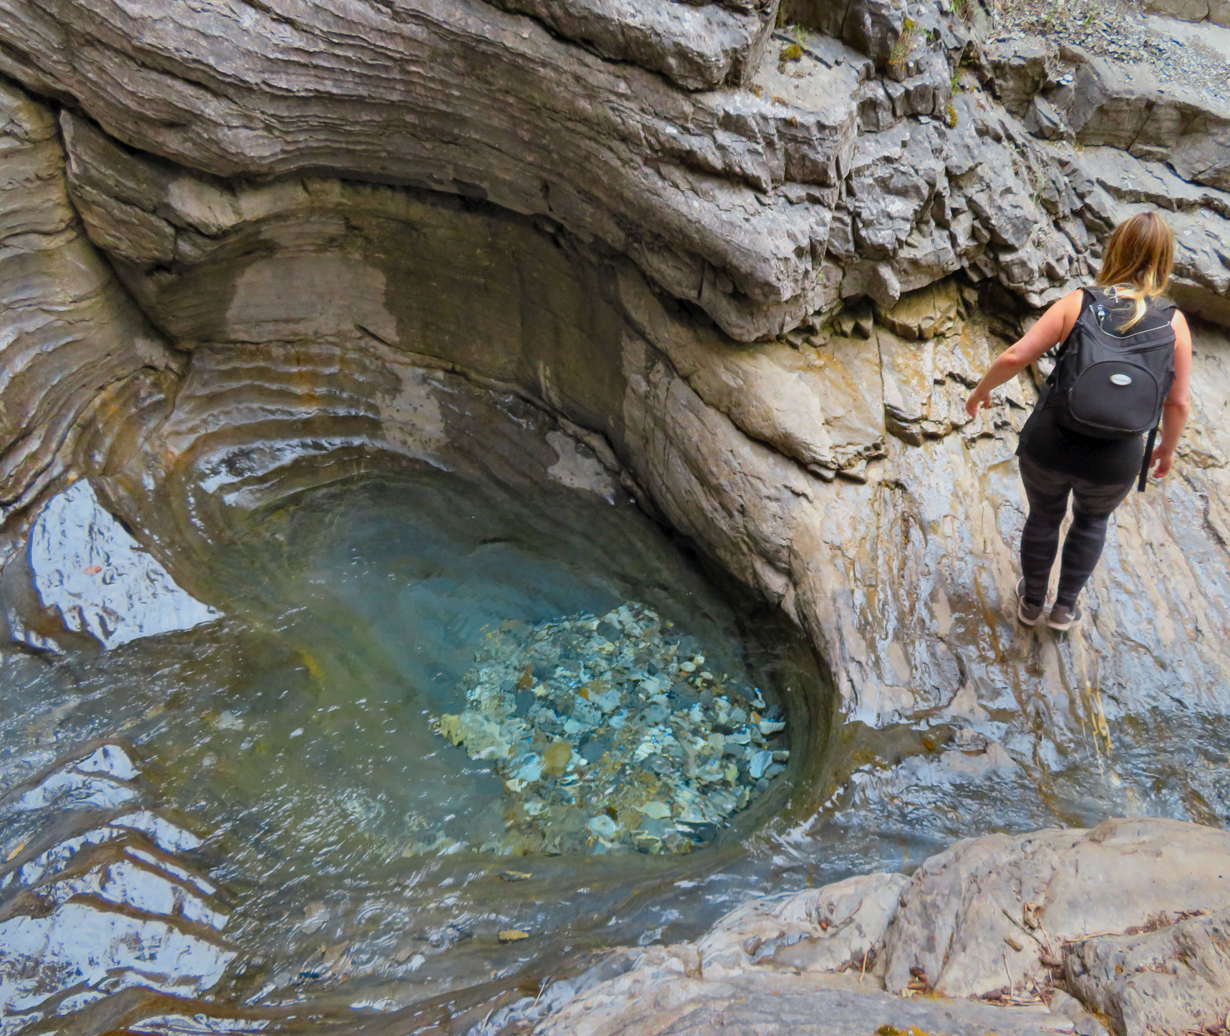

Carolyn Cameron explores the rugged rock formations surrounding Hamilton Falls

Along the trail you will see signs explaining the incredible finds in the surrounding Burgess Shale. The Burgess Shale Formation is an exposed fossil-bearing deposit. It is famous for the exceptional preservation of the soft parts of its fossils. At 508 million years old, it is one of the earliest fossil beds containing soft-part imprints. Interpretive hiking tours can be booked to view the deposits.

HOW TO GET THERE – From Golden, take Highway 1 towards Field and take the Emerald Lake exit on the left. Park in the Emerald Lake parking lot and look for the sign marking the trailhead for Hamilton Falls. It is a 2km round trip hike to the falls.

