Beat the heat this summer at bear creek falls

Bear Creek Falls is on the same forest service road as Rainbow Falls (the previous page) just a bit farther up the road. There is a campground across the road from the falls on Harrison Lake that is a popular spot with locals.
The base of the falls is much more accessible than Rainbow Falls and there is even a pool at the bottom where a person could cool off on a hot day. The big rock that Garrett is standing is a great location for a selfie of you and the falls.
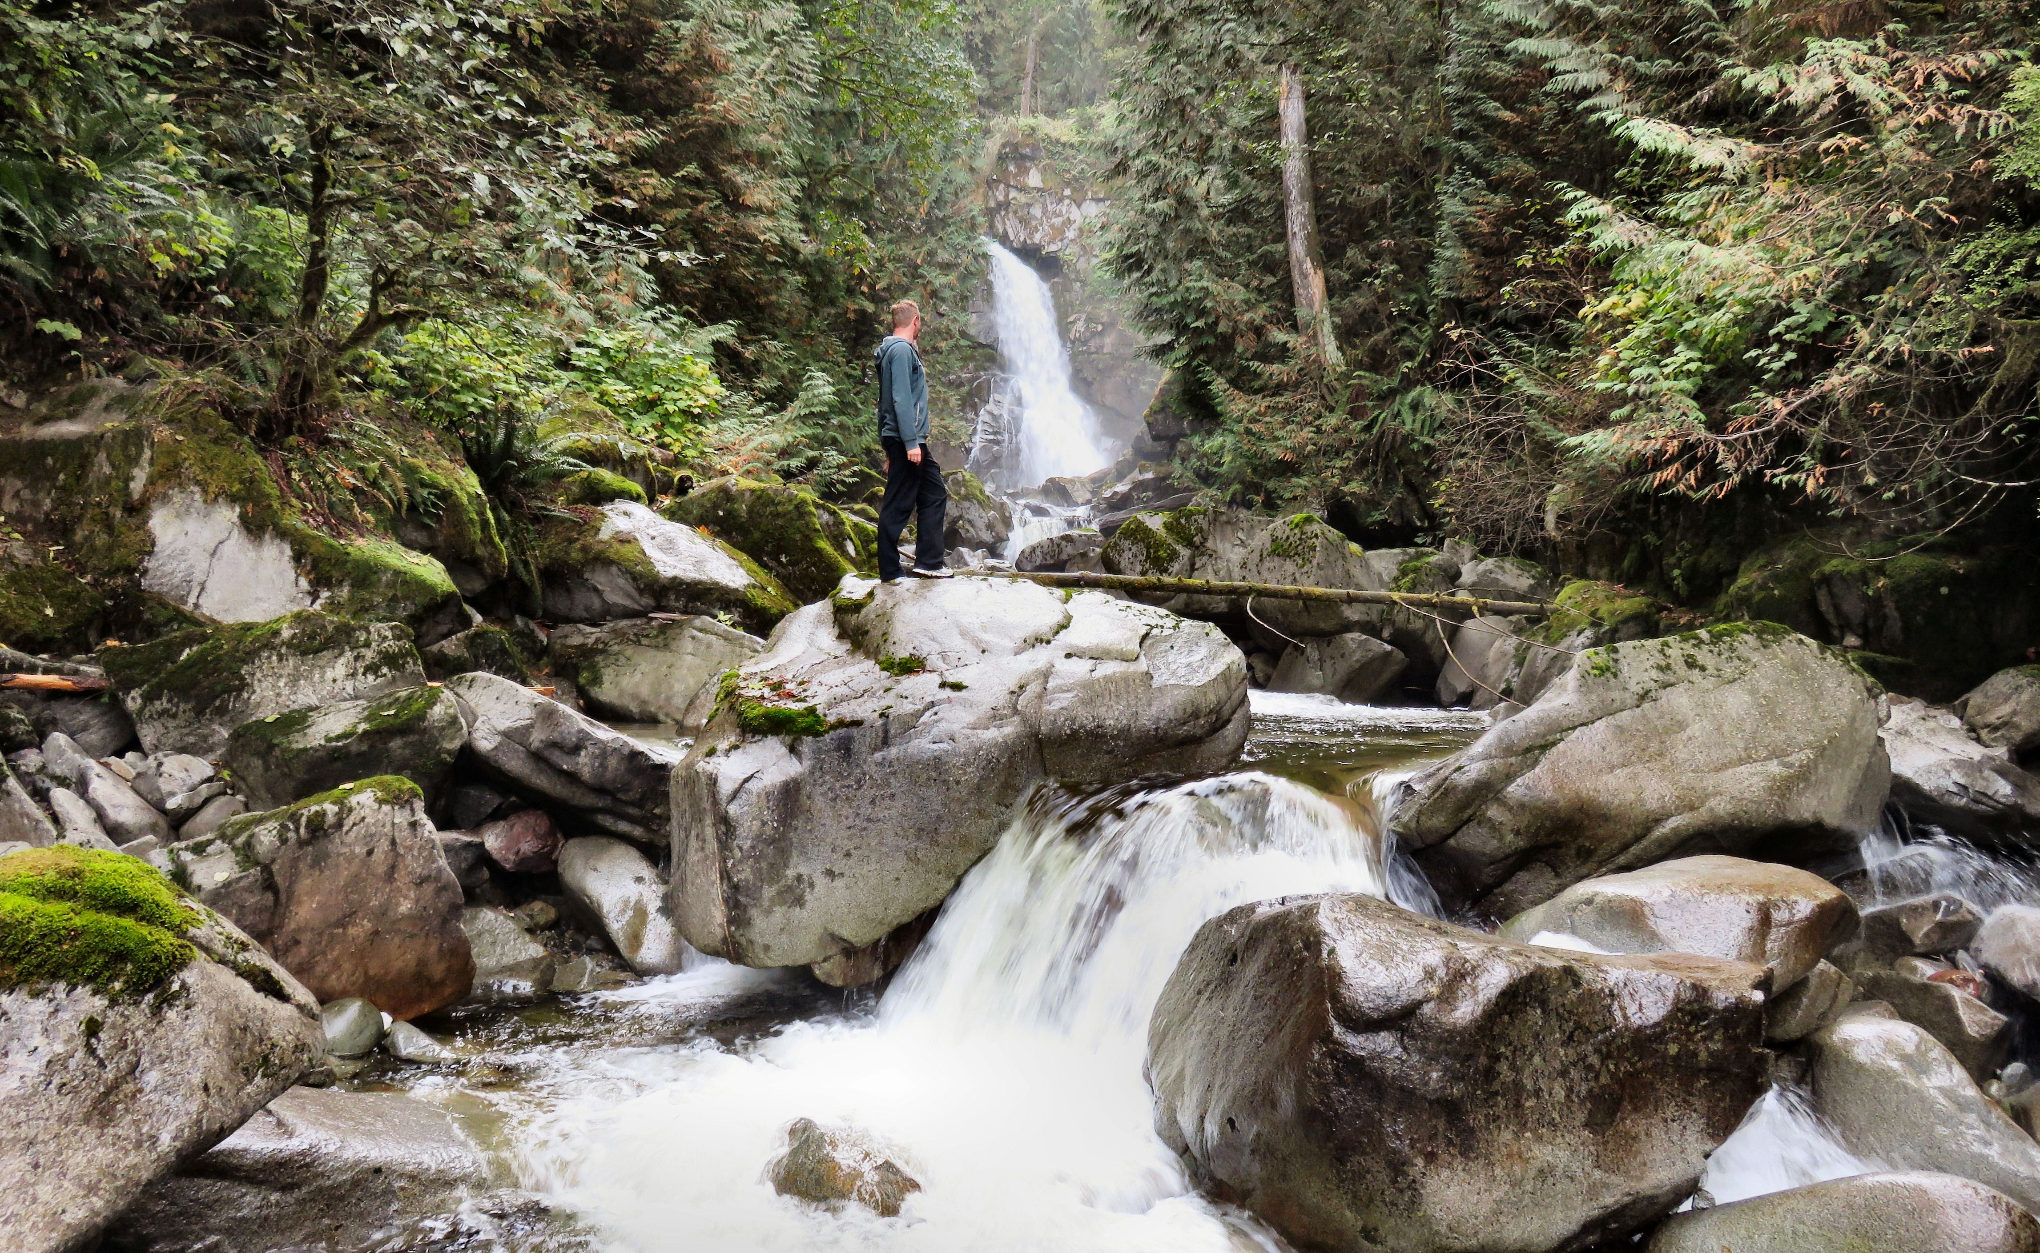

Garrett Eidem admires Bear Creek Falls from a rock.

HOW TO GET THERE – From Kamloops drive past Hope and between Hope and Bridal Falls turn right at the signs for Harrison. Follow the Agassiz-Rosedale Highway in Harrison Hot Springs and then turn right onto Lillooet Avenue. Follow it as it turns into Rockwell Drive and goes past Sasquatch Provincial Park. The road turns to gravel and transitions into the Harrison East Forest Service Road. It is the second falls you will see from the road on the right, the first is Rainbow Falls.

