Discover how Nairn Falls came to be

Nairn Falls Provincial Park was established in 1966 to protect a very special area.
Over 150 million years ago this area was near the shore of a vast ocean but over time the Earth’s crust moved transforming it into a mountainous area. Look for “potholes” created in the rocks as the water spins trapped particles in rock circles.
The falls can be reached from a 1.5k hiking starting at the parking lot, or if you want an extended hike, you can park at the Tourist Information Center in Pemberton and take the One-Mile Lake loop that intersects with a trail to the falls.
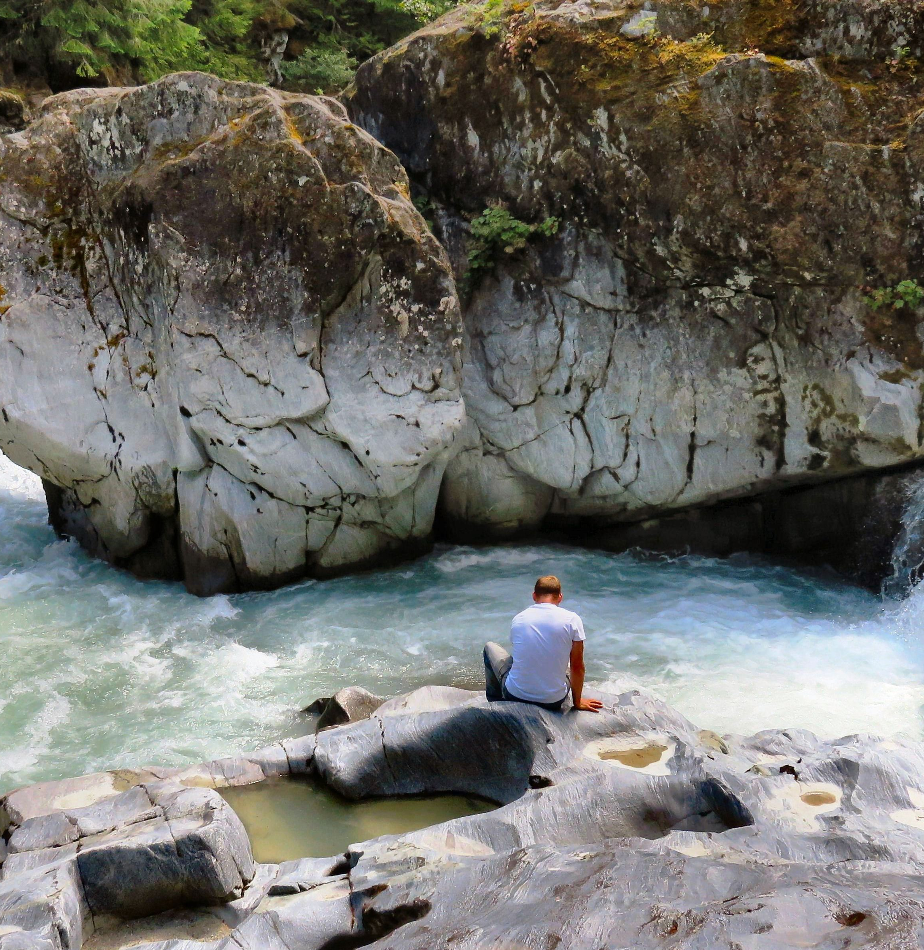

Below the falls there are areas where you can get close up to the river and see some of the incredible rock formations.

DID YOU KNOW? Nairn Falls is home to the rubber boa. Smallest of the boa constrictor family, its average length is only 45 cm. Its nocturnal habits mean that this shy snake is rarely observed. The boa’s brown or gray, plasticine-like appearance and two blunt ends make it hard to identify as a living animal from a distance. If you see a worm-like snake, do not disturb it!

HOW TO GET THERE – Nairn Falls Provincial Park is located 5 minutes from Pemberton town center on the highway heading to Whistler. The falls are a 1.5k hike from the parking lot.
