Awestruck and Amazed at alexander falls

Located in the Callaghan Valley region where the 2010 Olympic Nordic events took place, One of Alexander Falls is one of Whistler’s most impressive hidden gems. The waterfall is easy to access by car and the viewing platform is right next to the parking lot. No hiking is required.
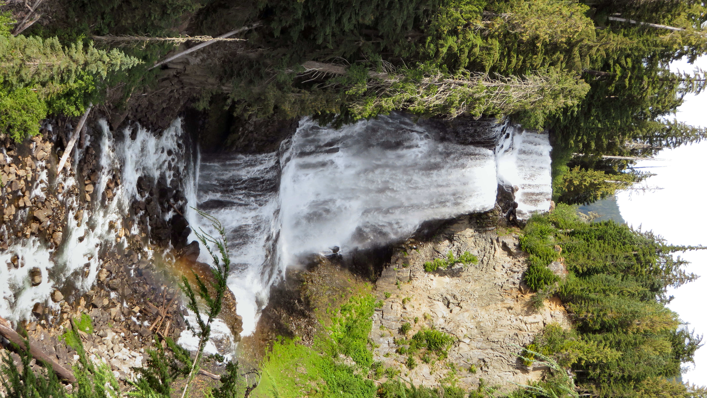
Alexander Falls is on Madeley Creek, a tributary of Callaghan Creek. The falls consist of three drops that total of 43 meters in and are about 12 meters wide.

DID YOU KNOW...the 2010 Winter Olympics, officially known as the XXI Olympic Winter Games were held from February 12 to 28, 2010, in Vancouver, with some events held in the Richmond, West Vancouver and Whistler. Approximately 2,600 athletes from 82 nations participated in 86 events in fifteen disciplines. The 2010 Winter Olympics were the third Olympics hosted by Canada and the first by the province of British Columbia. Canada hosted the 1976 Summer Olympics in Montreal and the 1988 Winter Olympics in Calgary.
Canada won 14 gold medals breaking the record for the most gold medals won at a single Winter Olympics. The previous was 13, set by the former Soviet Union in 1976 and Norway in 2002.
One of the most memorable events was ice hockey. Twelve teams competed in the men's event and eight teams competed in the women's event. Canada won both tournaments with victories against the United State. The games came to an epic climax with the Canadian men’s team beating the United States 3-2 in an overtime thriller.

HOW TO GET THERE – Alexander Falls is located just off the Sea to Sky Highway between Squamish and Whistler. Take the turnoff to Callaghan Lake Provincial Park and follow the signs to the parking area for Alexander Falls.,

Alexander Falls is easily accessible with a great viewing platform.

