Breathtakingly beautiful brandywine falls

Established on January 18, 1973, Brandywine Falls Provincial Park covers an area of 420 hectares. The falls are accessed by a short trail from the parking lot. A large viewing platform is available. If you continue walking down the trail past the platform there is another viewing area where you can also see Daisy Lake in the distance.
The cover of a Squamish guidebook features an award-wining image of a person standing at the foot of the falls. The shot showcases the enormous 70 meter drop. However, getting to the foot of the falls is not easy. Anyone caught going past the fence line risks a hefty fine. It is located at the edge of a steep canyon and climbing down the edge is risky business.
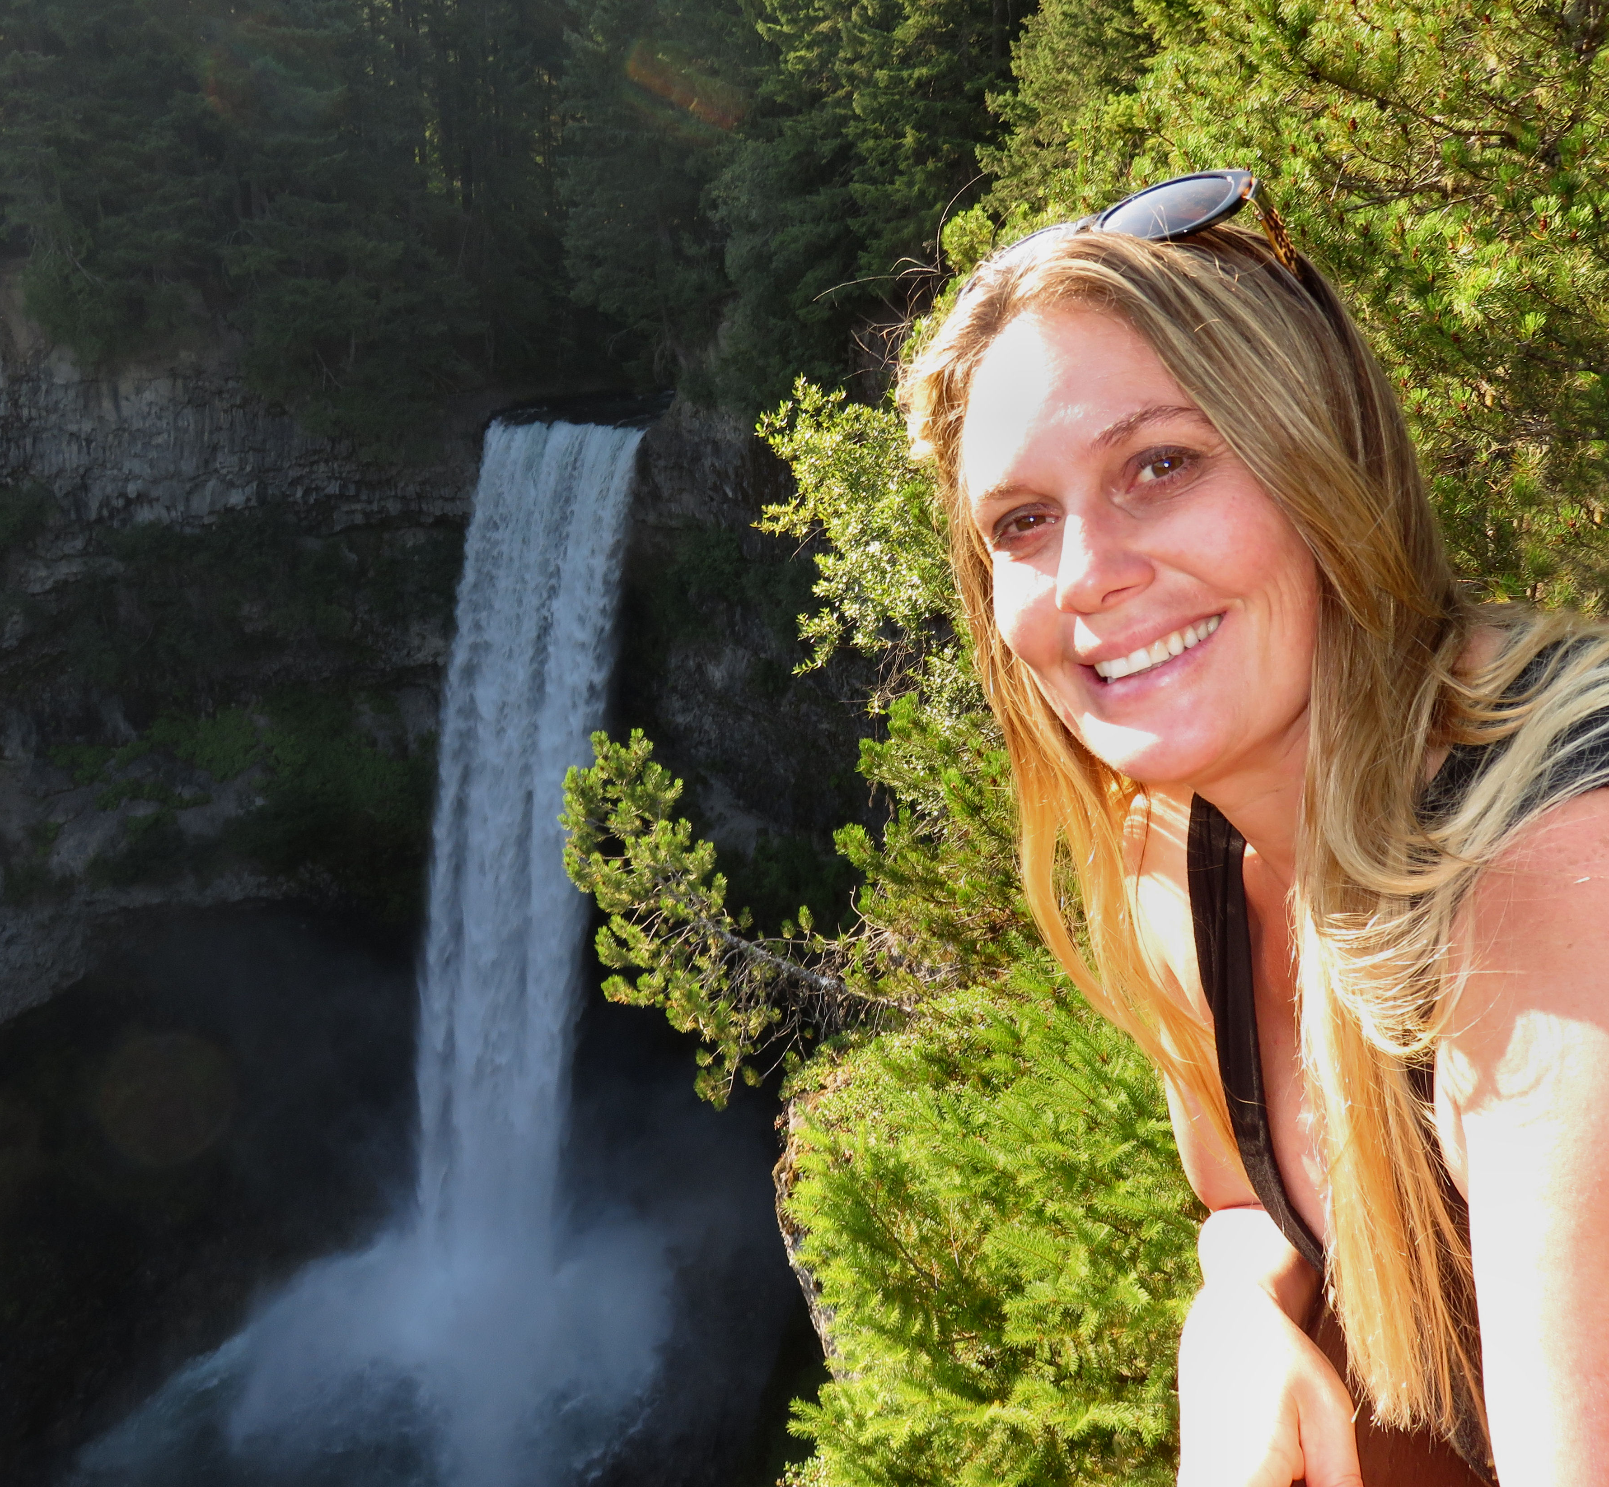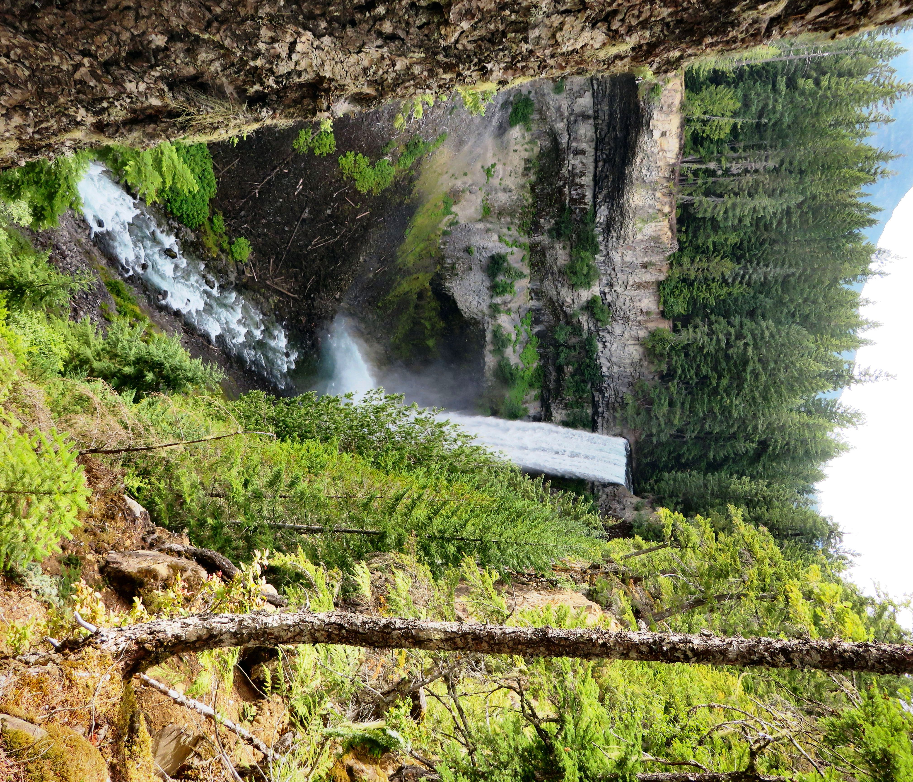

Taking a selfie in front of Brandywine Falls can be a challenge with the crowds of people on the platform.

Since the falls make a straight drop, another popular falls pose is one where you open your mouth and have it appear as though you are vomiting the falls. I witnessed 2 girls attempting this pose during my visit.

DID YOU KNOW...the park was tripled in size in 2010 to include unique habitat for red-legged frog. They are considered a provincial “blue listed” species at risk.

HOW TO GET THERE – Brandywine Falls Provincial Park is located on the Sea to Sky Highway between Squamish and Whistler.

