A Symphony of Water at shannon Falls

Composed of a series of cliffs, rising 335 metres above Highways 99, Shannon Falls is the third highest falls in British Columbia. It ranks behind Della Falls in Strathcona Provincial Park at 481 metres and Hunlen Falls in Tweedsmuir Provincial Park at 396 metres. Shannon Falls originate from Mount Habrich and Mount Sky Pilot.
The falls are named after brick-maker William Shannon who first settled the property in 1889.
This park provides picnicking, hiking and access to the trail in Stawamus Chief Provincial Park. There is also a concession and information centre located next to the flush toilet building on the trail to the waterfall.
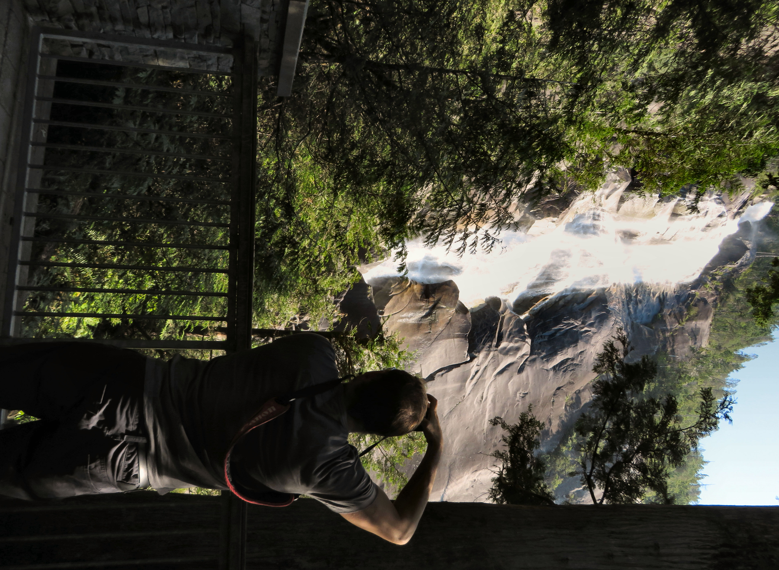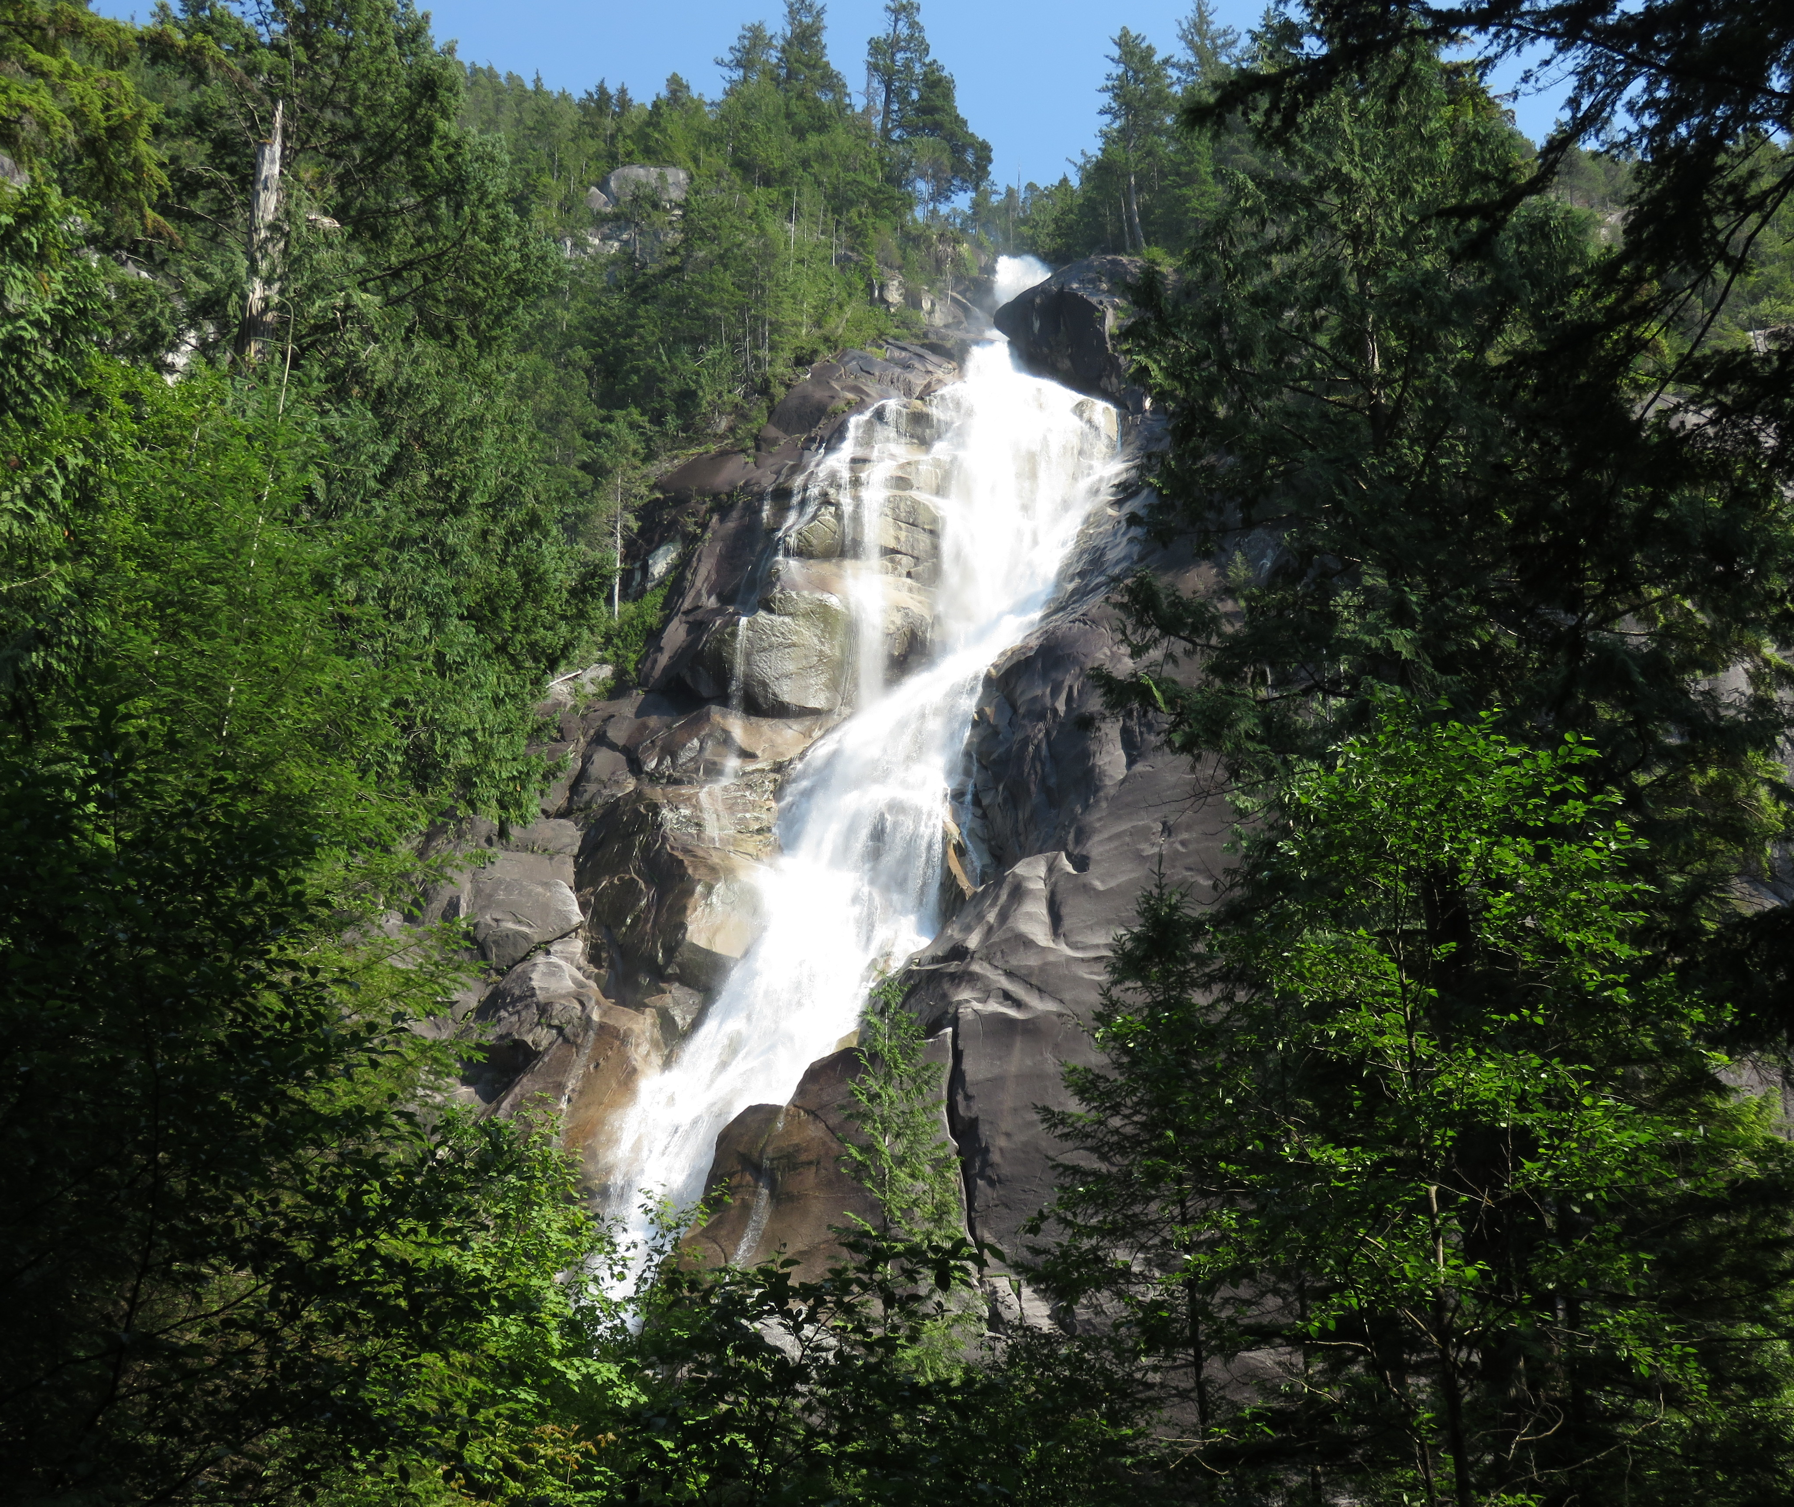

Photographer Jason Humber shoots the falls from the viewing platform.

The falls and adjoining woods are commonly used in television and film production. They are located near Stawamus Chief Provincial Park. The 3-hour climb to the top of the Chief is a huge attraction in the area. It towers over 700 m above the waters of nearby Howe Sound and claims to be the "second largest granite monolith in the world". It is world famous in the rock-climbing world housing some of the best long free and aid routes in Canada.

HOW TO GET THERE – Shannon Falls Provincial Park It is located 58 kilometers from Vancouver and 2 kilometers south of Squamish along the Sea to Sky Highway.

